Comprehensive and Systematic Analysis of Gene Expression Patterns Associated with Body Mass Index

Paule V. Joseph¹, Rosario B. Jaime-Lara¹, Yupeng Wang³, Lichen Xiang², Wendy A. Henderson²
¹ Sensory Science and Metabolism Unit, Biobehavioral Branch, Division of Intramural Research, National Institute of Nursing Research, , National Institutes of Health, Department of Health and Human Services, Bethesda, MD, 20892, USA
² Digestive Disorders Unit, Biobehavioral Branch, Division of Intramural Research, National Institute of Nursing Research, , National Institutes of Health, Department of Health and Human Services, Bethesda, MD, 20892, USA
³BDX Research & Consulting LLC, Fairfax, VA 22031, USA
*Corresponding author:
Dr. Wendy A. Henderson, hendersw@mail.nih.gov, Telephone: +1-3014519534, Fax: +1-3014801413

Fig. S1. Comparison of racial compositions between normal and over weight individuals without (A) and with (B) use of race-specific BMI cutoffs for determining over weight status.
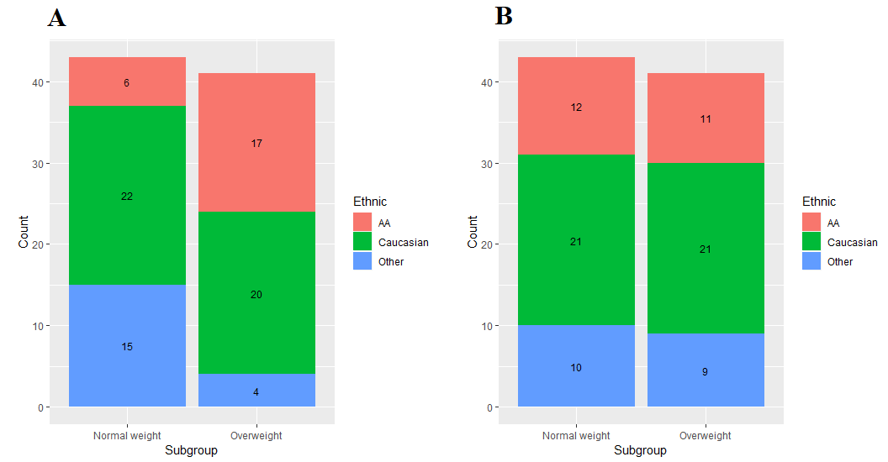

Fig. S2. PCA analysis of microarray data before and after batch effect removal.
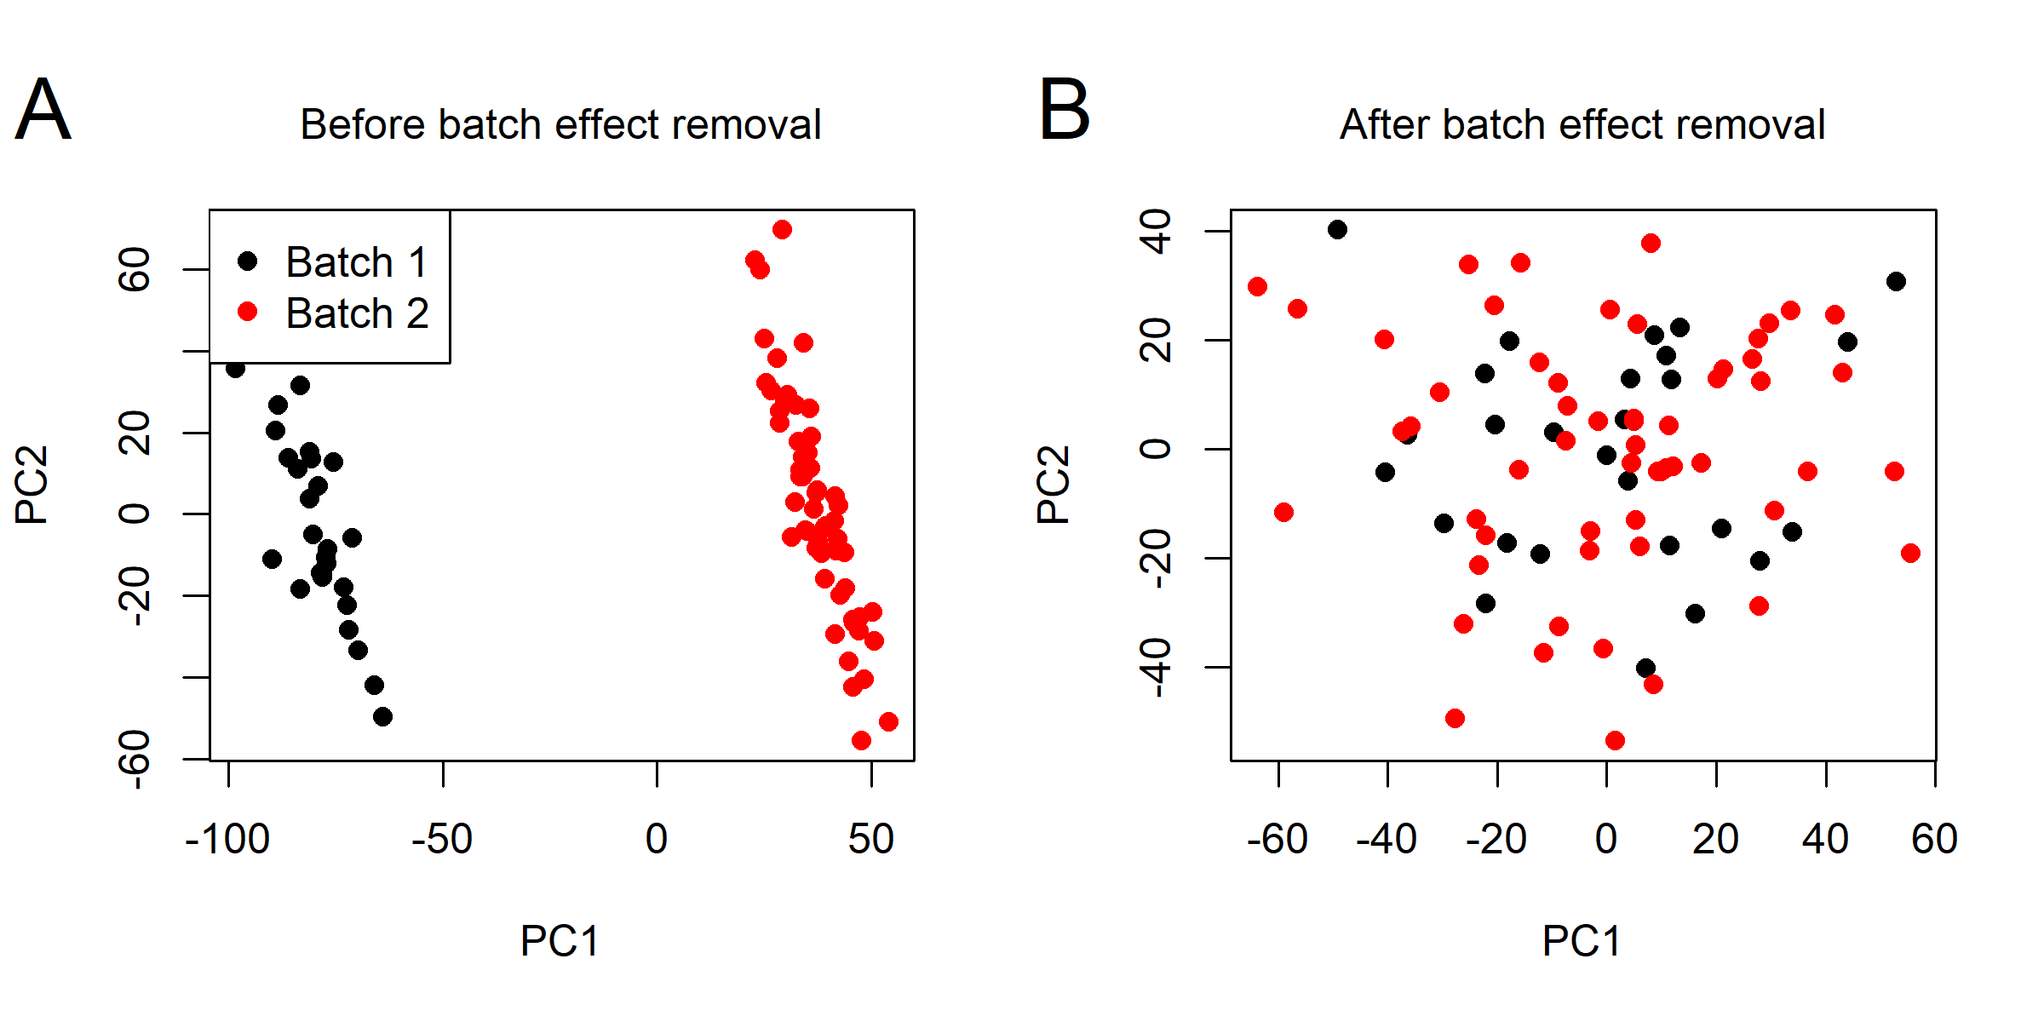

Fig. S3. Scale-free topology properties of the generated coexpression network.
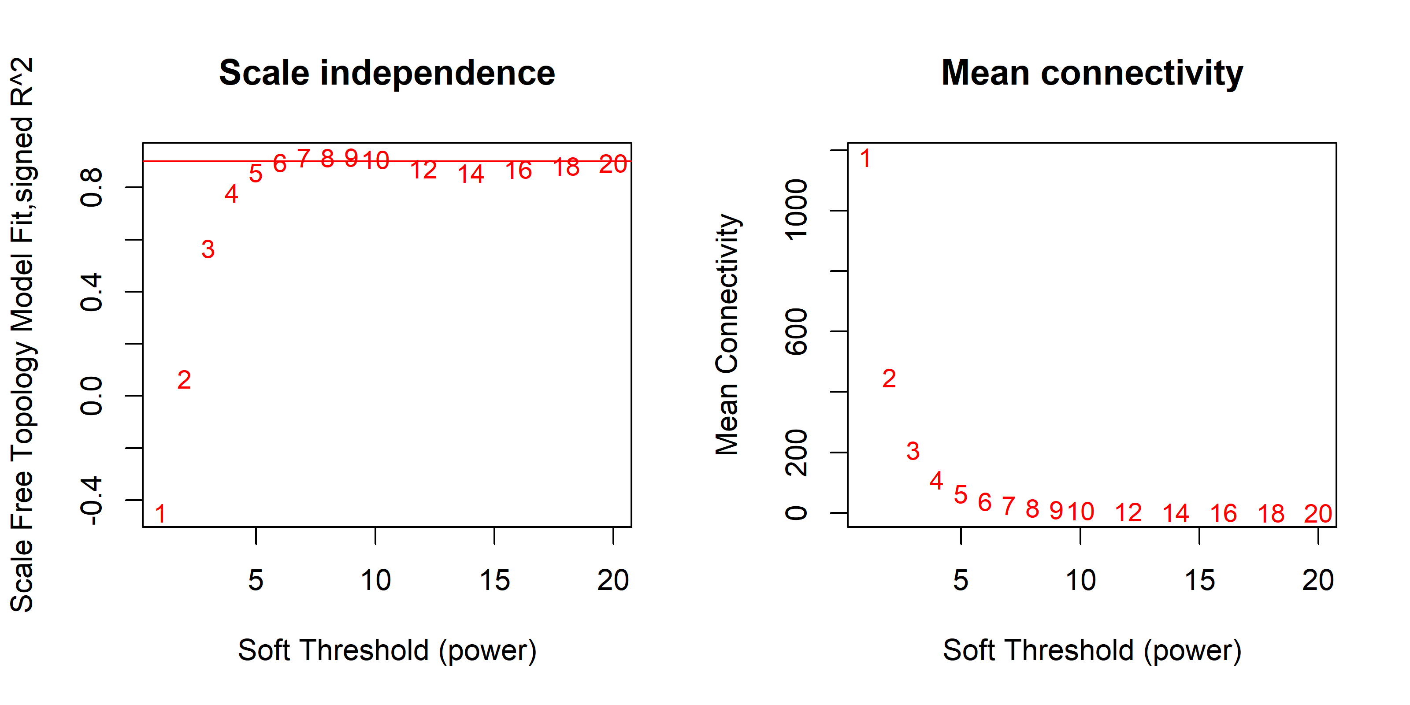

Fig. S4. Gene dendrogram and co-expression modules generated by WGCNA and labeled by colors.
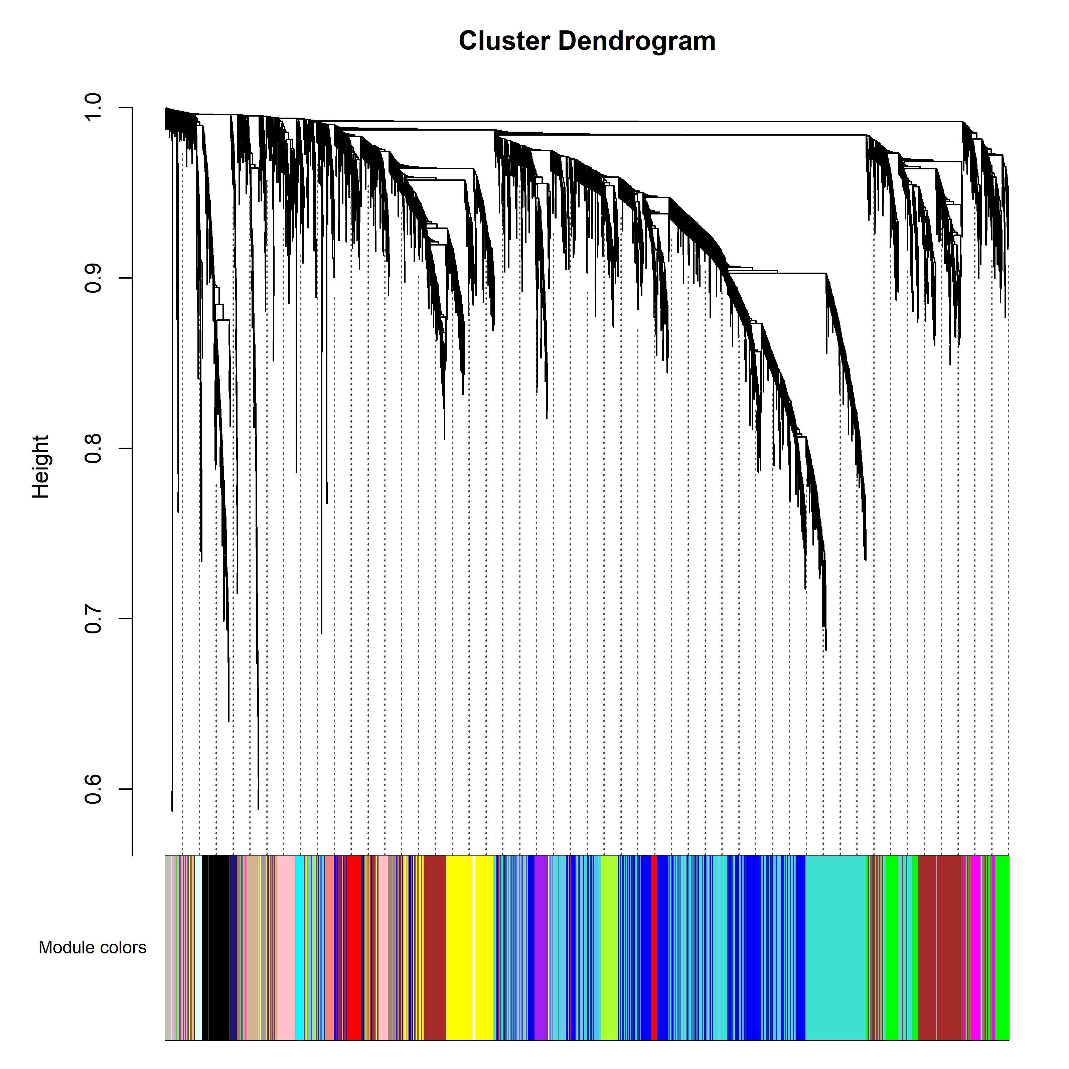

Fig. S5. Signal (gene expression level) distributions of microarray data for all individuals after preprocessing
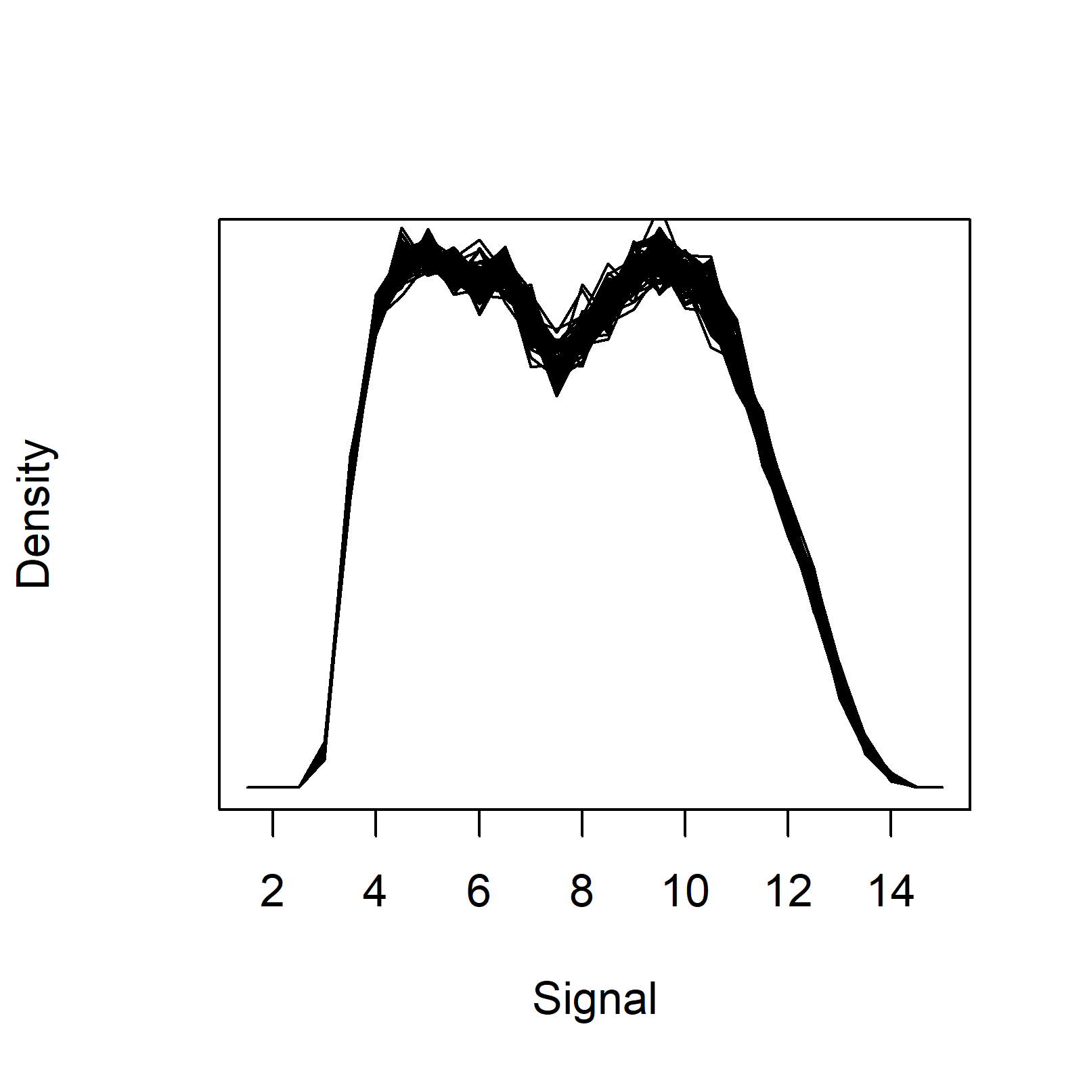

Fig. S6. Major principal components of microarray data are not associated with gender, race or age.
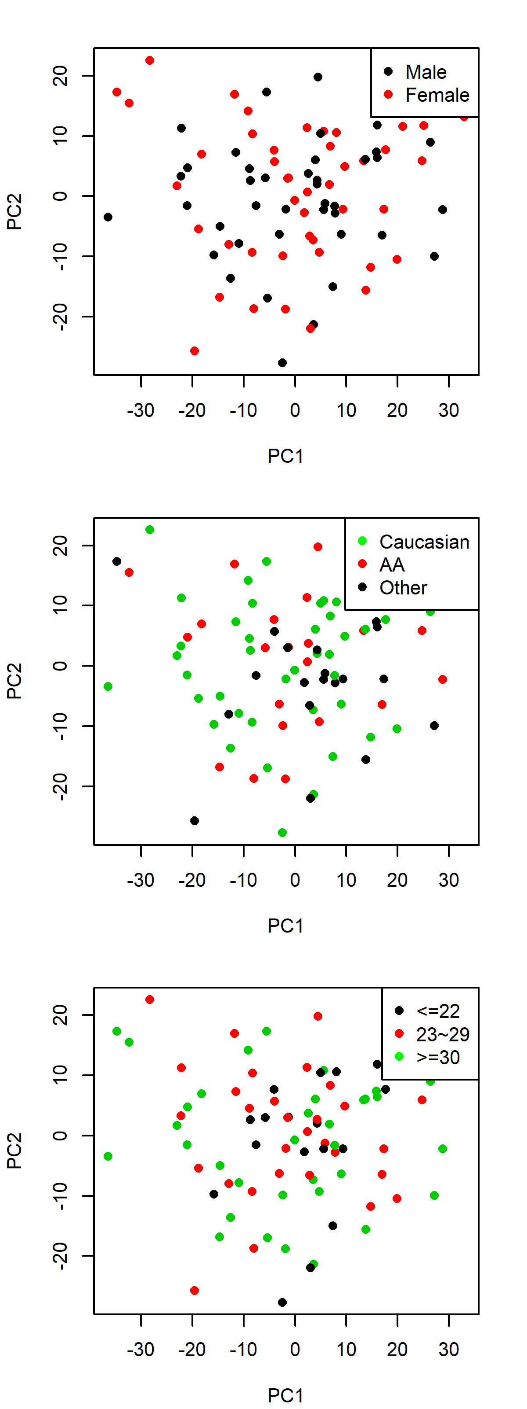

Table S1. Microarray data are not significantly associated with gender, race or age by ANOVA.
Variable | P-value of F test
Variable | PC1 | PC2 | PC3
Gender | 0.948 | 0.605 | <2.2×10⁻¹⁶
Race | 0.539 | 0.319 | 0.124
Age | 0.652 | 0.493 | 0.134

Fig. S7. Power versus sample size based on 20 randomly selected samples.
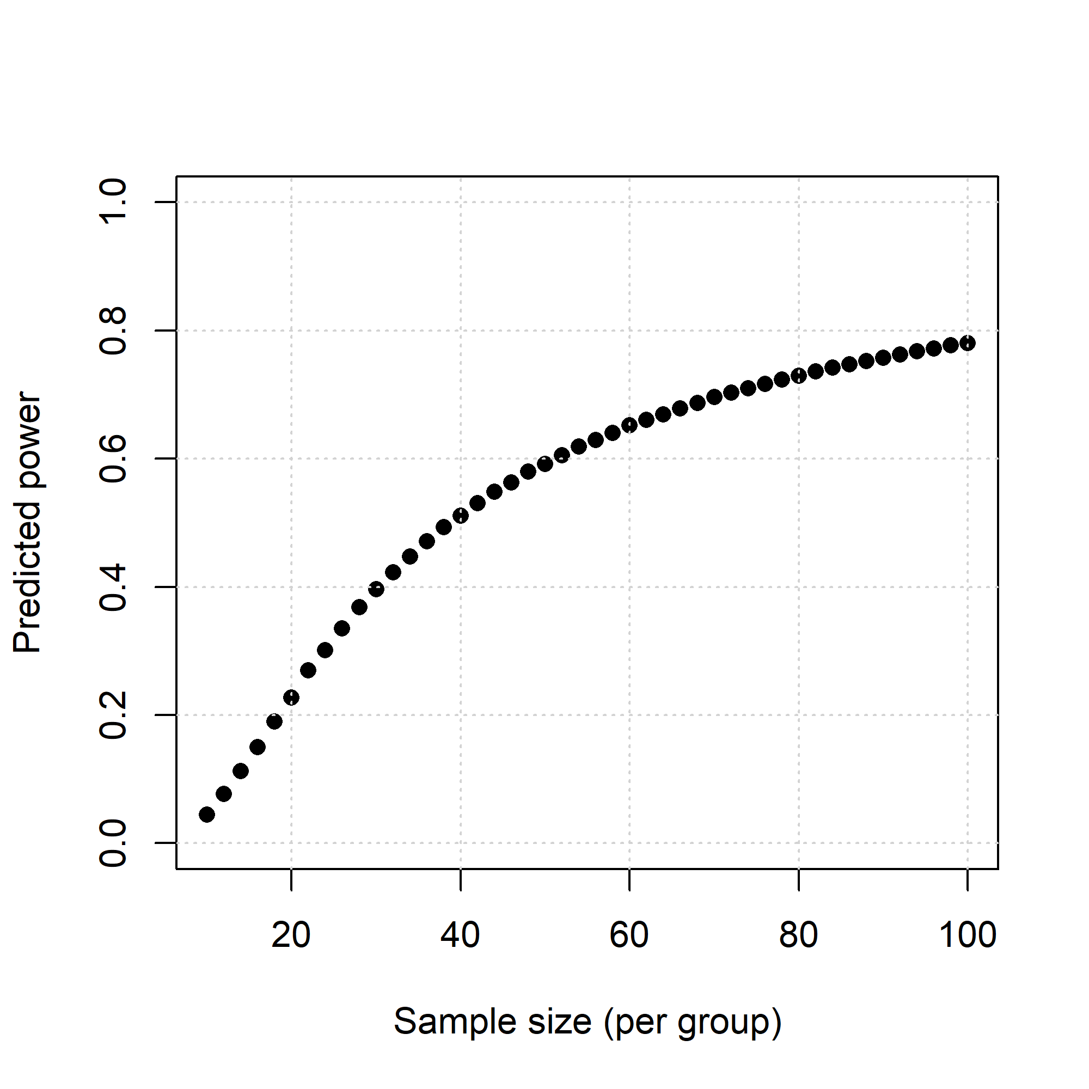

Fig. S8. First and second components of microarray data are not associated with weight status.
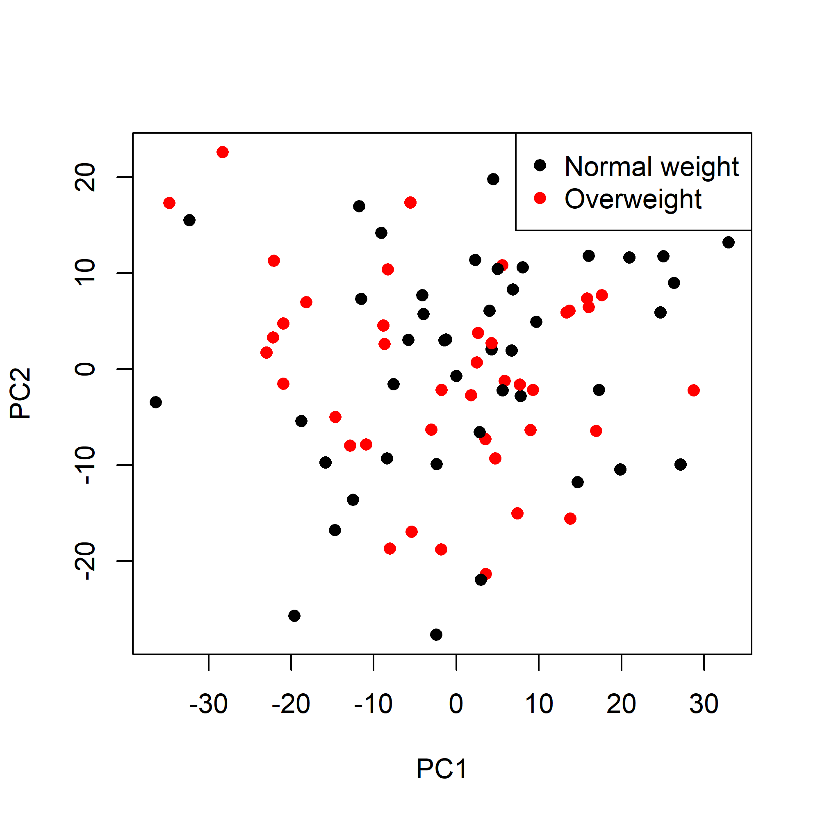

Fig. S9. Volcano plot to visualize significance versus fold-change following the DE analysis
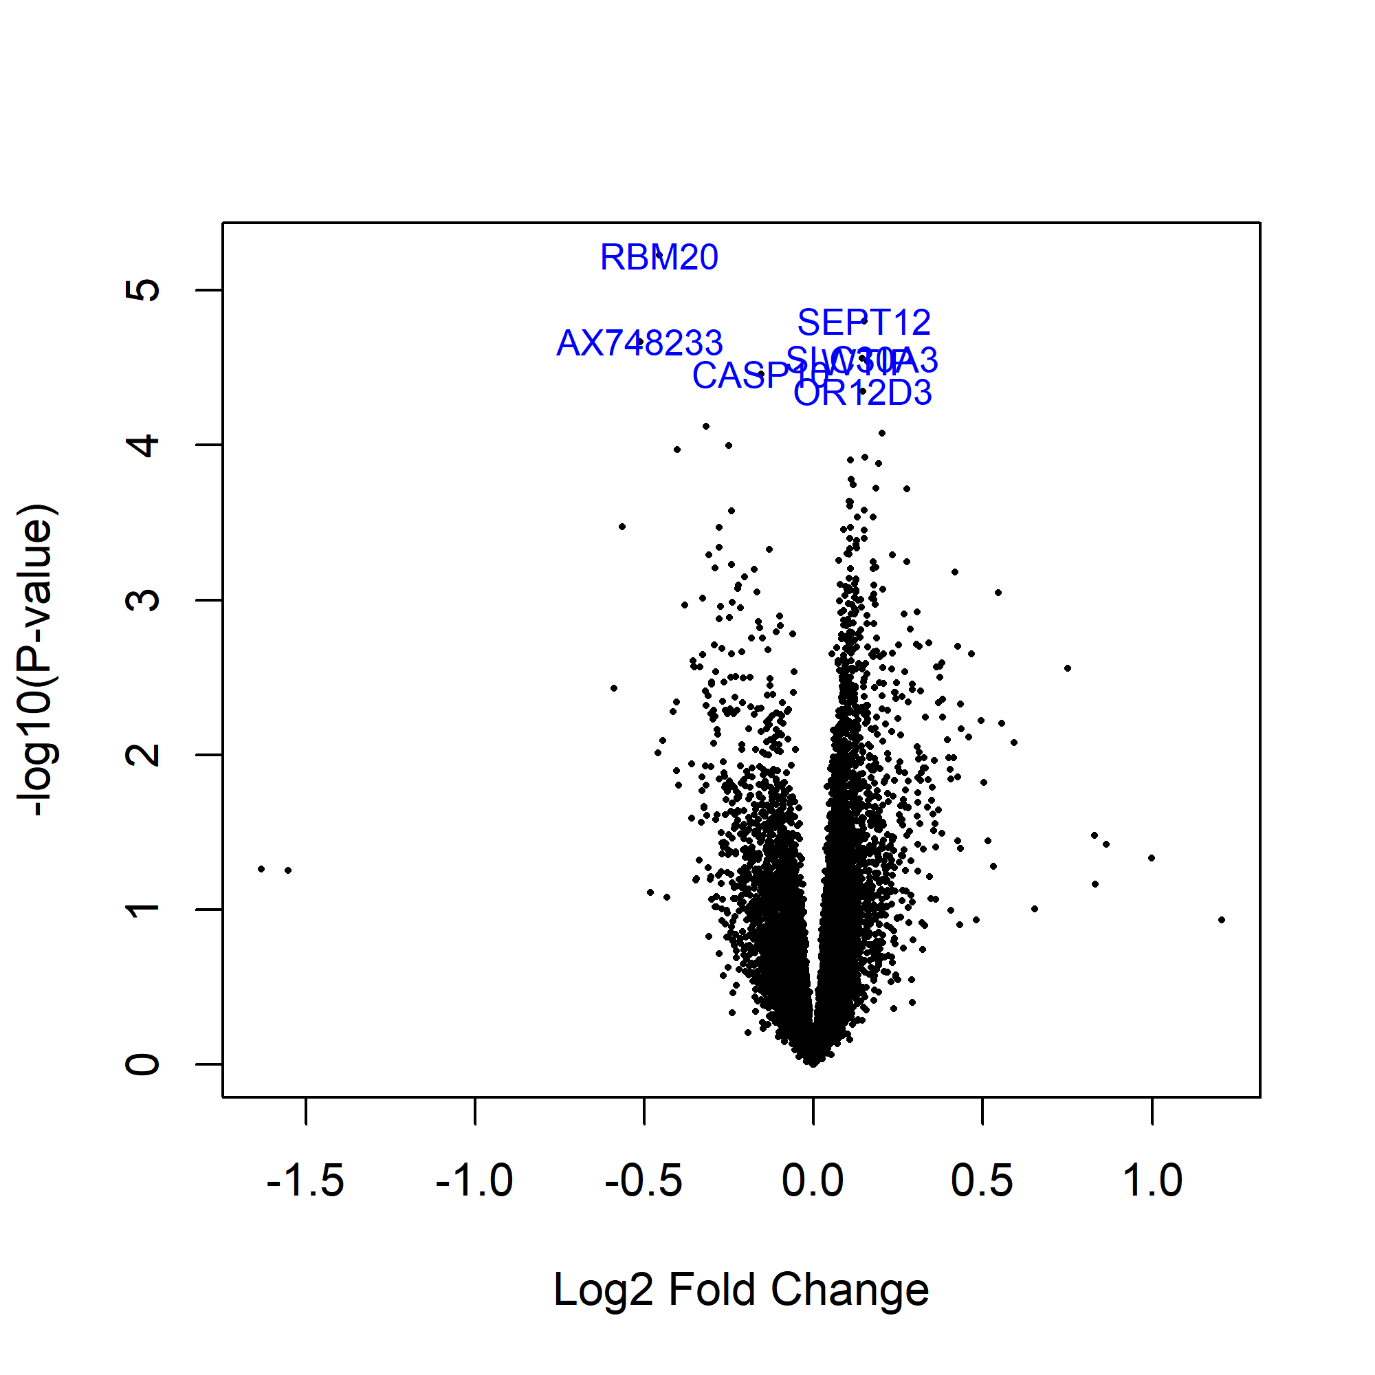

Fig. S10. Three DE genes of this study were found to be differentially expressed in external microarray datasets related to weight traits.
