A Pavlovian account for paradoxical effects of motivation on controlling response vigour

Delphine Oudiette^{1,2*}, Fabien Vinckier^{1,3}, Emmanuelle Bioud¹, Mathias Pessiglione^{1*}

¹ Motivation, Brain and Behavior lab, Institut du Cerveau et de la Moelle épinière (ICM); Inserm U1127 ; CNRS U7225 ; Sorbonne Universités, Paris, France
² Unité des Pathologies du Sommeil, Hôpital de la Pitié-Salpétrière, Assistance Publique - Hôpitaux de Paris, France
³ Département de Psychiatrie, Service Hospitalo-Universitaire, Centre Hospitalier Sainte-Anne

* Corresponding authors: delphine.oudiette@gmail.com, mathias.pessiglione@gmail.com

Supplementary Figure legends
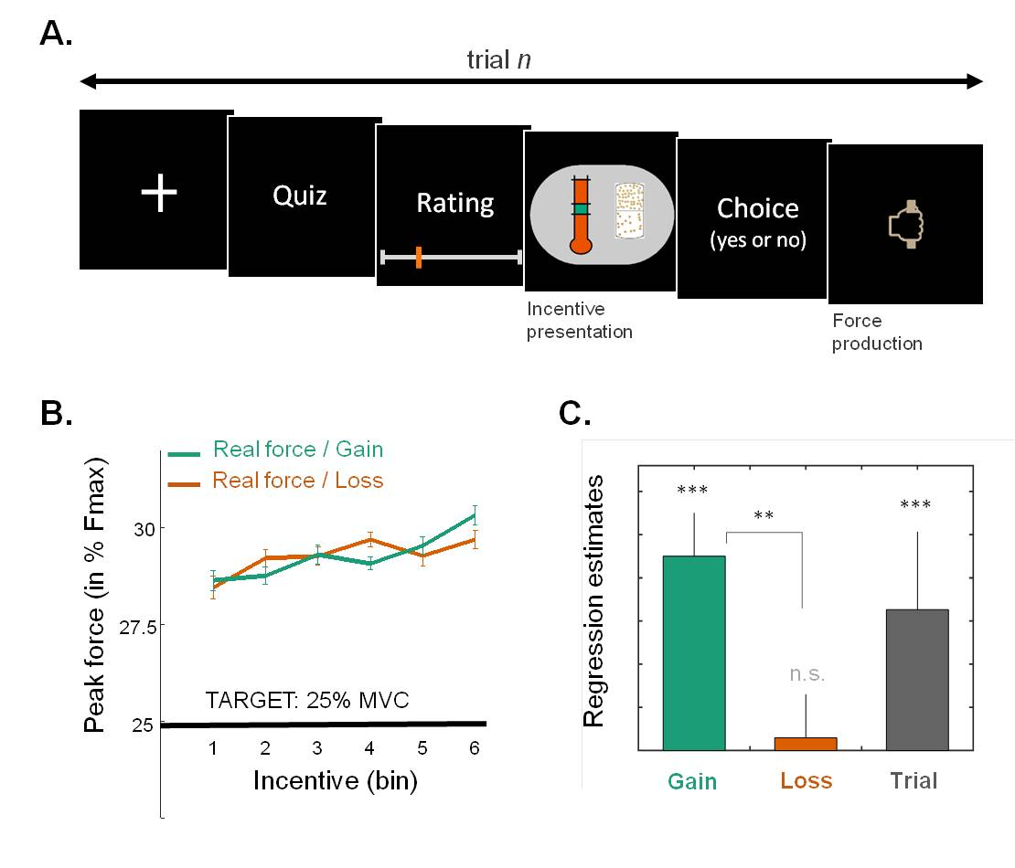
Sup Figure 1. Influence of gain and loss prospects on force precision (Exp 4)
Details about task design can be found in Vinckier et al., 2018 ³¹.
- Example trial. Participants (n=61) performed two unrelated but interleaved tasks. The first was a cultural quiz, irrelevant to the present topic. The second involved both choice and force production, and can be considered as a variant of the motor precision tasks presented in the main text. Critical differences were that 1) due to the presence of a quiz task, and a rest period between the two tasks, force exertion was less frequent (one trial every 30 s on average), 2) the force target was always low (25% of maximal force), 3) the outcome was binary, depending upon whether force peak was within a force window around the target, 4) task difficulty (size of target window) was manipulated in addition to potential gain in case of success (10-cent coin images) and potential loss in case of failure (crossed coins), 5) participants could accept or decline the motor challenge, 6) there was no subjective estimation of force produced.
- Variations of peak force as a function of both gain and loss levels. Participants tended to overshoot the target, and even more with higher incentive levels. Data points are group-level means ± inter-subject s.e.m. Variance between individual means has been removed from error bars to better illustrate the effect of incentives.
- Regression estimates (betas) of a linear model fitted to trial-by-trial series of force peaks. The model included a constant, potential gain, potential loss, target size and trial index. Participants overshot the target (29.3±0.69 vs. 25%, t(60)=6.1; p<0.001). A significant positive modulation of peak force was found for potential gain, target size and trial index (all p<0.001), but not for potential loss (t(60)=0.3; p=0.77). Moreover, the direct comparison of reward vs. loss estimates was significant (t(60)=3.0; p=0.003).
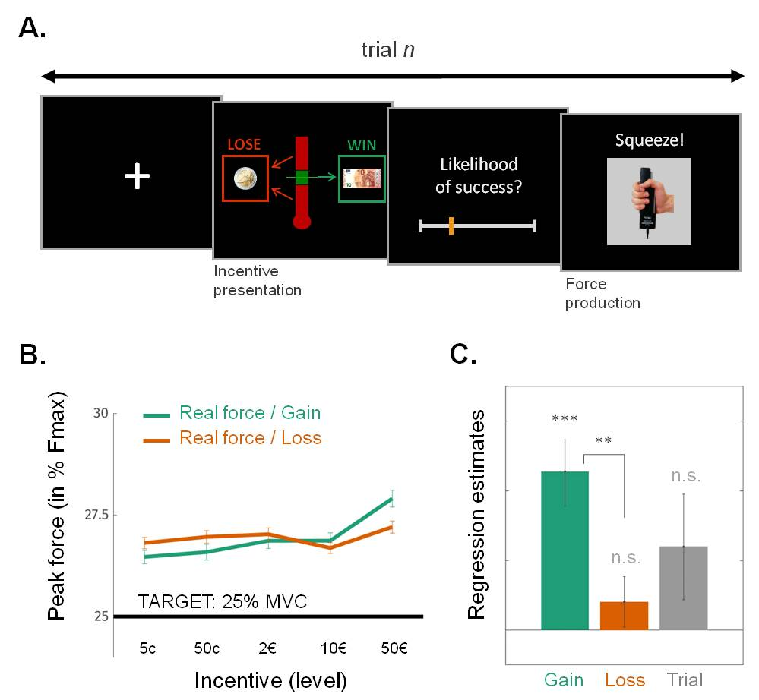
Sup Figure 2. Influence of gain and loss prospects on force precision (Exp 5)

- Example trial. Participants (n=21) performed another variant of task design, similar to that used in Exp 4. Critical difference were 1) the absence of the quiz task, 2) the introduction of a confidence judgment on a rating scale prior to effort exertion, which is the matter of another paper, 3) the presentation of incentives as unique coins and notes (instead of multiple 10-cent images)
- and (C) Same legend as previous figure. As in Exp 4, participants overshot the target (t(20)=3.5; p=0.0022). A significant positive modulation of peak force was found for potential gain (t(20)=4.6; p<0.001), but not for potential loss (t(20)=1.1; p=0.27), trial index (t(20)=1.6; p=0.12) or target size (t(20)=0.53; p=0.60. Moreover, the direct comparison of reward vs. loss estimates was significant (t(60)=3.6; p=0.0018).

