Supplementary information

Identifying the origin of nitrous oxide dissolved in deep ocean by concentration and isotopocule analyses

Sakae Toyoda^{1*}, Osamu Yoshida², Hiroaki Yamagishi^{3,6}, Ayako Fujii^{3,7}, Naohiro Yoshida^{1,4}, Shuichi Watanabe⁵

¹Department of Chemical Science and Engineering, School of Materials and Chemical Technology, Tokyo Institute of Technology, Yokohama, Japan
²College of Agriculture, Food and Environment Sciences, Rakuno Gakuen University, Ebetsu, Hokkaido, Japan
³Iinterdisciplinary Graduate School of Science and Engineering, Tokyo Institute of Technology, Yokohama, Japan
⁴Earth-Life Science Institute, Tokyo Institute of Technology, Tokyo, Japan
⁵Mutsu Institute for Oceanography, Japan Agency for Marine-Earth Science and Technology, Mutsu, Aomori, Japan
⁶ Present address: Environmental Health Department, Ministry of the Environment, Tokyo, Japan
⁷ Present address: Tokyo University of Agriculture, Tokyo, Japan

Estimation of isotopic ranges of N₂O produced by each microbial process
Ranges shown as rectangles in Fig. 4 were calculated based on isotopic fractionation (ε values, Table S2) and isotope ratios of substrates of N₂O (Table S3) in the literature. For example, the range for N₂O from NH₃ oxidation via NH₂OH by nitrifying bacteria (Table S4) was estimated as follows.
δ¹⁵N_{min} = δ¹⁵N_{NH4min} + ε(¹⁵N)_{AOBmin},
δ¹⁵N_{max} = δ¹⁵N_{NH4max} + ε(¹⁵N)_{AOBmax},
δ¹⁸O_{min} = δ¹⁸O_{O2min} + ε(¹⁸O)_{AOBmin},
δ¹⁸O_{max} = δ¹⁸O_{O2max} + ε(¹⁸O)_{AOBmax},
while SP values were same as those in Table S2 assuming that they do not depend on δN values of substrates (Toyoda et al., 2005; Sutka et al., 2006).

Supplementary Tables and Figures

Table S1. List of observational data used in this study.
Table S2. Isotopic fractionation or SP values during N₂O production and consumption by bacteria and archaea

Table S3. Range of nitrogen and oxygen isotope ratios for substrates of N₂O production.
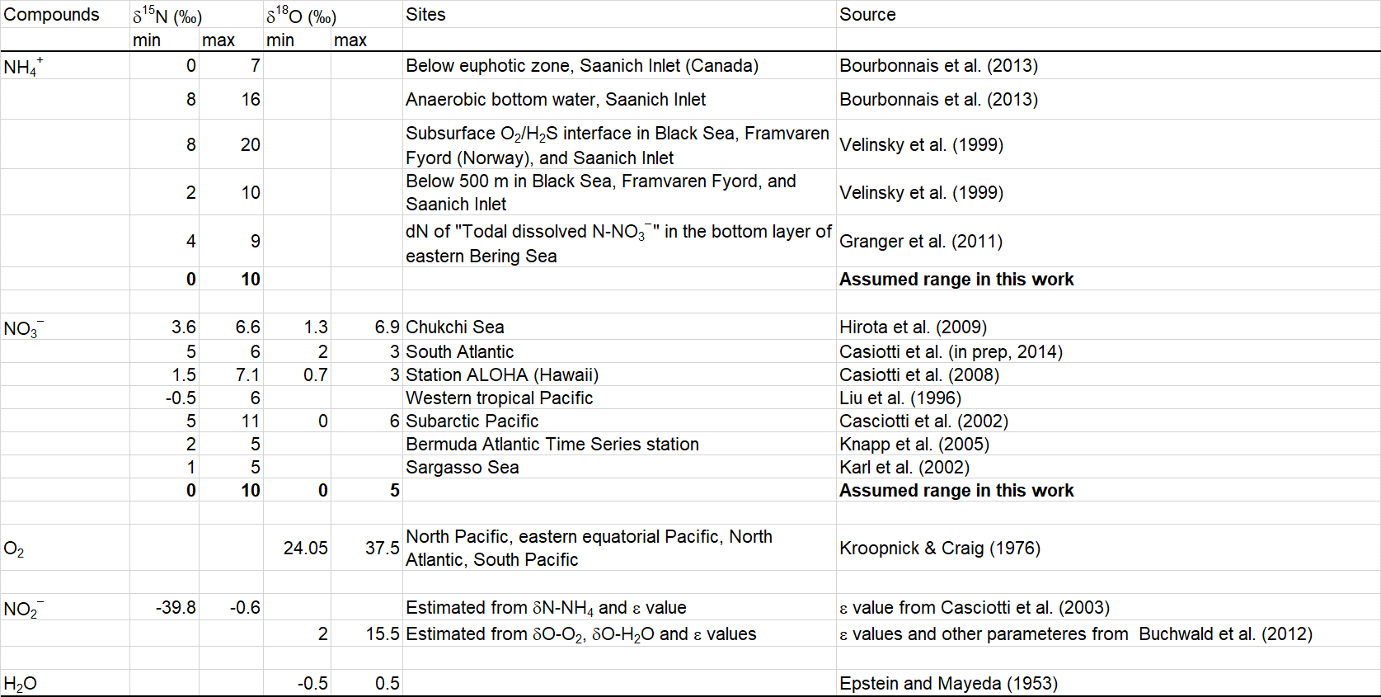

Table S4. Estimated range of isotopocule ratios of N₂O produced at concentration maximum and in deep ocean.

Fig. S1. Production and consumption processes of N₂O in the ocean (Modified from Toyoda et al. 2017).

References* *Those listed in the reference section of main text are not listed.
Bourbonnais, A., R. T. Letscher, H. W. Bange, V. Echevin, J. Larkum, J. Mohn, N. Yoshida, and M. A. Altabet (2017), N₂O production and consumption from stable isotopic and concentration data in the Peruvian coastal upwelling system, Global Biogeochem. Cycles, 31(4), 678–698, doi:10.1002/2016gb005567.
Buchwald, C., A. E. Santoro, M. R. McIlvin, and K. L. Casciotti (2012), Oxygen isotopic composition of nitrate and nitrite produced by nitrifying cocultures and natural marine assemblages, Limnol. Oceanogr., 57(5), 1361–1375, doi:10.4319/lo.2012.57.5.1361.
Casciotti, K. L., D. M. Sigman, M. G. Hastings, J. K. Böhlke, and A. Hilkert (2002), Measurement of the oxygen isotopic composition of nitrate in seawater and freshwater using the denitrifier method, Anal. Chem., 74, 4905–4912.
Casciotti, K. L., D. M. Sigman, and B. B. Ward (2003), Linking diversity and stable isotope fractionation in ammonia-oxidizing bacteria, Geomicrobiology Journal, 20, 335–353.
Casciotti, K. L., T. W. Trull, D. M. Glover, and D. Davies (2008), Constraints on nitrogen cycling at the subtropical North Pacific Station ALOHA from isotopic measurements of nitrate and particulate nitrogen, Deep Sea Res., Part II, 55, 1661–1672, doi:10.1016/j.dsr2.2008.04.017.
Epstein, S., and T. Mayeda (1953), Variation of O18 content of waters from natural sources, Geochim. Cosmochim. Acta, 4(5), 213–224, doi:https://doi.org/10.1016/0016-7037(53)90051-9.
Granger, J., M. G. Prokopenko, D. M. Sigman, C. W. Mordy, Z. M. Morse, L. V. Morales, R. N. Sambrotto, and B. Plessen (2011), Coupled nitrification-denitrification in sediment of the eastern Bering Sea shelf leads to15N enrichment of fixed N in shelf waters, J. Geophys. Res., 116(C11), doi:10.1029/2010jc006751.
Hirota, A., A. Ijiri, D. D. Komatsu, S. B. Ohkubo, F. Nakagawa, and U. Tsunogai (2009), Enrichment of nitrous oxide in the water columns in the area of the Bering and Chukchi Seas, Marine Chemistry, 116, 47–53, doi:10.1016./j.marchem.2009.09.001.
Karl, D., A. Michaels, B. Bergman, D. Capone, E. Carpenter, R. Letelier, F. Lipschultz, H. Paerl, D. M. Sigman, and L. Stal (2002), Dinitrogen fixation in the world’s oceans, Biogeochemistry, 57/58, 47–98.
Knapp, A. N., D. M. Sigman, and F. Lipschultz (2005), N isotopic composition of dissolved organic nitrogen and nitrate at the Bermuda Atlantic Time-series Study site, Global Biogeochem. Cycles, 19(1), GB1018, doi:10.1029/2004gb002320.
Kroopnick, P., and H. Craig (1976), Oxygen isotope fractionation in dissoved oxygen in the deep sea, Earth and Planetary Science Letters, 32, 375-388.
Liu, K. K., M. J. Su, C. R. Hsueh, and G. C. Gong (1996), The nitrogen isotopic composition of nitrate in the Kuroshio Water northeast of Taiwan: evidence for nitrogen fixation as a source of isotopically light nitrate, Mar. Chem., 54, 273–292.
Velinsky, D. J., and M. Fogel (1991), Isotopic fractionation of dissolved ammonium at the oxygen-hydrogen sulfide interface in anoxic waters, Geophys. Res. Lett., 18(4), 649–652.
Yoshida, N., A. Hattori, T. Saino, and S. M. E. Wada (1984), ¹⁵N/¹⁴N ratio of dissolved N₂O in the eastern tropical Pacific Ocean, Nature, 307, 442–444.

