Supplementary Information

  - Monodisperse droplet formation by spontaneous and interaction based mechanisms in partitioned EDGE microfluidic device

  - S. ten Kloosterª, S. Sahinª, K. Schroënª
  - ªFood Process Engineering, Wageningen University (WUR), The Netherlands

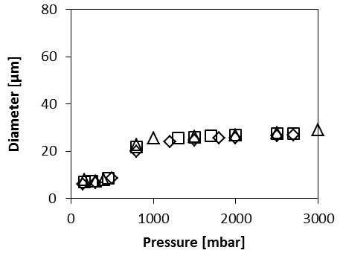
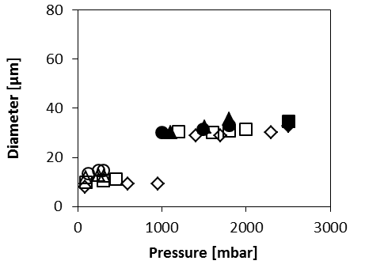
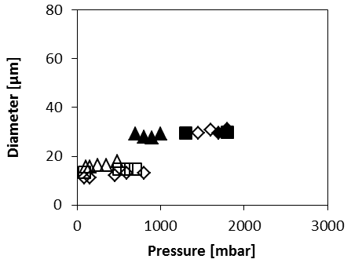
Supplementary Figure 1. Droplet size generated by PE 5 as function of applied pressure for various continuous phase viscosities, going from low to high in the order of ◊, □, ∆, ○. Open symbols denote monodisperse droplets with a CV < 10%, filled symbols denote polydisperse droplets with a CV between 10 and 20%. The used dispersed phases are: (a) silicon oil (η_{d}=50 mPa s), (b) hexadecane (η_{d}=3.47 mPa s) and (c) decane (η_{d}=0.92 mPa s).
c
a
b
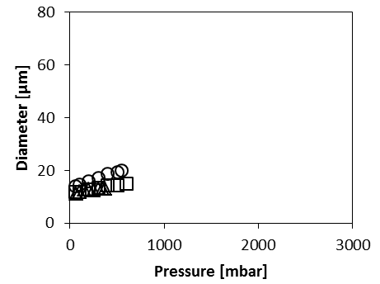
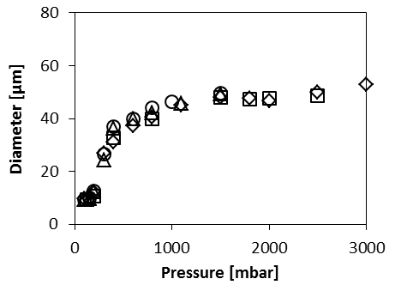
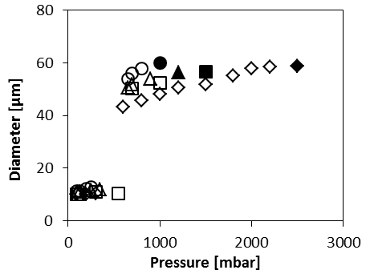
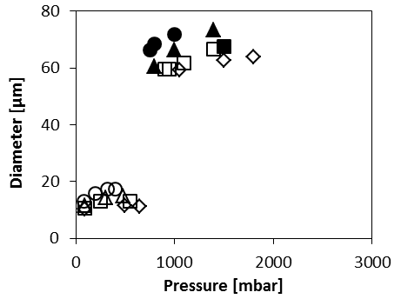
Supplementary Figure 3. Droplet size generated by PE 40 as function of applied pressure for: decane/50% glycerol (○), decane/20% glycerol (□), and hexadecane/40% glycerol (∆). All droplets over this pressure range were monodisperse with a CV < 10%.

Supplementary Figure 2. Droplet size generated by PE 20 as function of applied pressure for various continuous phase viscosities, going from low to high in the order of ◊, □, ∆, ○. Open symbols denote monodisperse droplets with CV < 10%, filled symbols denote polydisperse droplets with CV between 10 and 20%. The used dispersed phases are: (a) paraffin-hexadecane (η_{d}=44.5 mPa s), (b) hexadecane (η_{d}=3.47 mPa s), (c) decane (η_{d}=0.92 mPa s).
a
b
c
Supplementary Table 1. The expansion rates, (and corresponding) acting interfacial tensions, critical velocity, critical capillary number and critical Weber number for dispersed phases of silicon oil, hexadecane and decane in a continuous phase of water + 0.5 wt% SDS for PE 5.
 | ω [s⁻¹] | γ (mN/m) | η [mPa s] | ρ [kg/m³] | d* [m] | U_{c}* [m/s] | Ca* [-] | We* [-]
Silicon oil | 100 | 7.8 | 50 | 960 | 1.3E-05 | 0.0015 | 9.5E-03 | 3.5E-06
Hexadecane | 2000 | 40 | 3.47 | 770 | 9.3E-06 | 0.040 | 3.5E-03 | 2.9E-04
Decane | 4800 | 52 | 0.92 | 730 | 8.6E-06 | 0.13 | 2.3E-03 | 2.0E-03

Normalizing pressure
Supplementary Figure 4: Droplet volume against pressure for two data points of hexadecane in water + 0.5 wt.% SDS for PE 5.
The droplet size input, used for figure 6, needed to be normalised, as the pressure has a slight influence on droplet volume. The droplet volumes were linearly interpolated; for example, the droplet size of hexadecane with a continuous phase of 0.5 wt.% SDS and 40 wt.% glycerol was measured at 120mbar and 250 mbar, and needed to be compared at 200 mbar (Supplementary Figure 4). To get a value for the droplet size of hexadecane with a continuous phase of 0.5 wt.% SDS and 40 wt.% glycerol at 200mbar, we interpolated a droplet volume (V_{d}), read the corresponding droplet volume and calculated droplet size by: $d=2{\left(\frac{V_{d}}{\frac{4}{3} π}\right)}^{\frac{1}{3}}$.

Calculation of continuous phase inflow velocity
Supplementary Figure 5. The blow-up pressure against the viscosity ratio for: hexadecane-paraffin (∆) (44 mPa s), hexadecane (○) (3.5 mPa s) and decane (□) (0.92 mPa s) for PE 20.
$$U_{c}=\frac{γ r cos⁡(θ)}{4{ η}_{c} s}$$
The equation above (for further explanation, see main article), was used to calculate the inflow velocity. For s we take a measured distance at which the neck approximately meets the micro-plateau walls (about 4 μm) (see figure 1a), r is the diameter of a round capillary of 1.8 μm, the surface is assumed to be fully wetting and therefore 𝜃 = 0ᴼ, η_{c} =1 mPa s (the viscosity of pure water) and γ is taken as the SDS equilibrium interfacial tension (7.8 mN m⁻¹). We then find a continuous phase inflow velocity of 0.8 ms⁻¹.
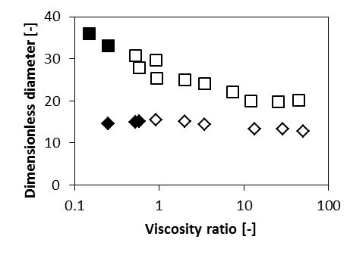
Supplementary Figure 7. Influence of the viscosity ratio on the droplet diameter for PE 5 (◊) and PE 20 (□) in the second monodisperse droplet formation regime (of larger droplets). Open symbols denote monodisperse droplets with a CV < 10%, filled symbols denote polydisperse droplets with CV between 10 and 20%.

Supplementary Figure 6. Normalised droplet size (compared to η_{c}= 1mPa s) (d/d_{ref}) versus viscosity ratio of continuous phase and reference case, for dispersed phases of decane (0.92 mPa s), at an applied pressure of 90 mbar (grey □) and 300 mbar (black □), and hexadecane (3.47 mPa s) at an applied pressure of 300 mbar (○), for PE 20. Black line indicates the theory as derived for PE 5 in the main article.

