Supplementary Information
Characterization of protein extracts from different types of human teeth and insight in biomineralization
Vaibhav Sharma¹, Alagiri Srinivasan², Ajoy Roychoudhury³ Komal Rani¹, Mitali Tyagi¹, Kapil Dev⁵, Fredrik Nikolajeff ⁴, Saroj Kumar^{1*}
¹ Department of Biophysics, All India Institute of Medical Sciences(AIIMS), New Delhi, India.
² Department of Biochemistry, Jamia Hamdard University, New Delhi, India.
³ Department of Oral and Maxillofacial Surgery, Center for Dental Education and Research (CDER), All India Institute of Medical Sciences(AIIMS), New Delhi, India.
⁴Department of Engineering Science, Uppsala University, Uppsala 75105 (Sweden)
⁵ Department of Biotechnology, Jamia Milia Islamia, New Delhi, India

*Corresponding author: sarojgupta.k@gmail.com; Tel: +91-011-26594240

Supplementary Figure:1

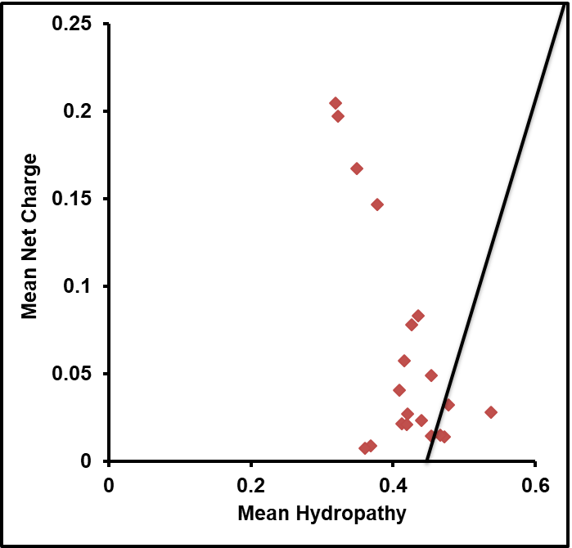

Supplementary Figure:2

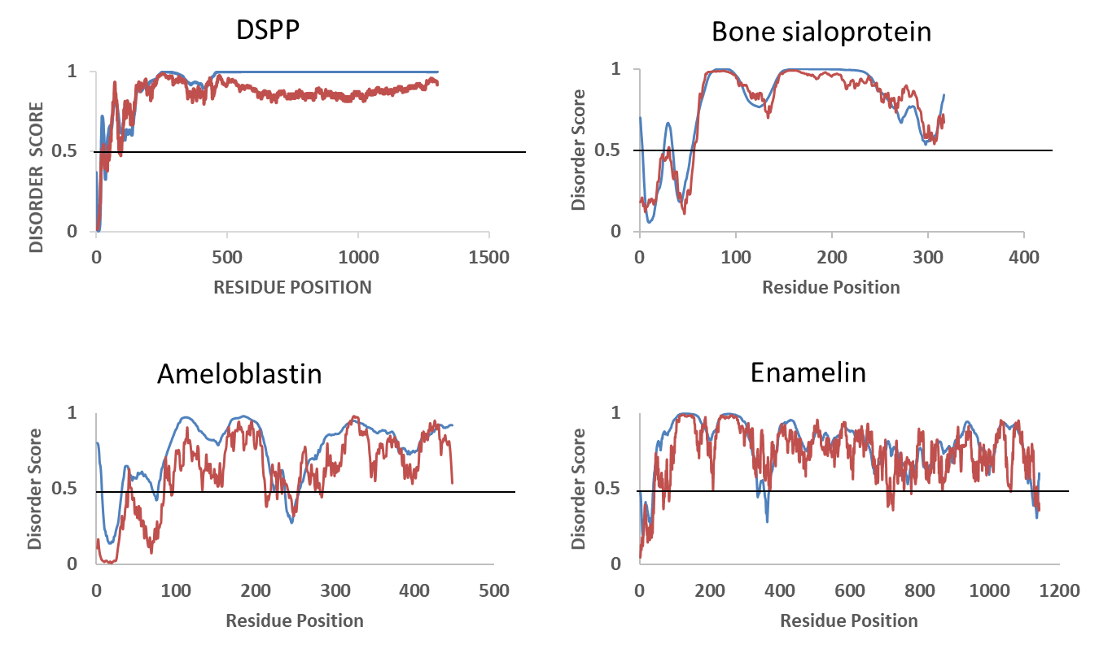
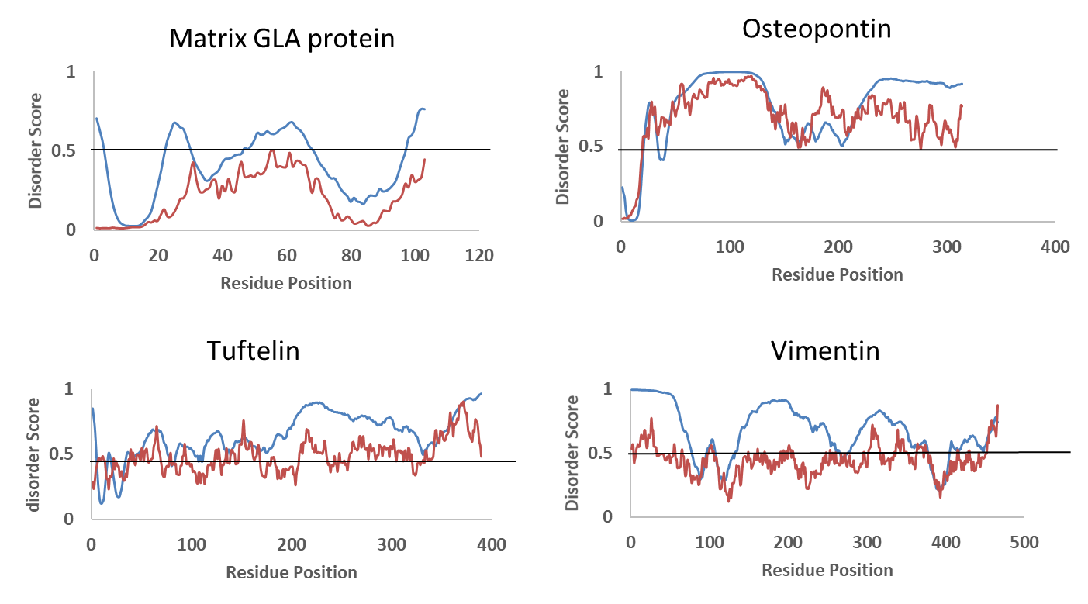
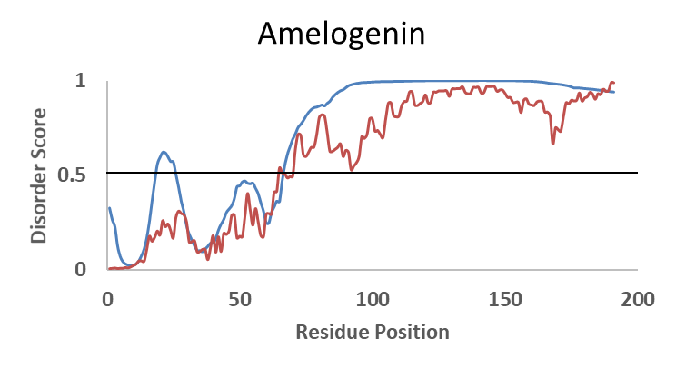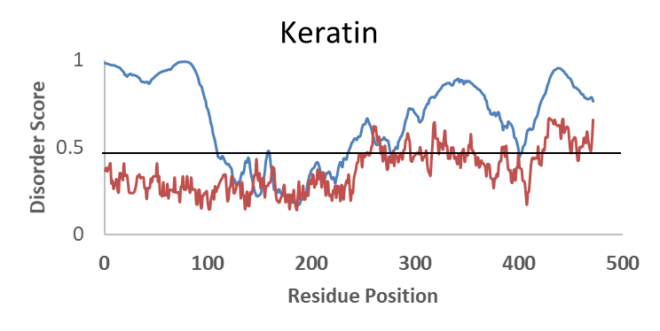
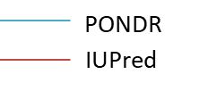

Supplementary Figure:3

B
A
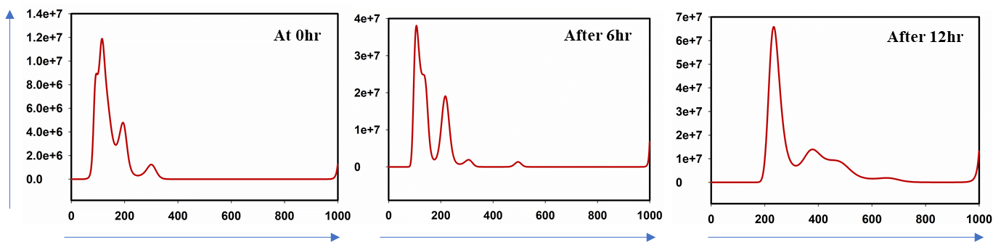
Concentration (particles/ml)
Size (nm)
C

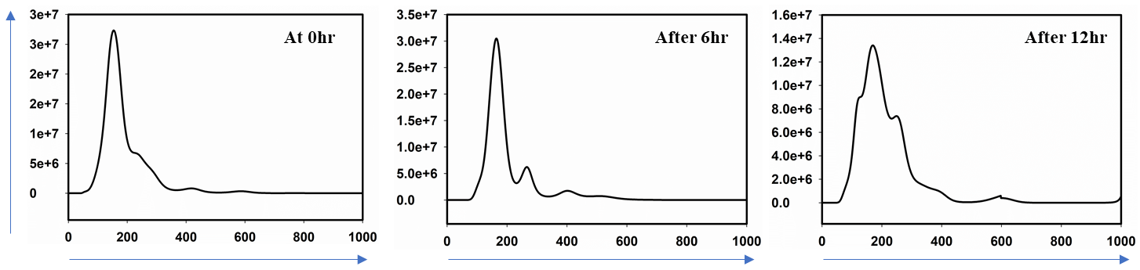
Concentration (particles/ml)
Size (nm)
Supplementary Figure:4

A
B
C
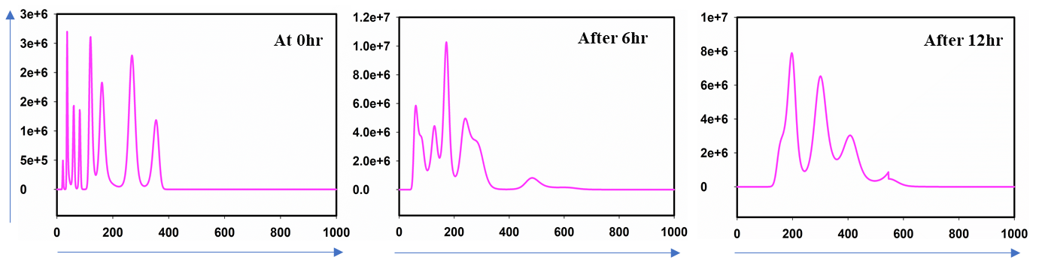
Concentration (particles/ml)
Size (nm)
Supplementary Figure:5
Supplementary Figure:5
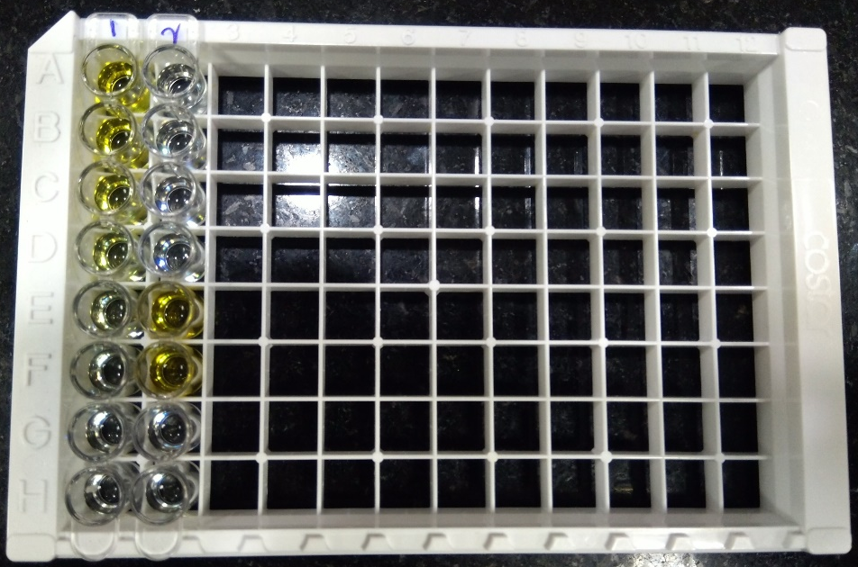
Supplementary Figure:6

Supplementary Figure:1 A) Infrared absorbance spectrum of a tooth protein in mid-infrared region (4000 to 900 cm⁻¹)
B) Raw data of infrared absorbance spectra of all four teeth protein extracts.
C) Second derivative of the infrared absorbance spectra of all four teeth protein extracts presented in B .
Supplementary Figure: 2 Charge hydropathy (CH) plot between mean hydropathy and mean net charge. The solid line represents the border between intrinsically disordered and native proteins.
Supplementary Figure: 3 Disorder pattern of selected proteins from Human teeth. The proteins are predicted to be mostly or fully disordered by IUPred (red line) and PONDR© VSL2 (blue line) predictors. Residues above the 0.5 thresholds are considered disordered.

Supplementary Figure:4 Control Nanoparticle tracking analysis (NTA) experiments
A) BSA (alone) and BSA+ Calcium phosphate.
B)Cisplatin injured rat kidney tissue (excessive collagen content)+Calcium phosphate
C) Molar protein ageing with time (Only protein control, No calcium phosphate)
Supplementary Figure:5 A) 12% SDS Gel electrophoresis with silver stain. Lane:1 Prestained marker; Lane:2 Canine extract; Lane:3 Insoluble extract left after 3% perchloric (PCA) treatment of Canine extract.
B) Size measurement experiment of the insoluble left out extract after 3% PCA treatment (Canine extract) at 0 hour, 6 hours and 12 hours.
C) Size measurement experiment of the pelleted extract after 3% PCA treatment (Canine extract) at 0 hour, 6 hours and 12 hours.
Supplementary Figure: 6 Rat Collagen I ELISA Plate assay (CUSA BIO)
Column1: Standard - 5000pg/ml(A1) to 0pg/ml (H1)
Column:2 A1-D1- 4 different tooth protein extracts
E1,F1- Cisplatin injured Rat kidney isolate
G1,H1-Control

