Supplementary Material
Enhanced auditory disembedding in an interleaved melody recognition test is associated with absolute pitch ability

Teresa Wenhart^{1,2} , Ye-Young Hwang¹, Eckart Altenmüller^{1,2}*

A
Table A.1. IMRT differences: imperfect version (N=21) vs. correct version (N=38)
 | Version A |  | Version B |  |  | t-test
 | Mean | SD |  | Mean | SD |  | t (df) | p-value
All | 3.240 | 0.86 |  | 3.354 | 0.99 |  | 0.444 (36.8) | 0.660
0 ST | 2.04 | 1.21 |  | 2.20 | 1.17 |  | -0.488 (42.8) | 0.628
6 ST | 2.98 | 0.55 |  | 2.99 | 0.80 |  | -0.060 (30.7) | 0.952
12 ST | 3.450 | 0.38 |  | 3.458 | 0.38 |  | -0.215 (41.0) | 0.941
24 ST | 3.543 | 0.28 |  | 3.526 | 0.36 |  | 0.189 (33.9) | 0.851
Means, standard deviations (SD) and statistical comparisons (post-hoc t-test, two tailed) of IMRT performance (perceptual sensitivity index d’) by version (Version A vs. B) and separation condition (in semitones, ST). * p <.05, ** p<.01, . p<.10

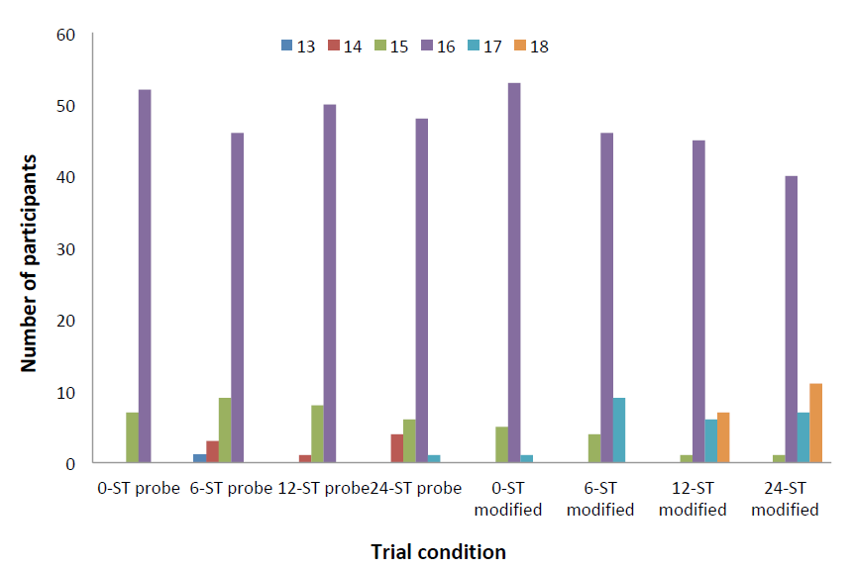
Figure A.1. Trial distribution per condition due to randomization error. The figure visualizes the distribution of number of trials for each of the 8 melody conditions (0, 6, 12, 24 ST separation x original (probe)/modified melody (modified)) in the interleaved melody recognition test (IMRT). Due to a technical error regarding randomization of trails the expected number of trials within condition (N=16) was accidentally shifted in N=21 participants. While the total amount of trials remained the same, the number of trials per condition was not (range= 13-18). The distributions per condition show the number of participants receiving 13 to 18 trials within the condition. It can be seen that most of the participants still received the expected 16 trials and of the remaining participants the discrepancy was usually no more than 2 trials.

B
Table B.1. IMRT differences: Version A vs. B (N=59)
 | Version A |  | Version B |  |  | t-test
 | Mean | SD |  | Mean | SD |  | t (df) | p-value
All | 3.000 | 0.8 |  | 3.575 | 0.92 |  | -2.586 (55.4) | 0.012 *
0 ST | 1.698 | 1.21 |  | 2.515 | 1.03 |  | -2.796 (56.1) | 0.007 *
6 ST | 2.889 | 0.67 |  | 3.084 | 0.62 |  | -1.165 (56.9) | 0.249
12 ST | 3.356 | 0.41 |  | 3.554 | 0.31 |  | -2.098 (54.0) | 0.041
24 ST | 3.461 | 0.37 |  | 3.616 | 0.21 |  | -1.981 (45.5) | 0.054
Means, standard deviations (SD) and statistical comparisons (t-test, two tailed) of IMRT performance (perceptual sensitivity index d’) by version (Version A vs. B) and separation condition (in semitones, ST). Significance after Bonferroni-Holm-correction: * p<.05, ** p<.01

Table B.2. IMRT group differences: response bias c (N=59)
 | AP |  | RP |  |  | t-test
 | Mean | SD |  | Mean | SD |  | t (df) | p-value | Cohen´s d
All | 0.093 | 0.29 |  | 0.159 | 0.45 |  | 0.677 (53.9) | 0.501 | 0.171
0 ST | 0.236 | 0.51 |  | 0.474 | 0.78 |  | 1.416 (53.8) | 0.163 | 0.357
6 ST | -0.048 | 0.22 |  | -0.073 | 0.45 |  | -0.276 (46.6) | 0.784 | -0.068
12 ST | -0.018 | 0.18 |  | 0.008 | 0.16 |  | 0.561 (52.8) | 0.577 | 0.148
24 ST | 0.005 | 0.16 |  | 0.027 | 0.19 |  | 0.469 (56.9) | 0.641 | 0.121
Means, standard deviations (SD) and statistical comparisons (post hoc t-test, two-tailed) of response bias c on IMRT by group (AP, absolute pitch; RP, relative pitch) and per separation condition (in semitones, ST). Positive values of c indicate a tendency towards “no” responses and negative values a tendency towards “yes” responses.

