Supplementary Information
Aptamer-based Targeted Delivery of a G-quadruplex Ligand in Cervical Cancer Cells
Josué Carvalho ¹, Artur Paiva ^{2,3,4}, Maria Paula Cabral Campello ⁵, António Paulo ⁵, Jean-Louis Mergny ^{6,7}, Gilmar F. Salgado ⁶, João A. Queiroz ¹, Carla Cruz ^{1,}*
¹ CICS-UBI - Centro de Investigação em Ciências da Saúde, Universidade da Beira Interior, Av. Infante D. Henrique, 6200-506 Covilhã, Portugal. Tel: +351 275 329 076; Fax: +351 275 329 099.
² Unidade de Gestão Operacional em Citometria, Centro Hospitalar e Universitário de Coimbra (CHUC), Portugal.
³ CIMAGO/iCBR/CIBB, Faculdade de Medicina da Universidade de Coimbra, Portugal.
⁴ Instituto Politécnico de Coimbra, ESTESC-Coimbra Health School, Ciências Biomédicas Laboratoriais, Portugal
⁵ Centro de Ciências e Tecnologias Nucleares, Instituto Superior Técnico, Universidade de Lisboa, Estrada Nacional 10 (km 139,7), 2695-066 Bobadela LRS, Portugal.
⁶ Univ. Bordeaux, ARNA laboratory, INSERM, U1212, CNRS UMR 5320, IECB, F-33600 Pessac, France.
⁷ Institute of Biophysics, AS CR, v.v.i. Kralovopolska 135, 612 65 Brno, Czech Republic.
* corresponding author email: carlacruz@fcsaude.ubi.pt

Table S1. Ligand-induced thermal stabilization (∆T_{m}) measured by CD melting experiments.
 |  |  | ∆T_{m} (°C) ª
Aptamer |  | 0.5 eq C₈ |  | 1 eq C₈ | 2 eq C₈ | 4 eq C₈
AS1411 |  | 12.7 ± 0.3 |  | 20.5 ± 0.2 | 28.4 ± 0.2 | >30
LNA-AS1411 |  | 6.4 ± 0.2 |  | 12.0 ± 0.2 | 17.5 ± 0.1 | 22.6 ± 0.2
U-AS1411 |  | 5.1 ± 0.5 |  | 14.9 ± 0.5 | 24.5 ± 0.4 | >30
ª ΔT_{m} represents the difference in melting temperature [ ΔT_{m} = T_{m} (DNA + ligand) − T_{m} (DNA)]. The buffer used was 10 mM lithium cacodylate, pH 7.2, supplemented with 10 mM KCl and 90 mM LiCl. The T_{m} values for the aptamers are 56.3 ± 0.1 °C for AS1411, 51.6 ± 0.2 °C for LNA-AS1411, 52.6 ± 0.2 °C for U-AS1411. Values are reported as ΔT_{m} ± SE.

Figure S1. CD melting curves of (A) AS1411, (B) LNA-AS1411 and (C) U-AS1411 in the presence of increasing amounts of ligand C₈. Melting curves were obtained by monitoring the ellipticity at 262 nm between 20 and 110 °C.
Figure S2. Relative cell viability of HeLa and NHDF cells incubated for 7 days with the aptamers at 15 μM.

Figure S3. Dose-response data of cell viability measured by MTT assay after incubation of (A) HeLa and (B) NHDF cells with C₈ for 7 days.
Figure S4. Relative cell viability of PC-3 and A549 cancer cells incubated for 7 days with free AS1411, free C₈ or the pre-formed aptamer-ligand complex at a C₈ concentration of 1 μM.
Figure S5. CTCF of the cells incubated with free Cy5-AS1411 or Cy5-AS1411-C₈ complex. Data is represented as fluorescence intensity relatively to free aptamer images (positive control). Data represent the average of three experiments ± SEM, having considered at least 100 Cy5-AS1411-positive cells; **p < 0.01.
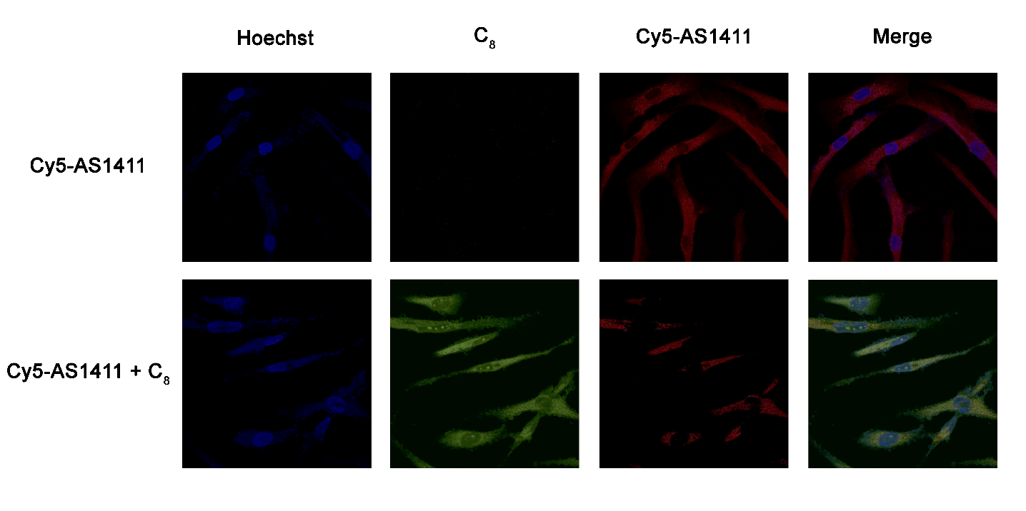
Figure S6. Confocal microscopy images of NHDF cells incubated with Cy5-AS1411 and Cy-AS1411-C₈ complex for 7 days. Cell nuclei are stained with Hoechst 33342 (blue), C₈ emits green fluorescence and Cy5-AS1411 is shown in red. Overlapping of the two stains, observed as yellow regions can be seen in the merge images. Brightness was adjusted to facilitate analysis.
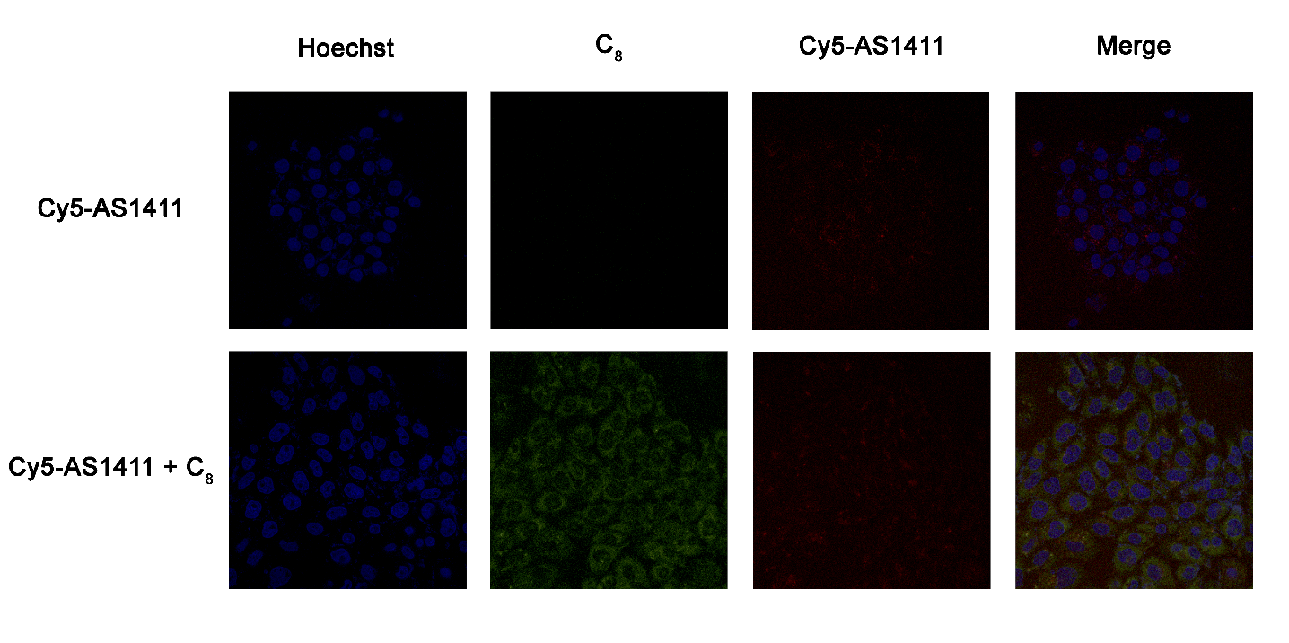
Figure S7. Confocal microscopy images of HeLa cells incubated with Cy5-AS1411 and Cy-AS1411-C₈ complex for 6 days followed by 1-day incubation in fresh media. Cell nuclei are stained with Hoechst 33342 (blue), C₈ emits green fluorescence while Cy5-AS1411 fluorescence is showed in red. Brightness was adjusted to facilitate analysis.

