Biomimetic Thermal-sensitive Multi-transform Actuator
Tae Hyeob Kim,† Jung Gi Choi,† Ju Hyeong Byun, Yongwoo Jang, Sung Min Kim, Geoffrey. M. Spinks and Seon Jeong Kim*
[a] T. H. Kim, J. G Choi, J. H Byun, Prof. Y. Jang, Prof. S. J Kim*
Center for Bio-Artiﬁcial Muscle, Department of Biomedical Engineering, Hanyang University, Seoul 04763, South Korea
[b] Prof. S. M. Kim
Department of Physical Education
Hanyang University, Seoul 04763, South Korea
[c] Prof. G. M. Spinks
ARC Centre of Excellence for Electromaterials Science, Intelligent Polymer Research Institute, University of Wollongong, Wollongong, New South Wales 2522, Australia.
*To whom correspondence should be addressed: sjk@hanyang.ac.kr
† These authors contributed equally to this work.

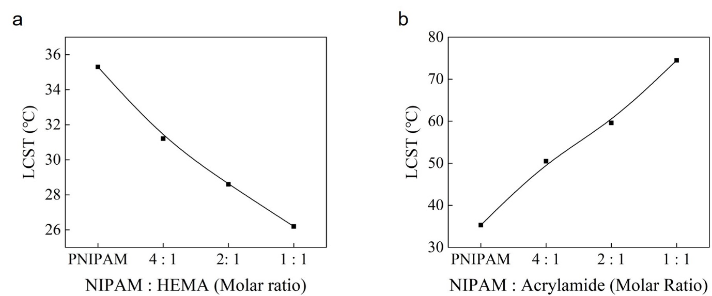
Figure S1 LCST shifts with PNIPAM hydrogel containing (a)HEMA, and hydrogel containing (b)acrylamide.
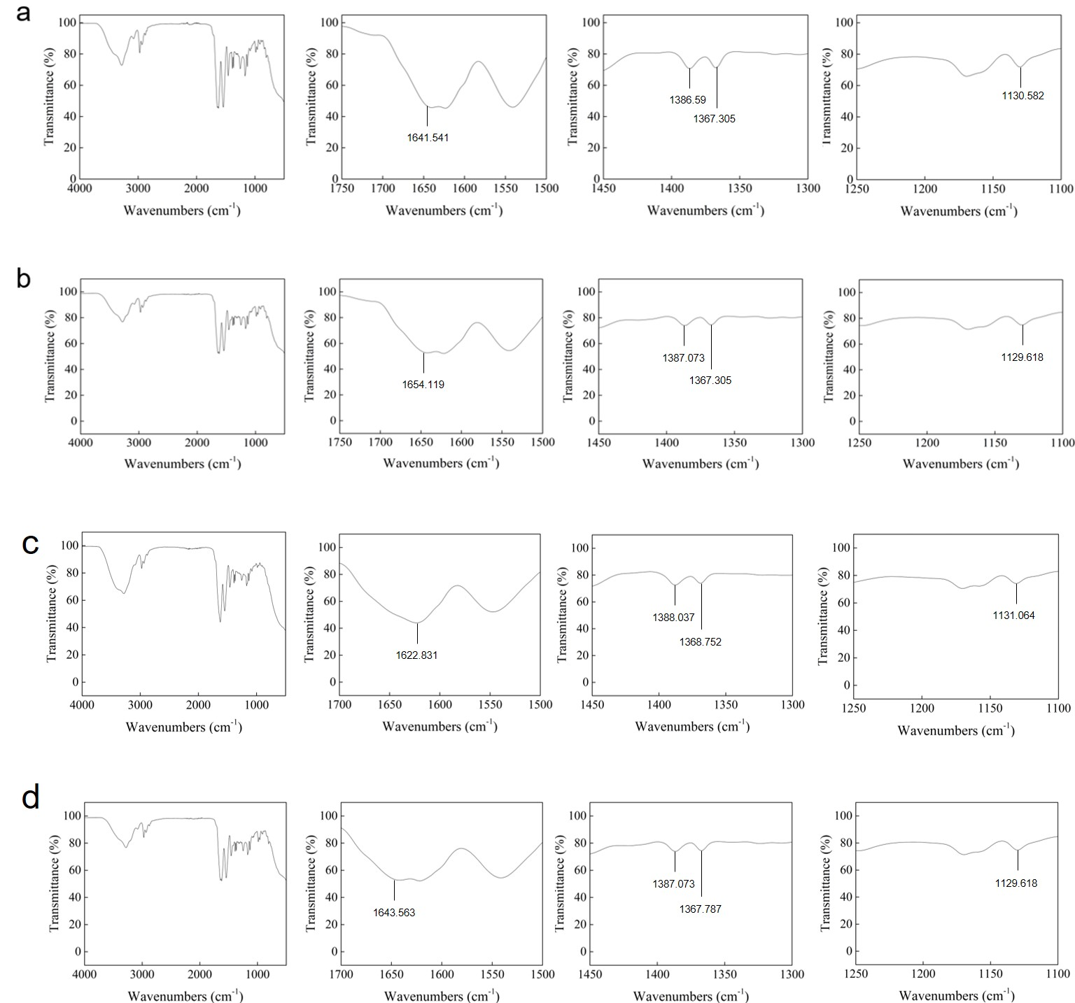
Figure S2. The FT-IR spectrum of four kind of f-PNIAM with different LCST. a) FT-IR spectrum of f-PNIPAM(48℃). b) 53.8℃. c) 60.8℃. d) 68.2℃. The peak near 1640 shows carbonyl groups of acrylamide are in f-PNIPAM polymer. The spectrums show two peaks between 1350 and 1400 of NIPAM. They also show the peak of HEMA near 1130.

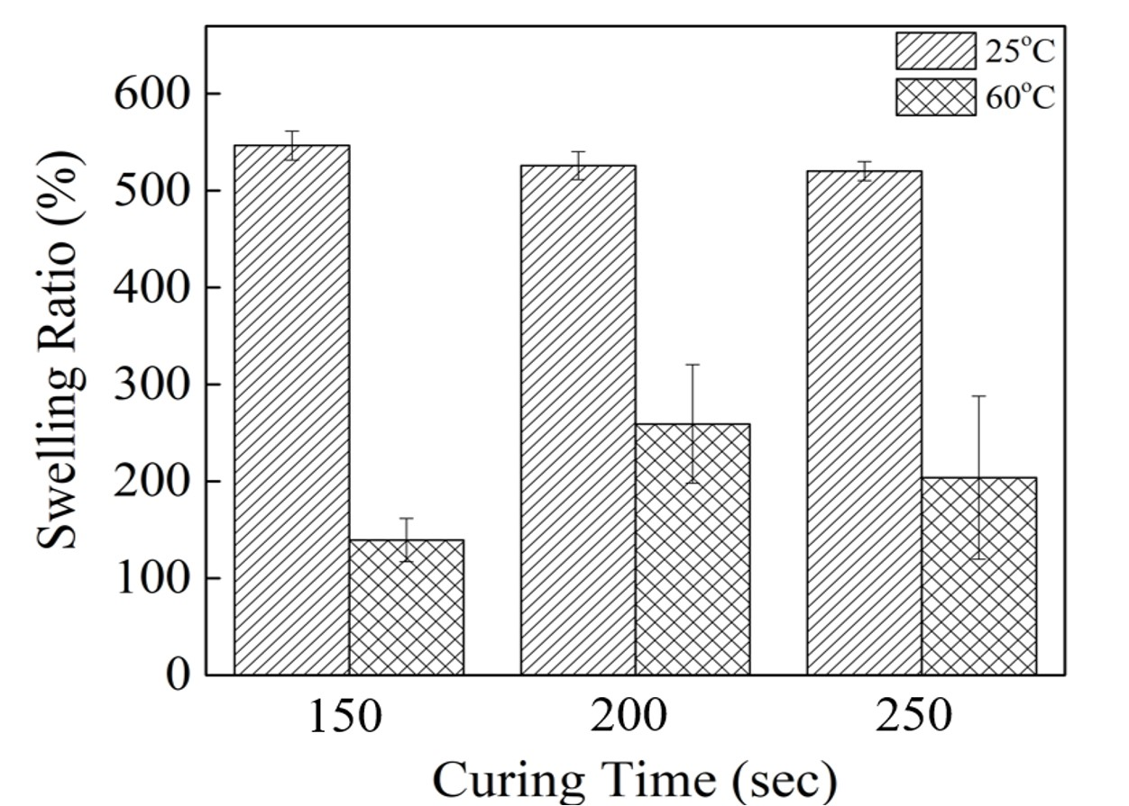
Figure S3. Equilibrium swelling ratio in water at 25°C and 60°C of sheets cured by exposing both sides to UV irradiation for different curing times.

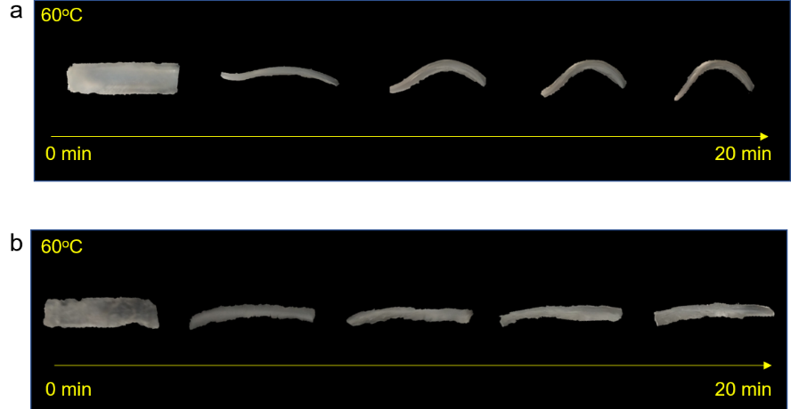
Figure S4. Comparison of motion performance between both sides cured sheet (b) and one side cured sheet (a).

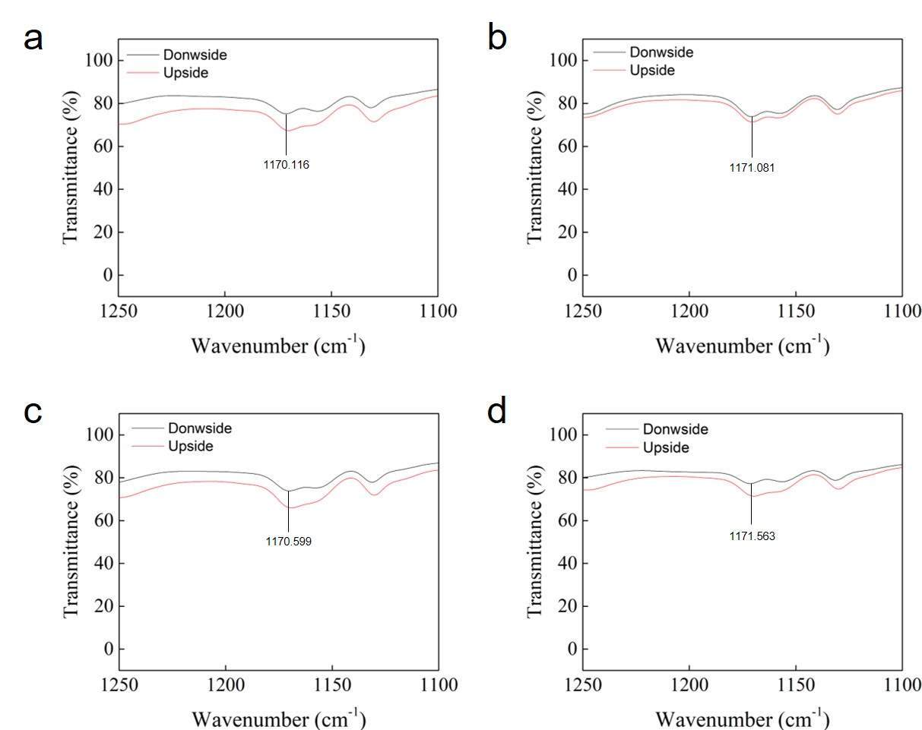
Figure S5 Results of FT-IR spectroscopy about top and bottom side of f-PNIPAM with different LCST. a) Spectrum of f-PNIPAM(48℃). b) 53.8℃. c) 60.8℃. d) 68.2℃. Peak near 1170 means the single bonds between carbon molecules which are made up during polymerization of f-PNIPAM.

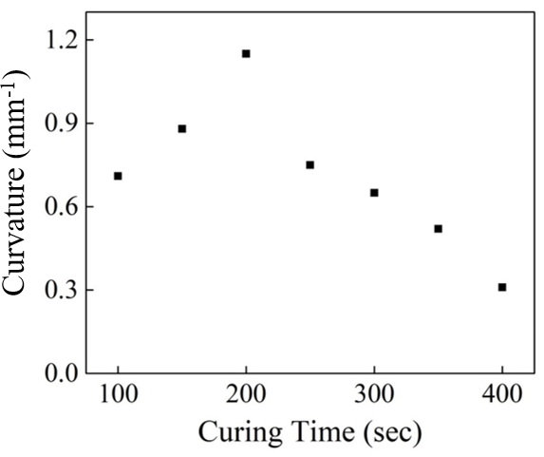
Figure S6. Comparison of final curvature above LCST for samples prepared with different UV-curing times.

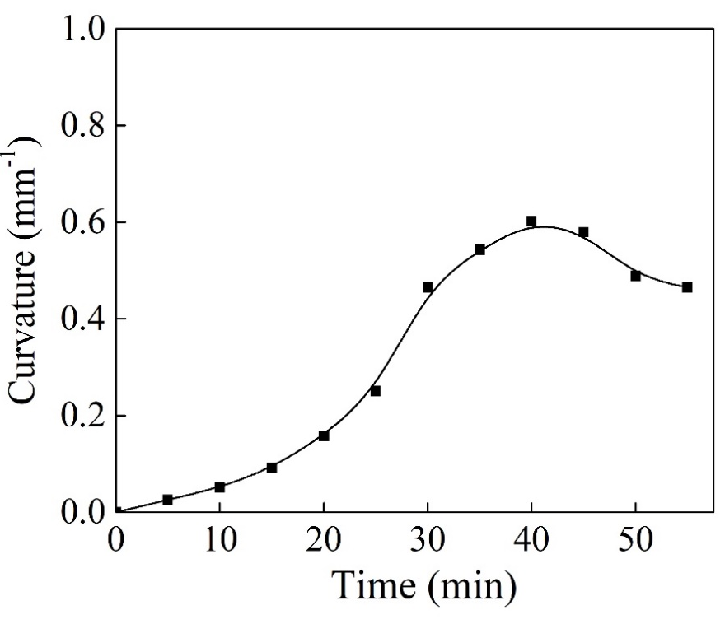
Figure S7. Curvature change with time. PNIPAM sheet which has 48 ºC of LCST is observed its curvature in water heated from 54 ºC to 67 ºC for 55 minutes.

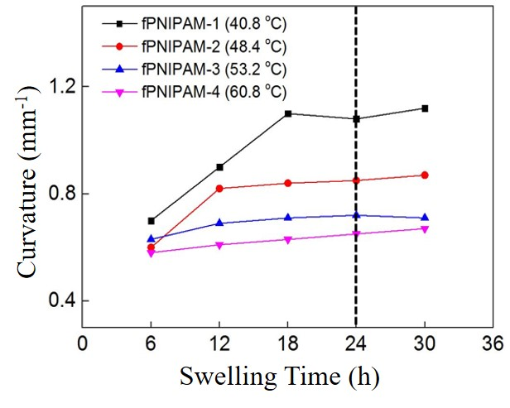
Figure S8. Actuation performance of each f-PNIPAM by water swelling time.

