Supplementary Data

Genome-wide alternative splicing landscapes modulated by biotrophic sugarcane smut pathogen

Renesh Bedre¹, Sonia Irigoyen¹, Patricia D.C. Schaker^{2, a}, Claudia B. Monteiro-Vitorello², Jorge A. Da Silva^{1,3}, and Kranthi K. Mandadi^{1,4*}

¹Texas A&M AgriLife Research & Extension Center, Texas A&M University, Weslaco, TX, USA
²Departamento de Genética, Universidade de São Paulo, Escola Superior de Agricultura “Luiz de Queiroz,” Piracicaba, São Paulo, Brazil
³Department of Soil & Crop Sciences, Texas A&M University, 2474 TAMU, College Station, Texas 77843
⁴Department of Plant Pathology & Microbiology, Texas A&M University, College Station, TX, USA
ªPresent address: Universidade Tecnológica Federal do Paraná, Toledo, Paraná, Brasil

*corresponding author: kkmandadi@tamu.edu

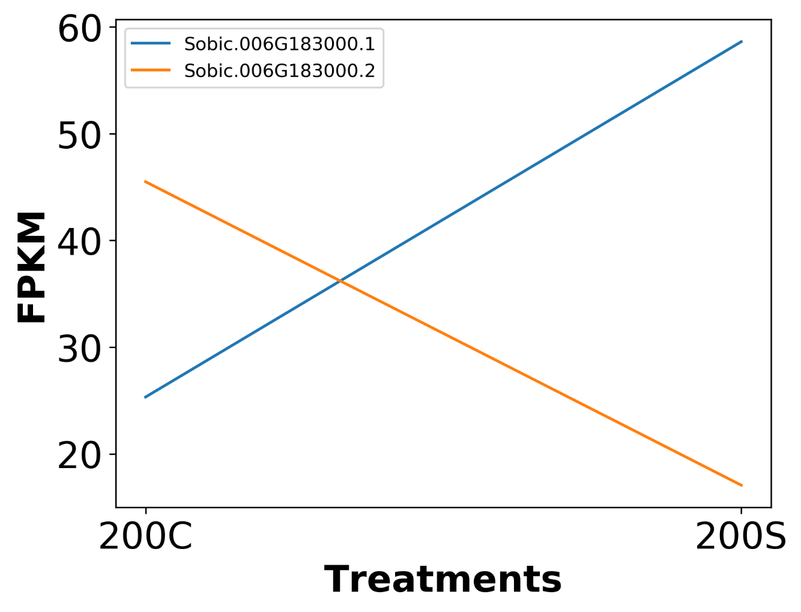
Figure S1. Isoform switching of a gene encoding a zinc finger protein. Changes in isoform expression of a gene encoding a zinc finger protein at 200 DAI in response to smut infection (200C: 200 DAI Control; 200S: 200 DAI infected).

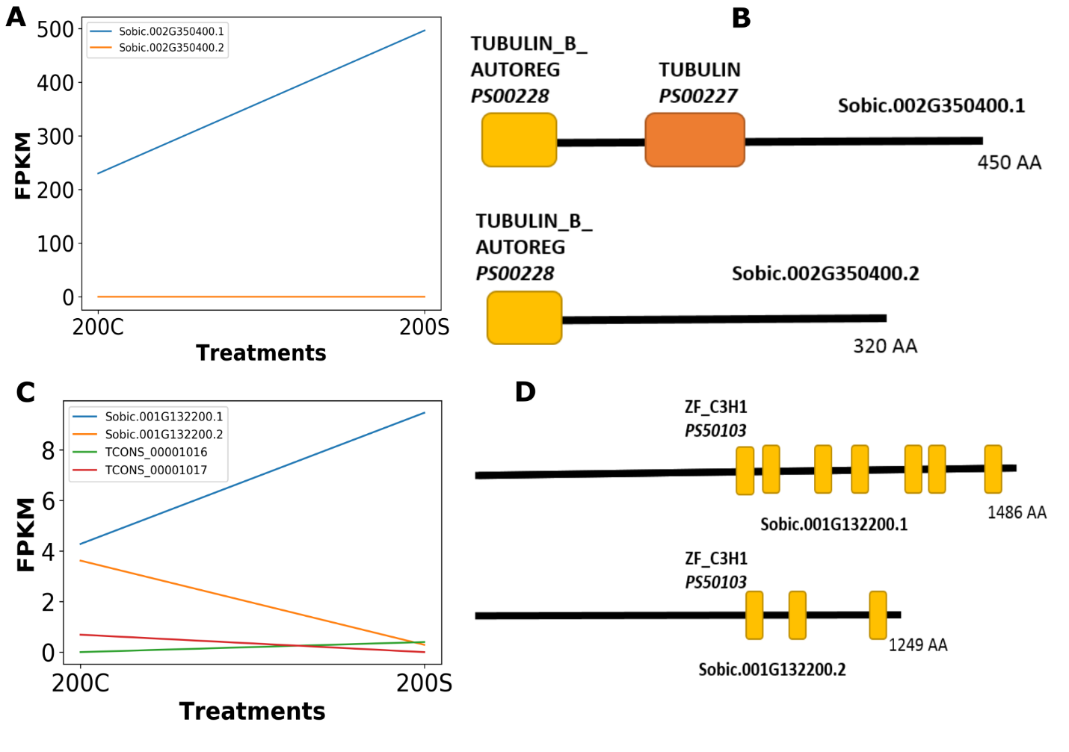
Figure S2. Gain and loss of protein domains induced by alternative splicing. A) and C) FPKM expression changes under control and stress conditions at 200 DAI (200C: 200 DAI Control; 200S: 200 DAI infected). B) and D) Predicted protein domain dynamics (loss or gain) as a result of AS in the respective isoforms.

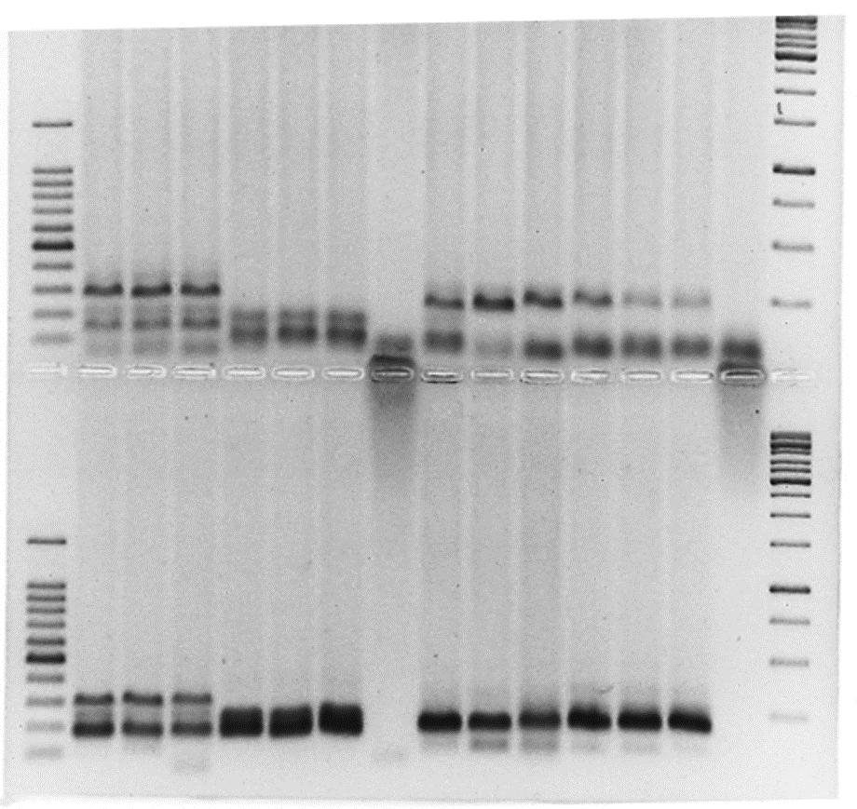
Figure S3. Uncropped gel image used to prepare Figure 7.

Table S1. Trinity assembly statistics
Parameter | Assembly count
Total assembled transcripts | 322,205
Total assembled unigenes | 212,023
Total assembled unigenes having isoforms | 36,925
Total assembled bases (bp) | 244,038,570

