Supplementary information

Intensified East Asian winter monsoon during the last geomagnetic reversal transition

Yusuke Ueno¹, Masayuki Hyodo^{1,2★}, Tianshui Yang³, Shigehiro Katoh⁴

¹Department of Planetology, Kobe University, Kobe 657-8501, Japan
²Research Center for Inland Seas, Kobe University, Kobe 657-8501, Japan
³China University of Geosciences, Beijing, China
⁴Museum of Nature and Human Activities, Hyogo, Sanda 669-1546, Japan

★e-mail: mhyodo@kobe-u.ac.jp

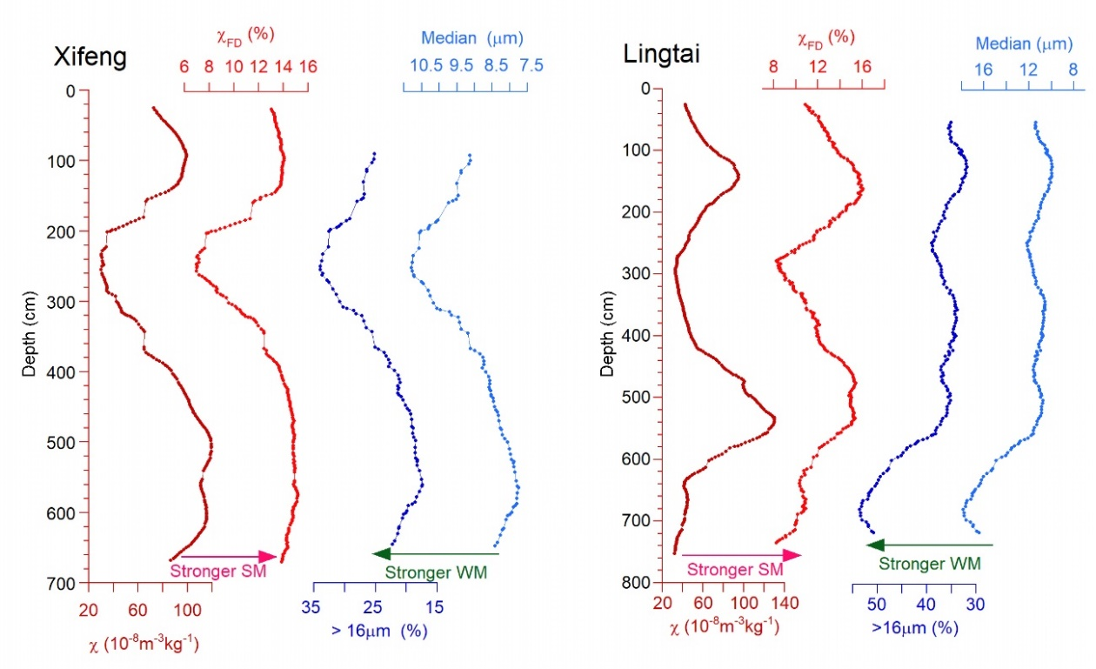
Figure S1. Down-section long-wavelength changes in the East Asian summer and winter monsoon proxies from Xifeng (left) and Lingtai (right). Plotted are the 21-point moving averaged magnetic susceptibility (χ), frequency-dependence of magnetic susceptibility (χ_{FD}), content of coarse fraction (> 16μm), and median grain size data.

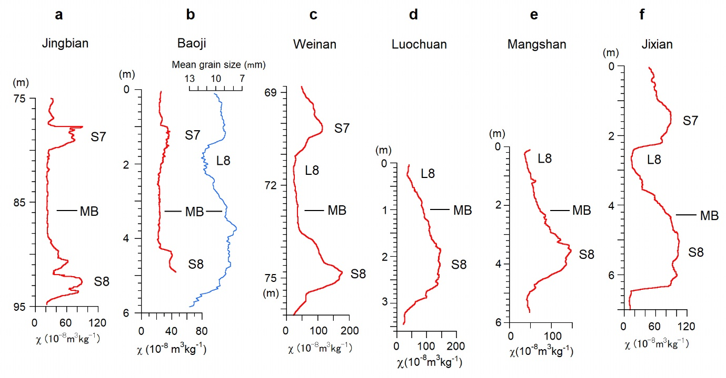
Figure S2. Magnetic susceptibility (χ) records across the Matuyama‒Brunhes magnetic polarity boundary in the loess-paleosol sequences of the Chinese Loess Plateau. a, Jingbian.¹ b, Baoji.² c, Weinan.³ d, Luochuan.⁴ e, Mangshan.⁵ f, Jixian.⁶ The mean grain size data from Baoji⁷ are plotted together with χ in b. MB shows the mid-level of the Matuyama‒Brunhes transition zone.
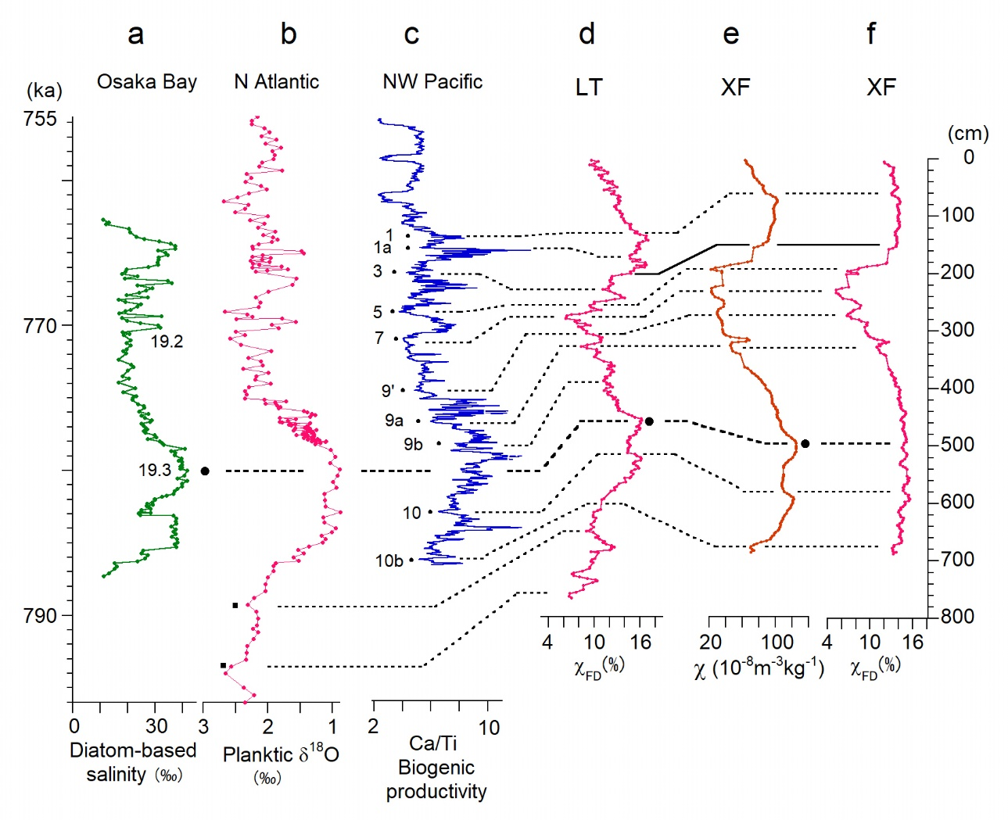
Figure S3. Climatostratigraphic correlation of the summer monsoon proxy curves from Lingtai and Xifeng with paleoceanic records. a, Diatom sea-level proxy from Osaka Bay.⁸ b, Planktonic δ¹⁸O from the North Atlantic mid-latitude (IODP Site U13113)⁹ plotted to the age model.¹⁰ c, Biogenic productivity proxy from the Northwest Pacific (Chiba Section core TB2).¹⁰ d, Frequency-dependence of magnetic susceptibility (χ_{FD}) from Lingtai. e, The magnetic susceptibility (χ) from Xifeng. f, χ_{FD} from Xifeng. The summer monsoon maxima are correlated with the highest sea-level highstand MIS 19.3 and oxic/low sea-level/cooling events,¹⁰ as connected by the dotted lines. The solid line shows the correlation between the Lingtai and Xifeng data. In c, the labels 1 to 10b of the correlation points indicated by dots follow Hyodo et al.,¹⁰ except 1a and 9’ defined in this study.

Reference
1 Guo, B. et al. A short reverse polarity interval within the Jaramillo subchron: evidence from the Jingbian section, northern Chinese Loess Plateau. J. Geophys. Res. 107, doi:10.1029/2001JB000706 (2002).

2 Yang, T.S. et al. Multiple rapid polarity swings during the Matuyama‒Brunhes (M‒B) transition from two high resolution loess-paleosol records. J. Geophys. Res. 115, B05101. http://dx.doi.org/10.1029/2009JB006301 (2010).

3 Pan, Y.X. et al. Geomagnetic episodes of the last 1.2 Myr recorded in Chinese loess. Geophys. Res. Lett. 29, doi:10.1029/2001GL014024 (2002).

4 Jin, C.S., Liu, Q.S. & Larrasoaña, J.C. A precursor to the Matuyama–Brunhes reversal in Chinese loess and its palaeomagnetic and stratigraphic significance. Geophys. J. Int. 190, 829–842 (2012).

5 Jin, C.S. & Liu, Q.S. Revisiting the stratigraphic position of the Matuyama-Brunhes geomagnetic polarity boundary in Chinese loess. Palaeogeog. Palaeoclimat. Palaeoecol. 299, 309–317 (2011).

6 Wang, X.S. The Matuyama-Brunhes polarity reversal in four Chinese loess records: high-fidelity recording of geomagnetic field behavior or a less than reliable chronostratigraphic marker? Quat. Sci. Rev. 101, 61‒76 (2014).

7 Wang K. Investigation on the reasons for positional discrepancy of the Matuyama-Brunhes boundary among different loess section. Master thesis of China University of Geosciences, Beijing. 60 pp (2013).

8 Maegakiuchi. K. et al. Brief sea-level fall event and centennial to millennial sea-level variations during Marine Isotope Stage 19 in Osaka Bay, Japan. J. Quat. Sci. 31, 809–822 (2016).

9 Ferretti, P., Crowhurst, S.J., Naafs, B.D.A. & Barbante, C. The Marine Isotope Stage 19 in the mid-latitude North Atlantic Ocean: astronomical signature and intra-interglacial variability. Quat. Sci. Rev. 108, 95–110 (2015).

10 Hyodo, M. et al. Millennial-scale northern Hemisphere Atlantic-Pacific climate teleconnections in the earliest Middle Pleistocene. Sci. Rep. 7, 10036 (2017).

