Genome-scale metabolic model of the rat liver predicts effects of diet restriction

Priyanka Baloni¹, Vineet Sangar¹, James T Yurkovich¹, Max Robinson¹, Scott Taylor², Christine M. Karbowski², Hisham K. Hamadeh^{2,†}, Yudong D. He², Nathan D Price^{1,}*

Email: nprice@systemsbiology.org

Supplementary materials
Data S1: iRatLiver model in mat format

Data S2: The rat liver model is available as SBML format

Data S3: Supplementary Tables S1 through S6

Supplementary figure

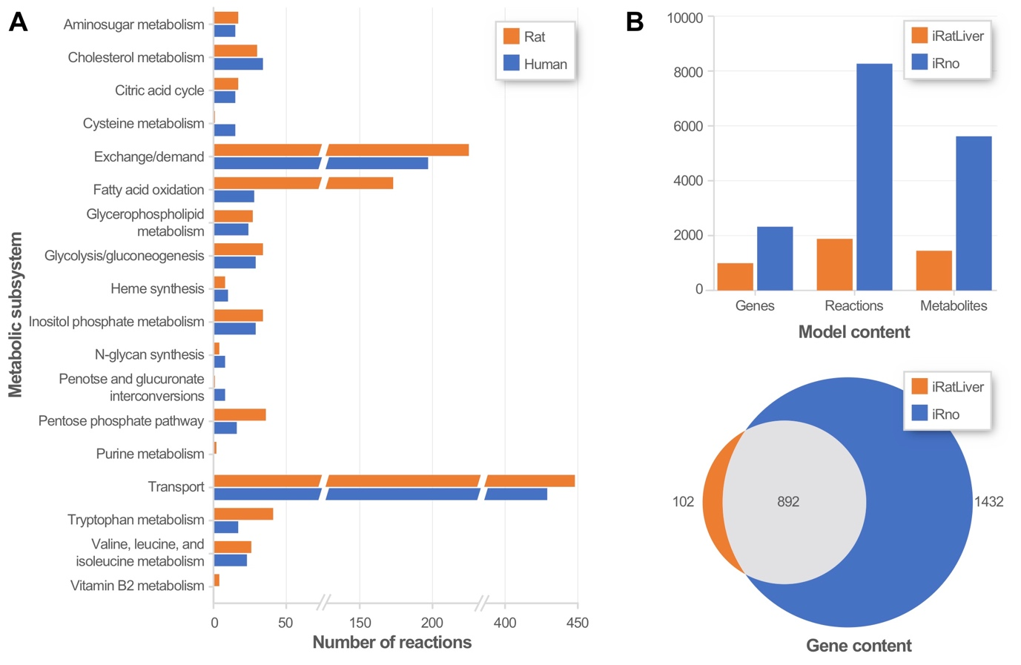

Supplementary figure 1. Overview of the iRatLiver GEM. (A) A comparison of the reaction content between iRatLiver and the human liver model¹⁶. (B) A comparison of the model and gene content between iRatLiver and the global rat metabolic reconstruction iRno³⁰.

