Supplementary information

Generation and characterization of a stable cell line persistently replicating and secreting the human hepatitis delta virus
Yi Ni^{1, 2}, Zhenfeng Zhang¹, Lisa Engelskircher¹, Georg Verch¹, Thomas Tu¹, Florian A. Lempp^{1,2}, Stephan Urban^{1,2}

¹ Dept. of Infectious Diseases, Molecular Virology, University Hospital Heidelberg, Heidelberg, Germany.
² German Center for Infection Research (DZIF), partner site Heidelberg, TTU Hepatitis, Heidelberg, Germany.

Supplemental figures and legends
Supplemental figure 1. Characterization of HuH7-HDV-Env cells (A) HBsAg secretion of three cell lines. HuH7, HuH7-HDV and HuH7-HDV-Env cells were seeded and the cell culture medium between d2-5 post seeding were analyzed for HBsAg. (B) Secretion of infectious virus by HuH7-HDV-Env. The cell culture supernatant of HuH7-HDV-Env at d0-3 post seeding were used to infect HepG2-NTCP cells. At d5 post infection, HepG2-NTCP were stained for HDAg (red). Nuclei were counter-stained with Hoechst (blue).
Supplemental figure 2. Primer specificity for the detection of gt1 and gt3 HDV. For quantitative PCR, 10⁸ copies of plasmids pJC126 (gt1) and pcDNA3.1-HDV-gt3-peru (gt3) were amplified with gt1 or gt3-specific primers. The absolute amount of HDV RNA were calculated using the respective plasmids as standards. The detection limit is around 100 copies/PCR reaction.
Supplemental figure 3. HDAg expression of 10 clones derived from HuH7-HDV-Env cells 10 clones (C1-C10) were generated by serial dilution using HuH7-END as the parental cells. These clones were analyzed for HDAg expression (red) by IF.

Supplemental figure 1.

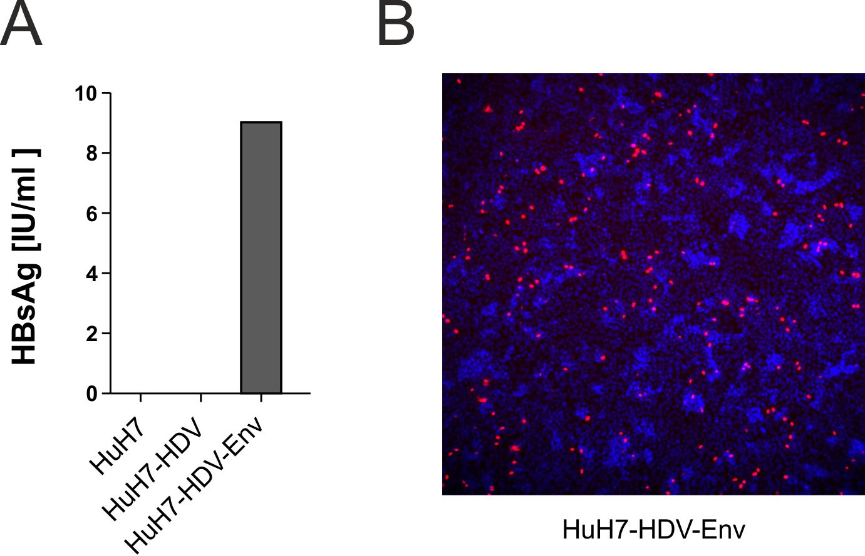

Supplemental figure 2.

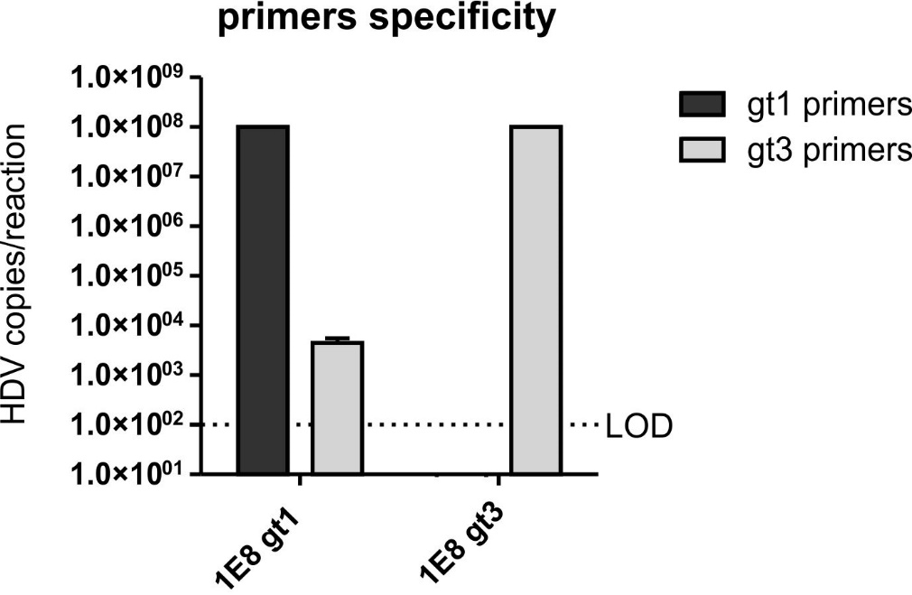

Supplemental figure 3.

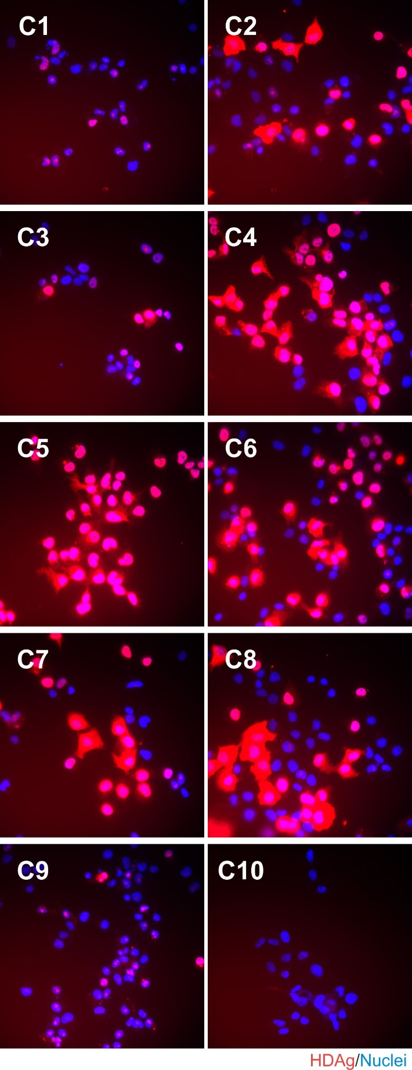

Figure 1C. Files with full-length blot

