Supplementary information for

C mobilisation in disturbed tropical peat swamps: old DOC can fuel the fluvial efflux of old carbon dioxide, but site recovery can occur.

Susan Waldron¹, Leena Vihermaa¹, Stephanie Evers^{2,3}, Mark H. Garnett⁴, Jason Newton⁵ and Andrew C. G. Henderson⁶

Supplementary information.

Table SI1. Sample code, site description and co-ordinates of samples collected during the July 2013 campaign from North Selangor Peat Swamp Forest and an oil palm plantation near Kuala Lumpur International Airport. Sample coding commenced WP represents sites sampled and marked as a way-point with a GPS. Other coding for NSPSF are sites sampled more frequently as part of TROCARI field-research programmes. The location was not recorded for all sites.
Sample | Site description | Northings | Eastings
North Selangor Peat Swamp Forest
RT1 | River Tengi(RT)-Bernam canal that drains from the north | 03 59 116 | 101 34 983
RT1B | Taken from a blackwater behind the bund that holds the canal | 03 35 463 | 101 24 974
RT2 | River Tengi before joining the canal | 03 57 515 | 101 35 233
RT3 | Side tributary of the R.Tengi with irregular burning (~ every 5 years) | 03 54 370 | 101 35 409
RT4 | River Tengai that drains from the north | 03 53 780 | 101 32 329
RT4B | Peat drain into the R.Tengai main river adjacent to RT4
RT5 | River Tengai, just before meeting the main paddy canal | 03 47 851 | 101 22 726
BF1 | Canal in a regularly-burnt forest (BF) area (annually for past 20 years; some young oil palm) | 03 42 878 | 101 33 670
BF2 | The same canal as WP 25 but downstream of a drain block between WP24/5; ~ 1 km apart | 03 42 879 | 101 33 670
PSF1 | Canal in a regenerated peat swamp forest (PSF), not logged for ~30 years, south of WP30 | 03 68 764 | 101 18 503
PSF2 | Drainage canal at foot of observation tower and trek into regenerated forest, near road, palm oil to the north | 03 69 811 | 101 18 484
OP1 | New road construction area (oil palm (OP) *approx 10-15yrs old) on NE, Forest on W | 03 66 966 | 101 24 425
CF1 | Side drain in 2013 clear felled (CF) forest (5m upstream of a small drain block) | 03 66 230 | 101 32 843
CF2 | Main drain in clear-felled 2013 area (roadside drain - draining larger CF and forest area, slow-moving) | 03 66 368 | 101 32 845
Palm Oil Plantation near Kuala Lumpur International Airport
WP40* | Canal draining palm oil plantation (southern edge of plantation) | 02 75 617 | 101 66 577
WP41* | Canal draining palm oil plantation (to the N of WP 40) | 02 70 757 | 101 66 342
WP42 | Canal draining palm oil plantation covered in algae | 02 72 053 | 101 64 520
KLIACF1 | Drains in recently clear-felled oil palm area
KLIACF2 | Drains in recently clear-felled oil palm area | 02 46 878 | 101 39 895
KLIACF3 | Drains in recently clear-felled oil palm area | 02 46 554 | 101 39 674

Table SI2. The scenarios used in the Bayesian End-Member Mixing Model SIAR for the peat source contribution. All sites are assumed to also have a fossil (¹⁴C dead) contribution (0 %modern) and a modern atm. contribution considered to be 102.76 ± 0.35. Where a surface or basal value was calculated from two cores, the full range (mean ± SD) was used to calculate the average, which accommodated differences in analytical uncertainty between cores influencing the age range. The intermediate ages were calculated from measured top and bottom ages, extended by the largest analytical uncertainty in the measured data to again give a range that was used in the model.

Scenario | Surface peat | Intermediate | Basal peat
Forest  NSPSF  (all sites) | 102.12 ± 0.47  (After AD 1950)  Used surface ages from one core for both as only have this date | 81.75 ± 0.47  (1573 - 1665)  Used mid-value of the range of the two cores & range as uncertainty | 61.52 ± 0.61  (3823-3983 yr BP)  Used mid value of the range of the two cores & range as uncertainty
OP-Plantation
WP40 | 94.73 ± 0.34  (406-464 yrBP)  Site-specific | 83.84 ± 0.47  (1371-1461 yr BP)  Estimated from the site-specific data | 72.87 ± 0.27  (2513 - 2572 yr BP)  Site-specific
WP41 | 93.26 ± 1.82  (405-719 yr BP)  Range of WP40 & adjacent core as similar and no site-specific ages | 82.12 ± 0.47  (1537-1629 yr BP)  Estimated from estimates | 73.17 ± 0.57  (2447 - 2572 yr BP)  Range of WP40 & adjacent core as similar and no site-specific ages

Table SI3. Hydrochemical composition of the sites described in Table SI1. Not all parameters were measured due to time and sample bottle constraints (NM), particularly measurement of CO₂ efflux which takes approximately 30 minutes. KLIA clear-felled sites had considerably higher specific conductivity than had been observed elsewhere and this raised concerns that chemicals had been used part of the clearing operations that could damage equipment and thus [DOC] was not measured. However, the CF sites been included given the importance of sharing data from palm oil plantations and particularly clear-felling.
Sample | Date sampled | pH | SC | %DO | Temp˚C | [Ca] | [DIC] | δ¹³C-DIC | [DOC] | [POC] | CO₂ efflux | [CH₄-C_{aq}]
Forest
RT1 | 24/7/13 11.30 | 6.48 | 33.9 | 80.8 | 28.0 | 2.45 | 3.16 | -12.2 | 3.2 | 3.29 | 8.23 ± 0.53 | 4.5
RT1B | 24/7/13 11.45 | 3.78 | 86.1 | 21.9 | 26.7 | 0.64 | 5.11 | -26.2 | 90.2 | 2.08 | NM | 17.9
RT2 | 24/7/13 13.15 | 6.30 | 92.8 | 26.1 | 27.8 | 1.95 | 7.56 | -9.3 | 11.7 | 2.54 | 1.60 ± 0.07 | 2.5
RT3 | 24/7/13 14.20 | 3.90 | 45.0 | 64.0 | 29.3 | 0.49 | 2.52 | -23.4 | 45.9 | 1.79 | 1.78 ± 0.42 | 6.6
RT4 | 24/7/13 16.00 | 6.30 | 34.6 | 80.4 | 29.1 | 0.78 | 3.01 | -12.3 | 3.7 | 5.31 | 0.77 ± 0.35 | 4.9
RT4B | 24/7/13 16.10 | 3.74 | 81.6 | 44.4 | 31.9 | 0.43 | 3.21 | -25.4 | NM | 1.39 | NM | 9.7
RT5 | 24/7/13 18.45 | 6.25 | 34.3 | 68.5 | 29.5 | 0.72 | 3.23 | -13.1 | 5.4 | 2.96 | NM | 10.7
BF1 | 25/7/13 11.05 | 3.74 | 75.2 | 6.7 | 29.7 | 0.96 | 5.40 | -25.0 | 83.6 | 0.94 | 2.00 ± 0.39 | 15.3
BF2 | 25/7/13 14.55 | 3.71 | 74.7 | 19.3 | 28.9 | 0.95 | 6.00 | -25.7 | 83.0 | 0.76 | 23.99 ± 3.4 | 3.5
PSF1 | 26/7/13 10.55 | 3.64 | 129.7 | 1.6 | 25.6 | 0.93 | 4.92 | -23.8 | 144.8 | 4.35 | 1.3 ± 0.04* | 247.5
PSF2 | 26/7/13 15.00 | 3.58 | 90.3 | 30.6 | NM | 0.44 | NM | NM | 124.6 | 44.2 | NM | 6.7
OP1 | 26/7/13 15.10 | 4.13 | 67.6 | 27.7 | NM | 0.32 | 3.05 | -25.0 | 127.5 | 3.62 | NM | 1.9
CF1 | 26/7/13 15.25 | 3.14 | 72.7 | 23.1 | NM | 0.36 | 5.51 | -27.4 | 60.6 | 1.84 | NM | 8.6
CF2 | 26/7/13 15.40 | 3.69 | 79.1 | 44.1 | NM | 0.22 | 4.74 | -23.1 | 71.9 | 8.60 | NM | 110.8
OP-Plantation
WP40 | 29/7/13 12.00 | 3.88 | 334.3 | 25.5 | 30.0 | 6.90 | 3.12 | -18.6 | 22.5 | 11.52 | 0.69 ± 0.11* | 0.5
WP41 | 30/7/13 15.45 | 4.06 | 206.6 | 54.6 | 27.7 | 2.91 | 0.84 | -24.5 | 109.0 | 12.07 | 0.51 ± 0.08* | 1.4
WP42 | 30/7/13 14.30 | 3.89 | 168.0 | 18.8 | 33.2 | NM | 3.62 | -20.6 | 153.4 | 24.71 | NM | 8.3
KLIACF1 | 30/7/13 13.30 | 2.14 | 1359 | 9.0 | 32.1 | 1.98 | NM | NM | NM | NM | NM | 28.5
KLIACF2 | 30/7/13 13.35 | 2.65 | 2353 | 23.3 | 29.8 | 0.21 | NM | NM | NM | NM | NM | Not detected (0.0)
KLIACF3 | 30/7/13 13.40 | 2.87 | 1783 | 22.1 | 31.3 | 0.38 | NM | NM | NM | NM | NM | 14.1

Table SI4. Site categorization for the [CH₄-aq] land use analysis in Figure 2:
Sample | [CH₄-C_{aq}] | Categorisation
Forest
RT1 | 4.5 | Regional drainage
RT1B | 17.9 | Within site artificial drainage
RT2 | 2.5 | Regional drainage
RT3 | 6.6 | Within site artificial drainage
RT4 | 4.9 | Regional drainage
RT4B | 9.7 | Within site artificial drainage
RT5 | 10.7 | Regional drainage
BF1 | 15.3 | Within site artificial drainage
BF2 | 3.5 | Within site artificial drainage
PSF1 | 247.5 | Forest not logged for 30 years
PSF2 | 6.7 | Within site artificial drainage
OP1 | 1.9 | Site boundaries
CF1 | 8.6 | Drainage in felled areas
CF2 | 110.8 | Drainage in felled areas
Oil Palm plantation
WP40 | 0.5 | Site boundaries
WP41 | 1.4 | Within site artificial drainage
WP42 | 8.3 | Within site artificial drainage
KLIACF1 | 28.5 | Drainage in felled areas
KLIACF2 | Not detected (0.0) | Drainage in felled areas
KLIACF3 | 14.1 | Drainage in felled areas

Fig. SI1. Box and whisker plot of the [CH₄-aq] as a function of site sampled -the forest reserve (NSPSF) or the OP-plantation – showing the maximum, minimum, median and 1st and 3rd quartiles. Outliers are shown and the forest site has more outliers to the population composition.
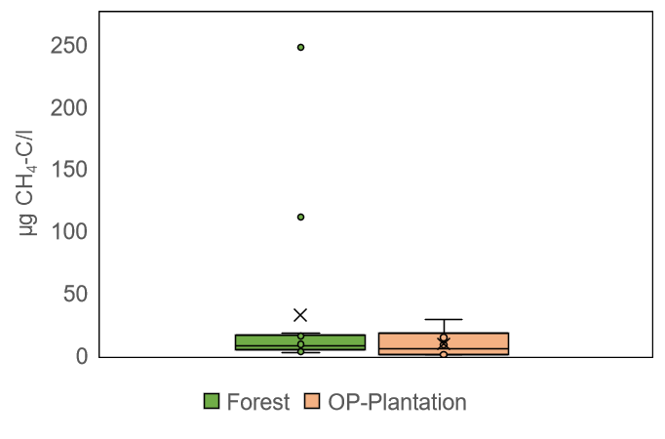
Fig.SI2 The algal-covered surface of the drainage system at PSF1 in Forest reserve, with the algal-surface cover punctuated by rounded breaks that could have been caused by the upward pressure of ebullitive methane fluxes e.g. in front of the log in the water to the left-hand side of the image are two larger circular holes but there are many smaller ones.

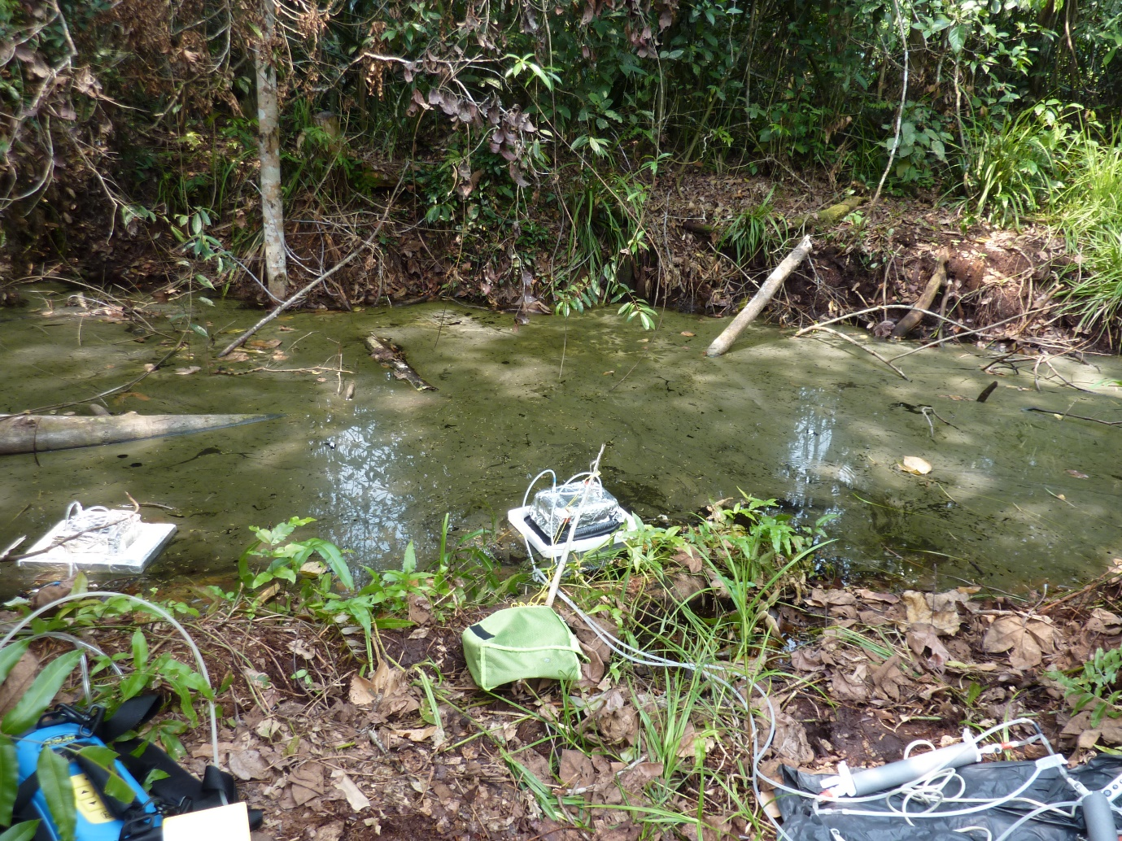

Fig. SI3 An example of the peat surface at the OP-Plantation, where blackened showing signs of fire possibly smouldering underground.
