Supplementary information

Loss of Cubilin, the intrinsic factor-vitamin B12 receptor, impairs visceral endoderm endocytosis and endodermal patterning in the mouse

Aitana Perea-Gomez^{1§}, Olivier Cases², Vincent Lelièvre³, Maria V. Pulina^{4#}, Jérôme Collignon¹, Anna-Katerina Hadjantonakis⁴, Renata Kozyraki^{2*}

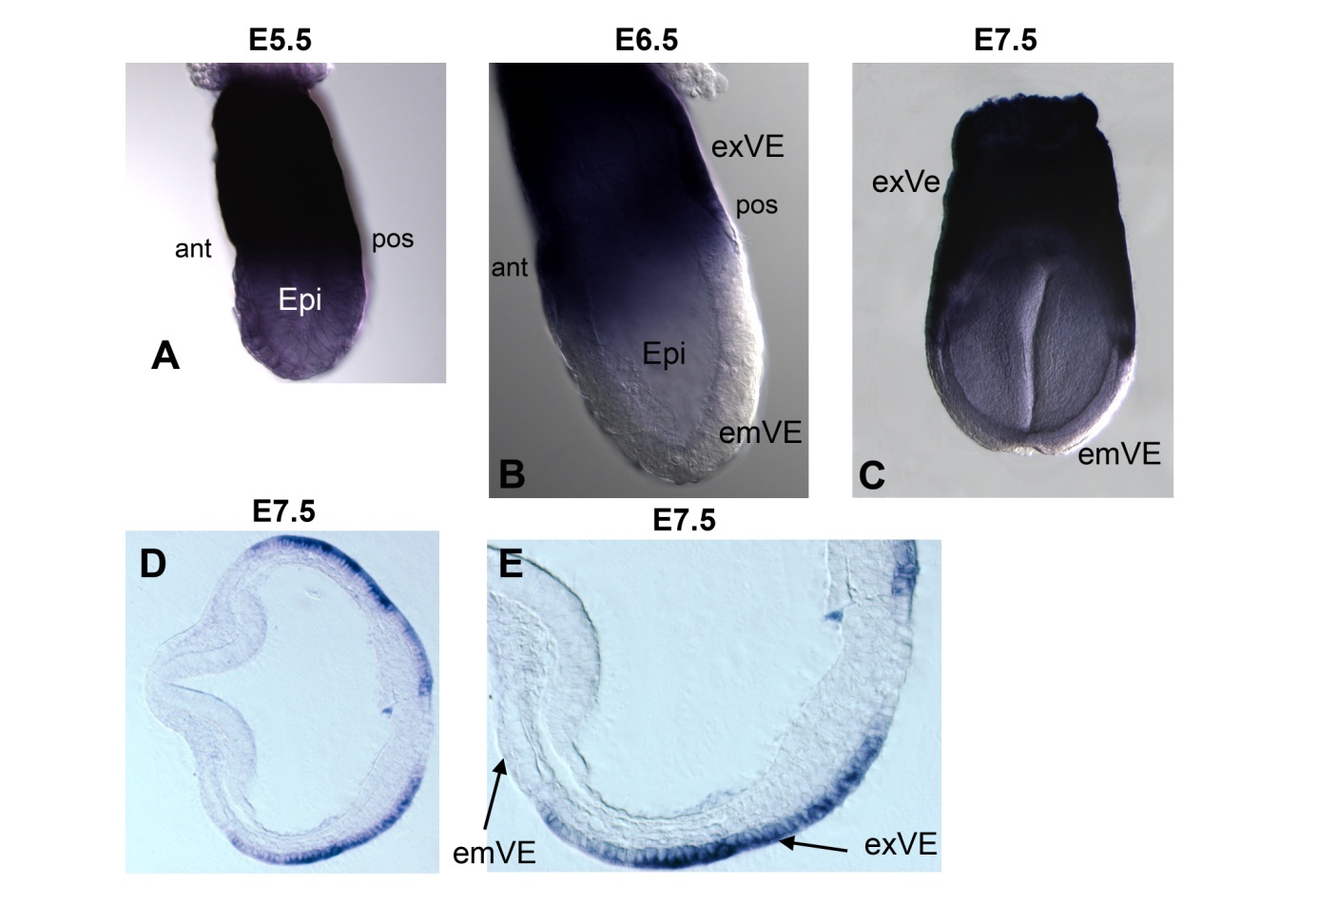
Suppl. Figure 1: Expression of Cubn mRNA between E5.5 and E7.5. WMHIS of Cubn mRNA showing strong expression at the level of the extraembryonic visceral endoderm (exVE) at E5.5 (A), E6.5 gastrulation stage (B) and E7.5 (C). (D, E) Cross section through a E7.5 embryo showing Cubn expression in exVE cells. ant: anterior, emVE: embryonic visceral endoderm, Epi: epiblast, pos: posterior.

Suppl. Figure 2. Marker analysis of Cubn^{0/0} mutants at E6.5 and E7.5. (A, B) By E6.5, Hex and Lefty-1 delineate the anterior visceral endoderm (AVE) whereas T and Lefty-2 are expressed in the nascent primitive streak. (A’, B’) In Cubn^{0/0} embryos Hex and Lefty-1 are expressed in the anterior visceral endoderm whereas T expression is greatly down regulated and Lefty-2 expression is absent. (C) Nodal is expressed in the epiblast with higher posterior expression. (C’) In Cubn^{0/0} embryos, Nodal is homogeneously distributed in the epiblast.
(D) Quantitative RT-PCR performed in five mutants and seven controls for each gene analyzed at E7.5 confirms the upregulation of Fgf8 and unmodified expression of Snail in mutants. The Fgf8 target and posterior mesoderm marker Twist is downregulated whereas Nodal is strongly upregulated in the Cubn^{0/0} embryos.

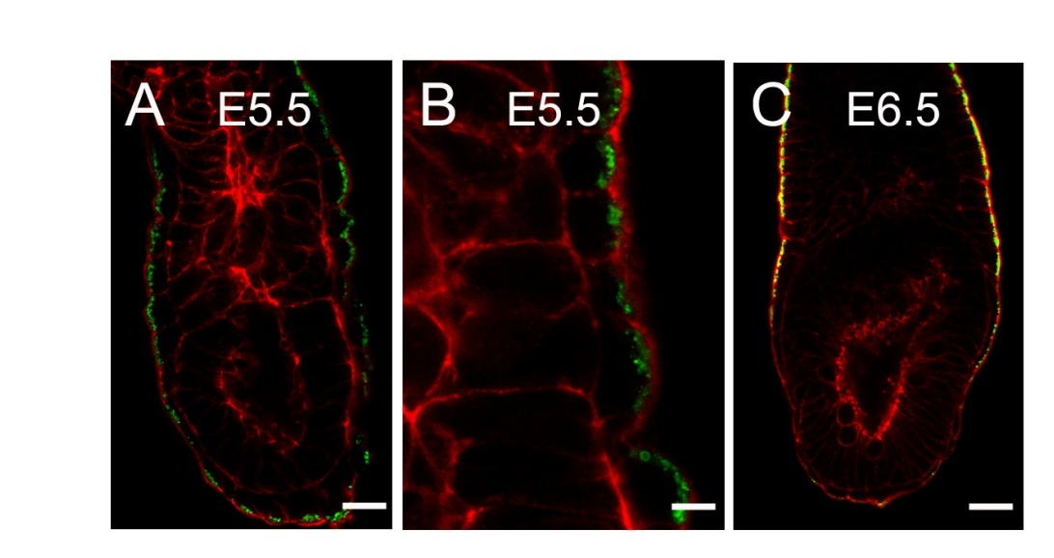
Suppl. Figure 3. Confocal imaging of transferrin uptake (green) and actin staining (red). (A) By E5.5, transferrin uptake occurs in embryonic visceral endoderm (emVE) and extraembryonic visceral endoderm (exVE) cells. (B) Transferrin accumulates in subapical vesicles. (C) By E6.5, transferrin uptake is localized mainly in exVE cells. Some uptake is also seen in emVE cells. All images show single confocal sections. Scale bars: 25 μm in A; 10 μm in B; 40 μm in C.

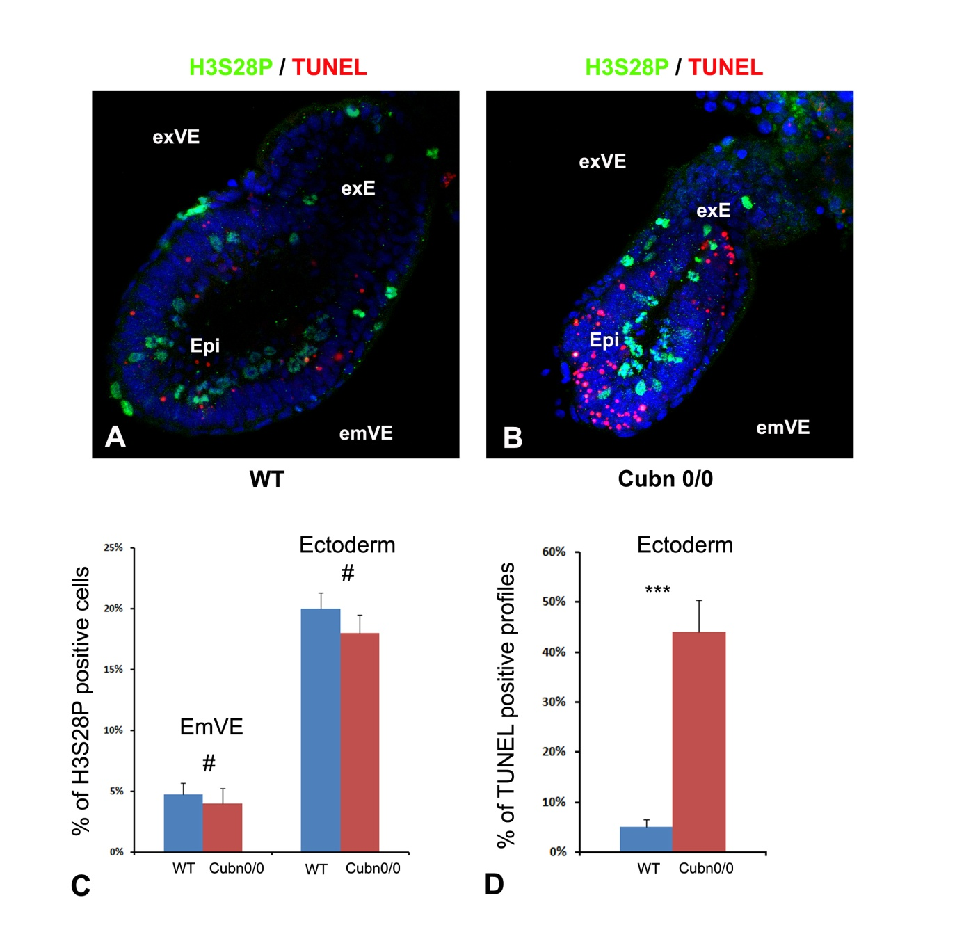
Suppl. Figure 4. Proliferation and TUNEL assay in E6.5 Cubn null embryos. (A, B) H3S28P immunofluorescence (green) and TUNEL staining (red) in a confocal section of E6.5 embryos. (A) H3S28P positive cells and TUNEL positive profiles are evenly scattered along the ectoderm (epiblast (Epi) and extraembryonic ectoderm(exE)) of wild-type controls. (B) In Cubn null embryos, numerous TUNEL positive profiles are concentrated in the distal anterior epiblast and the posterior extraembryonic ectoderm. (C) Graph showing the percentages of embryonic visceral endoderm (emVE) and ectoderm (epiblast and extraembryonic ectoderm)-specific cells positive for H3S28P-immunofluorescence in seven consecutive confocal sections of wild-type littermate (blue plot; n = 3) and Cubn null embryos (red plot; n =3). All results are calculated as mean and SEM. The differences between wild-type littermate and Cubn null embryos are not significant (emVe p-value 0.85; ectoderm p-value 0.37). (D) Graph showing the percentages of ectoderm (epiblast and extraembryonic ectoderm)-specific profiles for TUNEL staining in seven consecutive confocal sections of wild-type littermate (blue plot; n = 3) and Cubn null embryos (red plot; n =3). The difference between wild-type littermate and Cubn null embryos is highly significant (p-value 5.4 x 10⁻⁴).

Suppl. Figure 5: (A) Clathrin adaptator complex 1 gamma-adaptin (AP1G1, AP-1) immunoreactivity is found at the plasma membrane (arrow) and large vacuoles (arrowhead). In Cubn^{0/0} embryos, AP-1 is absent from the plasma membrane and condenses in small vesicles near the plasma membrane (arrowheads). (B) Full length blots showing the presence of Lamp2 and beta-actin in ten independent samples (extraembryonic visceral endoderm extracts of gastrulating control (1-5) and mutant (6-10) embryos). Scale bars: 15μm.
Table S1. List of primers used in genotyping and real time RT-PCR
Gene | Forward Primer | Reverse Primer | Fragment | sequence
Genotyping
Cubilin | 5’ATGCTCAGCTGGGACTGTCT3’ | 5’AAGGGACTAGGGACAGGTACATC3’ | 27435-27743 | NM001081084
 | 5’GTTGTCAGAACCGATGAGGA3’ | 5’AAGGGACTAGGGACAGGTACATC3’ | 24181-27743* | “ “
Real time RT-PCR
mAmn | 5’ CCCTACTGCCTCAAGGACAAT 3’ | 5’ GGTACCGCTCCAGGTCAAAT 3’ | 736-822 | NM033603
mBMP4 | 5’ GGCTGGAATGATTGGATTGTG 3’ | 5’ CAATGGCATGGTTGGTTGAGT 3’ | 1389-1497 | NM087554
mCubn | 5’ ACGAGCTCCTGGACTGGTTAT 3’ | 5’ GCTCTGGTAGGCAAAGGTTC 3’ | 1438-1530 | NM_001081084
maFP | 5’ TCCCTCATCCTCCTGCTACAT 3’ | 5’ TCTTCTCCGTCACGCACTG 3’ | 89-191 | NM007423
mFGF8 | 5’ CGCTCCGCGCTGAGCTG 3’ | 5’ CGAGTGTCAGCTGGCTTC 3’ | 31-130 | NM010205
mGATA4 | 5’ ACTCCAGCAATGCCACTAGC 3’ | 5’ TGTGCCCATAGTGAGATGACA 3’ | 1650-1739 | NM008092
mHNF4 | 5’ CCATCATCTTCTTTGATCCAG 3’ | 5’ CTCACTTGCACCTGTGACC 3’ | 989-1070 | NM008261
mHPRT | 5’ TGGTGAAAAGGATCTCTCGAA 3’ | 5’ TCAAGGGCATATTCAACAATA 3’ | 637-727 | NM013556
nodal | 5’ CTGTAGAGAGGGGCGGATG 3’ | 5’GGTTGAAGTCCACCTGGAACT 3’ | 695-793 | NM013611
mSnail1 | 5’ TGAAGAGATACCAGTGCCAGG 3’ | 5’ CGGAGCAGCCAGACTCTTG 3’ | 761-844 | NM011127
mTTR | 5’ GGCTTCCCTTCGACTCTTC 3’ | 5’ ATCCAGGACTTTGACCATCAG 3’ | 29-140 | NM013697
mTwist | 5’ CTCGGACAAGCTGAGCAAGA 3’ | 5’ CTGCAGGACCTGGTACAGGAA 3’ | 736-811 | NM011658
mvHNF1 | 5’ ATAGCTCCAACCAGACGCACA 3’ | 5’ TAGCGCACTCCTGACATCT 3’ | 1134-1236 | NM009330
mWnt3a | 5’ GCACTCAGCCCATTCTCTGT 3’ | 5’ TCCACGTAGTTCCTGCAGAAG 3’ | 235-310 | NM009522

