Supplementary Information for:
Habitat use of urban-nesting lesser black-backed gulls during the breeding season

Anouk Spelt¹, Cara Williamson¹, Judy Shamoun-Baranes², Emily Shepard³, Peter Rock¹, and Shane Windsor ¹*

¹Department of Aerospace Engineering, University of Bristol, Bristol, BS8 1TR, United Kingdom

²Institute for Biodiversity and Ecosystem Dynamics, University of Amsterdam, Amsterdam, 1098XH, The Netherlands

³Department of Biosciences, Swansea University, Swansea, SA2 8PP, United Kingdom

*shane.windsor@bristol.ac.uk
Supplementary methods
Study area and species – extra information
Lesser black-backed gulls nesting on two buildings in the city centre were tagged in this study (Figure 1b – white stars); the Arts and Social Science Library (ASSL) at the University of Bristol and the dBs Music building in the centre of Bristol. ASSL is a large building (LxWxH is 41x48x13 m) in the middle of the University of Bristol. Nesting has been recorded since at least 2004 (P. Rock, personal observation) and on average 6 to 8 gulls were nesting on this roof during 2016-2018. Nests were spread out (>20 m between nests) and built upon the stone roof structure. dBs Music is a smaller building (LxWxH is 34x16x11 m) in the centre of Bristol. Nesting has been recorded since 1980 (P. Rock, personal observation) and on average 8 to 10 gulls were nesting on this roof during 2017-2018. Nests were closer to each other on this roof (>5 m between nests) and the stone roof structure contained a mossy layer on which nests were built.

The first large gulls started to populate the roofs of Bristol as early as 1972 ⁵⁴. Between 1998 and 2002 the nationwide survey of seabirds "Seabird 2000" recorded 850 apparently occupied nests (AON) of lesser black-backed gulls in the city ²⁶. a gulls species which is amber listed in the UK due the fact that they are considered localised (70-80% of the UK breeding population being located in 10 or fewer Important Bird Areas ⁷).

Breeding activity
On average the gulls were tracked for 128±26 days (range: 19-299) during the three breeding seasons (2016-2018, Supplementary Table S1), with five birds being tagged at the beginning of the 2016 breeding season and then an additional seven birds in 2017. Mean first egg laying date was 5th May in 2016 (range: 15/04-02/06), 3th May in 2017 (range: 26/04-22/05) and 10th May in 2018 (range: 30/04-22/05). Mean hatching date of the first egg was 2rd June in 2016 (range: 20/05 - 22/06), 28th May in 2017 (range: 24/05 - 13/06) and 4rd June in 2018 (range: 28/5-13/6). During the breeding season of 2016 all five individuals produced chicks, with three individuals successfully fledging chicks (Supplementary Table S1). In 2017 nine individuals produced eggs, chicks hatched in seven nests and four individuals had one or two chicks successfully fledged. In 2018 eight individuals produced eggs of which chicks hatched in six nests and five individuals had one or two chicks successfully fledged.

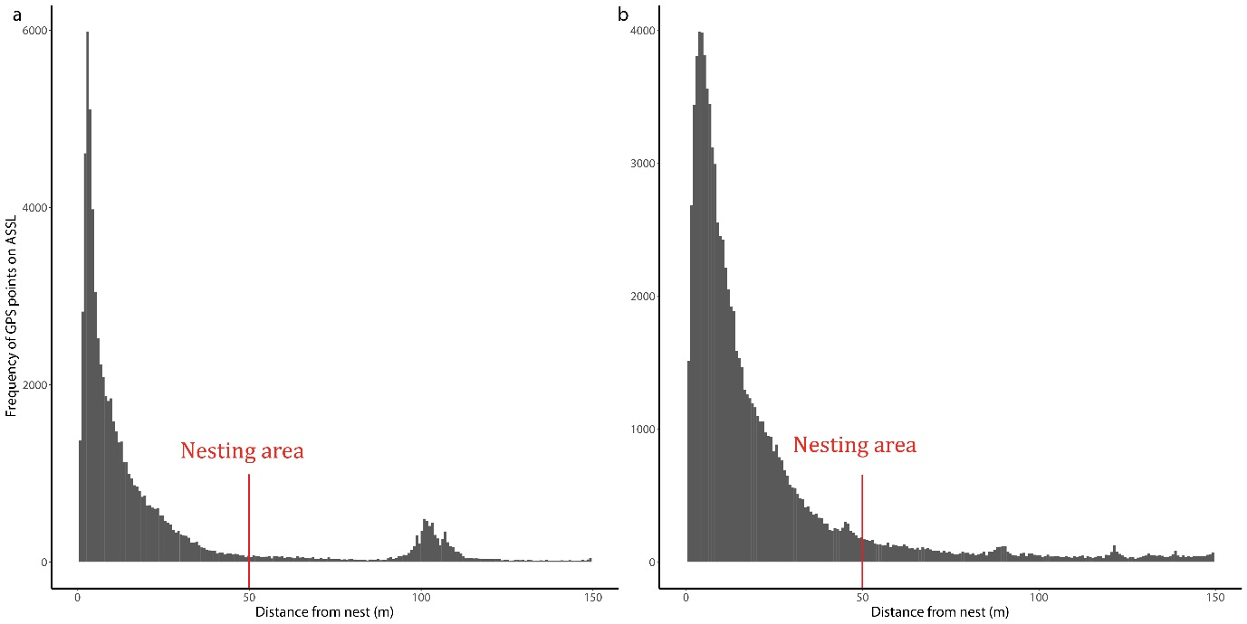Supplementary Figure S1: The frequency of distance from each nest (m) per GPS measurement. a) Arts and Social Sciences library (ASSL). b) dBs Music Centre (dBs). The cut-off for defining the nesting area was determined visually and was defined as a radius of 50 m for all nests.

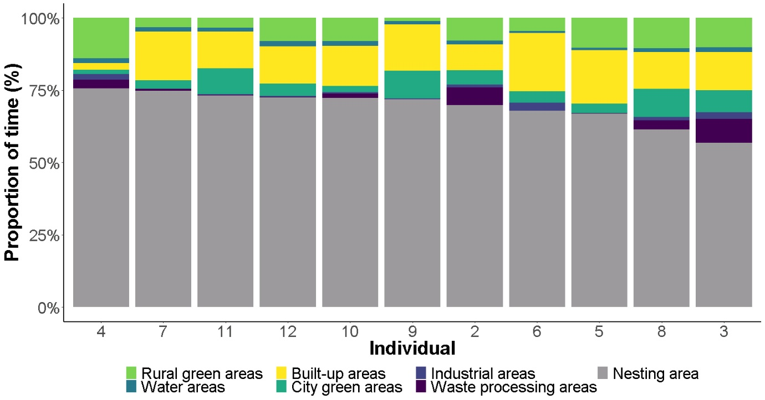
Supplementary Figure S2: The mean proportion of time spent in seven different habitats by individual urban-nesting gulls in Bristol during three breeding seasons (2016-2018). Individuals are shown from left to right in descending order of proportion of time spent in the nesting area. The data of individual 1 is not included because it was excluded from this study.

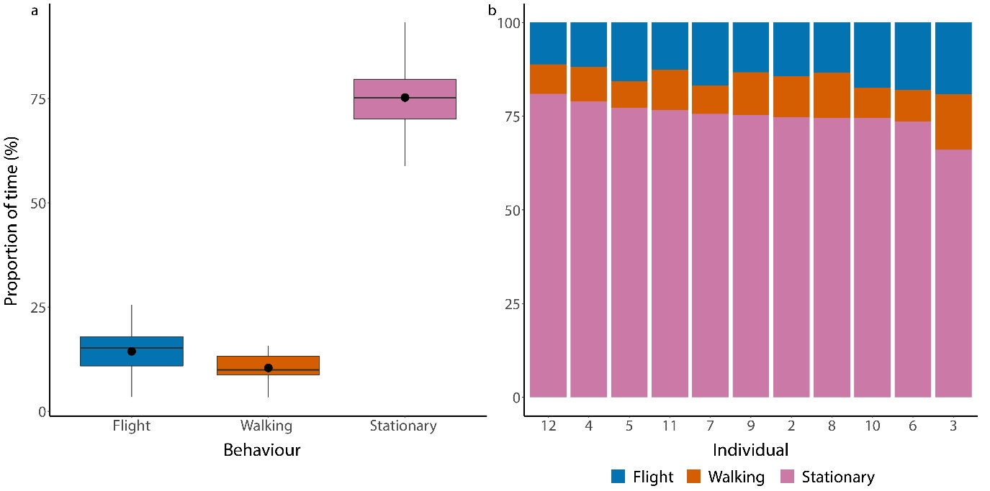Supplementary Figure S3: Mean proportion of time spent on each of the three behaviour types during three breeding seasons (2016-2018). a) Mean over the whole breeding season. b) Mean per individual

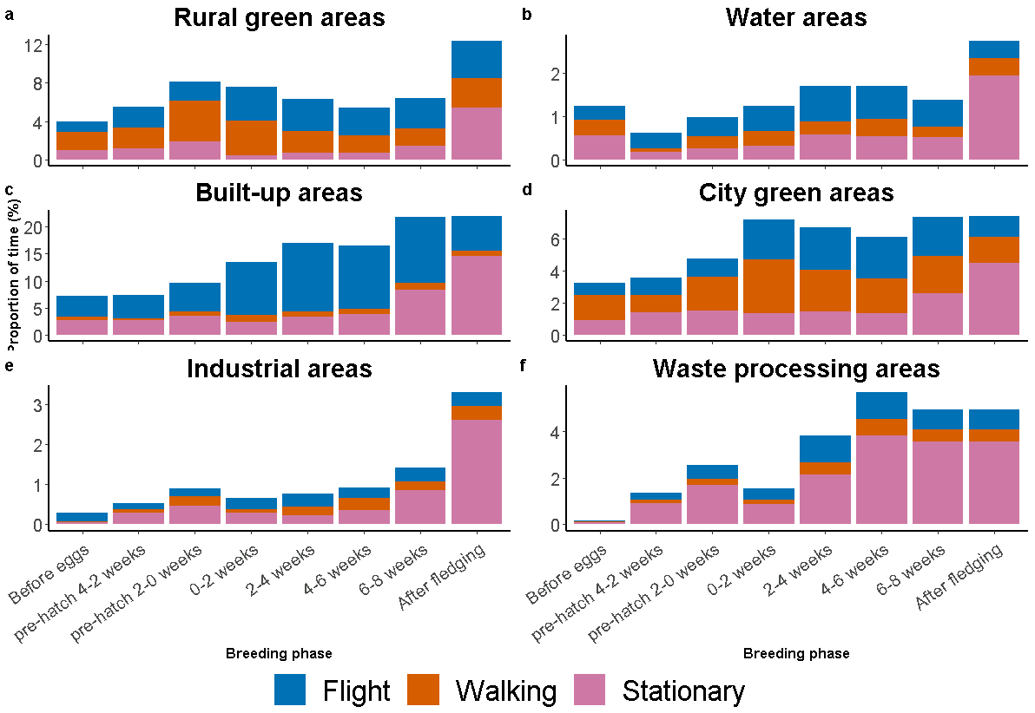

Supplementary Figure S4. Mean proportion of time spent on each of the three behaviour types depending on breeding stage for the different habitats when away from the nesting area. a) Rural green areas. b) Water areas. c) Built-up areas. d) City green areas. e) Industrial areas. f) Waste processing areas. g) Nesting area. Behaviour classification is based on accelerometer data

Supplementary Table S1: Overview of 12 individual gulls followed during three breeding seasons (2016-2018) in Bristol. In 2016, 5 individuals were tagged, and one GPS device failed after a week (id 1). In 2017, another 7 individuals were tagged, and one GPS device stopped working in 2018 (id 7). The birds were nesting on two different roofs; Art and Social Sciences Library (ASSL) and dBs music Centre (dBs). Days, fixes and fixes per day (fix/day) are given for data when birds were breeding and include the nesting area (30-min data set). Laying dates (lay) and hatching dates (hatch) are given for each individual for each year. Nest info gives information about the state of the nest at the end of each of the breeding seasons; individual was not breeding (no nest), breeding at another colony (other nest), chicks did not hatch (eggs), chicks died during the season (died) or the chicks fledged at the end of the season (fledged).

ID | Sex | Start date | End date | Roof | Breeding only |  |  | 2016 |  | 2017 |  | 2018 |  | Nest info
 |  |  |  |  | Days | Fixes | Fix/day | Lay | Hatch | Lay | Hatch | Lay | Hatch | 2016 2017 |  | 2018
1 | F | 04/05/2016 | 11/05/2016 | ASSL |  |  |  | 01/May | 30/May |  |  |  |  | Fledged
2 | F | 04/05/2016 | Ongoing | ASSL | 207 | 9,879 | 48 | 04/May | 27/May | 22/May | 13/Jun | 22/May | 11/Jun | Fledged | Died | Died
3 | F | 04/05/2016 | Ongoing | ASSL | 299 | 14,058 | 47 | 15/Apr | 20/May | 30/Apr | 25/May | 05/May | 28/May | Fledged | Fledged | Fledged
4 | F | 05/05/2016 | Ongoing | ASSL | 33 | 1,537 | 47 | 04/May | 07/Jun |  |  |  |  | Died | No nest | Another nest
5 | F | 09/06/2016 | Ongoing | ASSL | 19 | 888 | 47 | 02/Jun | 22/Jun |  |  |  |  | Died | No nest | No nest
6 | F | 18/05/2017 | Ongoing | ASSL | 72 | 3,449 | 48 |  |  | 10/May |  | 22/May | 13/Jun |  | Eggs | Died
7 | F | 08/05/2017 | 20/05/2018 | dBs | 88 | 4,180 | 48 |  |  | 27/Apr | 24/May | 06/May |  |  | Fledged | Eggs
8 | M | 08/05/2017 | Ongoing | dBs | 197 | 9,226 | 47 |  |  | 30/Apr | 24/May | 30/Apr | 28/May |  | Fledged | Fledged
9 | F | 08/05/2017 | Ongoing | dBs | 46 | 2,173 | 47 |  |  | 30/Apr | 26/May |  |  |  | Died | No nest
10 | F | 10/05/2017 | Ongoing | dBs | 146 | 6,679 | 46 |  |  | 27/Apr | 25/May | 16/May | 07/Jun |  | Died | Fledged
11 | M | 12/05/2017 | Ongoing | dBs | 120 | 5,627 | 47 |  |  | 26/Apr |  | 30/Apr | 29/May |  | Eggs | Fledged
12 | F | 19/05/2017 | Ongoing | dBs | 184 | 8,531 | 46 |  |  | 09/May | 31/May | 15/May | 05/Jun |  | Fledged | Fledged
 |  |  | Mean |  | 128 | 6,021 | 47 | 05/May | 02/Jun | 03/May | 28/May | 10/May | 04/Jun
 |  |  | Min |  | 19 | 888 | 46 | 15/Apr | 20/May | 26/Apr | 24/May | 30/Apr | 28/May
 |  |  | Max |  | 299 | 14,058 | 48 | 02/Jun | 22/Jun | 22/May | 13/Jun | 22/May | 13/Jun

Supplementary Table S2: Overview of habitat types quantified in this study. Initially 31 habitats were taken from the Corine Land Cover database, 5 habitats from different governmental databases and 11 habitats from an extra layer. These 47 layers were reclassified into 7 main habitat categories for the final habitat map: built-up areas, industrial areas, waste processing areas, city green areas, rural green areas and water areas. The first four are together referred to as suburban and urban areas.
Nr | CLC | Databases | Extra layer | Main habitat categories
1 | Continuous urban fabric |  |  | Built-up areas
2 | Discontinuous urban fabric |  |  | Built-up areas
3 | Industrial or commercial units |  |  | Industrial areas
4 | Road and rail networks and associated land |  |  | Industrial areas
5 | Port areas |  |  | Industrial areas
6 | Airports |  |  | Industrial areas
7 | Mineral extraction sites |  |  | Waste processing area
8 | Dump sites |  |  | Waste processing area
9 | Construction sites |  |  | Industrial areas
10 | Green urban areas |  |  | City green areas
11 | Sport and leisure facilities |  |  | City green areas
12 | Non-irrigated arable land |  |  | Rural green areas
13 | Fruit trees and berry plantations |  |  | Rural green areas
14 | Pastures |  |  | Rural green areas
15 | Complex cultivation patterns |  |  | Rural green areas
16 | Land principally occupied by agriculture |  |  | Rural green areas
17 | Broad-leaved forest |  |  | Rural green areas
18 | Coniferous forest |  |  | Rural green areas
19 | Mixed forest |  |  | Rural green areas
20 | Natural grasslands |  |  | Rural green areas
21 | Moors and heathland |  |  | Rural green areas
22 | Transitional woodland-shrub |  |  | Rural green areas
23 | Beaches, dunes, sands |  |  | Rural green areas
24 | Inland marshes |  |  | Rural green areas
25 | Peat bogs |  |  | Rural green areas
26 | Salt marshes |  |  | Water areas
27 | Intertidal flats |  |  | Water areas
28 | Water courses |  |  | Water areas
29 | Water bodies |  |  | Water areas
30 | Estuaries |  |  | Water areas
31 | Sea and ocean |  |  | Water areas
32 |  | Landfills |  | Waste processing area
33 |  | Green Spaces |  | City green areas
34 |  | Allotment |  | City green areas
35 |  | Rivers Bristol |  | Water areas
36 |  | Estuary |  | Water areas
37 |  |  | Shortwood Landfill | Waste processing area
38 |  |  | Northway Landfill | Waste processing area
39 |  |  | Sewage Works | Waste processing area
40 |  |  | Lower Compton | Waste processing area
41 |  |  | Bristol Waste Com | Waste processing area
42 |  |  | Other landfills | Waste processing area
43 |  |  | Sport fields | City green areas
44 |  |  | Golf courses | City green areas
45 |  |  | Avon River | Water areas
46 |  |  | Nest dBs | Built-up areas
47 |  |  | Nest ASSL | Built-up areas
Supplementary Table S3: Definition of 10 activity classes of Lesser black-backed gulls, used to annotate tri-axial acceleration data. These activity classes were combined to create 7 final activity classes: soaring, flapping, extreme flapping (exflap), mixed flight (mixed), stationary, walking and other. Modified from Shamoun-Baranes et al.⁵⁹.
General activity | Activity class | Final class | Description
Flight | Soaring | Flight | Flight with no wing beat, includes climbing and gliding
 | Flapping | Flight | Flapping flight with regular wing beat
 | ExFlap | Flight | Irregular and intense wing beat, e.g. during take-off
 | Mixed | Flight | Mixed flap-gliding
Stationary | Stationary | Stationary | Sitting or standing on land or static structure at sea
 | Boat | Stationary | Sitting or standing on a boat
Terrestrial locomotion | Walking | Walking | Walking
 | Pecking | Walking | Walk and peck.
Float | Float | Other | Floating with the currents at sea
Other | Other | Other | Activity signal that doesn't fit in the above classes.

Supplementary dataset 1
Dataset used for model 1. The variables are explained as follows:
- id identification of individuals (2-12)
- year year when GPS fix was taken (2016)
- idYear combination of individual and year (2_2016)
- habitat habitat where the GPS fix was taken (see Table S2)
- breedingPhase breeding phase when the GPS fix was taken (see methods, paper)
- duration duration of time spent (in hours)
- totalDuration total time spent per 2-week interval (in hours)

Supplementary dataset 2
Dataset used for model 2. The variables are explained as follows:
- id identification of individuals (2-12)
- year year when GPS fix was taken (2016)
- idYear combination of individual and year (2_2016)
- behaviour behaviour of individual when GPS fix was taken (see Table S3)
- habitat habitat where the GPS fix was taken (see Table S2)
- breedingPhase breeding phase when the GPS fix was taken (see methods, paper)
- duration duration of time spent (in hours)
- totalDuration total time spent per 2-week interval (in hours)
Supplementary dataset 3
The raw dataset used to create datasets 1-2. The variables are explained as follows:
- id identification of individuals (2-12)
- date date and time when GPS fix was taken (yyyy/mm/dd hh:mm:ss)
- latitude latitude in decimal degrees (xx.xxxxxxx)
- longitude longitude in decimal degrees (xx.xxxxxxx)
- altitude altitude above ground level (in meters)
- behaviour behaviour of individual when GPS fix was taken (see Table S3)
- breedingSeason breeding season when the GPS fix was taken (2016,2017,2018)
- breedingPhase breeding phase when the GPS fix was taken (see methods, paper)
- breedingStage breeding stage when the GPS fix was taken
- habitat habitat where the GPS fix was taken (see Table S2)
- duration duration between subsequent GPS fixes (in secs) after 30-min filter

