Supplementary Information

Intensification of hot Eurasian summers by climate change and land–atmosphere interactions

Tomonori Sato^{1,*} and Tetsu Nakamura¹

¹Hokkaido University, Sapporo, 060-0810, Japan

*Corresponding Author: Tomonori Sato
E-mail: t_sato@ees.hokudai.ac.jp

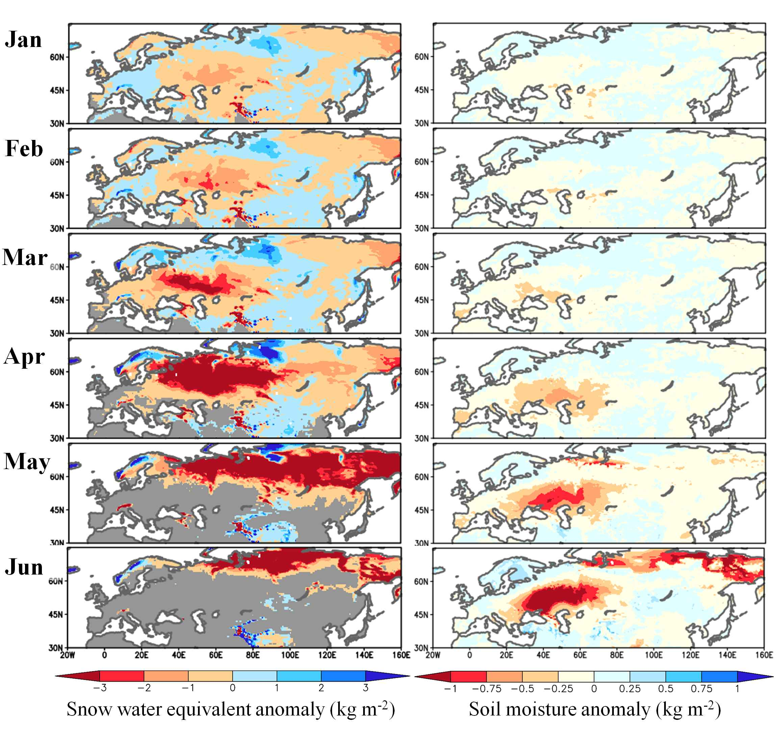

Supplementary Figure 1: Seasonal variations of snow water equivalent and soil moisture associated with external forcing.
Regression maps of snow water equivalent (Left) and surface soil moisture (Right) anomalies against normalised PC1 scores. The grey shading represents the area where climatological snow cover fraction is <0.1. Soil moisture at 0–10 cm depth is presented.

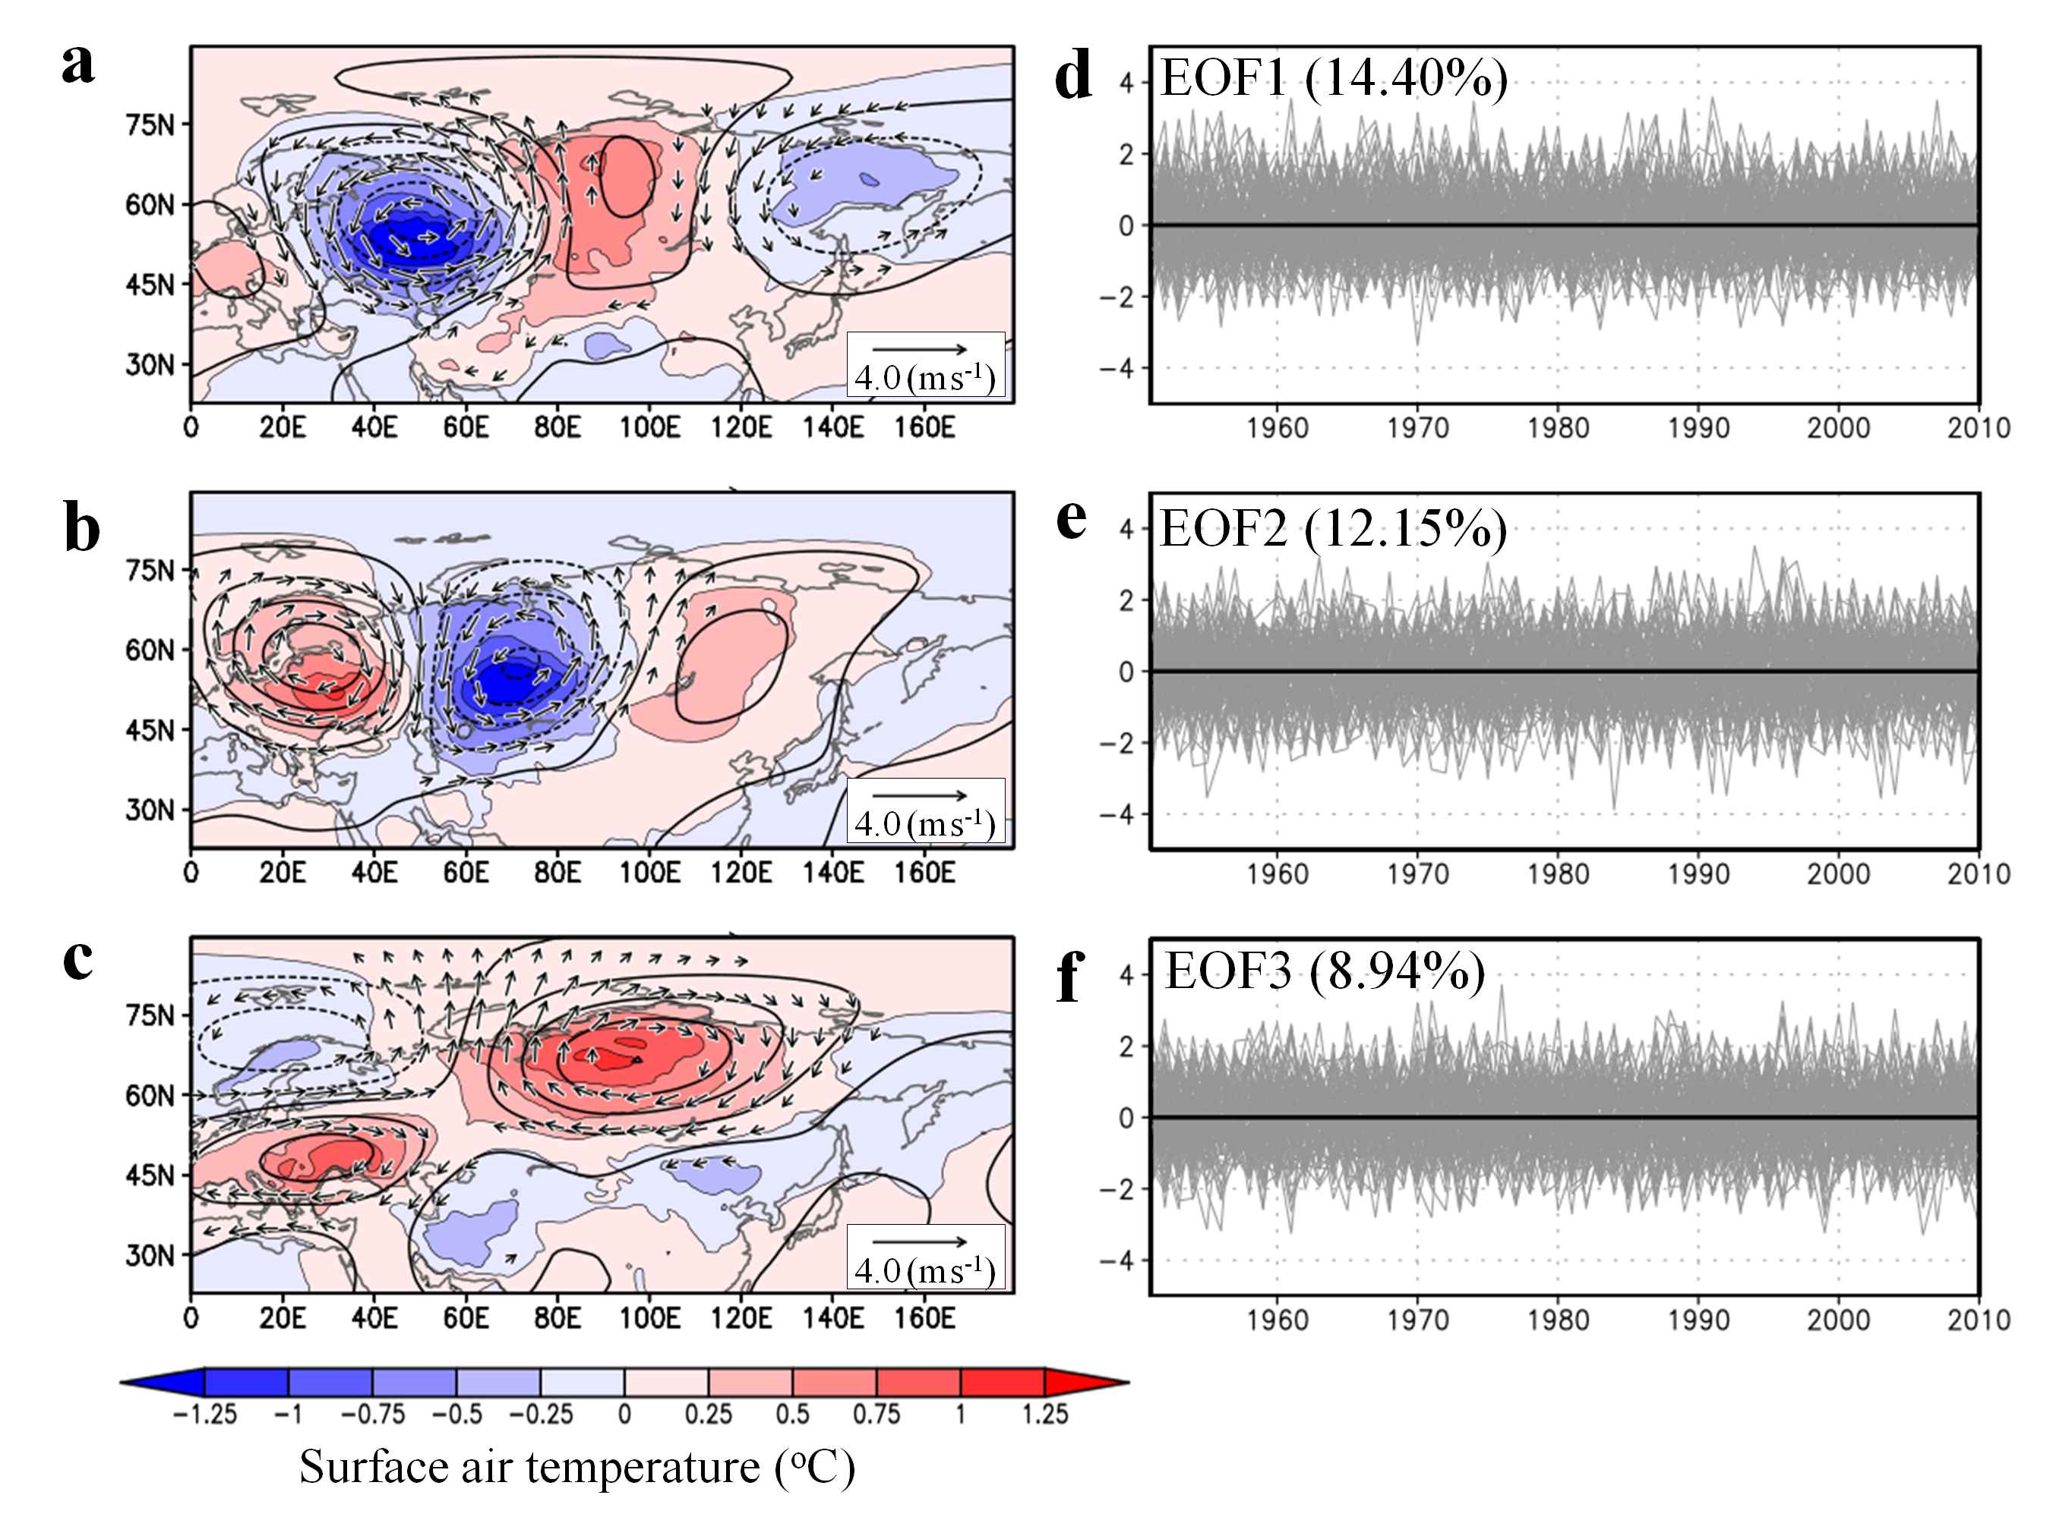

Supplementary Figure 2: Simulated three leading modes of summer SAT anomalies in d4PDF and their time series associated with internal variability.
The panels are the same as Fig. 2 but are for the EOF analysis conducted for JJA-averaged SAT anomalies with respect to the ensemble average.

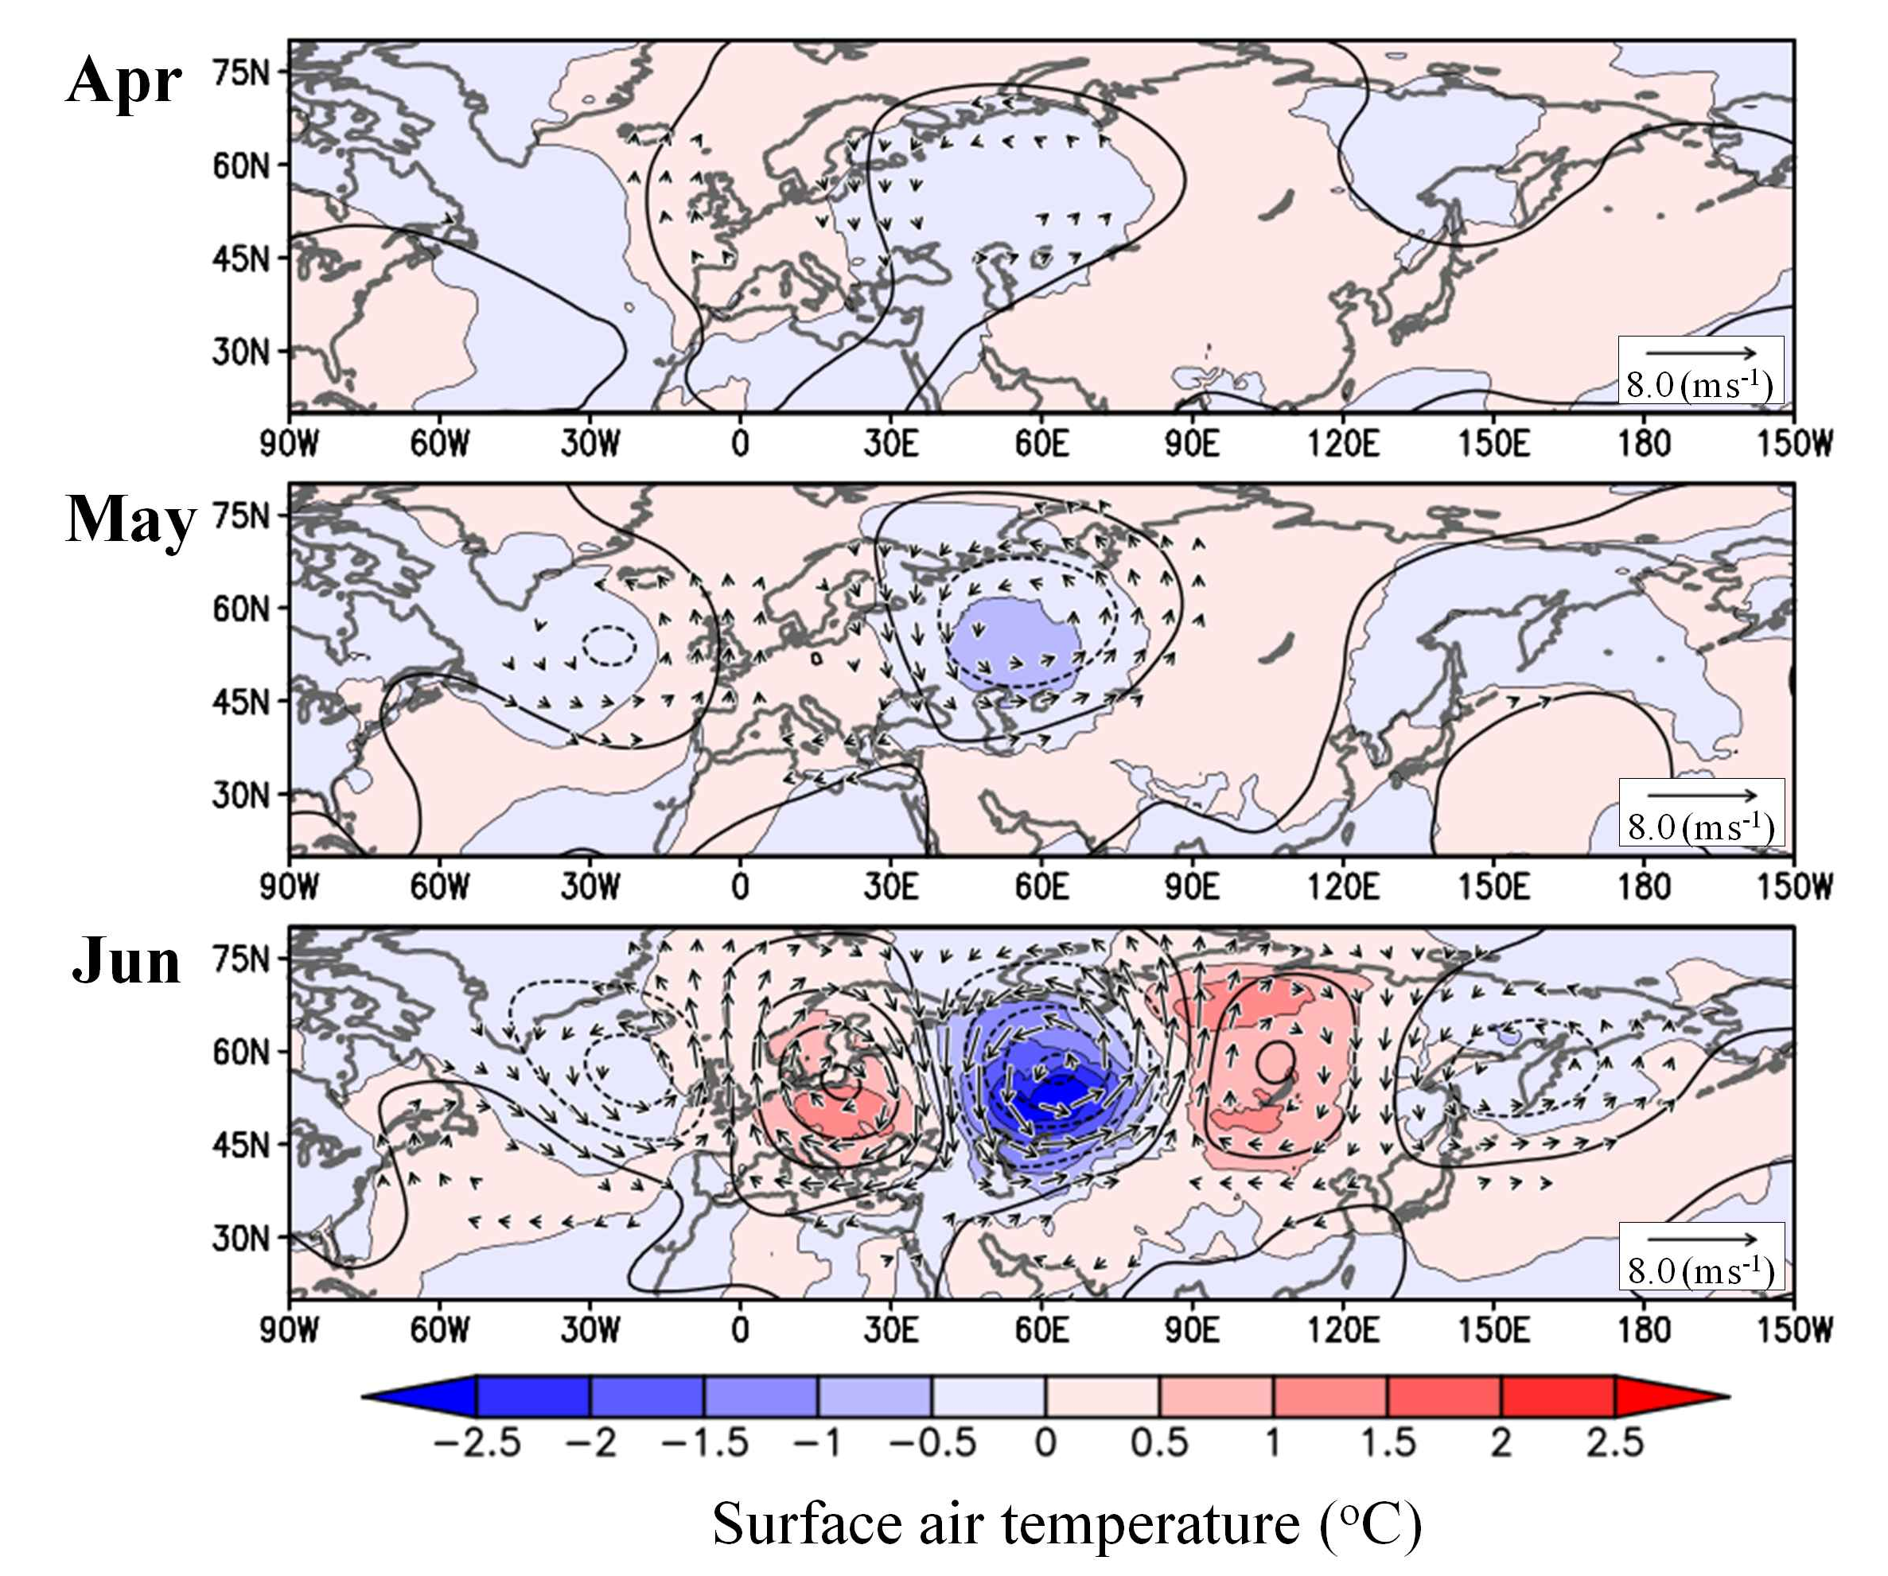

Supplementary Figure 3: Monthly variations in atmospheric circulation associated with internal forcing.
The panels are the same as in Fig. 5 but for SAT (shading), 500 hPa geopotential height anomalies (contour: 10 m interval), and wind vectors (wind speeds <0.5 m s⁻¹ omitted) derived from d4PDF.

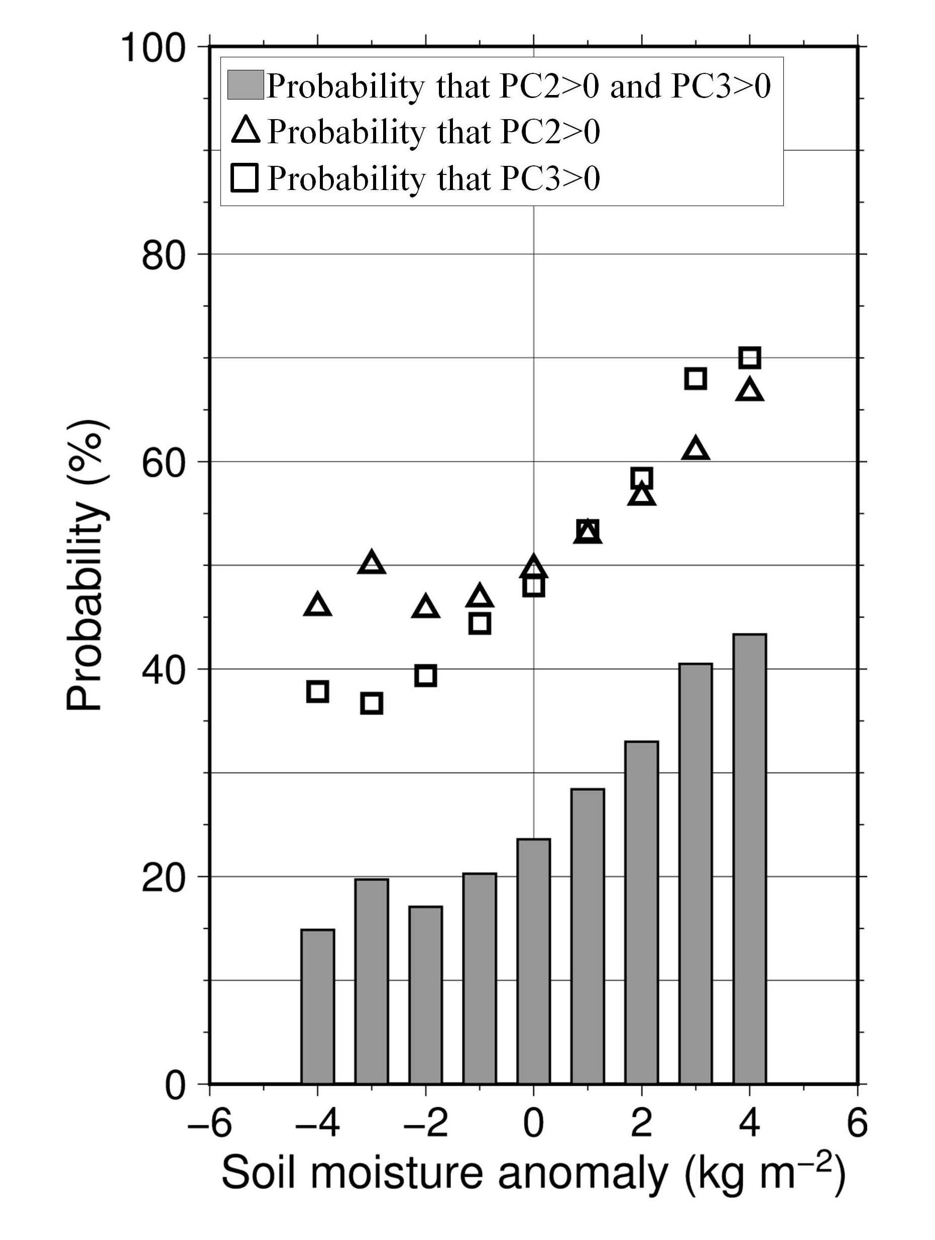

Supplementary Figure 4: Probability of leading mode resonance affected by spring soil moisture.
The explanation is the same as in Fig. 6 but for the probability that both PC2 and PC3 are positive (bars) and the probability that PC2 (triangles) and PC3 (squares) are positive.

