Title page

A Statistical Test for Differential Network Analysis Based on Inference of Gaussian Graphical Model
Authors
Hao He¹, Shaolong Cao^{1,2}, Ji-gang Zhang¹, Hui Shen¹, Yu-Ping Wang^{1,2}, Hong-wen Deng^{1*}

Affiliations
¹Center for Bioinformatics and Genomics, Department of Global Biostatistics and Data Science, Tulane University School of Public Health and Tropical Medicine, New Orleans, LA 70112, USA
²Department of Biomedical Engineering, Tulane University, New Orleans, LA, 70118, USA

*Corresponding author
Hong-Wen Deng, Ph.D.
Professor, Center for Bioinformatics and Genomics,
Department of Global Biostatistics and Data Science,
School of Public Health and Tropical Medicine, Tulane University,
1440 Canal St., Suite 2001, New Orleans, LA 70112, USA,
Email: hdeng2@tulane.edu
Supplementary Table 1. The result of function analysis for the differential network
Name | #Gene | PValue
Metabolic reprogramming in colon cancer | 11 | 0.00459
Photodynamic therapy-induced HIF-1 survival signaling | 9 | 0.0195
Pancreatic adenocarcinoma pathway | 17 | 0.0196
EPO Receptor Signaling | 7 | 0.0223
Apoptosis | 16 | 0.0239
ATM Signaling Network in Development and Disease | 10 | 0.0261
PDGFR-beta pathway | 7 | 0.0394
Target Of Rapamycin (TOR) Signaling | 8 | 0.0454
4-hydroxytamoxifen, Dexamethasone, and Retinoic Acids Regulation of p27 Expression | 5 | 0.0454
Endometrial cancer | 12 | 0.0476

Supplementary Table 2. The result of function analysis for the clusters from DiffCoEx
Module name | Term | #Gene | Pvalue
darkgrey | Oxidative phosphorylation | 27 | 4.06E-14
grey | Lysosome | 52 | 5.72E-11
blue | Ribosome | 48 | 9.36E-11
magenta | Pertussis | 8 | 1.22E-08
orange | Ribosome | 13 | 2.39E-07
red | Focal adhesion | 8 | 9.48E-05
yellow | Metabolic pathways | 12 | 0.000133
darkorange | Pathogenic Escherichia coli infection | 5 | 0.000157
white | TNF signaling pathway | 3 | 0.00059
saddlebrown | RNA degradation | 2 | 0.004825
steelblue | Ubiquitin mediated proteolysis | 2 | 0.011649
darkgreen | RNA degradation | 2 | 0.01193
royalblue | Pyrimidine metabolism | 2 | 0.022379

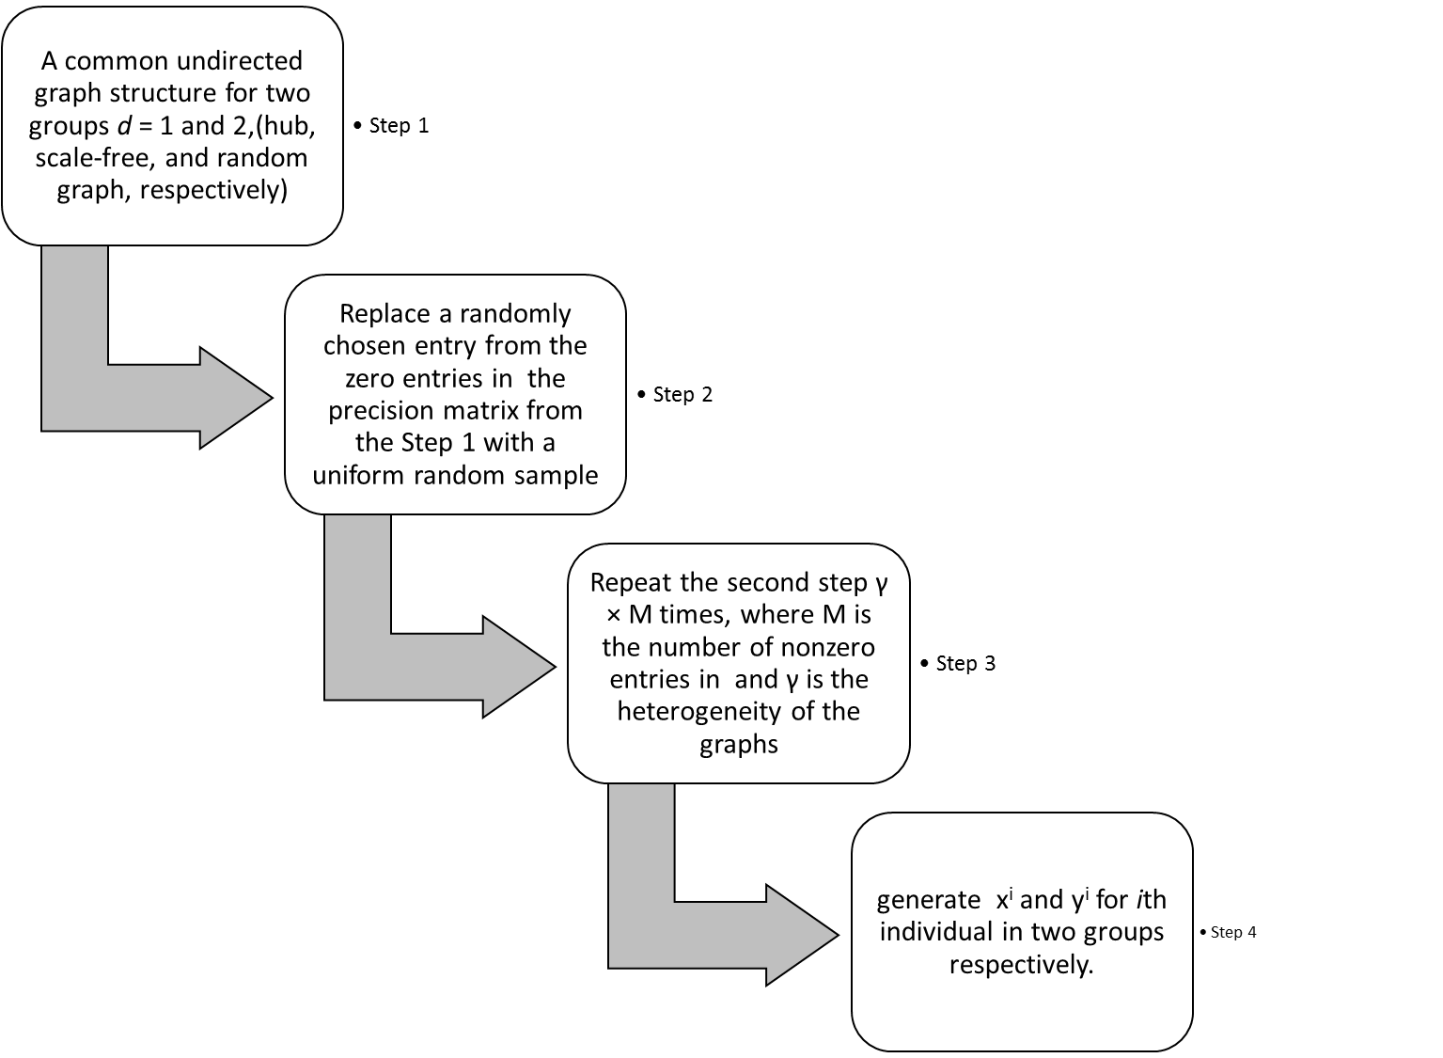
Supplementary Fig S1. A workflow of simulation steps.

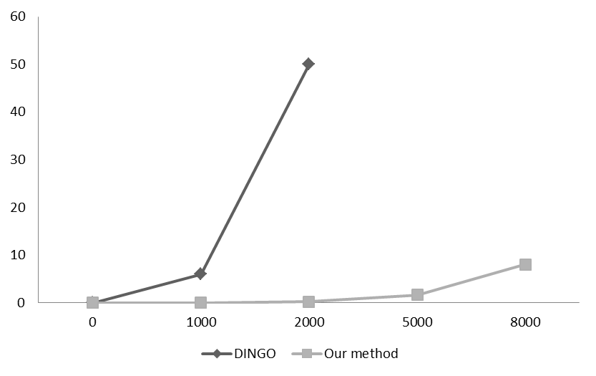
p
Hours

Supplementary Fig S2. Comparison of computational time.

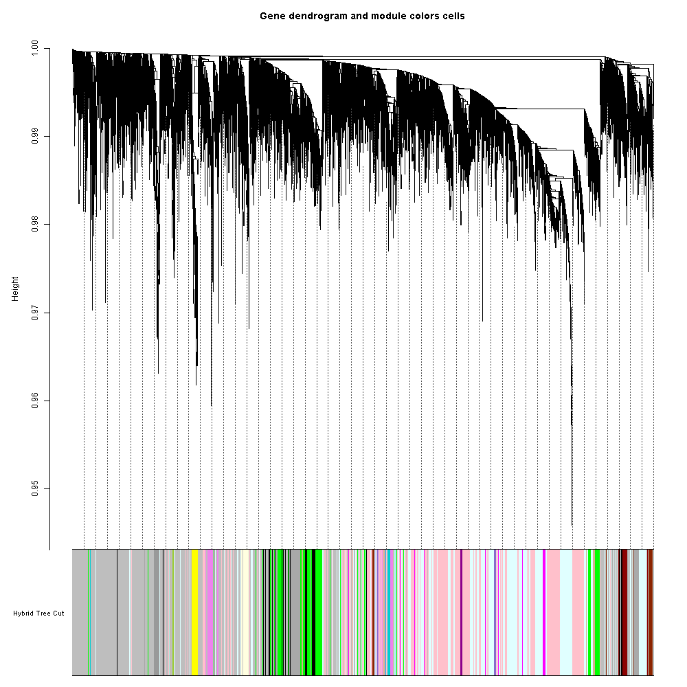

Supplementary Fig S3. Clustering dendrogram and module assignment by DiffCoEx. Topological overlap dissimilarity measure is clustered by average linkage hierarchical clustering and module assignments (dynamic hybrid algorithm) are denoted in the color bar (bottom). 7827 genes were assigned to 19 modules.

