The potential role of scavengers in spreading African swine fever among wild boar

Carolina Probst^{1*}, Jörn Gethmann¹, Susanne Amler¹, Anja Globig¹, Bent Knoll², Franz J. Conraths¹

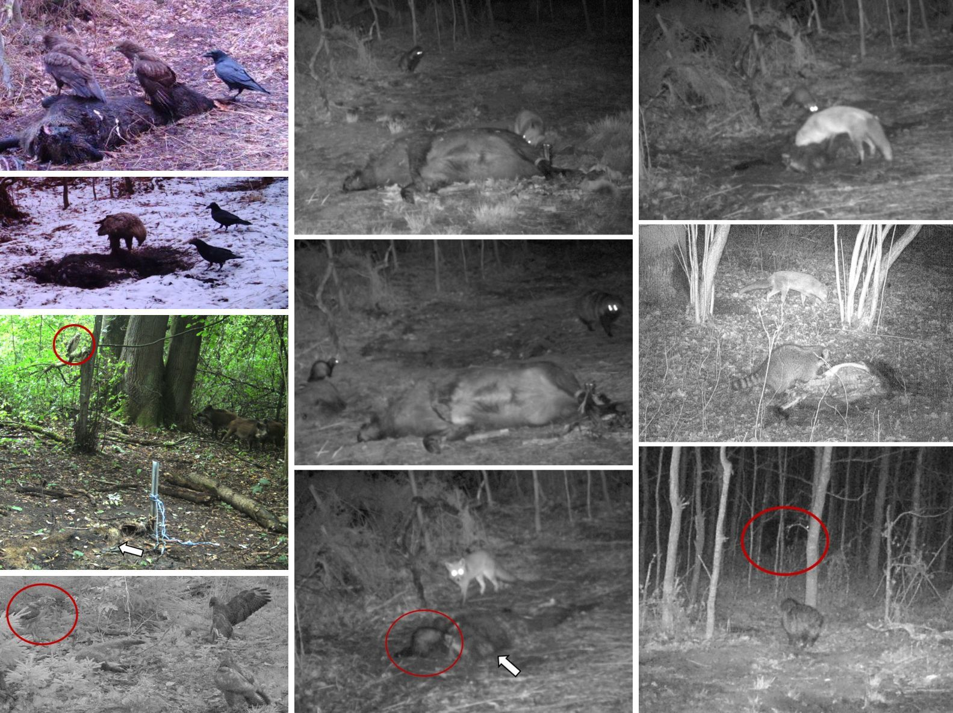
Supplementary Figure S1: Mixed species encounters. Top to bottom, left to right. Two buzzards and one raven; Two raven and one white-tailed eagle; One buzzard (red circle) and three wild boar (arrow marks the location of the carcass); Two buzzards and one hawk (red circle); Red fox scavenging, while raccoon dog is watching; Raccoon dog and polecat; Red fox arrives at carcass site while marten (red circle) is scavenging; Marten arrives at carcass site while red fox is scavenging; Red fox and raccoon; Raccoon dog stops scavenging when wild boar (red circle) arrive.

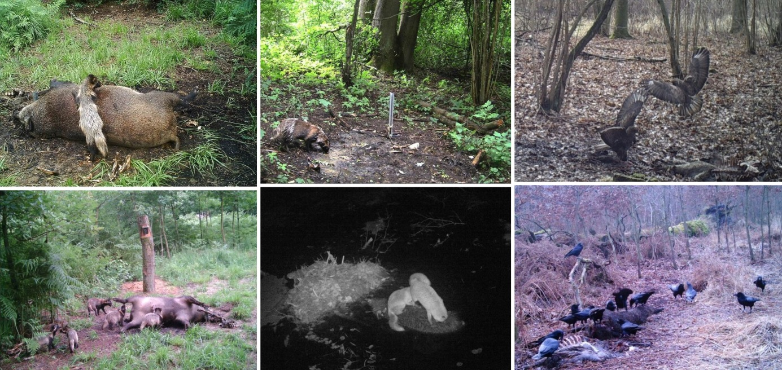
Supplementary Figure S2: Scavenging and fighting at the carcass sites. Top to bottom, left to right. Raccoon dog exploring fresh carcass 24 a few hours after exposure (note the round swollen body); Raccoon dog visiting the carcass with offspring one day later; Raccoon dog sniffing on the decomposition island of carcass 20 (note the lack of vegetation as an effect of the body fluids); Two foxes scavenging on carcass 1; Buzzards fighting at carcass 9; Group of 14 ravens at carcass 3.

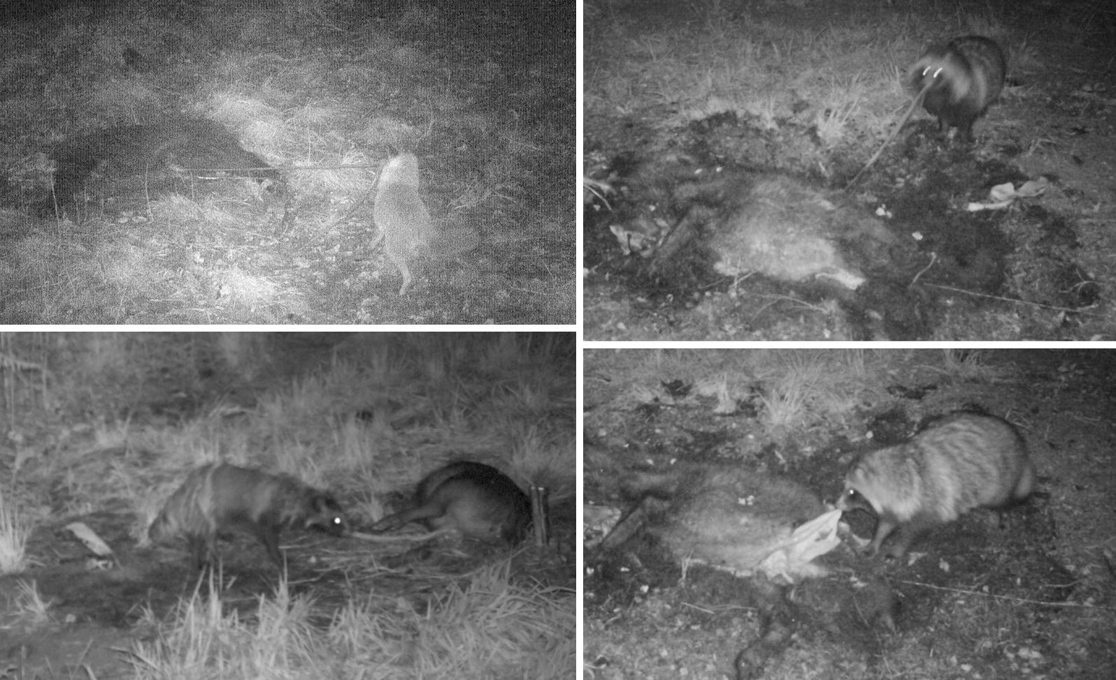
Supplementary Figure S3: Tearing out intestines. Top to bottom, left to right. Fox and raccoon dogs tearing out the intestines from the abdomen of carcasses.

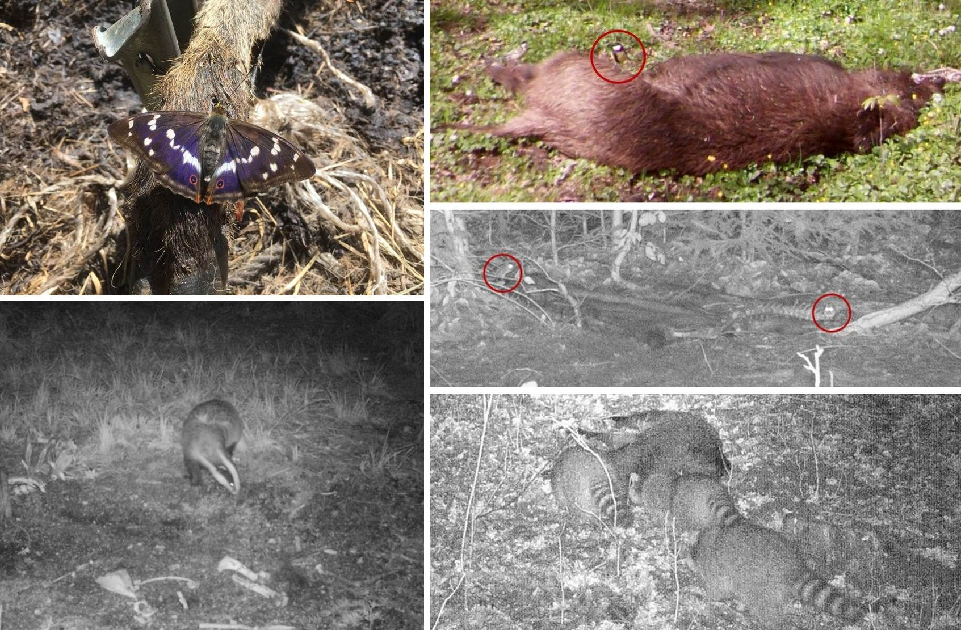
Supplementary Figure S4: Other animals approaching the carcasses. Top to bottom, left to right. Purple emperor on the leg of carcass 23; Badger on the decomposition island of carcass 24 (carcass fluids have killed the surrounding vegetation); Great tit (red circle) on carcass 15; Two water voles (red circles) on carcasses 6 and 7 (some bones and pieces of tissue are still attached to the skin of the piglets); Three raccoons at carcass 9.

Supplementary Table S5: List of R packages and functions used for the analyses.
Package | Version | Function used | Description
AER | 1.2-6 | dispersiontest | Dispersion Test. Tests the null hypothesis of equidispersion in Poisson GLMs against the alternative of over- and/or underdispersion
lme4 | 1.1-20 | fixef | Extract fixed-effects estimates
lme4 | 1.1-20 | glmer | Fitting Generalized Linear Mixed-Effects Models
lme4 | 1.1-20 | glmer.nb | Fitting Negative Binomial GLMMs
lme4 | 1.1-20 | ranef | Extract the modes of the random effects
lmtest | 0.9-36 | lrtest | Likelihood Ratio Test of Nested Models
MASS | 7.3-51.1 | glm.nb | Fit a Negative Binomial Generalized Linear Model
MASS | 7.3-51.1 | stepAIC | Choose a model by AIC in a Stepwise Algorithm
MuMIn | 1.42.1 | model.sel | Model selection table
stats | 3.5.1 | binom.test | Exact Binomial Test
stats | 3.5.1 | fisher.test | Fisher's Exact Test for Count Data
stats | 3.5.1 | glm | Fitting Generalized Linear Models
stats | 3.5.1 | kruskal.test | Kruskal-Wallis Rank Sum Test
stats | 3.5.1 | logLik | Extract Log-Likelihood
stats | 3.5.1 | wilcox.test | Wilcoxon Rank Sum and Signed Rank Tests
survival | 2.43-3 | coxph | Fit Proportional Hazards Regression Model
survival | 2.43-3 | survdiff | Test Survival Curve Differences

