Supplementary Material
Low-temperature catalyst based Hydrothermal liquefaction of harmful Macroalgal blooms, and aqueous phase nutrient recycling by microalgae

Vinod Kumar*¹, Sanjay Kumar², P K Chauhan³, Monu Verma⁴, Vivekanand Bahuguna⁵, Harish Chandra Joshi¹, Waseem Ahmad¹, Poonam Negi¹, Nishesh Sharma⁵, Bharti Ramola¹, Indra Rautela⁵, Manisha Nanda*⁶, Mikhail S. Vlaskin⁷
¹Deptt. of Chemistry, Uttaranchal University, Dehradun-248007,India
²Deptt. of Life Sciences, Food Science, Graphic Era Deemed to be University, Dehradun-248001, India
³ Faculty of Applied Sciences and Biotechnology, Shoolini University, Solan, HP, India
⁴Deptt. of Chemistry, Amity University, Gurgaon, Haryana, India
⁵Deptt. of Biotechnology, Uttaranchal University, Dehradun-248007, India
⁶Deptt. of Biotechnology, Dolphin (PG) Institute of Biomedical and Natural Sciences, Dehradun-248007, India
⁷Joint Institute for High Temperatures, 13/2 Izhorskaya St, Moscow, 125412, Russia

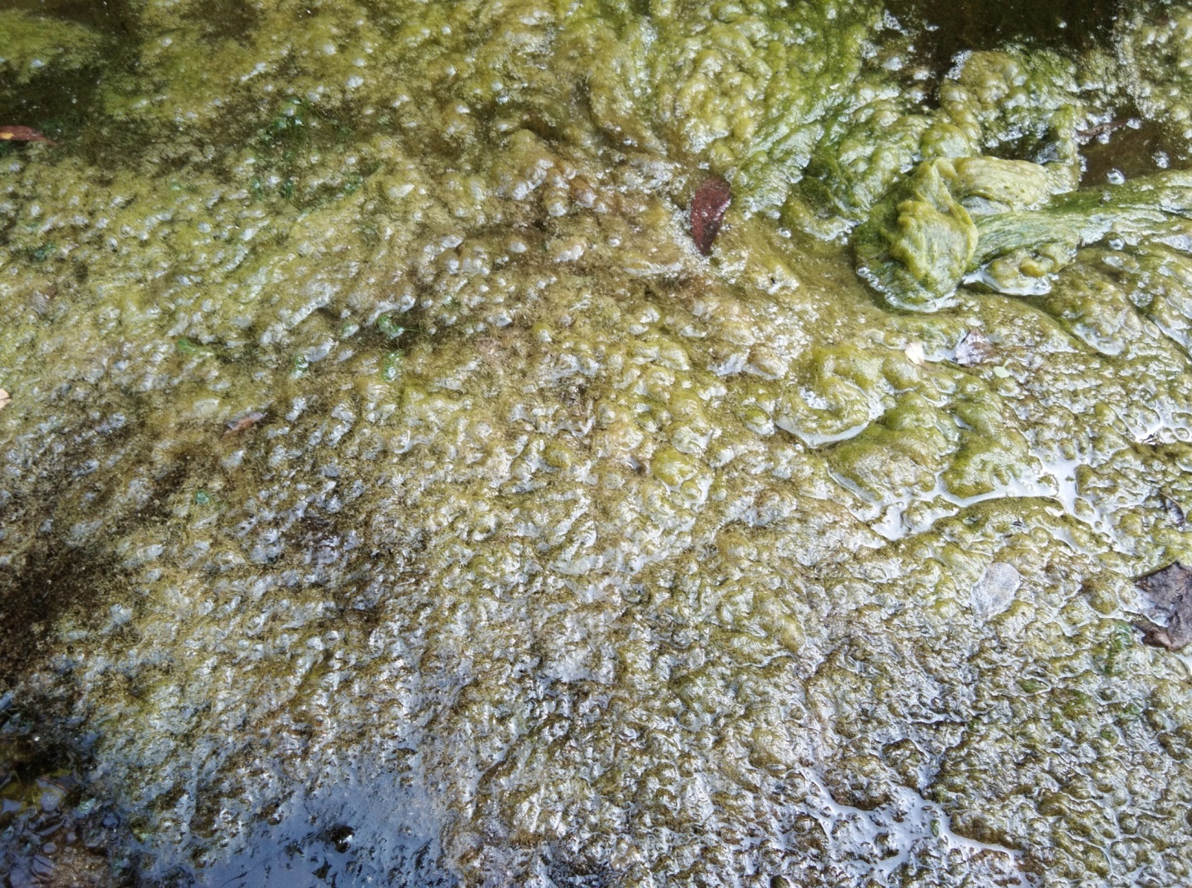
S Fig1: Harmful macroalgal blooms mat in fresh water pond.
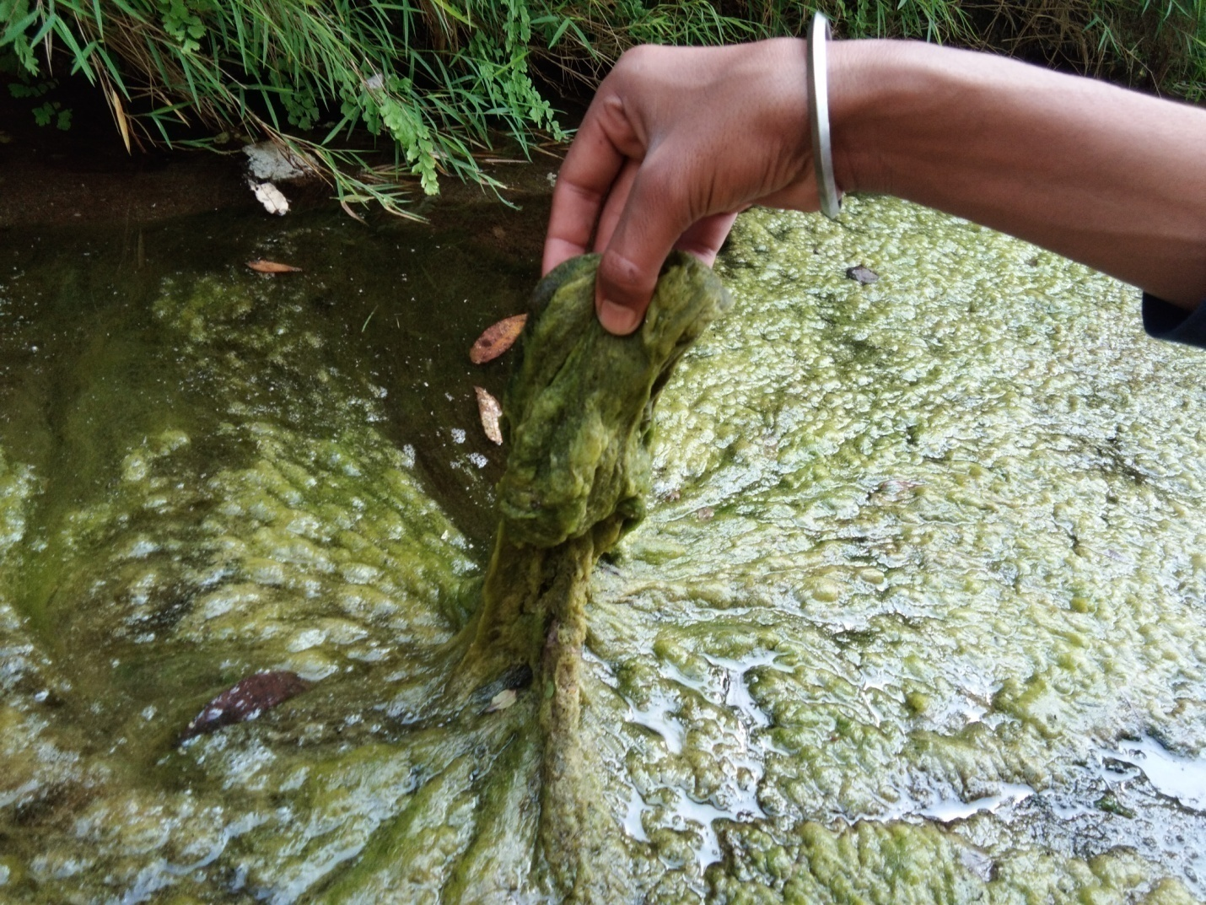

S Fig 2: Collection of Harmful macroalgal blooms

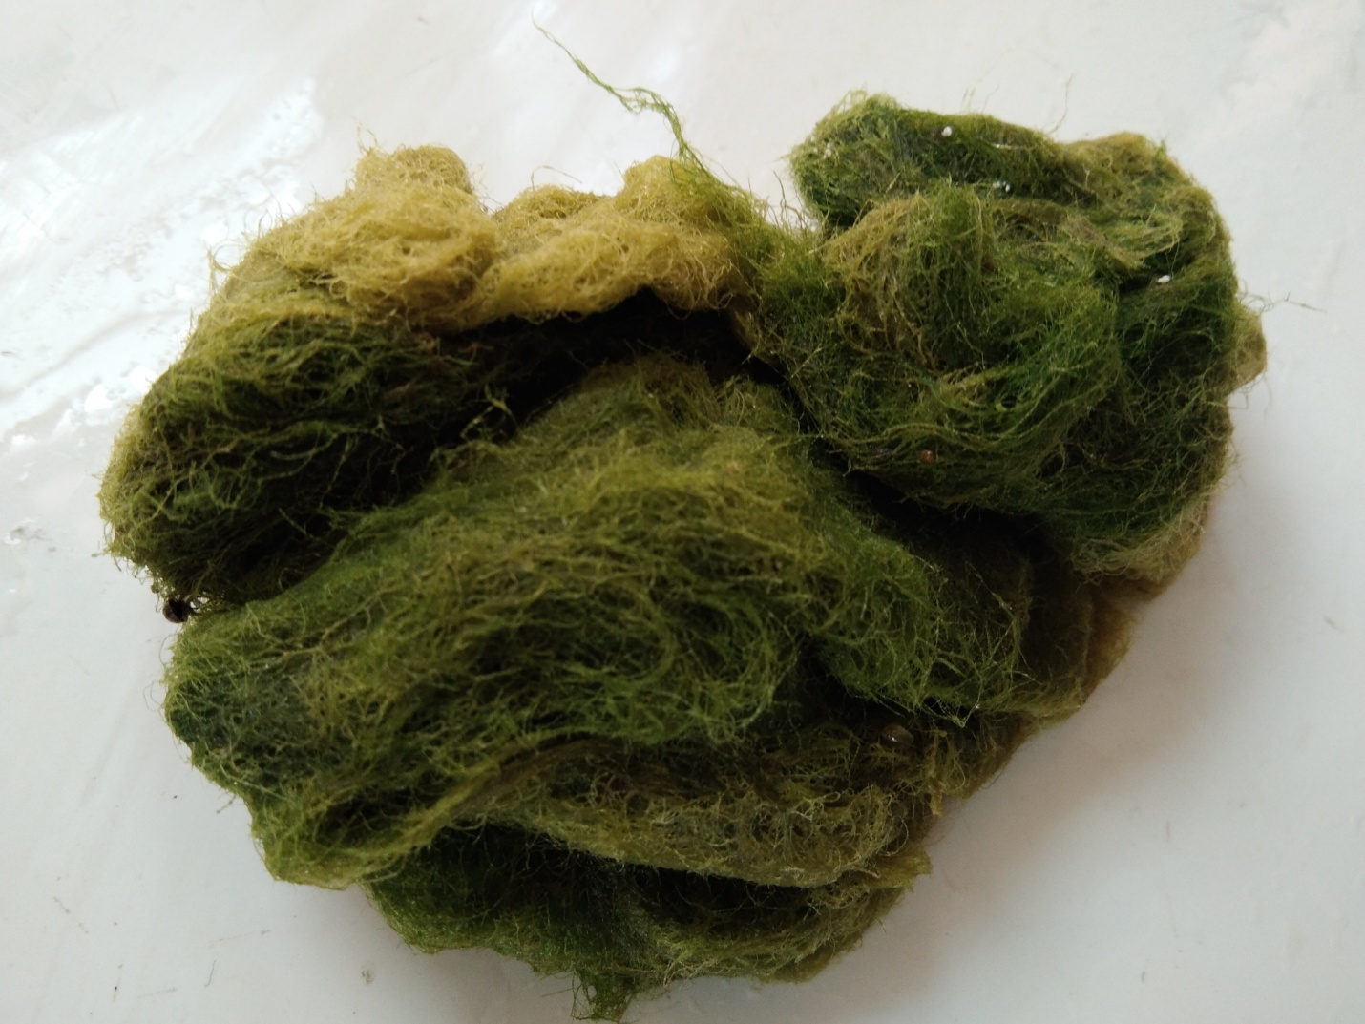.

S Fig 3: Harmful macroalgal blooms

S Fig 4: FTIR spectrum of harmful macroalgal blooms.

