Enrichment technique to allow early detection and monitor emergence of KRAS mutation in response to treatment

Yoshiyasu Kitagawa^{1,2}, Kazuhiro Okumura²; Takayoshi Watanabe², Kei Tsukamoto³, Shiro Kitano³, Rino Nankinzan¹, Takuto Suzuki¹, Taro Hara⁴; Hiroaki Souda⁵, Tadamichi Denda⁶, Taketo Yamaguchi⁶, Hiroki Nagase²

Corresponding author: Hiroki Nagase, MD, PhD
Division of Cancer Genomics, Chiba Cancer Center, 666-2 Nitonacho, Chuo-ku, Chiba, Japan
Phone: 043-264-5431, Fax: 043-262-8680, Email: hnagase@chiba-cc.jp

¹Endoscopy Division, Chiba Cancer Center, Chiba, Japan; ²Division of Cancer Genomics, Chiba Cancer Center, Chiba, Japan; ³TOPPAN PRINTING CO., LTD., Technical Research Institute, Saitama, Japan; ⁴Hara Clinic, Chiba, Japan; ⁵Division of Gastroenterological Surgery, Chiba Cancer Center, Chiba, Japan; ⁶Department of Gastroenterology, Chiba Cancer Center, Chiba, Japan

SUPPLEMENTARY INFORMATION
Supplementary Table. 1–2, with legends
Supplementary Fig. S1–S3, with legends

SUPPLEMENTARY INFORMATION
SUPPLEMENTARY TABLES

Table S1 Additional experiments to evaluate the limit of enrichment assay using plasmid DNA.

Status | G12D * | G12C *
Number of experiments | 10 | 20
Mean folds of enrichment assay | 397.0 | 909.1
Maximum folds of enrichment assay | 769.1 | 10000.0

* Each plasmid DNA containing KRAS mutations (G12C and G12D) was mixed with wild-type DNA, and titration samples (fraction of mutant alleles: 0.01%) were prepared.
** The fold enrichment was calculated from the ddPCR results, and defined as the fractional abundance of the assay divided by that of the titration samples.

Table S2 Digital PCR analysis of ctDNA samples before and after enrichment assay.

 |  |  |  |  |  |  |  | Before enrichment assay |  | After enrichment assay
Case | Sex | Age, years | Primary site | Stage | CEA, | Concentration, | KRAS status, | Mutant (Copies/μL) | FA (%) | Mutant (Copies/μL) | FA (%)
 |  |  |  |  | < 5.0 ng/mL | ng/mL of serum | primary | Wild (Copies/μL) | FA (%) | Wild (Copies/μL) | FA (%)
1 | M | 71 | Rectum | Ⅰ | 3.4 | 60 | G12D | n.d. | – | 13.9 | 81.8
 |  |  |  |  |  |  |  | 1.6 | – | 3.1 | 81.8
2 | F | 82 | A-colon | Ⅰ | 2.5 | < 20 | G12V | n.d. | – | 5.9 | 79.7
 |  |  |  |  |  |  |  | 1.5 | – | 1.5 | 79.7
3 | M | 73 | Rectum | Ⅱ | 10 | < 20 | G12V | 1.7 | 48.6 | 5.2 | 78.8
 |  |  |  |  |  |  |  | 1.8 | 48.6 | 1.4 | 78.8
4 | M | 71 | Cecum | Ⅱ | 4.8 | < 20 | G12V | n.d. | – | n.d. | –
 |  |  |  |  |  |  |  | 1.2 | – | n.d. | –
5 | M | 79 | A-colon | Ⅲ | 6.3 | < 20 | G12D | n.d. | – | 20.1 | 61.8
 |  |  |  |  |  |  |  | 1.6 | – | 12.4 | 61.8
6 | M | 45 | Rectum | Ⅲ | 22.5 | 60 | G12D | n.d. | – | 8.6 | 70.5
 |  |  |  |  |  |  |  | 5.5 | – | 3.6 | 70.5
7 | F | 72 | Cecum | Ⅲ | 40.2 | < 20 | G12D | n.d. | – | 4.1 | 75.9
 |  |  |  |  |  |  |  | 4.5 | – | 1.3 | 75.9
8 | M | 49 | S-colon | Ⅲ | 12.5 | < 20 | G12D | n.d. | – | 3 | 63.8
 |  |  |  |  |  |  |  | 1.2 | – | 1.7 | 63.8
9 | M | 65 | S-colon | Ⅲ | 18.5 | 122 | G12V | n.d. | – | 5.5 | 68.8
 |  |  |  |  |  |  |  | 9.3 | – | 2.5 | 68.8
10 | F | 74 | Cecum | Ⅳ | 12.4 | 199 | G12D | n.d. | – | 1.9 | 37.3
 |  |  |  |  |  |  |  | 5 | – | 3.2 | 37.3
11 | F | 77 | S-colon | Ⅳ | 101.5 | 120 | G12D | 1.9 | 21.1 | 3 | 40.5
 |  |  |  |  |  |  |  | 7.1 | 21.1 | 4.4 | 40.5
12 | F | 49 | Rectum | Ⅳ | 24.5 | 343 | G12D | 9 | 22.6 | 7 | 42.4
 |  |  |  |  |  |  |  | 30.9 | 22.6 | 9.5 | 42.4
13 | F | 68 | A-colon | Ⅳ | 329.5 | 231 | G12V | 7.1 | 26.3 | 5.1 | 34.7
 |  |  |  |  |  |  |  | 19.9 | 26.3 | 9.6 | 34.7
14 | M | 61 | D-colon | Ⅳ | 203 | 1040 | G12D | 48 | 33.6 | 7 | 34.1
 |  |  |  |  |  |  |  | 95 | 33.6 | 13.5 | 34.1
15 | F | 56 | S-colon | Ⅳ | 717 | 1690 | G12V | 7.9 | 0.6 | 3.9 | 1.5
 |  |  |  |  |  |  |  | 1240 | 0.6 | 250 | 1.5
16 | M | 74 | A-colon | Ⅳ | 498.4 | 3660 | G12D | 42 | 38.4 | 12.5 | 43.1
 |  |  |  |  |  |  |  | 67.4 | 38.4 | 16.5 | 43.1
17 | F | 47 | S-colon | Ⅳ | 10.9 | 100 | G12D | n.d. | – | 1.4 | 31.8
 |  |  |  |  |  |  |  | 11 | – | 3.1 | 31.8
18 | M | 68 | S-colon | Ⅱ | 21.2 | < 20 | WT | n.d. | – | n.d. | –
 |  |  |  |  |  |  |  | 1 | – | n.d. | –
19 | F | 65 | S-colon | Ⅱ | 10.6 | 60 | WT | n.d. | – | n.d. | –
 |  |  |  |  |  |  |  | 7.2 | – | 2.8 | –
20 | M | 60 | Rectum | Ⅲ | 4.6 | < 20 | WT | n.d. | – | n.d. | –
 |  |  |  |  |  |  |  | 2.1 | – | n.d. | –
21 | M | 57 | S-colon | Ⅲ | 2.5 | 110 | WT | n.d. | – | n.d. | –
 |  |  |  |  |  |  |  | 10.9 | – | 4.5 | –
22 | M | 75 | Rectum | Ⅲ | 80.4 | < 20 | WT | n.d. | – | n.d. | –
 |  |  |  |  |  |  |  | 1 | – | 1 | –
23 | M | 60 | S-colon | Ⅲ | 46.4 | < 20 | WT | n.d. | – | n.d. | –
 |  |  |  |  |  |  |  | 1.6 | – | n.d. | –
24 | M | 58 | Rectum | Ⅲ | 55.8 | 67 | WT | n.d. | – | n.d. | –
 |  |  |  |  |  |  |  | 5.3 | – | 3.8 | –
25 | M | 46 | Rectum | Ⅲ | 4.5 | 54 | WT | n.d. | – | n.d. | –
 |  |  |  |  |  |  |  | 4.3 | – | 4.3 | –
26 | M | 71 | A-colon | Ⅳ | 5 | 60 | WT | n.d. | – | n.d. | –
 |  |  |  |  |  |  |  | 3.4 | – | 2.5 | –
27 | M | 59 | Rectum | Ⅳ | 775 | 169 | WT | n.d. | – | n.d. | –
 |  |  |  |  |  |  |  | 19 | – | 6.5 | –
28 | M | 64 | S-colon | Ⅳ | 7.8 | < 20 | WT | n.d. | – | n.d. | –
 |  |  |  |  |  |  |  | 1.6 | – | 4.2 | –
29 | M | 72 | S-colon | Ⅳ | 183.8 | 1500 | WT | n.d. | – | n.d. | –
 |  |  |  |  |  |  |  | 263 | – | 43.6 | –
30 | F | 55 | S-colon | Ⅳ | 1.7 | < 20 | WT | n.d. | – | n.d. | –
 |  |  |  |  |  |  |  | 3.1 | – | n.d. | –
31 | M | 54 | S-colon | Ⅳ | 54.3 | 105 | WT | n.d. | – | n.d. | –
 |  |  |  |  |  |  |  | 12.2 | – | 4.3 | –
32 | M | 61 | S-colon | Ⅳ | 2.4 | 2170 | WT | n.d. | – | n.d. | –
 |  |  |  |  |  |  |  | 419 | – | 15.7 | –
33 | M | 39 | S-colon | Ⅳ | 647.8 | 1330 | WT | n.d. | – | n.d. | –
 |  |  |  |  |  |  |  | 194 | – | 5.6 | –
34 | F | 69 | T-colon | Ⅳ | 75.3 | 359 | WT | n.d. | – | n.d. | –
 |  |  |  |  |  |  |  | 40.5 | – | 7.2 | –
35 | M | 59 | S-colon | Ⅳ | 7317.9 | 1230 | WT | n.d. | – | n.d. | –
 |  |  |  |  |  |  |  | 80 | – | 7.4 | –
36 | M | 69 | S-colon | Ⅳ | 4.1 | 194 | WT | n.d. | – | n.d. | –
 |  |  |  |  |  |  |  | 21.1 | – | 4.8 | –
37 | M | 56 | T-colon | Ⅳ | 3690.1 | 476 | WT | n.d. | – | n.d. | –
 |  |  |  |  |  |  |  | 48.9 | – | 10.2 | –
38 | F | 64 | A-colon | Ⅳ | 616.7 | 634 | WT | n.d. | – | n.d. | –
 |  |  |  |  |  |  |  | 93 | – | 12.3 | –
39 | M | 61 | Rectum | Ⅳ | 60.7 | 454 | WT | n.d. | – | n.d. | –
 |  |  |  |  |  |  |  | 27.5 | – | 18 | –
40 | F | 75 | A-colon | Ⅳ | 2950 | 1630 | WT | n.d. | – | n.d. | –

Abbreviations used in Table S2: A-colon, ascending colon; S-colon, sigmoid colon; D-colon, descending colon; T-colon, transverse colon; CEA, carcinoembryonic antigen; WT, wild type; n.d., not detected; FA, fractional abundance.

SUPPLEMENTARY FIGURES
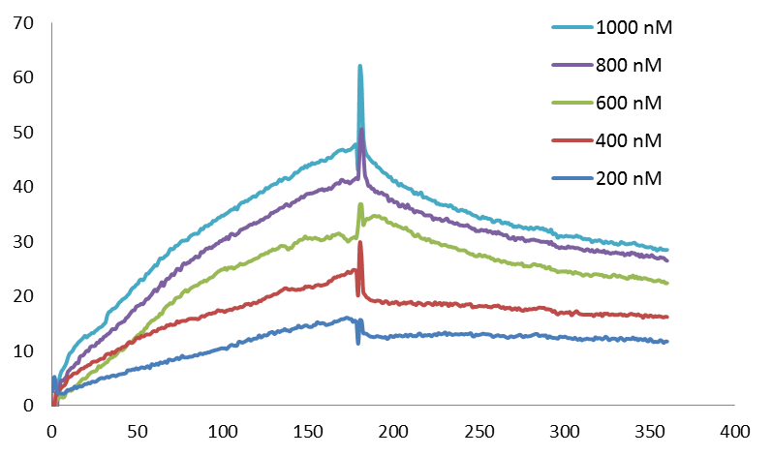
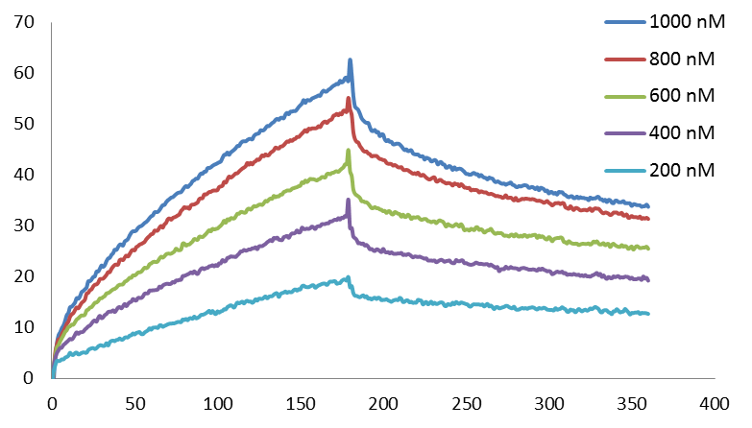
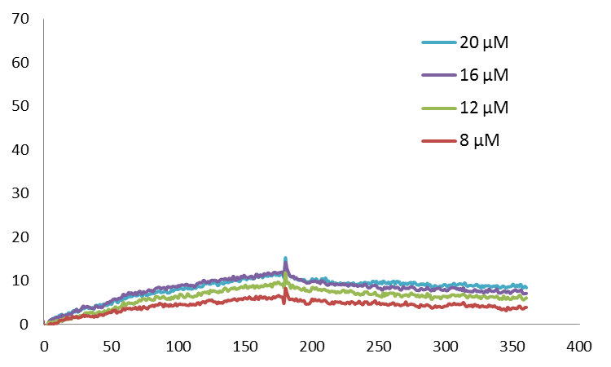
Time (s)
Time (s)
Time (s)
(a)
(b)
(c)
Response (RU)
Response (RU)
Response (RU)
Figure S1
Surface plasmon resonance sensorgrams for the interaction between KRAS 5 and hairpin DNAs containing the sequence (a) KRAS GAT mutation, (b) KRAS GTT mutation, and (c) KRAS GGT wild type immobilized on the surface of a sensor chip SA. In (a) and (b), each of the five curves of the lowest, mid–low, middle, mid–high, and highest indicates concentrations of 200, 400, 600, 800, and 1000 nM PI polyamides, respectively. In (c), each of the five curves, the lowest, mid–low, mid–high, and highest indicate concentrations of 8, 12, 16 and 20 μM PI polyamides, respectively.

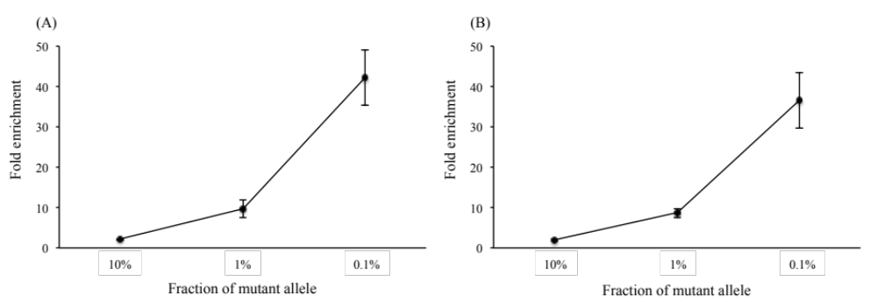

Figure S2 Relationship between fold of enrichment assay and fraction of mutant alleles (duplex analysis).
(A) Fold enrichment of KRAS5 for G12V alleles. (B) Fold enrichment of KRAS5 for G12D alleles.

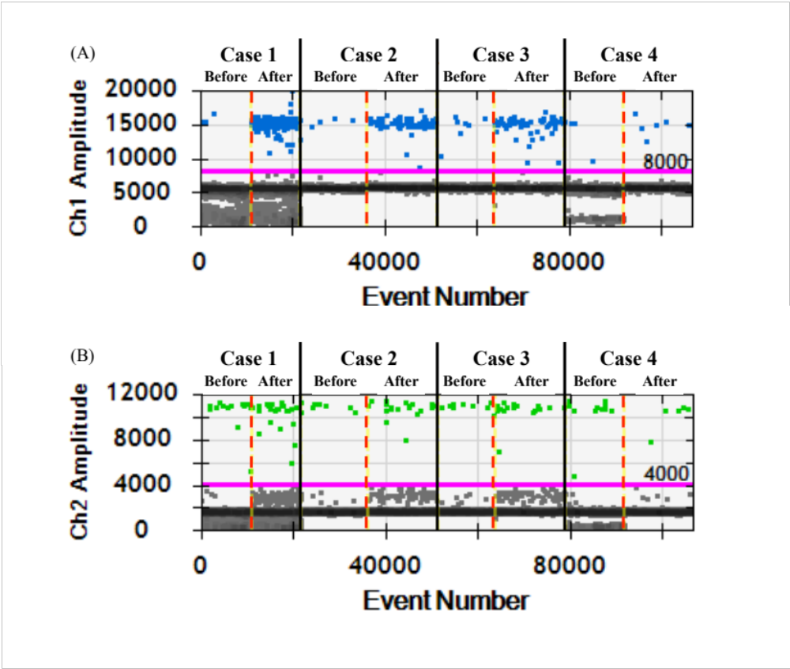
Figure S3-1 One-dimensional plots of digital PCR analysis before and after enrichment assay.
(A, FAM-positive) Blue dots represent droplets containing KRAS mutation. (B, HEX-positive) Green dots represent droplets containing wild type KRAS.

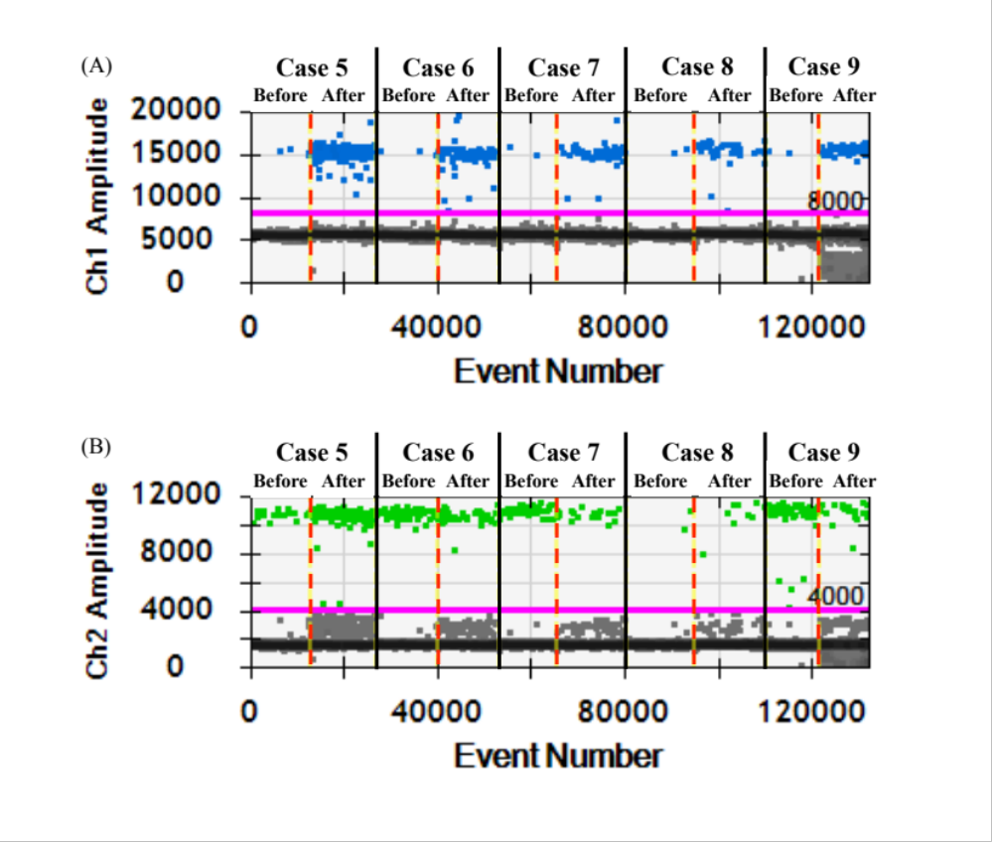
Figure S3-2 One-dimensional plots of digital PCR analysis before and after enrichment assay.
(A, FAM-positive) Blue dots represent droplets containing KRAS mutation. (B, HEX-positive) Green dots represent droplets containing wild type KRAS.

