Supplementary Online Content

Do population-level risk prediction models that use routinely collected health data reliably predict individual risks?
Scientific Reports XXX. Published online XXX
Doi: XXXX

eAppendix. Interpretation of appendix tables and figures.

eTable 1. Distribution across practices of the number of CVD cases, number of patients at risk and survival rate over 10 years

eFigure 1. Comparison of random effects model’s score and QRISK3 score
in the same group of patients (grouped by certain range (red lines) of QRISK3 score)

eFigure 2. Comparison of net benefit between QRISK3 and random effects model

eFigure 3-1. Calibration plot of QRISK3

eFigure 3-2. Calibration plot of random effects model

eFigure 4. Variation of QRISK3’s C-statistic among practices—a replication of Riley’s funnel plot

eAppendix. Interpretation of appendix tables and figures.

eTable 1 shows the distribution of number of CVD events, number of patients at risk and survival rate among practices at 10 years. The number of CVD events, number of patients at risk and survival rate of practices are generally decreasing along the 10 years. The number of CVD events and the number of patients at risk varied between 5~95% percentile practices. The survival rate of 5~95% practices has less variation. Practices which do not have survival rate in 10 years are because their longest follow-ups are less than 10 years.

eFigure 1 visualizes the inconsistencies between the risks predicted for the same group of individual patients by QRISK3 and the random effects model. Patients with a predicted QRISK3 risk between 9.5% ~ 10.5% were found to have a much larger range of risks in the random effects model (between about 6% ~15%)

eFigure 2 shows two models’ net benefit is about 3.1% at the threshold 10%, which means both of models predict about 3 true positive CVD events without adding new false positive CVD patients.

eFigure 3-1 and 3-2 show two models have similar calibration.

eFigure 4 is a replication of Riley’s ¹ funnel plot. The left panel shows that QRISK3 has variation of C-statistic among practices, and the right panel performed a formal meta-analysis to identify outlier practices (those red dots outside the 95% prediction interval). The figure shows that QRISK3 performs differently on different practices, which is consistent to Riley’s¹ finding on QRISK2.

References to online-only supplement
1. Riley, R. D. et al. External validation of clinical prediction models using big datasets from e-health records or IPD meta-analysis: opportunities and challenges. BMJ 353, i3140 (2016).

eTable 1. Distribution across practices of the number of CVD cases, number of patients at risk and survival rate over 10 years

 | Number of patients with CVD events  in practices (Percentile) |  |  |  | Number of patients at riskª  in practices (Percentile) |  |  |  | Life table estimate of proportion of  patients without CVD (Percentile)
Year | 5th | 25th | 75th | 95th | 5th | 25th | 75th | 95th | 5th | 25th | 75th | 95th
1 | 5.0 | 31.0 | 83.5 | 134.0 | 1789.0 | 4358.0 | 10247.5 | 14843.0 | 1.00 | 1.00 | 1.00 | 1.00
2 | 2.0 | 21.0 | 60.0 | 93.0 | 575.0 | 3019.3 | 7352.0 | 10560.0 | 0.99 | 0.99 | 0.99 | 1.00
3 | 0.0 | 14.0 | 49.0 | 76.0 | 85.5 | 2324.8 | 5763.3 | 8329.0 | 0.97 | 0.98 | 0.99 | 0.99
4 | 0.0 | 12.0 | 41.0 | 64.0 | 0.0 | 1821.3 | 4671.0 | 6707.5 | 0.95 | 0.97 | 0.98 | 0.99
5 | 0.0 | 10.5 | 34.0 | 54.0 | 0.0 | 1456.0 | 3893.0 | 5530.5 | NA^{b} | 0.96 | 0.98 | 0.98
6 | 0.0 | 9.0 | 29.5 | 48.0 | 0.0 | 1128.8 | 3225.0 | 4713.5 | NA | 0.95 | 0.97 | 0.98
7 | 0.0 | 7.0 | 26.0 | 42.0 | 0.0 | 839.0 | 2688.5 | 3995.5 | NA | 0.94 | 0.96 | 0.97
8 | 0.0 | 5.0 | 22.0 | 39.0 | 0.0 | 601.3 | 2208.0 | 3345.0 | NA | 0.93 | 0.95 | 0.97
9 | 0.0 | 4.0 | 18.0 | 32.0 | 0.0 | 420.0 | 1803.8 | 2788.0 | NA | 0.92 | 0.94 | 0.96
10 | 0.0 | 2.0 | 15.0 | 26.0 | 0.0 | 263.8 | 1426.8 | 2297.5 | NA | 0.91 | 0.93 | 0.95
a. Number of patients in the middle point of each year was used
b. NA is because practices have less than 10 years follow-up data

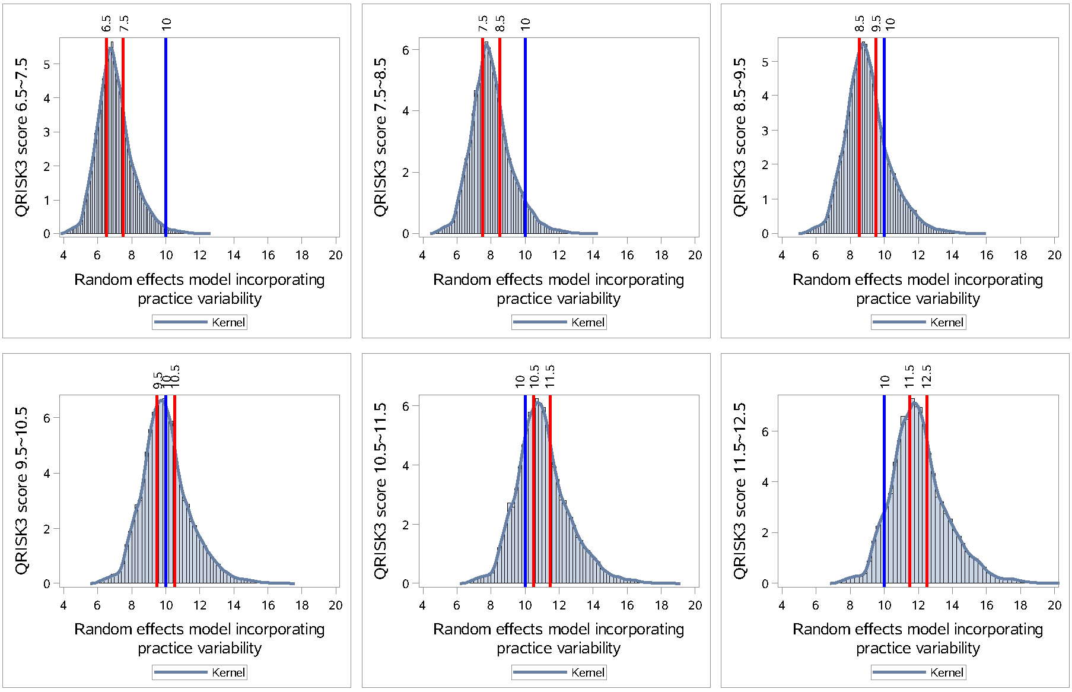
eFigure 1. Comparison of random effects model’s score and QRISK3 score
in the same group of patients (grouped by certain range (red lines) of QRISK3 score)

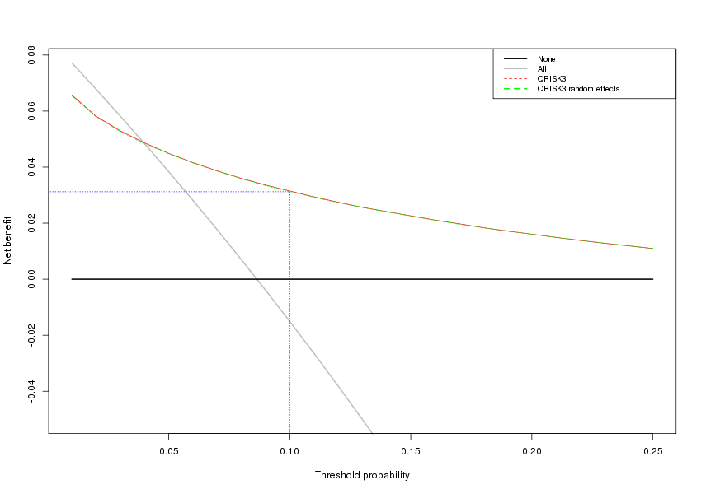
eFigure 2. Net benefit analysis on QRISK3 and random effects model

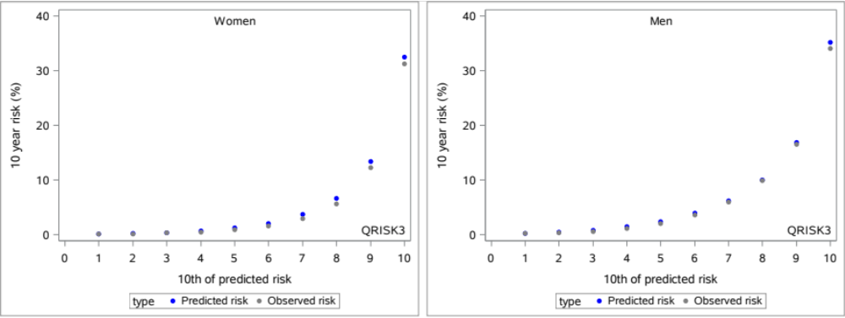
eFigure 3-1. Calibration plot of QRISK3

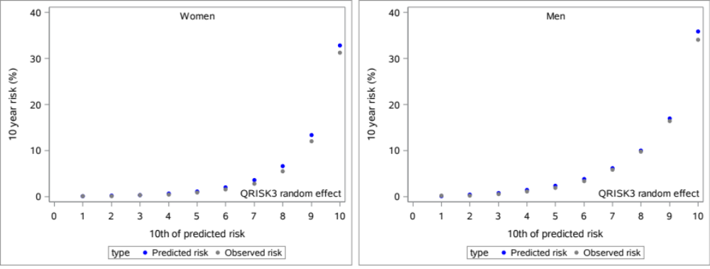

eFigure 3-2. Calibration plot of random effects model

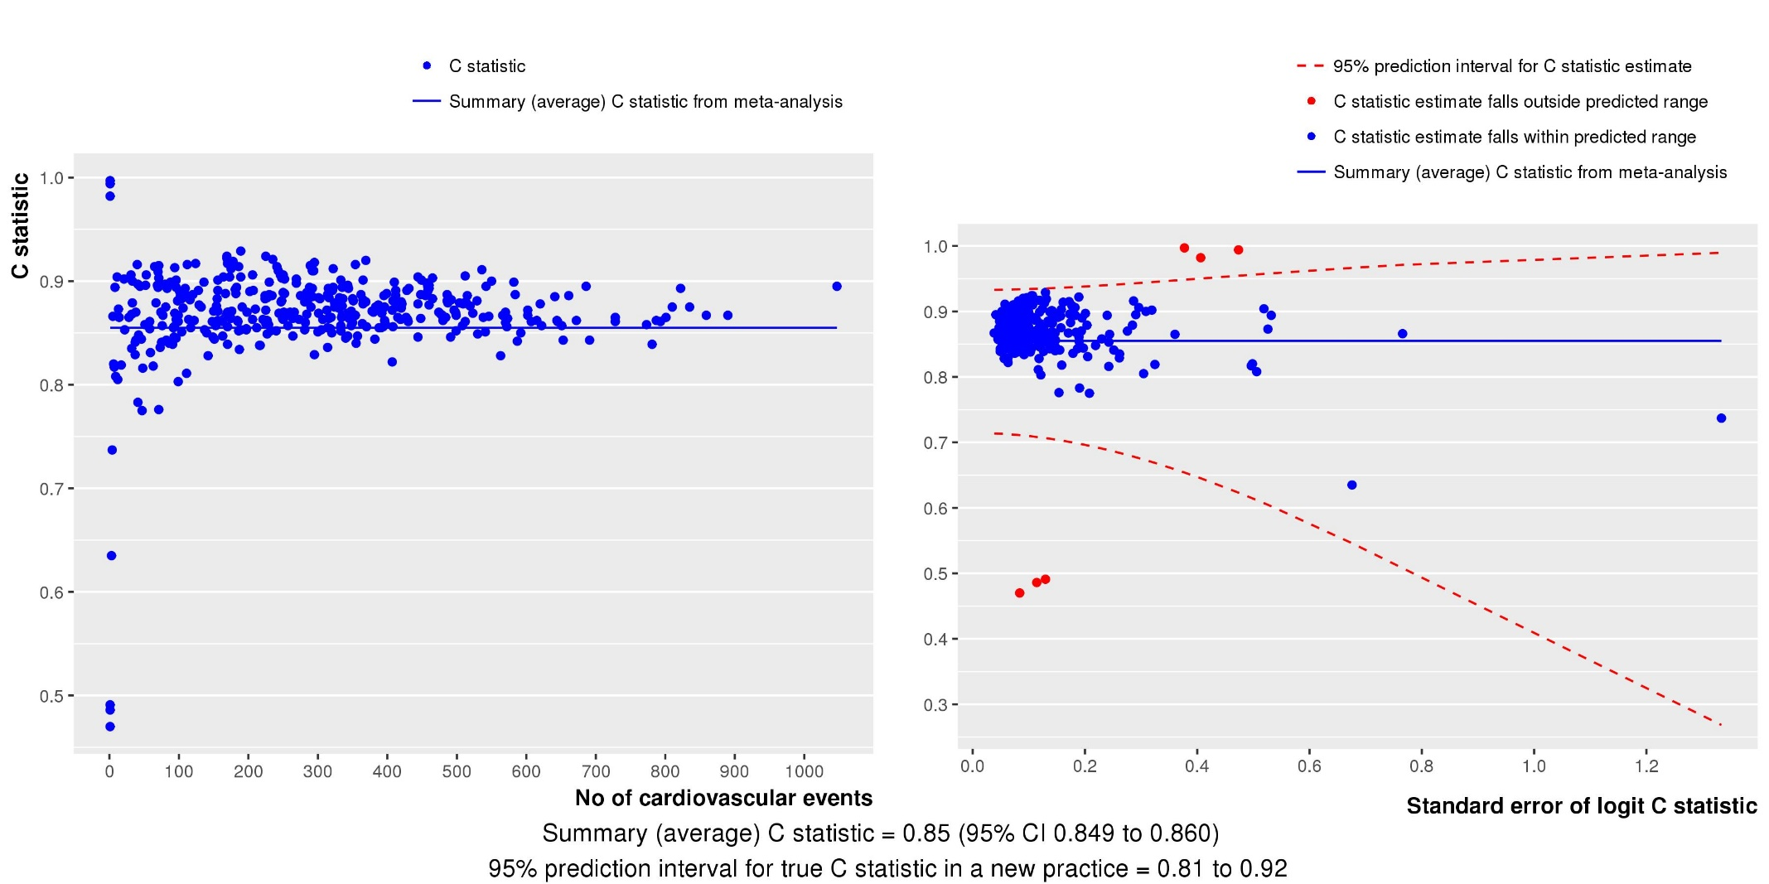

eFigure 4. Variation of QRISK3’s C-statistic among practices—
a replication of Riley’s¹ funnel plot

