Supplementary Information Figures S1–5 and Supplementary Table 1

Exosome surface glycans reflect osteogenic differentiation of mesenchymal stem cells: Profiling by an evanescent field fluorescence-assisted lectin array system

Asako Shimoda, Shin-ichi Sawada, Yoshihiro Sasaki, and Kazunari Akiyoshi*
Department of Polymer Chemistry, Graduate School of Engineering, Kyoto University, Katsura, Nishikyo-ku, Kyoto 615-8510, Japan

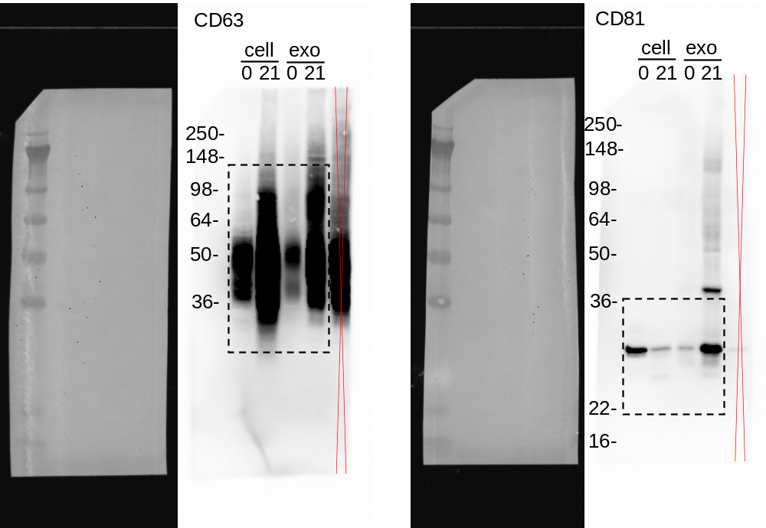
Supplementary Figure S1. Full length western blot for Figure 3

Supplementary Figure S2. Glycan profile of exosomes and cell membranes from MSCs by an EFF-lectin array.
Each fluorescence intensity was normalized to the average intensities of all lectins. Data represent the mean ± SD (cells: n=2; exosomes: n=3).

Supplementary Figure S3. Glycan profile of exosomes and cell membranes from osteogenically differentiated MSCs on day 21.
Each fluorescence intensity was normalized to the average intensities of all lectins. Data represent the mean ± SD (cells: n=2; exosomes: n=3).

Supplementary Figure S4. Binding curves of interactions between 45 lectins and exosomes. The resulting signals were normalized to the signal of LEL lectin. Data represent the mean ± SD of two independent experiments.
Supplementary Figure S5. Binding curves of interactions between 45 lectins and cell membrane fractions. The resulting signals were normalized to the signal of LEL lectin. Data represent the mean ± SD of two independent experiments.

Supplementary Table 1. A list of lectins of LecChipTM and glycan specificity.
Lectin | origin | Glycan specificity
LTL | Lotus tetragonolobus | Fuc α1-3 GlcNAc
PSA | Pisum sativum | Core Fuc [Fuc α1-6]
LCA | Lens culinaris | Core Fuc [Fuc α1-6]
UEA_I | Ulex europaeus | Fuc α1-2 (Galβ1-4)GlcNAc
AOL | Aspergillus oryzae | Fuc α1-6 GlcNAc, Fuc α1-2 Galβ1-4GlcNAc
AAL | Aleuria aurantia | Fuc α1-6 GlcNAc, Fuc α1-3(Galβ1-4)GlcNAc
MAL_I | Maackia amurensis | Siaα2-3Gal
SNA | Sambucus nigra | Siaα2-6Gal, Siaα2-6GalNAc
SSA | Sambucus sieboldiana | Siaα2-6Gal
TJA-I | Trichosanthes japonica | Siaα2-6, Galβ1-4GlcNAc
PHA(L) | Phaseolus vulgaris | tri/tetra-antennary complex-type N-glycan
ECA | Erythrina cristagalli | Galβ1-4GlcNAc
RCA120 | Ricinus communis | Galβ1-4GlcNAc
PHA(E) | Phaseolus vulgaris | Bisecting GlcNAc
DSA | Datura stramonium | Galactosylated tetraantenary N-type
GSL-II | Griffonia simplicifolia | agalactosylated tri/tetra antennary glycans and GlcNAc
NPA | Narcissus pseudonarcissus | non-substituted α1-6Man
ConA | Canavalia ensiformis | α-Man (inhibited by presence of bisecting GlcNAc)
GNA | Galanthus nivalis | non-substituted α1-6Man
HHL | Hippeastrum hybrid | non-substituted α1-6Man
Calsepa | Calystegia sepium | α‐Man, bianntenary with bisecting GlcNAc
ACG | Agrocybe cylindracea | Gal β1-3Gal, Siaα2-3Galβ1-4GlcNAc
TxLC_I | Tulipa gesneriana | Manα1-3(Manα1-6)Man, bi/tri-antennary complex-type N-glycan,  GalNAc
BPL | Bauhinia purpurea | Galβ1-3GalNAc
TJA-II | Tanthes japonica | β-GalNAc, Fuc α1-2 Gal
EEL | Euonymus europaeus | Galα1-3Galβ-1-4GlcNAc, Fucβ-1-2Galβ1-3GlcNAc
ABA | Agaricus bisporus | Galβ1-3GalNAc, GlcNAc
LEL | Lycopersicon esculentum | Poly-LacNAc, (GlcNAc)n
STL | Solanum tuberosum | Poly-LacNAc, (GlcNAc)n
UDA | Urtica dioica | Poly-LacNAc, (GlcNAc)n
PWM | Phytolacca Americana | Poly-LacNAc, (GlcNAc)n
Jacalin | Artocarpus integrifolia | GlcNAcβ1-3GalNAc (Core3), Siaα2-3Galβ1-3GalNAc (sialyl T),  Galβ1-3GalNAc (T-antigen), α-GalNAc (Tn-antigen)
PNA | peanut, Arachis hypogaea | Galβ1-3GalNAc
WFA | Wisteria floribunda | GalNAcβ1-4GlcNAc (LacdiNAc), Galβ1-3(-6)GalNAc
ACA | Amaranthus caudatus | Galβ1-3GalNAcα-Ser/Thr (T)
MPA | Maclura pomifera | Galβ1-3GalNAcα-Ser/Thr (T),GalNAcα-Ser/Thr (Tn)
HPA | Helix pomatia | GalNAc (Tn)
VVA | Vicia villosa | GalNAc, GalNAcα-Ser/Thr (Tn)
DBA | Dolichos biflorus | GalNAcα-Ser/Thr (Tn), GalNAcα1-3GalNAc
SBA | soybean, Dolichos biflorus | Terminal GalNAc
PTL_I | Psophocarpus tetragonolobus | α-GalNAc and Gal
MAH | Maackia amurensis | Siaα2-3Galβ1-3(Siaα2-6)GalNAc
WGA | wheat germ, Triticum aestivum | (GlcNAc)n, polySia
GSL_I_A4 | Griffonia simplicifolia | GalNAc
GSL_I_B4 | Griffonia simplicifolia | αGal

