Supplementary Information

Iron-rich Smectite Formation in Subseafloor Basaltic Lava in Aged Oceanic Crust

Seiya Yamashita¹, Hiroki Mukai¹, Naotaka Tomioka², Hiroyuki Kagi³, Yohey Suzuki^{1*}
¹Department of Earth and Planetary Science, The University of Tokyo, 7-3-1 Hongo, Bunkyo-ku, Tokyo, Japan
²Kochi Institute for Core Sample Research, Japan Agency for Marine-Earth Science and Technology (JAMSTEC), 200 Monobe Otsu, Nankoku, Kochi 783-8502, Japan
³Department of Chemistry, The University of Tokyo, 7-3-1 Hongo, Bunkyo, Tokyo 113-0033, Japan

Supplementary Figure S1–S8
Supplementary Table S1–S3

Supplementary Figure S1. A bathymetry map showing drilling locations modified after the reference 12.

Supplementary Figure S2. Mineralogical characteristics of Fe-rich phyllosilicate minerals in U1365E-12R2. (a) Bright-field TEM micrograph of fibrous material located between an iron-oxyhydroxide-filled vein and the groundmass. EDS spectra were obtained from circles with the same color. (b) Elemental mapping images of Fe, Si, Mg, and K by scanning transmission electron microscopy and an RGB synthesis image of Si, Fe and K. (c) Bright-field TEM micrograph of a suspended fraction of a powdered sample with a white circle, from which an SAED pattern and an EDS spectrum were obtained.
Supplementary Figure S3. Mineralogical characteristics of phyllosilicate minerals in U1367F-6R1. (a) Optical microscopy image of a thin section of a rock piece with veins. (b) Back-scattered electron image of mineral-filled veins with green (c) and orange (d) circlers from which EDS spectra were obtained.

Supplementary Figure S4. Depth profiles of porewater chemistry in sediments at Sites U1367 and U1368 showing pH and concentrations of silicate, calcium, magnesium, sodium, potassium, and dissolved oxygen (DO) ^{15,16}.

Supplementary Figure S5. Schematic illustrations of convection- (a) versus conduction-driven fluid flows (b) in aged oceanic crust, which was inferred from heat flow data from the seafloor at Sites U1365, U1367, and U1368¹². The extent of fluid flow is expressed as arrows: large, bold arrows showing strong fluid flow and small, thin arrows showing weak fluid flow.

Supplementary Figure S6. Schematic illustrations of formation processes of nontronite by hydrothermal alteration near the seafloor (a) versus by weathering in subsurface basaltic lava (b).

Supplementary Table S1. Crustal ages, sediment thicknesses and basement core recoveries at Sites U1365²⁴, U1367¹⁵, and U1368¹⁶.
 | Site U1365 | Site U1367 | Site U1368
Crustal age | 104 Ma | ~33.5 Ma | ~13.5 Ma
Sediment thickness | 75 m | 26 m | 16 m
Basement core recovery | 74.6 % | 11 % | 27.6 %

Supplementary Table S2. Photographic images and visual descriptions of basaltic core samples on shipboard at Sites U1365, U1367, and U1368.
U1365E-8R4 | Description
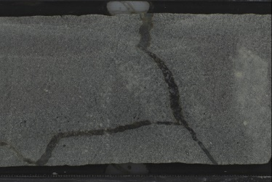 | Aphyric microcrystalline to fine grained massive basalt with a gray to green background (very slight celadonite alteration). One celadonite vein with minor pyrite is present through the center of the rock, which is flanked by a narrow and diffuse dark green halo (celadonite). Piece length is 10 cm.
U1365E-12R2 | Description
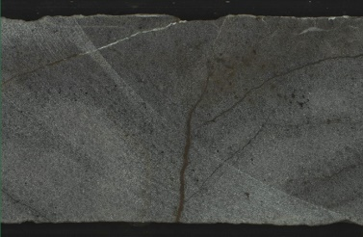 | Aphyric microcrystalline massive basalt with dark gray and brown background alteration. Mixed brown and dark green alteration halos flank one 0.1 to 0.3 mm branching iron-oxyhydroxide (vertical) and celadonitic (horizontal) veins. Alteration patches of celadonite and iron-oxyhydroxide are present. Piece length is 8 cm
U1367F-6R1 | Description
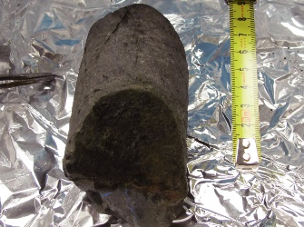 | Aphyric microcrystalline to cryptocrystalline basalt with green to gray background alteration that varies from slight to moderate. Veins are steeply dipping including a mixed celadonite (20% of vein fill), iron-oxyhydroxide at (80% of vein fill) vein (0.3mm wide) that is flanked by a brown (iron-oxyhydroxide) and dark green (celadonite) halo, and two celadonite veins (0.2mm wide).
U1368F-5R3 | Description
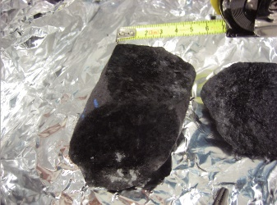 | Sparsely phyric microcrystalline massive basalt with slight dark green, pervasive alteration. Dark green celadonitic vein is present. Basaltic groundmass is sparsely vesicular with celadonite filling vesicles.
U1368F-7R3 | Description
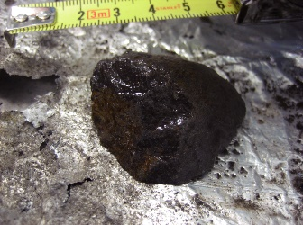 | Slightly altered massive microcrystalline to cryptocrystalline sparsely phyric basalt. Alteration is pervasive and it consists of iron-oxyhydroxides and celadonite within the whole rock. The vein is composed of iron-oxyhydroxides (curved and 0.1 mm thick with a narrow brown/red halo. Vesicles are filled with celadonite and iron-oxyhydroxides.
U1368F-9R1 | Description
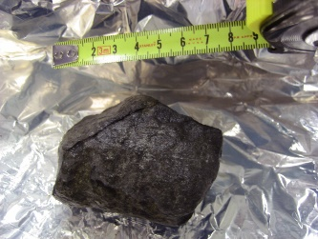 | Aphyric microcrystalline basalt with brown/green gray background that represents slight to moderate alteration. Alteration consists of celadonite and iron-oxyhydroxides. Vein is vertical and composed of iron-oxyhydroxides (90% and clay minerals 10%). Vein thickness is 0.4mm and it is not flanked by a halo. Vesicles are filled with celadonite and iron-oxyhydroxides and there are ~2-4% of vesicles in the whole rock.

Site | U1365 | U1365 | U1365 | U1365 |  | U1367 | U1367 | U1367 | U1367 | U1367
Core Unit | 12R2 | 12R2 | 12R2 | 12R2 |  | 6R1 | 6R1 | 6R1 | 6R1 | 6R1
SiO₂ | 41.17 | 54.36 | 55.08 | 50.99 |  | 41.01 | 59.96 | 55.44 | 55.94 | 53.50
Al₂O₃ | 12.15 | 8.42 | 6.19 | 8.64 |  | 2.35 | 5.00 | 3.26 | 3.97 | 1.08
TiO₂ | 1.95 | 0.35 | 0.20 | 0.10 |  | 2.31 | 0.47 | 0.94 | 0.58 | 0.64
Fe₂O₃ | 25.97 | 19.98 | 17.06 | 26.89 |  | 38.57 | 19.69 | 24.58 | 28.19 | 34.31
MnO | 0.00 | 0.00 | 0.00 | 0.00 |  | 1.23 | 0.15 | 0.00 | 0.00 | 0.00
MgO | 14.36 | 11.48 | 13.39 | 5.12 |  | 6.00 | 10.21 | 5.82 | 4.29 | 3.25
CaO | 0.62 | 2.19 | 1.69 | 1.57 |  | 3.27 | 1.02 | 2.93 | 1.33 | 0.66
K₂O | 3.47 | 2.80 | 4.82 | 6.26 |  | 2.17 | 1.42 | 5.69 | 4.71 | 6.56
Na₂O | 0.31 | 0.42 | 1.57 | 0.43 |  | 3.09 | 2.07 | 1.33 | 1.00 | 0.00
sum | 100.00 | 100.00 | 100.00 | 100.00 |  | 100.00 | 100.00 | 100.00 | 100.00 | 100.00
Supplementary Table S3. Compositions of nontronite in fractures/veins of basaltic basements at Sites U1365 and U1367 quantified by TEM-EDS and SEM-EDS, respectively.
Site | U1365 | U1365 | U1365 | U1365 | U1365 | U1365 |  | U1365 | U1365 | U1365
Core Unit | 8R4 | 8R4 | 8R4 | 8R4 | 8R4 | 8R4 |  | 12R2 | 12R2 | 12R2
SiO₂ | 62.74 | 52.82 | 52.65 | 49.94 | 57.10 | 59.42 |  | 43.25 | 41.37 | 43.80
Al₂O₃ | 4.81 | 5.78 | 9.20 | 8.10 | 1.15 | 0.27 |  | 11.66 | 12.31 | 11.59
TiO₂ | 0.04 | 0.09 | 0.40 | 0.38 | 0.48 | 0.49 |  | 0.84 | 1.20 | 0.85
Fe₂O₃ | 22.90 | 23.83 | 20.55 | 27.45 | 31.82 | 28.85 |  | 27.42 | 24.50 | 24.87
MnO | 0.00 | 0.00 | 0.00 | 0.00 | 0.00 | 0.00 |  | 0.00 | 0.00 | 0.00
MgO | 7.15 | 12.63 | 14.93 | 7.23 | 5.33 | 5.34 |  | 12.91 | 16.05 | 16.02
CaO | 0.28 | 0.54 | 1.57 | 2.06 | 0.33 | 0.32 |  | 0.78 | 1.42 | 0.00
K₂O | 2.09 | 4.30 | 0.69 | 4.83 | 3.68 | 5.31 |  | 3.13 | 3.15 | 2.87
Na₂O | 0.00 | 0.00 | 0.00 | 0.02 | 0.11 | 0.00 |  | 0.00 | 0.00 | 0.00
sum | 100.00 | 100.00 | 100.00 | 100.00 | 100.00 | 100.00 |  | 100.00 | 100.00 | 100.00

