Supporting Information

Field cancerization therapy with ingenol mebutate contributes to restoring skin-metabolism to normal-state in patients with actinic keratosis: a metabolomic analysis
Valeria Righi^{1,*,+}, Elisabetta Tarentini², Adele Mucci³, Camilla Reggiani², Maria Cecilia Rossi⁴, Federica Ferrari², Alice Casari², Cristina Magnoni^{2,+}
¹Dipartimento di Scienze per la Qualità della Vita, Università di Bologna, Campus Rimini, Corso D’Augusto 237, 47921 Rimini, Italy; ²Dipartimento Chirurgico, Medico, Odontoiatrico e di Scienze Morfologiche con interesse Trapiantologico, Oncologico e di Medicina Rigenerativa, Università di Modena e Reggio Emilia, via del Pozzo 71, 41124 Modena, Italy; ³Dipartimento di Scienze Chimiche e Geologiche, Università di Modena e Reggio Emilia, via G. Campi 103, 41125 Modena, Italy; ⁴Centro Interdipartimentale Grandi Strumenti, Università di Modena e Reggio Emilia, via G. Campi 213/A, 41125 Modena Italy

⁺V.R. and C.M. contributed equally to this work.
* corrisponding authors:
Valeria Righi
e-mail: valeria.righi2@unibo.it
Valeria Righi, PhD
Dipartimento di Scienze per la Qualità della Vita,
Università di Bologna, Campus Rimini,
Corso D’Augusto 237, 49921 Rimini, Italy

Table S1. List of ¹H and ¹³C chemical Shift (δ, ppm) of metabolites. ª,¹H chemical shifts refer to Ala doublet at 1.48 ppm; ^{b},¹³C chemical shifts refer to Ala at 16.8 ppm.
 | Metabolites | δ¹Hª | δ¹³C^{b} | Assignment
1 | Fatty acids | 0.89 | 16.5 | CH₃
1 | Fatty acids | 1.32–1.29 | 32.6–34.2 | (CH₂)_{n}
1 | Fatty acids | 1.59 | 27.4 | CH₂-CH₂-C=O
1 | Fatty acids | 2.04 | 29.6 | CH₂CH=CH
1 | Fatty acids | 2.27 | 36.1 | CH₂-C=O
1 | Fatty acids | 2.78 | 27.9 | =CH-CH₂-CH=
1 | Fatty acids | 5.32 | 128–130 | -CH=CH-
2 | Lactate | 1.33 | 22.7 | CH₃
2 | Lactate | 4.12 | 71.3 | CH
3 | Alanine | 1.48 | 19.3 | CH₃
3 | Alanine | 3.78 | c | α CH
4 | Valine | 0.98 | 21.7 | γ CH₃ (d)
4 | Valine | 1.04 | 20.7 | γ CH₃ (d)
4 | Valine | 2.27 | 30.5 | β CH
4 | Valine | 3.61 | c | α CH
5 | Leucine | 0.96 | 24.9 | δ CH₃
5 | Leucine | 0.97 | 25.3 | δ CH₃
5 | Leucine | 1.70 | 42.4 | β CH₂
5 | Leucine | 1.73 | 28.8 | γ CH₂
5 | Leucine | 3.72 | c | α CH
6 | Lysine | 1.88 | 32.9 | β CH₂
6 | Lysine | 1.47 | 22.6 | γ CH₂
6 | Lysine | 1.73 | 27.3 | δ CH₂
6 | Lysine | 3.03 | 39,7 | ε CH₂
6 | Lysine | 3.73 | c | α CH
7 | Isoleucine | 1.97 | 25.2 | CH₃
7 | Isoleucine | 0.95–0.93 | 21
8 | Acetate | 1.92 | 26.6 | CH₃ (s)
9 | Glutamine | 2.11 | 27.3 | β CH₂
9 | Glutamine | 2.44 | 31.4 | γ CH₂ (td)
9 | Glutamine | 3.71 | c | α CH
10 | Glutamate | 2.36 | 34.3 | γ CH₂
10 | Glutamate | 2.07 | 25.2 | β CH₂
10 | Glutamate | 3.73 | c | α CH
11 | Threonine | 1.32 | 21.8 | γ CH₃
11 | Threonine | 3.56 | 69 | β CH
11 | Threonine | 4.25 | 66.9 | α CH
12 | α-glucose | 5.24 | 92.6 | 1 CH (d)
12 | α-glucose | 3.55 | 72 | 2 CH
12 | α-glucose | 3.72 | 73.1 | 3 CH
12 | α-glucose | 3.42 | 76.4 | 4 CH
12 | α-glucose | 3.82 | 71.9 | 6 CH₂
13 | β-glucose | 4.64 | 96.4 | 1 CH (d)
13 | β-glucose | 3.25 | 74.7 | 2 CH
13 | β-glucose | 3.49 | 76.3 | 3 CH
13 | β-glucose | 3.4 | 70.2 | 4 CH
13 | β-glucose | 3.47 | 76.4 | 5 CH
13 | β-glucose | 3.91 | 61.3 | 6 CH₂
14 | Creatine | 3.06 | 39.6 | CH₃ (s)
14 | Creatine | 3.95 | 56.4 | CH₂ (s)
15 | Histidine | 7.03 |  | 2 CH
15 | Histidine | 7.73 |  | 4 CH
17 | UDP | 5.89–5.93 |  | CH
17 | UDP | 7.91 |  | CH
18 | Glycine | 3.56 | 44.3 | CH₂ (s)
19 | Taurine | 3.41 | 38.06 | N-CH₂ (t)
19 | Taurine | 3.26 | 48.4 | S-CH₂
20 | Tyrosine | 6.88 |  | 5 CH
20 | Tyrosine | 7.18 |  | 6 CH
21 | Succinate | 2.37 | 34.2 | CH₂ (s)
22 | Glycerol bound | 4.08 | 62.2 | CH₂
22 | Glycerol bound | 4.28 | 62.2 | CH₂
22 | Glycerol bound | 5.22 | 69.4 | CH
23 | Glyceryl phosphorylcholine | 4.32 | 60 | α’ CH₂
23 | Glyceryl phosphorylcholine | 3.67 | 66.6 | γ CH₂
23 | Glyceryl phosphorylcholine | 3.24 | 56.5 | N-CH₃ (s)
24 | Aspartate | 2.68–2.65 |  | CH₃
24 | Aspartate | 3.90 |  | CH₂
25 | Pyroglutamic acid | 2.03–2.51  2.41 | 25  30 | 2,4 CH₂  3 CH₂
25 | Pyroglutamic acid | 4.19 | 59 | 1 CH
26 | Myo-inositol | 3.53 | 72 | 1,3 CH
26 | Myo-inositol | 4.06 | 71.3 | 2 CH
26 | Myo-inositol | 3.63 | 73.1 | 4,6 CH
26 | Myo-inositol | 3.27 | 74.4 | 5 CH
27 | Scyllo-inositol | 3.36 | 73.6 | CH (s)
28 | Serine | 3.87  3.94 | 61  57 | α CH  β CH₂
29 | ETOH | 1.18  3.65 |  | CH₃  CH₂
30 | Glutathione | 2.55  2.95  4.57 |  | 5 CH₂  4 CH₂  1 CH
31 | Ascorbate | 4.52 |  | 4 CH
32 | Adenine | 8.23  8.35

Figure S1. PLS-DA cross validation details and permutation.

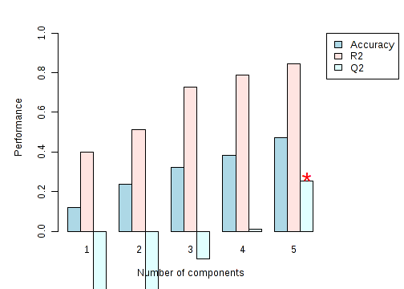

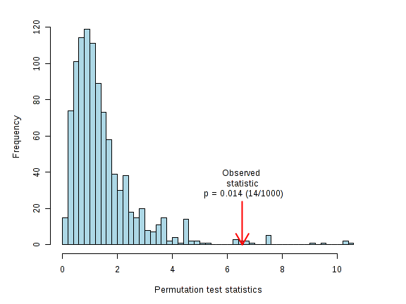

Figure S2. ANOVA results.
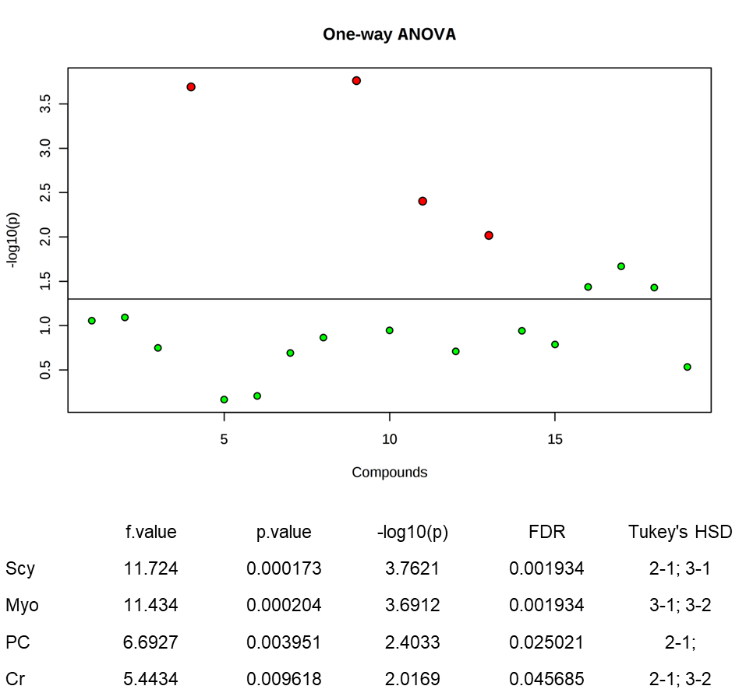

Figure S3. PLS-DA cross validation details.
