Particulate matter-attributable mortality and relationships with carbon dioxide in 250 urban areas worldwide
Susan C. Anenberg, Pattanun Achakulwisut, Michael Brauer, Daniel Moran, Joshua S. Apte, Daven K. Henze

Supplemental Information
This supplemental material contains additional figures and tables. City-specific results for population-weighted PM_{2.5} concentrations, PM_{2.5} deaths by cause, CO₂ emissions, and carbon footprints are provided in a supplemental appendix.

Supplemental Figures
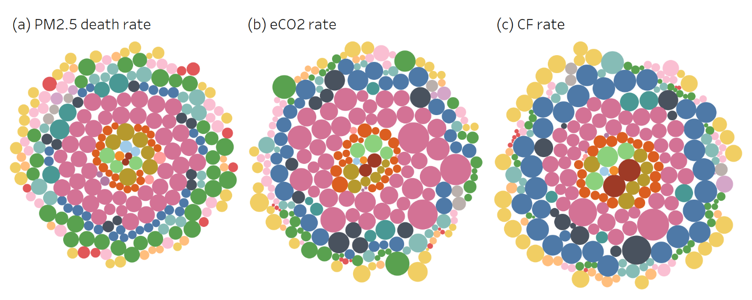
Figure S 1. City-specific estimates in 2016 for: (a) PM_{2.5}-attributable deaths per 100,000 people; (c) CO₂ emissions rate (t C per 100,000 people); (d) carbon footprint rate (kt CO₂ per 100,000 people). Bubbles are sized according to the city-specific value in each plot. Bubbles are generally grouped by region but position is random. Riyadh (CO₂ emission rate = 290,000 kt CO₂ per 100,000 people) was removed from panel b to show more detail in the rest of the dataset (CO₂ emission rate is likely unrealistically high due to very low population estimate in the GPWv4 dataset). Colors represent world regions – see Figure 1 for color legend.

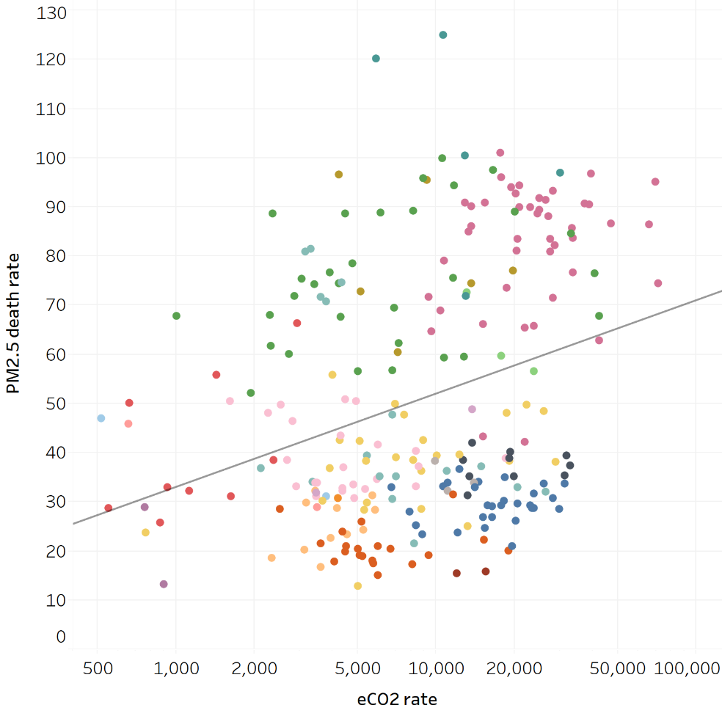
Figure S 2. As for Figure 2b but with CO₂ emissions rate on a log scale to show data points at the low end of the scale more clearly. The trendline depicted here shows a log-linear relationship. See Figure 1 for color legend.
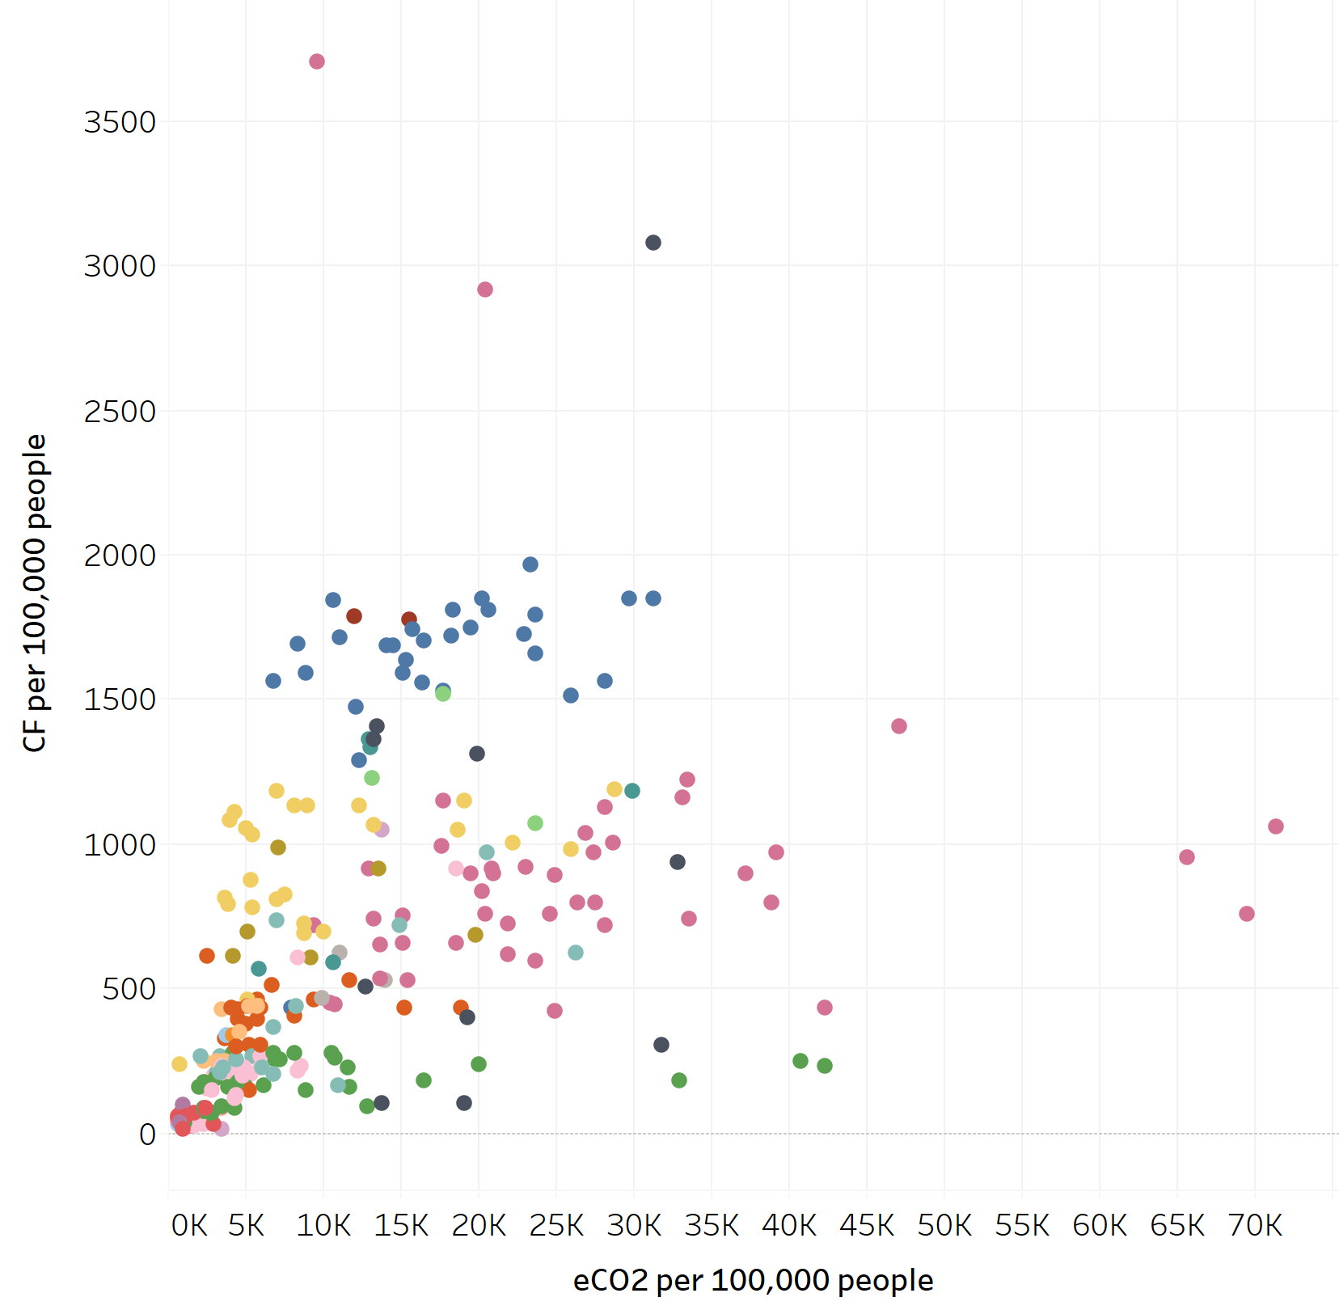
Figure S 3. Carbon footprint rate (kt CO₂ per 100,000 people per year) vs. CO₂ emissions rate (t C per 100,000 people per year) for each city. Riyadh (CO₂ emission rate = 290,000 kt CO₂ per 100,000 people and carbon footprint rate= 1900 t CO₂ per 100,000 people) was removed to show more detail in the rest of the dataset (CO₂ emission rate is likely unrealistically high due to very low population estimate in the GPWv4 dataset). See Figure 1 for color legend.

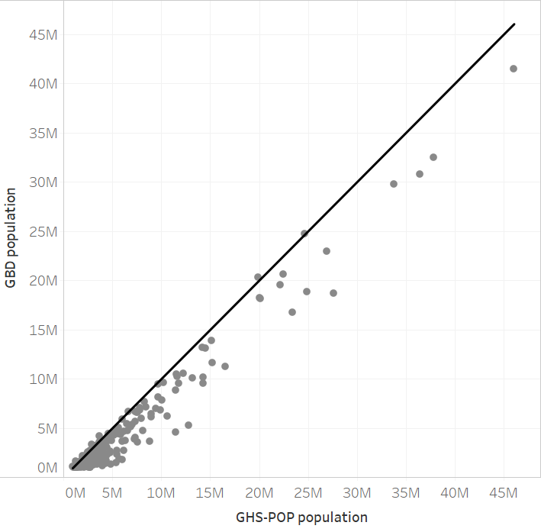
Figure S 4. Comparison between 2016 population from the GBD 2016 dataset versus GHS-POP in each city. Black line indicates 1:1 line.

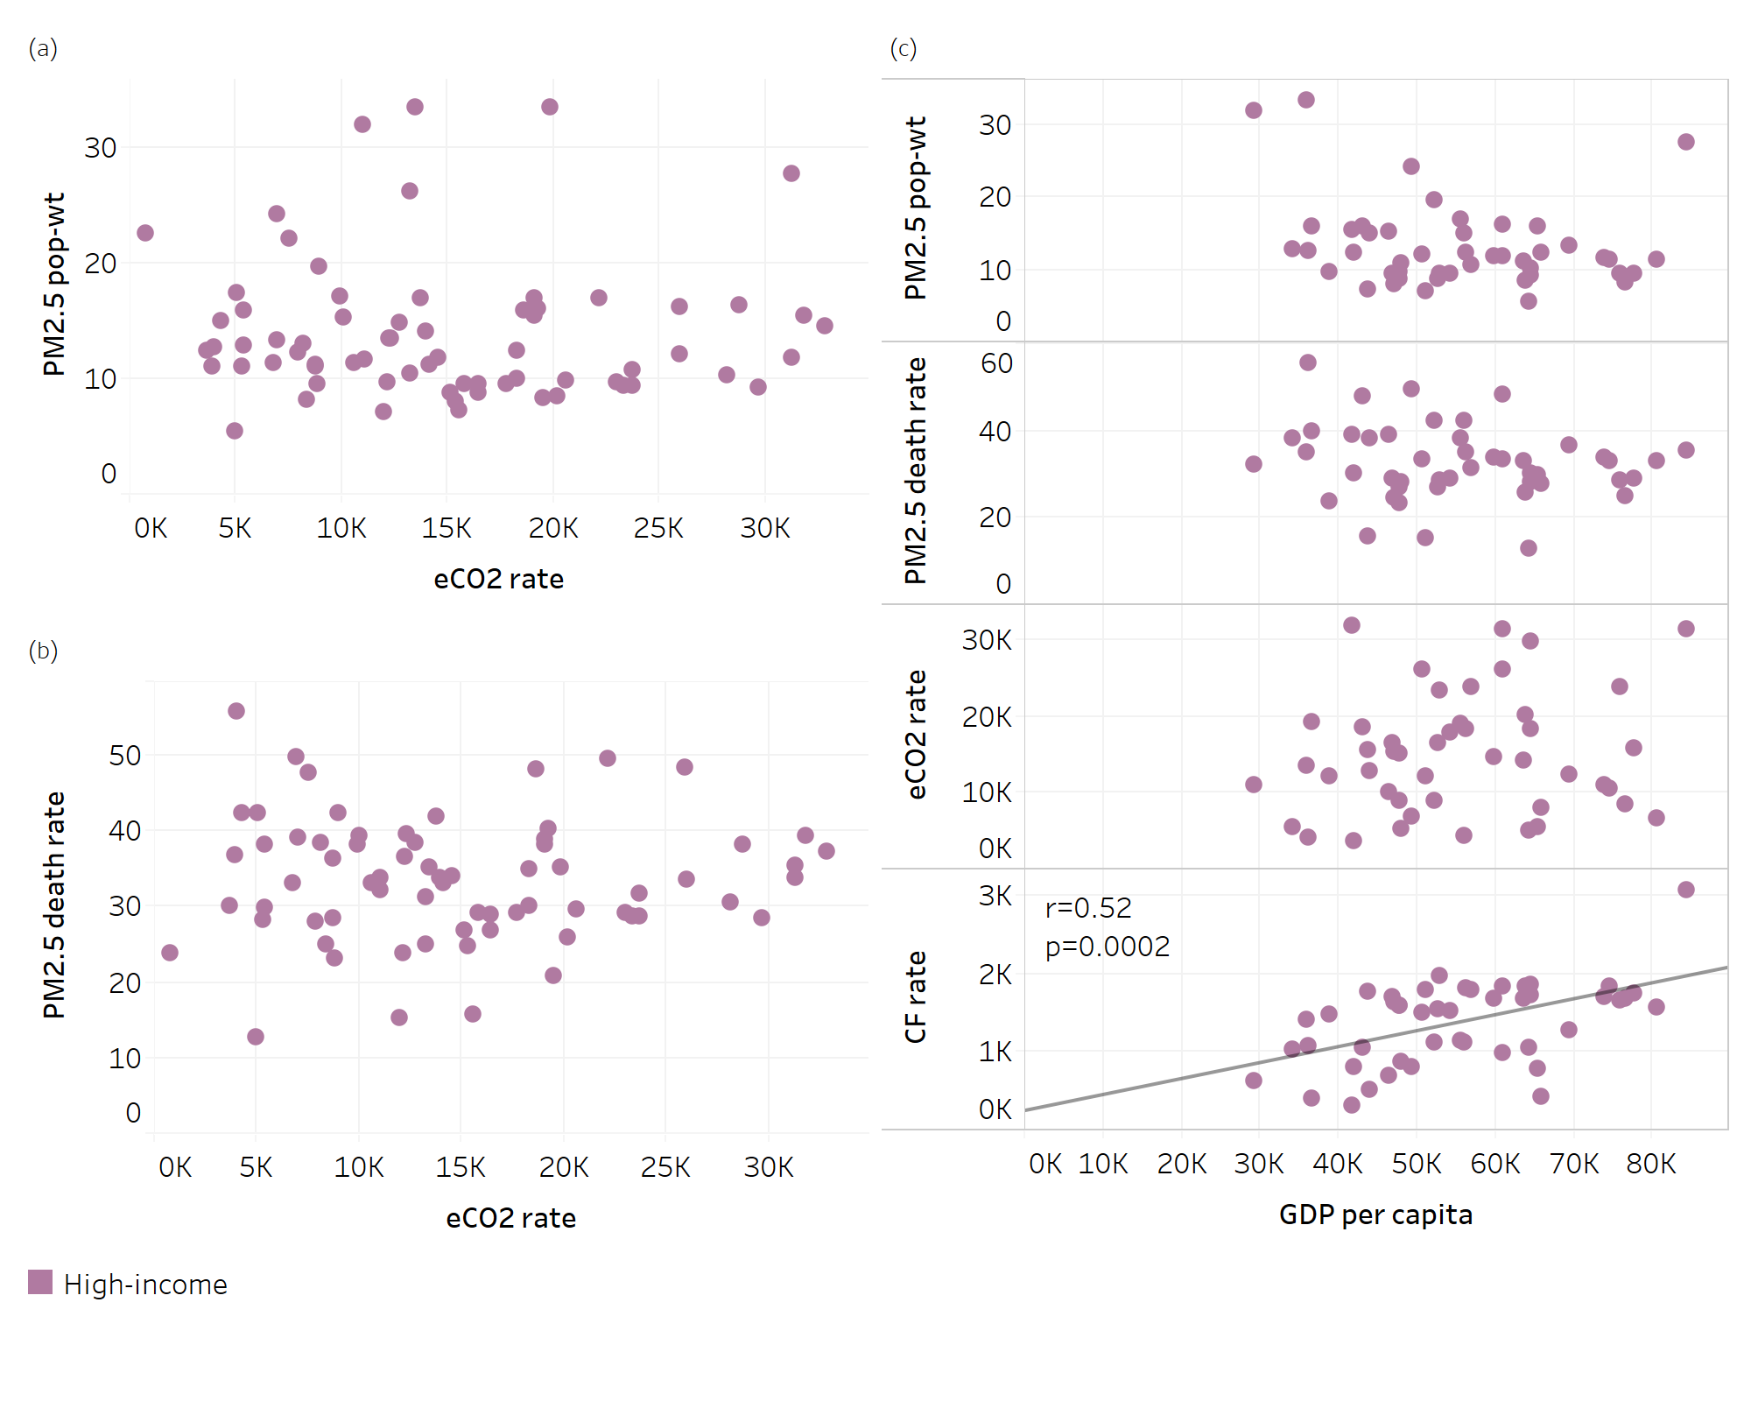
Figure S 5. As for Figure 2, but for the High-income super-region (n=69 for panels a and b, n=46 for panel c).
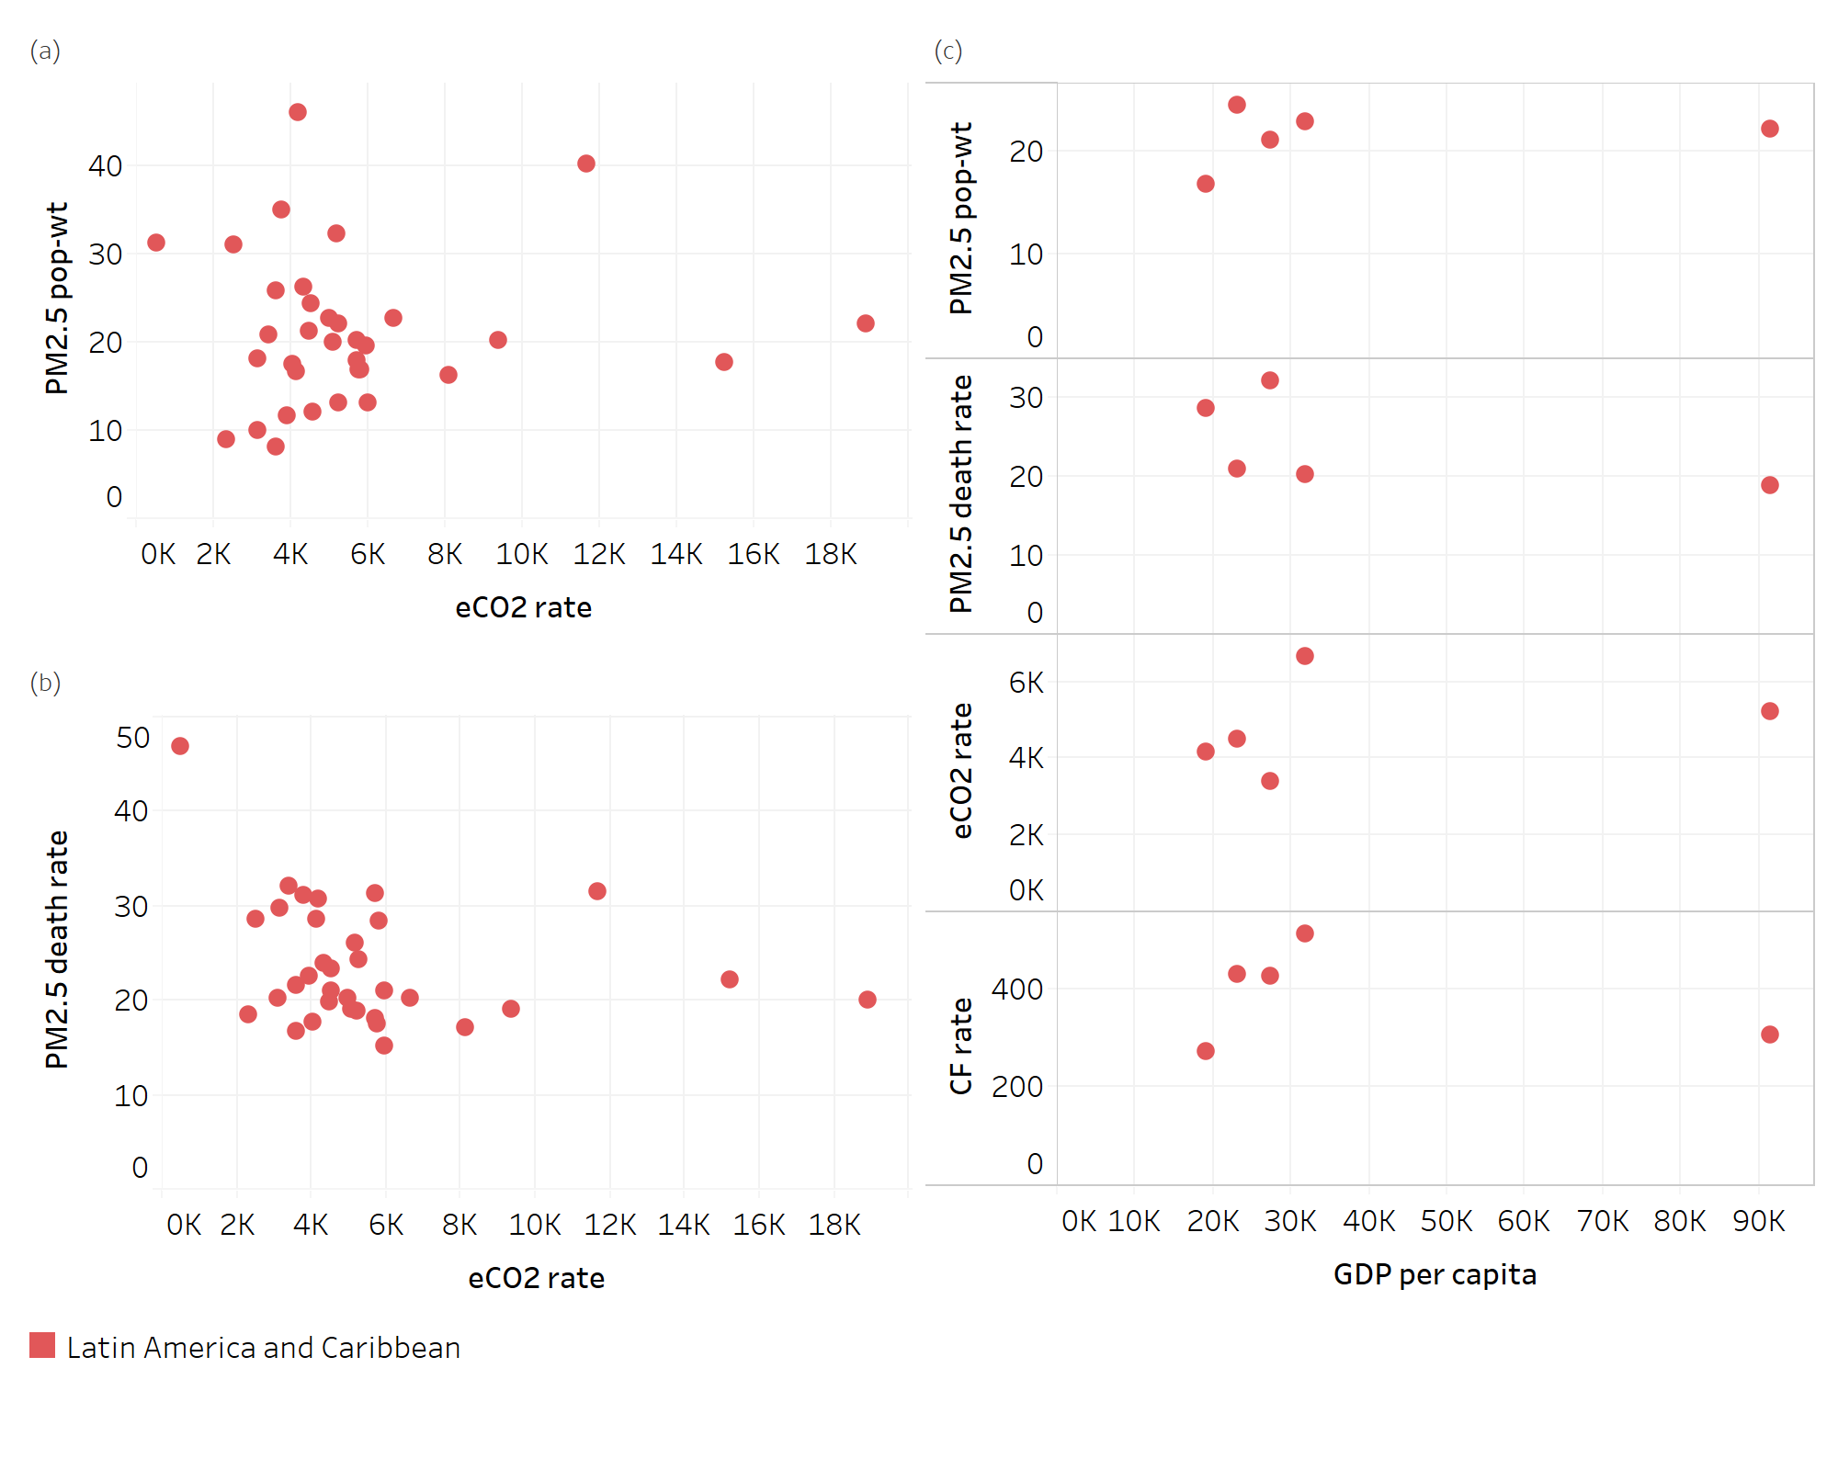
Figure S 6. As for Figure 2, but for the Latin America and Caribbean super-region (n=34 for panels a and b, n=5 for panel c).
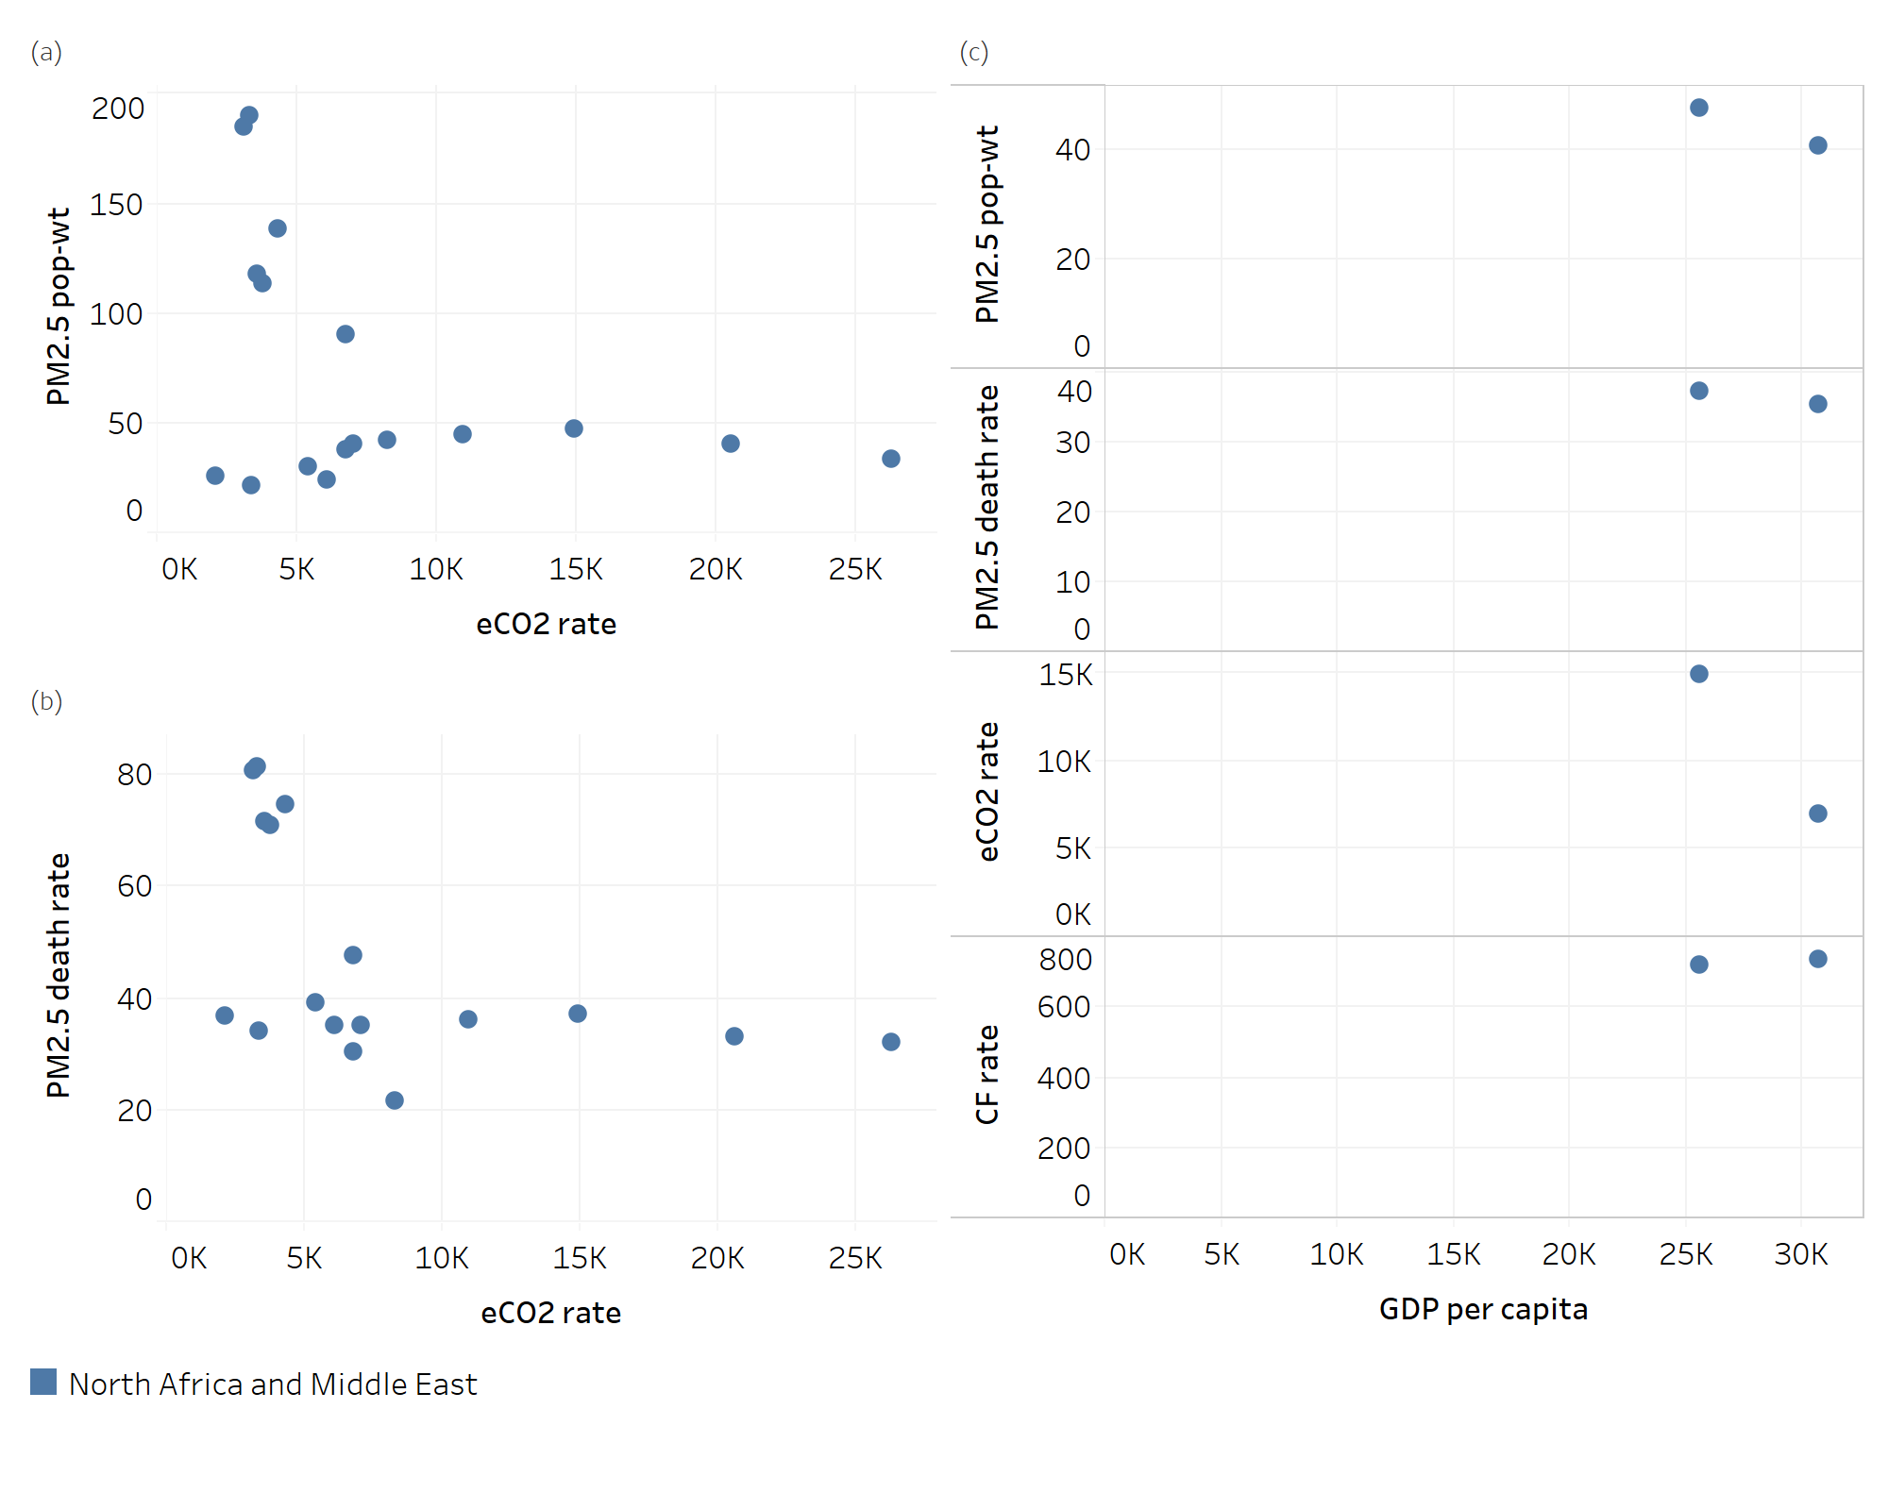
Figure S 7. As for Figure 2, but for the North Africa and Middle East super-region (n=18 for panels a and b, n=2 for panel c).

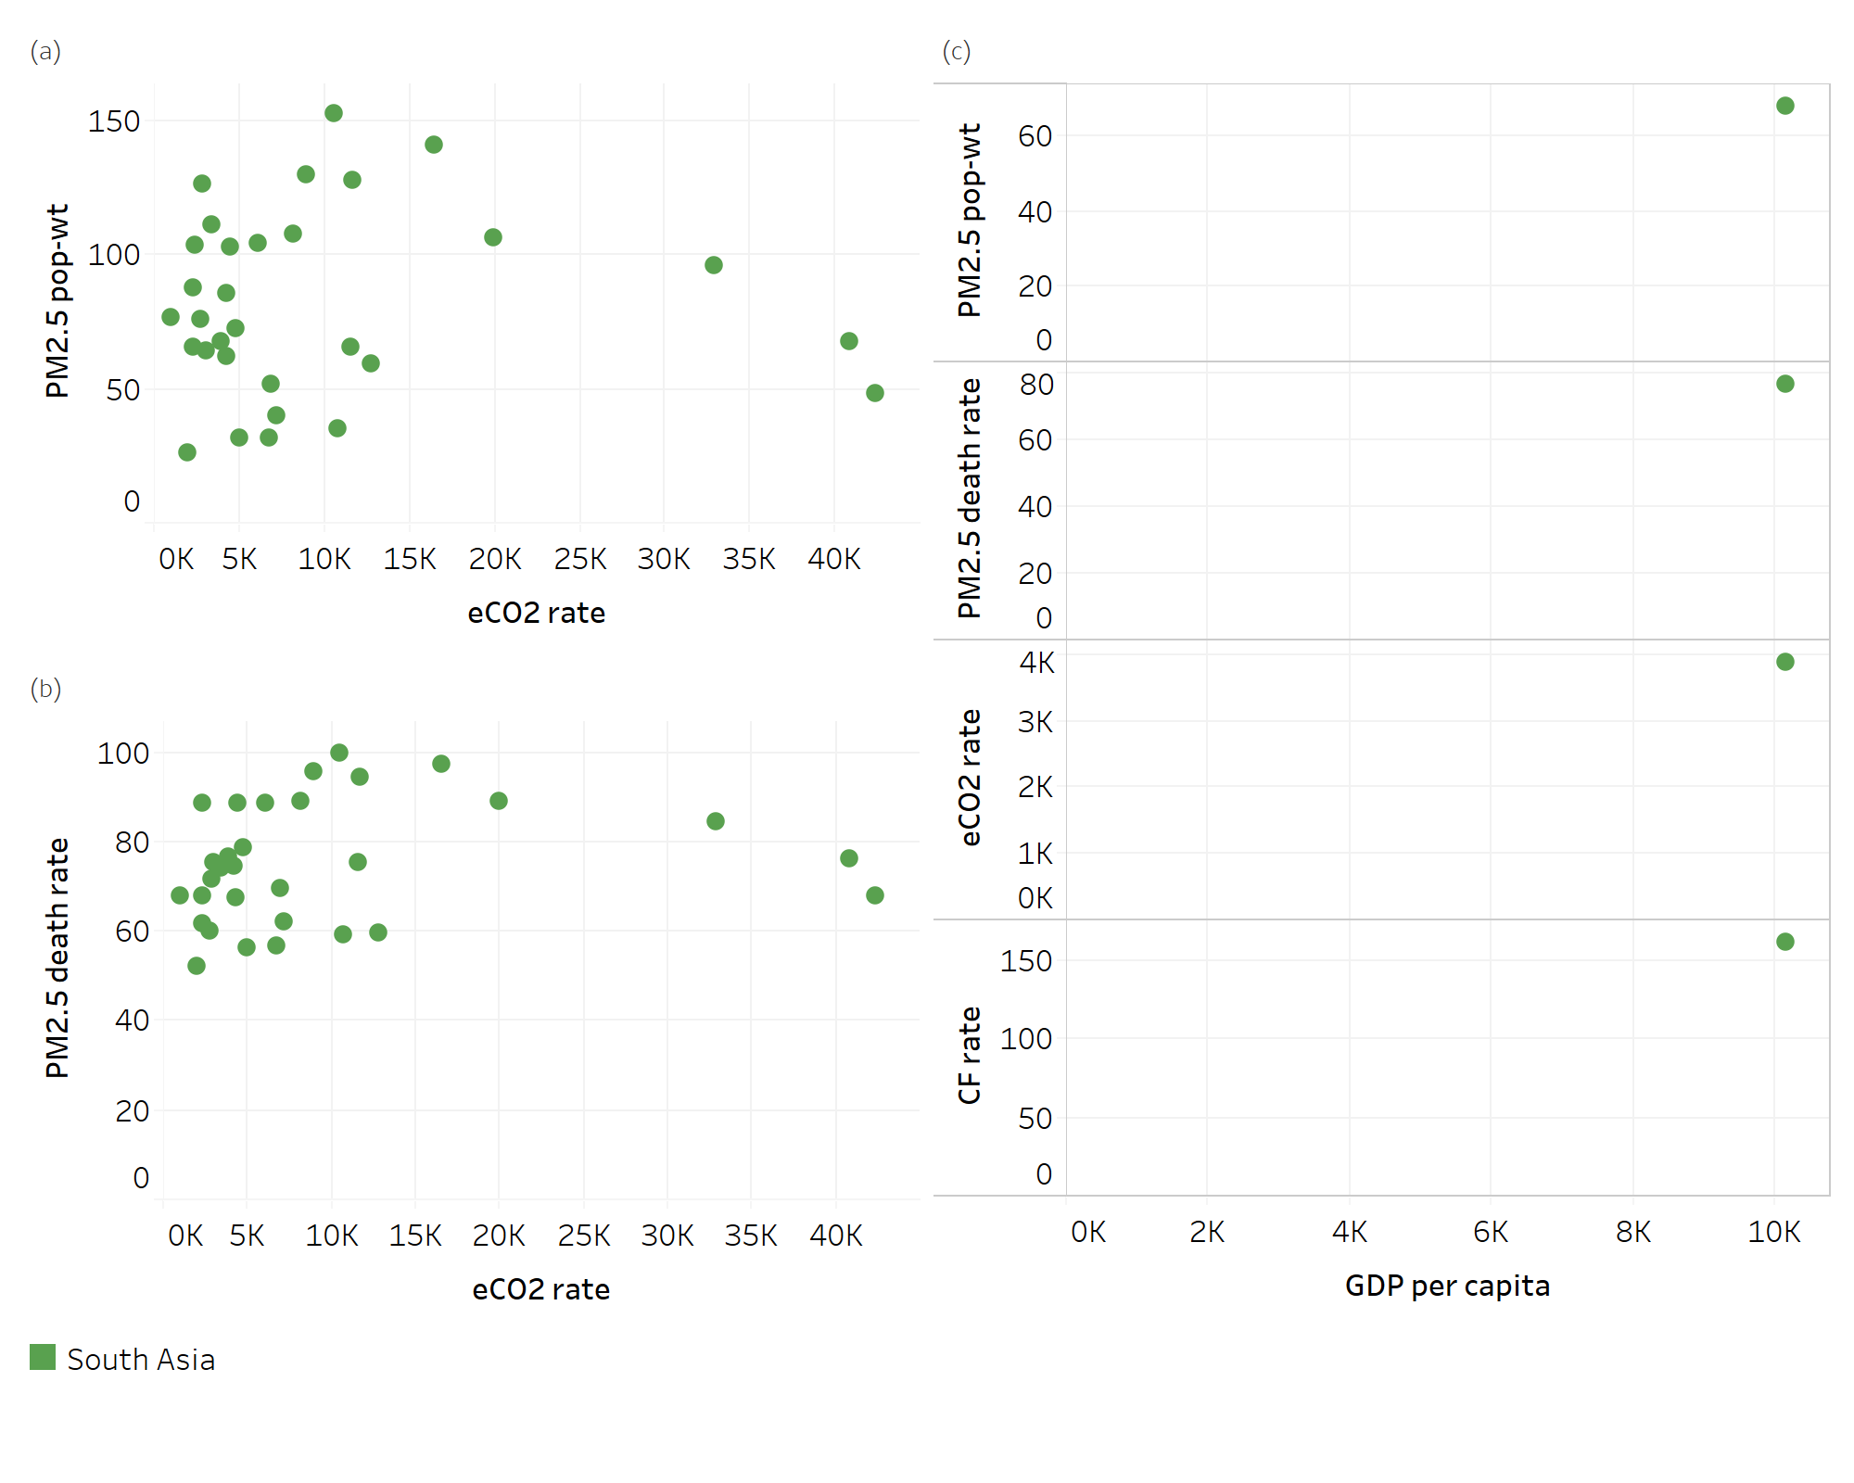
Figure S 8. As for Figure 2, but for the South Asia super-region (n=31 for panels a and b, n=1 for panel c).
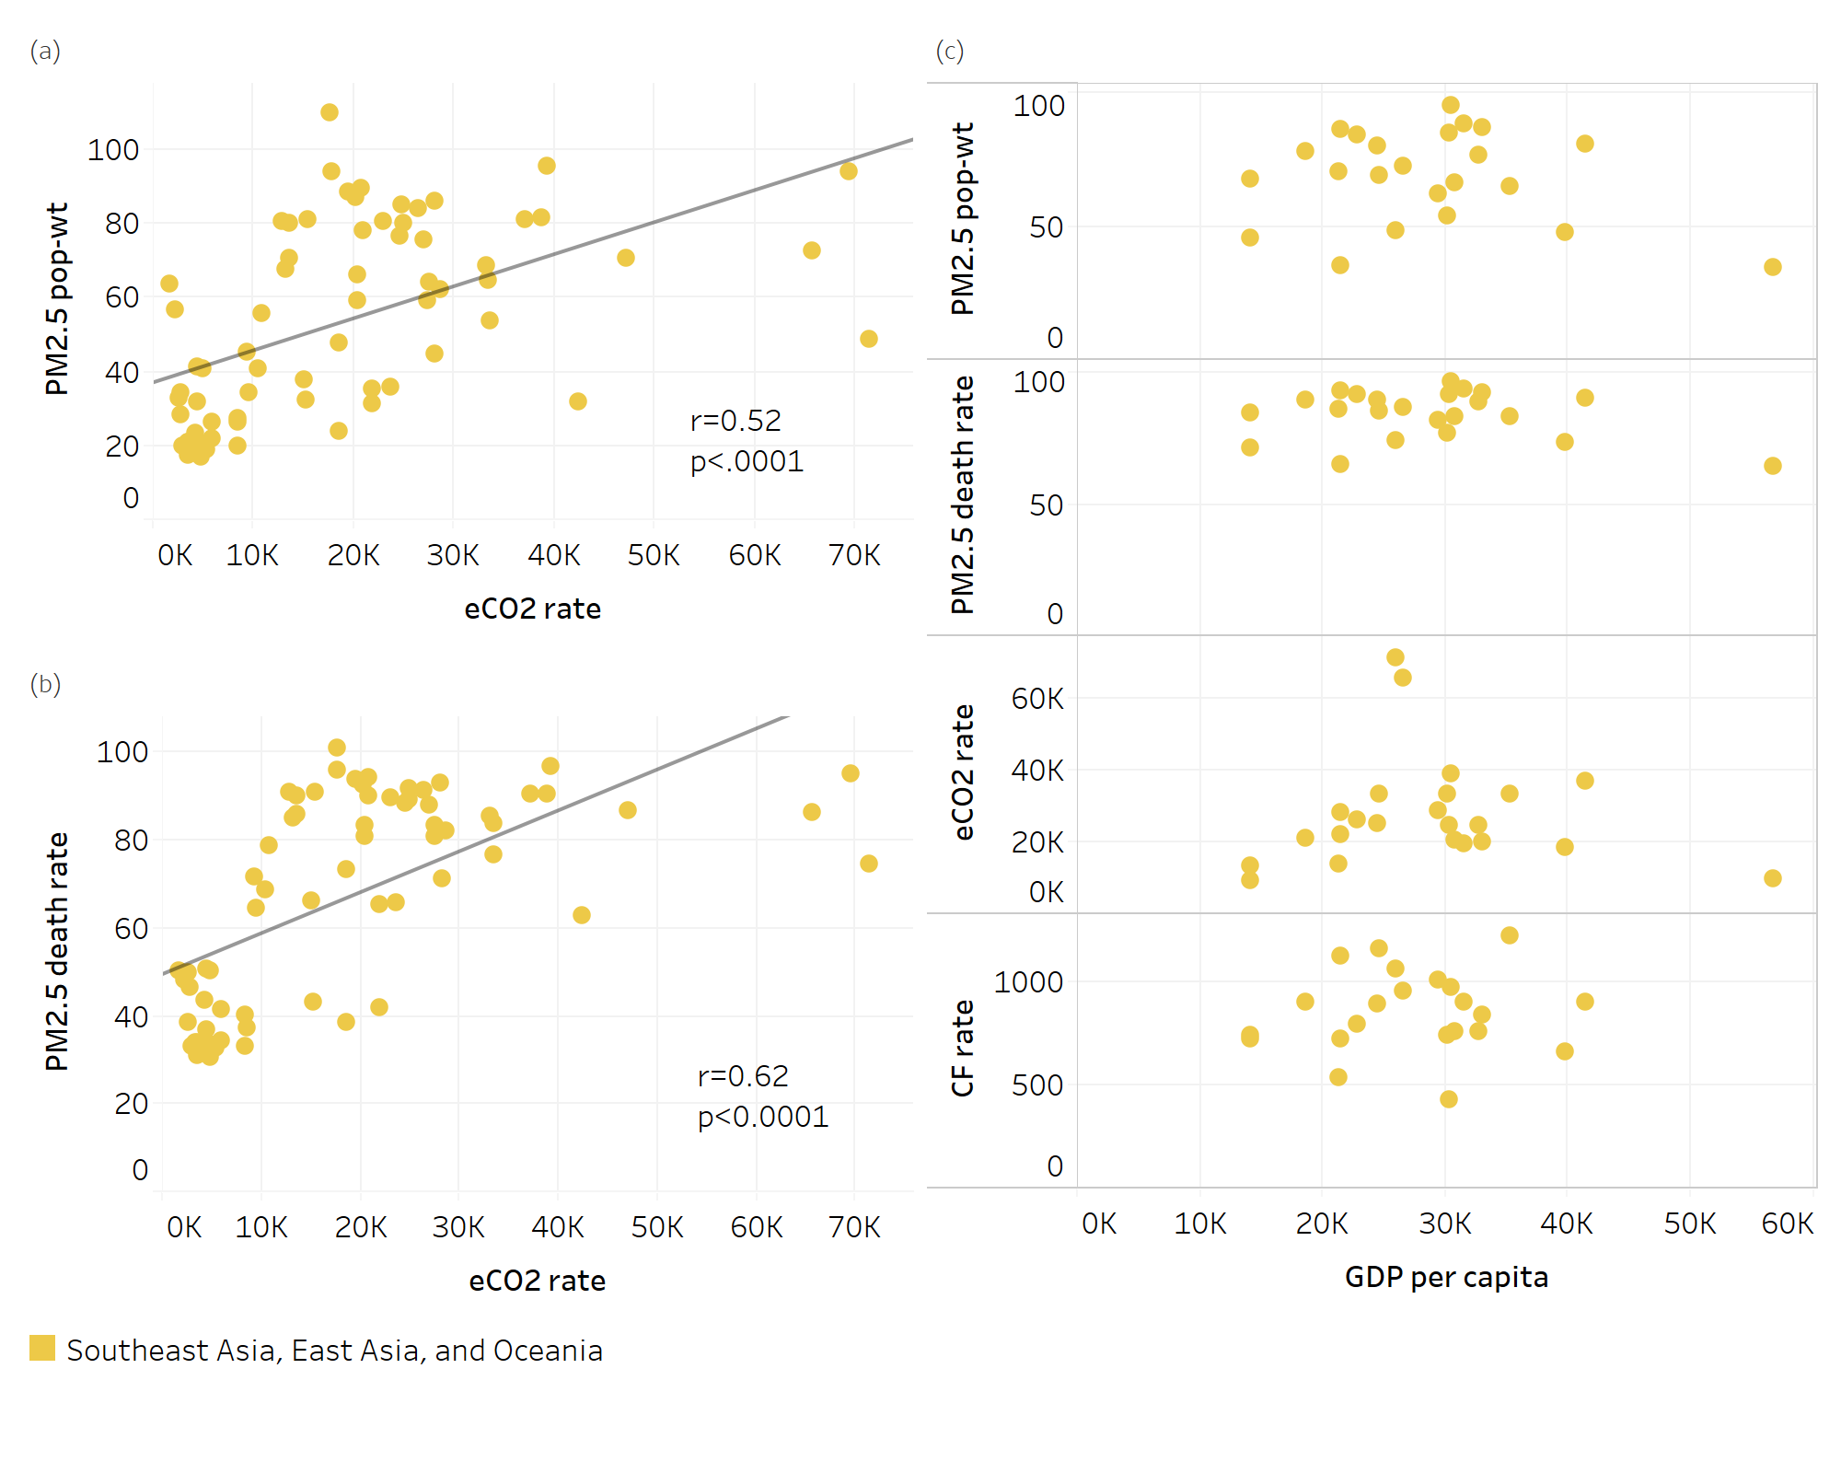
Figure S 9. As for Figure 2, but for the Southeast, East Asia, and Oceania super-region (n=69 for panels a and b, n=23 for panel c).
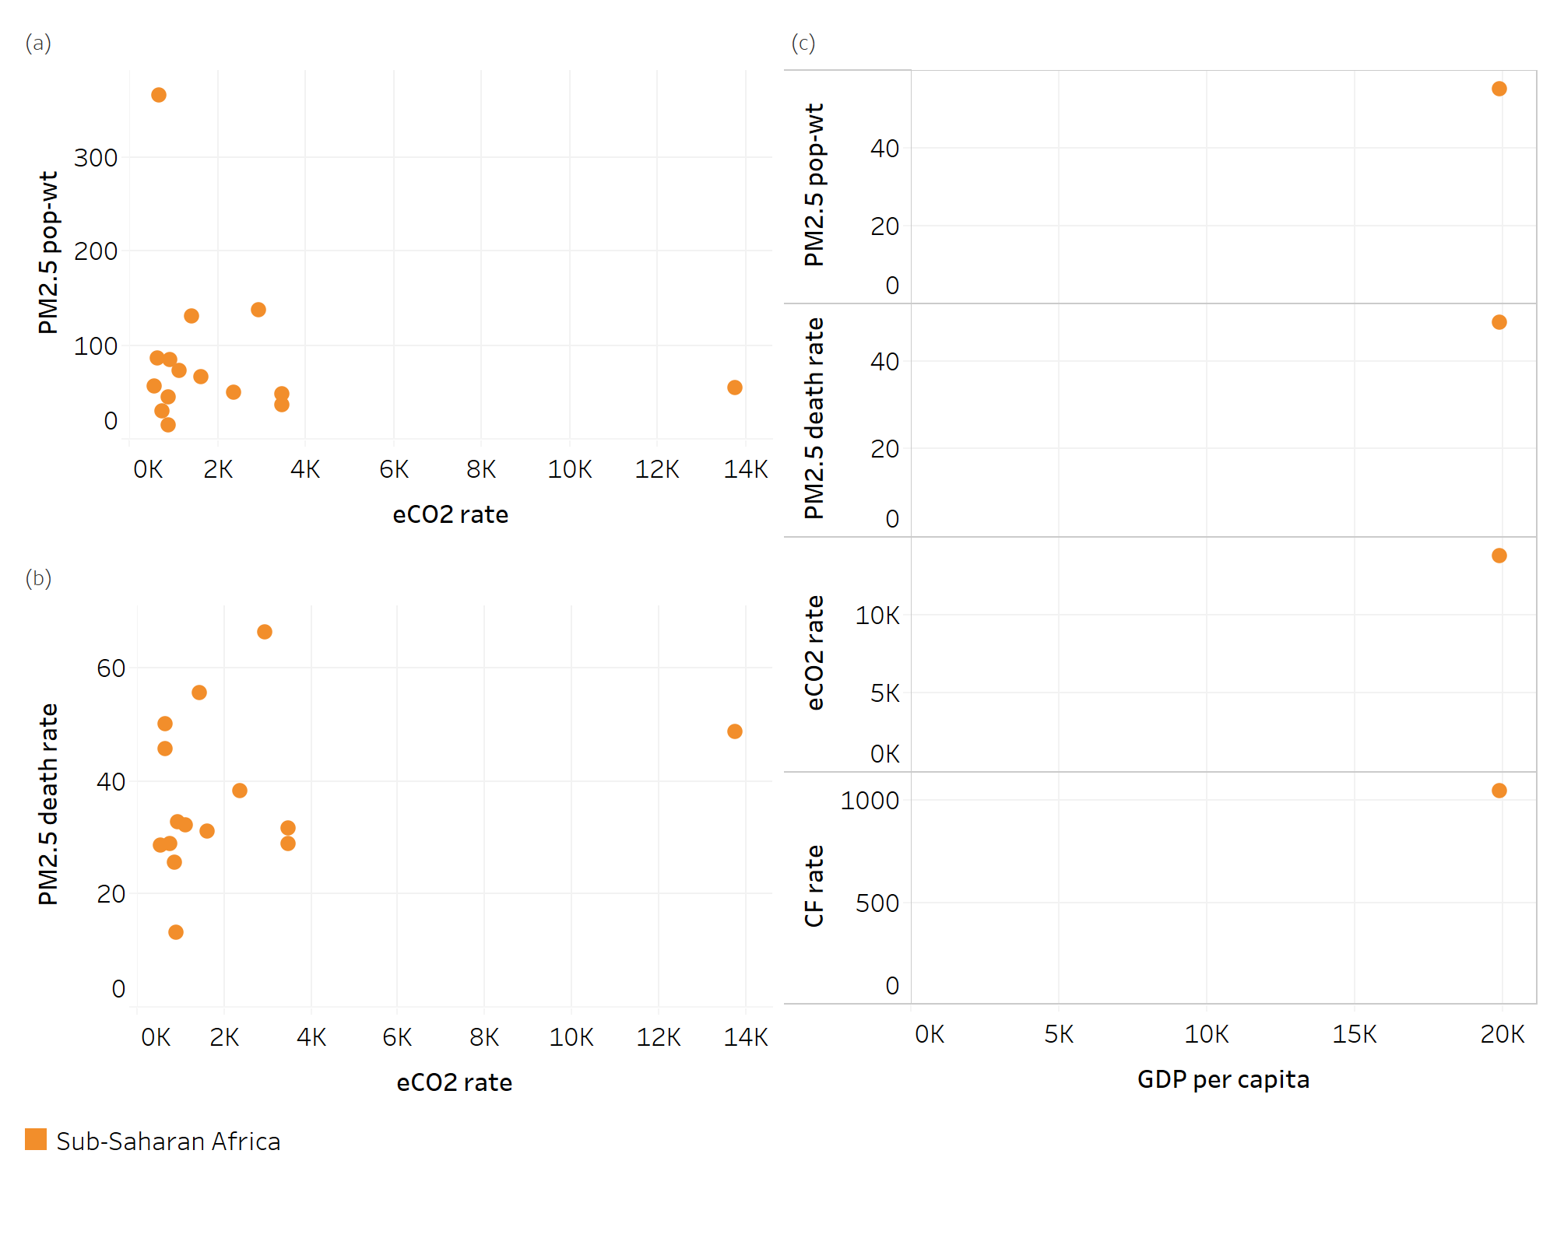
Figure S 10. As for Figure 2, but for the Sub-Saharan Africa super-region (n=15 for panels a and b, n=1 for panel c).
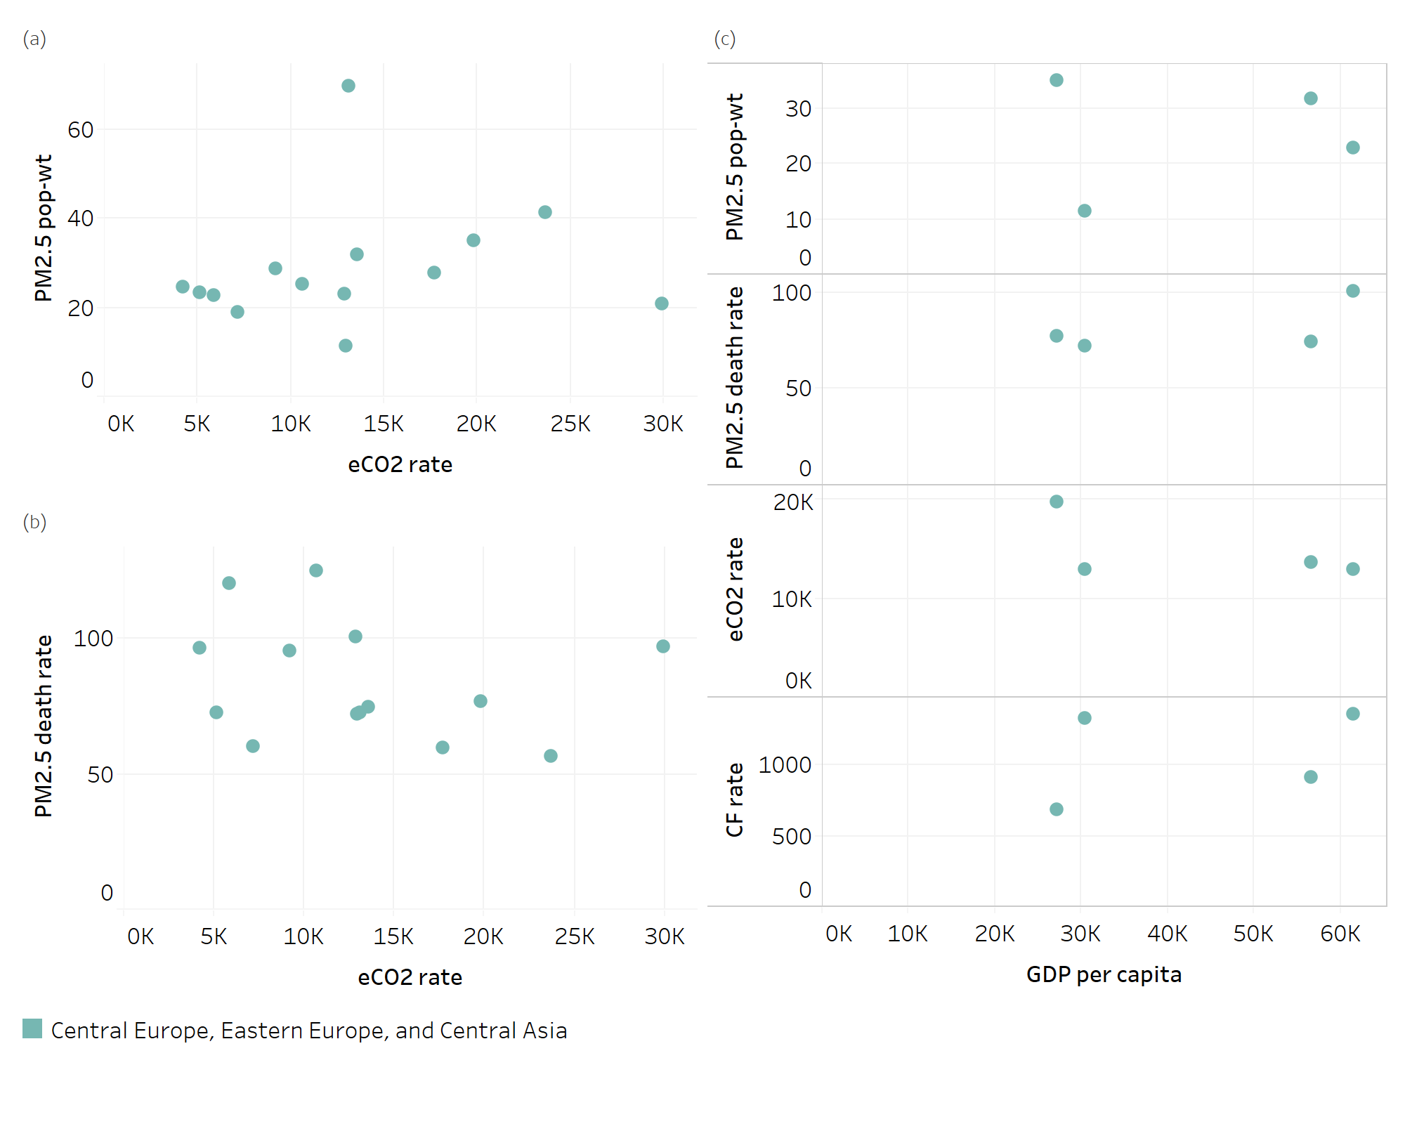
Figure S 11. As for Figure 2, but for the Central Europe, Eastern Europe, and Central Asia super-region (n=14 for panels a and b, n=4 for panel c).
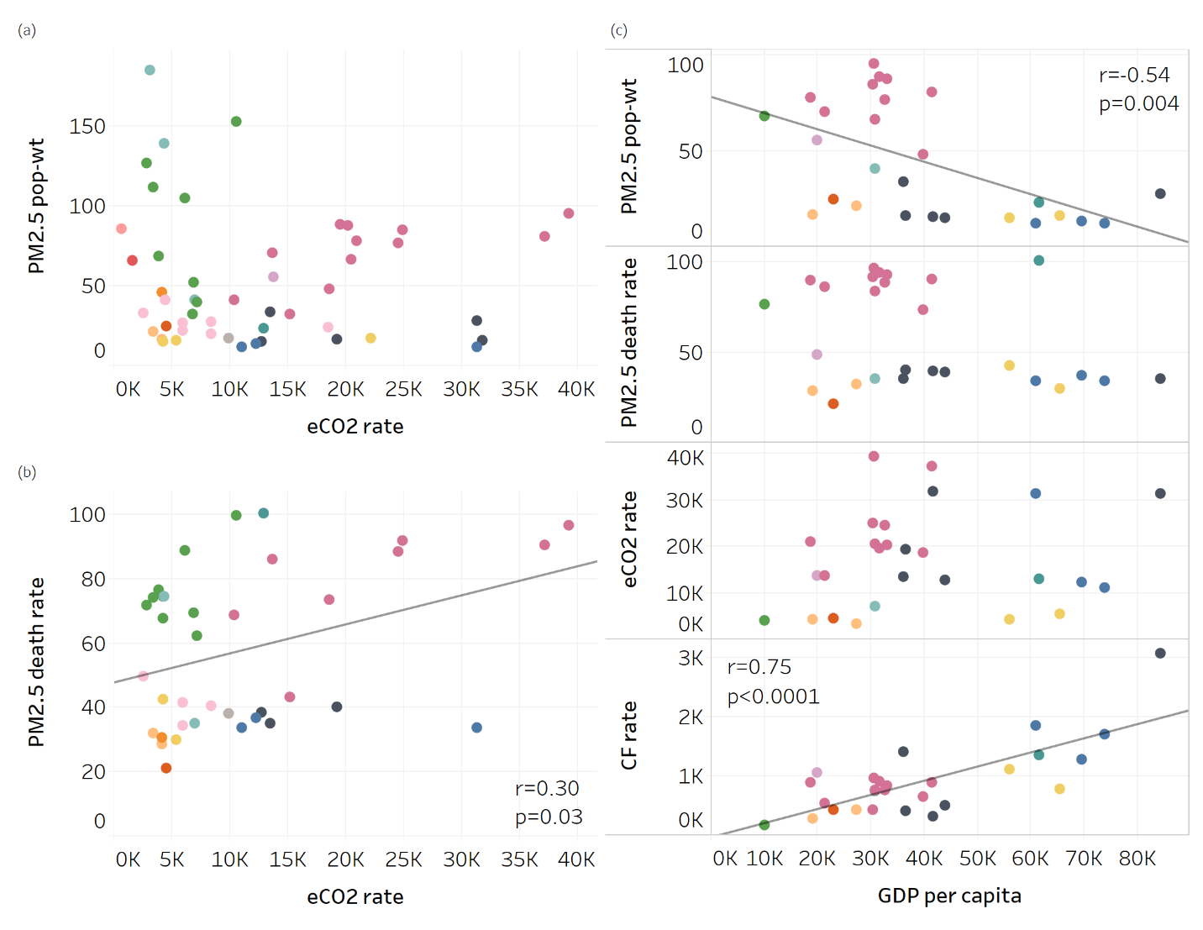
Figure S 12. As for Figure 2, but for the most populous 50 cities (n=50 for panels a and b, n=27 for panel c). See Figure 1 for color legends.

Table S 1. For each of the 250 urban areas analyzed, GBD region, population, population-weighted PM_{2.5} concentration (Popw PM_{2.5} in µg/m³), PM_{2.5} deaths, PM_{2.5} deaths 2.5th percentile and 97.5th percentile, and rank among all cities for PM_{2.5} deaths and PM_{2.5} deaths per 100,000 people. Results are all for 2016. In many cases, urban areas represent clusters of multiple cities. PM_{2.5} deaths are rounded to the nearest tens. Table is ordered by rank for PM_{2.5} deaths.
Urban area | Country | GBD region | GBD Super-region | Pop  2016 | Popw  PM2.5 | PM2.5 deaths | PM2.5 deaths 2.5 prctl | PM2.5 deaths 97.5 prctl | Rank PM2.5 deaths | Rank PM2.5 deaths per 100,000
Guangzhou | China | East Asia | Southeast Asia, East Asia, and Oceania | 4.15E+07 | 48 | 30,530 | 16,840 | 45,340 | 1 | 63
Cairo | Egypt | North Africa and Middle East | North Africa and Middle East | 3.42E+07 | 139 | 25,480 | 16,540 | 36,970 | 2 | 58
Shanghai | China | East Asia | Southeast Asia, East Asia, and Oceania | 2.39E+07 | 76 | 21,190 | 12,760 | 30,430 | 3 | 33
Kolkata | India | South Asia | South Asia | 2.31E+07 | 105 | 20,510 | 13,340 | 28,740 | 4 | 31
New Delhi | India | South Asia | South Asia | 2.03E+07 | 153 | 20,240 | 13,720 | 28,190 | 5 | 5
Beijing | China | East Asia | Southeast Asia, East Asia, and Oceania | 1.92E+07 | 85 | 17,660 | 10,810 | 25,230 | 6 | 19
Mumbai | India | South Asia | South Asia | 1.92E+07 | 68 | 14,750 | 9,060 | 21,020 | 7 | 54
Dhaka | Bangladesh | South Asia | South Asia | 1.97E+07 | 127 | 14,160 | 9,260 | 19,760 | 8 | 67
Moscow | Russia | Eastern Europe | Central Europe, Eastern Europe, and Central Asia | 1.37E+07 | 23 | 13,730 | 6,200 | 22,090 | 9 | 4
Tokyo | Japan | HI Asia Pacific | High-income | 3.11E+07 | 15 | 11,980 | 4,790 | 21,000 | 10 | 131
Manila | Philippines | Southeast Asia | Southeast Asia, East Asia, and Oceania | 2.17E+07 | 33 | 10,800 | 5,820 | 16,020 | 11 | 102
Jakarta | Indonesia | Southeast Asia | Southeast Asia, East Asia, and Oceania | 2.91E+07 | 22 | 10,060 | 4,470 | 16,200 | 12 | 154
Wuxi | China | East Asia | Southeast Asia, East Asia, and Oceania | 1.10E+07 | 81 | 9,990 | 6,080 | 14,290 | 13 | 23
Tianjin | China | East Asia | Southeast Asia, East Asia, and Oceania | 7.97E+06 | 95 | 7,700 | 4,820 | 10,910 | 14 | 8
Chengdu | China | East Asia | Southeast Asia, East Asia, and Oceania | 8.59E+06 | 70 | 7,380 | 4,380 | 10,660 | 15 | 38
Karachi | Pakistan | South Asia | South Asia | 9.74E+06 | 111 | 7,220 | 4,650 | 10,320 | 16 | 62
Shantou | China | East Asia | Southeast Asia, East Asia, and Oceania | 1.03E+07 | 41 | 7,080 | 3,780 | 10,650 | 17 | 73
Seoul | Korea, South | HI Asia Pacific | High-income | 1.97E+07 | 33 | 6,920 | 3,680 | 10,530 | 18 | 151
Wuhan | China | East Asia | Southeast Asia, East Asia, and Oceania | 7.01E+06 | 88 | 6,590 | 4,070 | 9,370 | 19 | 16
Sao Paulo | Brazil | Tropical Latin America | Latin America and Caribbean | 1.99E+07 | 21 | 6,400 | 2,980 | 10,200 | 20 | 176
Hangzhou | China | East Asia | Southeast Asia, East Asia, and Oceania | 7.17E+06 | 66 | 5,980 | 3,500 | 8,690 | 21 | 43
Johannesburg | South Africa | Southern sub-saharan Africa | Sub-Saharan Africa | 1.16E+07 | 55 | 5,640 | 3,580 | 7,840 | 22 | 104
Nanjing | China | East Asia | Southeast Asia, East Asia, and Oceania | 6.03E+06 | 87 | 5,590 | 3,430 | 7,970 | 23 | 18
Bangkok | Thailand | Southeast Asia | Southeast Asia, East Asia, and Oceania | 1.32E+07 | 28 | 5,310 | 2,780 | 8,080 | 24 | 121
Chennai | India | South Asia | South Asia | 8.48E+06 | 40 | 5,290 | 2,940 | 7,760 | 25 | 84
Hyderabad | India | South Asia | South Asia | 7.48E+06 | 52 | 5,190 | 3,050 | 7,490 | 26 | 72
Shenyeng | China | East Asia | Southeast Asia, East Asia, and Oceania | 5.39E+06 | 94 | 5,180 | 3,230 | 7,350 | 27 | 10
Los Angeles | United States | HI North America | High-income | 1.41E+07 | 13 | 5,170 | 2,060 | 8,960 | 28 | 145
New York | United States | HI North America | High-income | 1.51E+07 | 12 | 5,120 | 1,920 | 9,100 | 29 | 158
Xian | China | East Asia | Southeast Asia, East Asia, and Oceania | 5.47E+06 | 78 | 4,920 | 2,980 | 7,050 | 30 | 26
Osaka | Japan | HI Asia Pacific | High-income | 1.22E+07 | 16 | 4,920 | 2,040 | 8,470 | 30 | 122
Sohag | Egypt | North Africa and Middle East | North Africa and Middle East | 5.60E+06 | 185 | 4,530 | 3,040 | 6,530 | 32 | 49
Buenos Aires | Argentina | HI Southern Latin America | High-income | 1.17E+07 | 17 | 4,490 | 1,910 | 7,500 | 33 | 136
Istanbul | Turkey | North Africa and Middle East | North Africa and Middle East | 1.26E+07 | 41 | 4,430 | 2,440 | 6,600 | 34 | 149
Ho Chi Minh City | Vietnam | Southeast Asia | Southeast Asia, East Asia, and Oceania | 1.02E+07 | 26 | 4,230 | 2,020 | 6,740 | 35 | 120
Mexico City | Mexico | Central Latin America | Latin America and Caribbean | 1.99E+07 | 24 | 4,180 | 2,040 | 6,490 | 36 | 229
London | United Kingdom | HI Western Europe | High-income | 9.65E+06 | 15 | 4,100 | 1,670 | 7,070 | 37 | 115
Chongqing | China | East Asia | Southeast Asia, East Asia, and Oceania | 4.72E+06 | 67 | 4,010 | 2,370 | 5,800 | 38 | 40
Wenzhou | China | East Asia | Southeast Asia, East Asia, and Oceania | 5.40E+06 | 45 | 3,870 | 2,110 | 5,780 | 39 | 68
Zhengzhou | China | East Asia | Southeast Asia, East Asia, and Oceania | 4.17E+06 | 84 | 3,820 | 2,330 | 5,450 | 40 | 20
Bangalore | India | South Asia | South Asia | 6.51E+06 | 32 | 3,690 | 1,950 | 5,530 | 41 | 91
Harbin | China | East Asia | Southeast Asia, East Asia, and Oceania | 4.02E+06 | 80 | 3,610 | 2,190 | 5,170 | 42 | 27
Surat | India | South Asia | South Asia | 4.44E+06 | 73 | 3,480 | 2,170 | 4,950 | 43 | 51
Pune | India | South Asia | South Asia | 4.64E+06 | 62 | 3,450 | 2,090 | 4,930 | 44 | 61
Alexandria | Egypt | North Africa and Middle East | North Africa and Middle East | 4.76E+06 | 118 | 3,410 | 2,170 | 4,950 | 45 | 69
Hong Kong | China | East Asia | Southeast Asia, East Asia, and Oceania | 5.08E+06 | 34 | 3,280 | 1,700 | 5,010 | 46 | 82
Lahore | Pakistan | South Asia | South Asia | 4.79E+06 | 86 | 3,240 | 2,010 | 4,660 | 47 | 77
Shijianzhuang | China | East Asia | Southeast Asia, East Asia, and Oceania | 3.20E+06 | 110 | 3,230 | 2,060 | 4,560 | 48 | 3
Taipei | Taiwan | East Asia | Southeast Asia, East Asia, and Oceania | 7.38E+06 | 32 | 3,190 | 1,740 | 4,770 | 49 | 114
Lagos | Nigeria | Western sub-saharan Africa | Sub-Saharan Africa | 1.01E+07 | 66 | 3,120 | 2,220 | 4,050 | 50 | 185
Changchun | China | East Asia | Southeast Asia, East Asia, and Oceania | 3.26E+06 | 86 | 3,040 | 1,870 | 4,330 | 51 | 17
St. Petersburg | Russia | Eastern Europe | Central Europe, Eastern Europe, and Central Asia | 4.18E+06 | 11 | 3,010 | 1,050 | 5,510 | 52 | 66
Paris | French Republic | HI Western Europe | High-income | 9.88E+06 | 16 | 2,950 | 1,260 | 5,010 | 53 | 192
Hanoi | Vietnam | Southeast Asia | Southeast Asia, East Asia, and Oceania | 5.69E+06 | 41 | 2,890 | 1,550 | 4,340 | 54 | 45
Qingdao | China | East Asia | Southeast Asia, East Asia, and Oceania | 3.52E+06 | 62 | 2,890 | 1,680 | 4,210 | 54 | 97
Cologne | Germany | HI Western Europe | High-income | 5.75E+06 | 17 | 2,850 | 1,250 | 4,730 | 56 | 103
Taiyuan | China | East Asia | Southeast Asia, East Asia, and Oceania | 3.28E+06 | 71 | 2,840 | 1,700 | 4,100 | 57 | 36
Rio de Janeiro | Brazil | Tropical Latin America | Latin America and Caribbean | 9.82E+06 | 17 | 2,810 | 1,190 | 4,670 | 58 | 204
Kinshasa | Congo (Kinshasa) | Central sub-saharan Africa | Sub-Saharan Africa | 6.10E+06 | 86 | 2,800 | 1,870 | 3,790 | 59 | 79
Quanzhou | China | East Asia | Southeast Asia, East Asia, and Oceania | 4.24E+06 | 38 | 2,800 | 1,470 | 4,260 | 59 | 112
Dalian | China | East Asia | Southeast Asia, East Asia, and Oceania | 3.17E+06 | 65 | 2,650 | 1,550 | 3,850 | 61 | 42
Jinan | China | East Asia | Southeast Asia, East Asia, and Oceania | 3.07E+06 | 69 | 2,630 | 1,560 | 3,790 | 62 | 39
Chicago | United States | HI North America | High-income | 7.73E+06 | 12 | 2,610 | 980 | 4,640 | 63 | 161
Nagoya | Japan | HI Asia Pacific | High-income | 6.48E+06 | 15 | 2,550 | 1,040 | 4,430 | 64 | 126
Asyut | Egypt | North Africa and Middle East | North Africa and Middle East | 3.08E+06 | 190 | 2,510 | 1,690 | 3,620 | 65 | 46
Lima | Peru | Andean Latin America | Latin America and Caribbean | 7.94E+06 | 46 | 2,450 | 1,570 | 3,380 | 66 | 186
Kathmandu | Nepal | South Asia | South Asia | 3.47E+06 | 77 | 2,350 | 1,480 | 3,320 | 67 | 75
Nanchang | China | East Asia | Southeast Asia, East Asia, and Oceania | 2.95E+06 | 56 | 2,330 | 1,330 | 3,420 | 68 | 50
Asansol | India | South Asia | South Asia | 2.62E+06 | 104 | 2,320 | 1,510 | 3,250 | 69 | 34
Rangoon | Myanmar | Southeast Asia | Southeast Asia, East Asia, and Oceania | 4.79E+06 | 57 | 2,300 | 1,370 | 3,290 | 70 | 107
Singapore | Singapore | HI Asia Pacific | High-income | 6.48E+06 | 28 | 2,290 | 1,200 | 3,460 | 71 | 148
Peshawar | Pakistan | South Asia | South Asia | 3.66E+06 | 66 | 2,260 | 1,350 | 3,290 | 72 | 85
Kuala Lumpur | Malaysia | Southeast Asia | Southeast Asia, East Asia, and Oceania | 5.48E+06 | 24 | 2,120 | 1,030 | 3,290 | 73 | 130
Surabaya | Indonesia | Southeast Asia | Southeast Asia, East Asia, and Oceania | 6.10E+06 | 20 | 2,020 | 870 | 3,300 | 74 | 165
Faisalabad | Pakistan | South Asia | South Asia | 2.94E+06 | 88 | 2,000 | 1,250 | 2,870 | 75 | 74
Fuzhou | China | East Asia | Southeast Asia, East Asia, and Oceania | 3.05E+06 | 35 | 2,000 | 1,040 | 3,040 | 75 | 81
Milan | Italy | HI Western Europe | High-income | 3.96E+06 | 24 | 1,980 | 960 | 3,150 | 77 | 101
Kunming | China | East Asia | Southeast Asia, East Asia, and Oceania | 2.94E+06 | 36 | 1,930 | 1,010 | 2,940 | 78 | 80
Kiev | Ukraine | Eastern Europe | Central Europe, Eastern Europe, and Central Asia | 1.54E+06 | 25 | 1,920 | 880 | 3,040 | 79 | 1
Ningbo | China | East Asia | Southeast Asia, East Asia, and Oceania | 2.47E+06 | 54 | 1,890 | 1,060 | 2,790 | 80 | 53
Chittagong | Bangladesh | South Asia | South Asia | 3.13E+06 | 76 | 1,880 | 1,140 | 2,670 | 81 | 87
Bandung | Indonesia | Southeast Asia | Southeast Asia, East Asia, and Oceania | 5.07E+06 | 21 | 1,720 | 750 | 2,780 | 82 | 159
Tehran | Iran | North Africa and Middle East | North Africa and Middle East | 5.15E+06 | 41 | 1,700 | 920 | 2,550 | 83 | 167
Athens | Greece | HI Western Europe | High-income | 3.03E+06 | 13 | 1,690 | 650 | 3,030 | 84 | 94
Kano | Nigeria | Western sub-saharan Africa | Sub-Saharan Africa | 3.36E+06 | 365 | 1,680 | 1,290 | 2,050 | 85 | 100
Bucharest | Romania | Central Europe | Central Europe, Eastern Europe, and Central Asia | 1.71E+06 | 25 | 1,650 | 770 | 2,640 | 86 | 9
Colombo | Sri Lanka | Southeast Asia | Southeast Asia, East Asia, and Oceania | 4.43E+06 | 32 | 1,640 | 830 | 2,510 | 87 | 142
Budapest | Hungary | Central Europe | Central Europe, Eastern Europe, and Central Asia | 1.67E+06 | 29 | 1,600 | 800 | 2,480 | 88 | 12
Baghdad | Iraq | North Africa and Middle East | North Africa and Middle East | 3.31E+06 | 91 | 1,580 | 960 | 2,300 | 89 | 109
Baotou | China | East Asia | Southeast Asia, East Asia, and Oceania | 1.92E+06 | 59 | 1,560 | 900 | 2,280 | 90 | 47
Naples | Italy | HI Western Europe | High-income | 3.62E+06 | 17 | 1,530 | 670 | 2,570 | 91 | 117
San Francisco | United States | HI North America | High-income | 4.55E+06 | 11 | 1,500 | 550 | 2,700 | 92 | 168
Dallas | United States | HI North America | High-income | 4.94E+06 | 10 | 1,490 | 510 | 2,760 | 93 | 191
Manchester | United Kingdom | HI Western Europe | High-income | 3.79E+06 | 13 | 1,480 | 570 | 2,640 | 94 | 128
Tangshan | China | East Asia | Southeast Asia, East Asia, and Oceania | 1.63E+06 | 80 | 1,460 | 880 | 2,090 | 95 | 28
Dar es Salaam | United Republic of Tanzania | Eastern sub-saharan Africa | Sub-Saharan Africa | 4.90E+06 | 30 | 1,420 | 770 | 2,100 | 96 | 199
Santiago | Chile | HI Southern Latin America | High-income | 4.34E+06 | 32 | 1,400 | 740 | 2,110 | 97 | 174
Surakarta | Indonesia | Southeast Asia | Southeast Asia, East Asia, and Oceania | 4.29E+06 | 19 | 1,380 | 580 | 2,280 | 98 | 175
Anshan | China | East Asia | Southeast Asia, East Asia, and Oceania | 1.45E+06 | 90 | 1,370 | 850 | 1,950 | 99 | 14
Casablanca | Morocco | North Africa and Middle East | North Africa and Middle East | 3.86E+06 | 24 | 1,360 | 640 | 2,120 | 100 | 150
Miami | United States | HI North America | High-income | 5.45E+06 | 8 | 1,350 | 380 | 2,690 | 101 | 218
Jiaojing | China | East Asia | Southeast Asia, East Asia, and Oceania | 1.88E+06 | 45 | 1,350 | 730 | 2,010 | 101 | 70
Houston | United States | HI North America | High-income | 4.70E+06 | 9 | 1,340 | 440 | 2,540 | 103 | 203
Accra | Ghana | Western sub-saharan Africa | Sub-Saharan Africa | 3.43E+06 | 49 | 1,320 | 810 | 1,850 | 104 | 134
Algiers | Algeria | North Africa and Middle East | North Africa and Middle East | 4.30E+06 | 38 | 1,310 | 680 | 1,990 | 105 | 55
Nagpur | India | South Asia | South Asia | 1.72E+06 | 68 | 1,310 | 800 | 1,870 | 105 | 189
Philadelphia | United States | HI North America | High-income | 3.83E+06 | 12 | 1,300 | 490 | 2,310 | 107 | 155
Toronto | Canada | HI North America | High-income | 5.32E+06 | 10 | 1,240 | 410 | 2,340 | 108 | 44
Luoyang | China | East Asia | Southeast Asia, East Asia, and Oceania | 1.49E+06 | 64 | 1,240 | 730 | 1,800 | 108 | 223
Luanda | Angola | Central sub-saharan Africa | Sub-Saharan Africa | 4.25E+06 | 49 | 1,220 | 750 | 1,720 | 110 | 200
Berlin | Germany | HI Western Europe | High-income | 2.49E+06 | 16 | 1,200 | 510 | 2,010 | 111 | 60
Warsaw | Poland | Central Europe | Central Europe, Eastern Europe, and Central Asia | 1.62E+06 | 32 | 1,200 | 630 | 1,830 | 111 | 106
Tashkent | Uzbekistan | Central Asia | Central Europe, Eastern Europe, and Central Asia | 1.64E+06 | 70 | 1,190 | 690 | 1,760 | 113 | 35
Linyi | China | East Asia | Southeast Asia, East Asia, and Oceania | 1.36E+06 | 75 | 1,190 | 720 | 1,720 | 113 | 65
Zibo | China | East Asia | Southeast Asia, East Asia, and Oceania | 1.36E+06 | 73 | 1,180 | 700 | 1,700 | 115 | 37
Washington, D.C. | United States | HI North America | High-income | 3.51E+06 | 11 | 1,170 | 430 | 2,090 | 116 | 164
Dhanbad | India | South Asia | South Asia | 1.31E+06 | 103 | 1,160 | 760 | 1,630 | 117 | 32
Lucknow | India | South Asia | South Asia | 1.15E+06 | 141 | 1,120 | 750 | 1,560 | 118 | 6
Port-au-Prince | Haiti | Caribbean | Latin America and Caribbean | 2.36E+06 | 31 | 1,110 | 540 | 1,710 | 119 | 110
Rome | Italy | HI Western Europe | High-income | 2.73E+06 | 15 | 1,070 | 450 | 1,840 | 120 | 127
Handan | China | East Asia | Southeast Asia, East Asia, and Oceania | 1.12E+06 | 94 | 1,070 | 660 | 1,520 | 120 | 13
Ouagadougou | Burkina Faso | Western sub-saharan Africa | Sub-Saharan Africa | 1.88E+06 | 131 | 1,050 | 760 | 1,340 | 122 | 113
Chandigarh | India | South Asia | South Asia | 1.18E+06 | 107 | 1,050 | 680 | 1,470 | 122 | 29
Cebu | Philippines | Southeast Asia | Southeast Asia, East Asia, and Oceania | 2.42E+06 | 23 | 1,050 | 510 | 1,630 | 122 | 95
San Diego | United States | HI North America | High-income | 3.73E+06 | 12 | 1,040 | 380 | 1,880 | 125 | 210
Detroit | United States | HI North America | High-income | 3.08E+06 | 12 | 1,040 | 400 | 1,830 | 125 | 202
Orlu | Nigeria | Western sub-saharan Africa | Sub-Saharan Africa | 3.64E+06 | 56 | 1,040 | 730 | 1,370 | 125 | 162
Barcelona | Kingdom of Spain | HI Western Europe | High-income | 3.41E+06 | 12 | 1,030 | 390 | 1,840 | 128 | 190
Madrid | Kingdom of Spain | HI Western Europe | High-income | 3.62E+06 | 11 | 1,020 | 370 | 1,870 | 129 | 209
Phoenix | United States | HI North America | High-income | 3.49E+06 | 10 | 1,010 | 340 | 1,900 | 130 | 198
Taichung | Taiwan | East Asia | Southeast Asia, East Asia, and Oceania | 2.35E+06 | 32 | 990 | 530 | 1,490 | 131 | 118
Medan | Indonesia | Southeast Asia | Southeast Asia, East Asia, and Oceania | 2.64E+06 | 26 | 980 | 460 | 1,550 | 132 | 141
Santo Domingo | Dominican Republic | Caribbean | Latin America and Caribbean | 3.10E+06 | 35 | 960 | 480 | 1,490 | 133 | 184
Belo Horizonte | Brazil | Tropical Latin America | Latin America and Caribbean | 4.11E+06 | 12 | 960 | 340 | 1,720 | 133 | 21
Kochi | India | South Asia | South Asia | 1.69E+06 | 32 | 960 | 500 | 1,430 | 133 | 93
Anyang | China | East Asia | Southeast Asia, East Asia, and Oceania | 1.05E+06 | 81 | 960 | 580 | 1,370 | 133 | 224
Birmingham | United Kingdom | HI Western Europe | High-income | 2.47E+06 | 13 | 950 | 360 | 1,700 | 137 | 135
Rotterdam | Kingdom of the Netherlands | HI Western Europe | High-income | 2.41E+06 | 17 | 920 | 400 | 1,550 | 138 | 137
Katowice | Poland | Central Europe | Central Europe, Eastern Europe, and Central Asia | 1.19E+06 | 35 | 920 | 490 | 1,390 | 138 | 52
Busan | Korea, South | HI Asia Pacific | High-income | 2.89E+06 | 26 | 900 | 450 | 1,420 | 140 | 182
Guadalajara | Mexico | Central Latin America | Latin America and Caribbean | 4.59E+06 | 20 | 870 | 400 | 1,400 | 141 | 238
Monterrey | Mexico | Central Latin America | Latin America and Caribbean | 4.23E+06 | 23 | 860 | 410 | 1,350 | 142 | 172
Semarang | Indonesia | Southeast Asia | Southeast Asia, East Asia, and Oceania | 2.65E+06 | 19 | 860 | 370 | 1,420 | 142 | 232
Agra | India | South Asia | South Asia | 8.91E+05 | 130 | 850 | 570 | 1,190 | 144 | 11
Bamako | Mali | Western sub-saharan Africa | Sub-Saharan Africa | 2.51E+06 | 85 | 830 | 550 | 1,120 | 145 | 170
Xining | China | East Asia | Southeast Asia, East Asia, and Oceania | 9.67E+05 | 59 | 780 | 450 | 1,140 | 146 | 48
Vishakhapatnam | India | South Asia | South Asia | 1.14E+06 | 48 | 770 | 450 | 1,120 | 147 | 76
Curitiba | Brazil | Tropical Latin America | Latin America and Caribbean | 2.67E+06 | 17 | 760 | 320 | 1,260 | 148 | 208
Almaty | Kazakhstan | Central Asia | Central Europe, Eastern Europe, and Central Asia | 1.25E+06 | 28 | 750 | 350 | 1,180 | 149 | 88
Ankara | Turkey | North Africa and Middle East | North Africa and Middle East | 1.93E+06 | 48 | 720 | 410 | 1,060 | 150 | 140
Montreal | Canada | HI North America | High-income | 3.00E+06 | 10 | 710 | 240 | 1,340 | 151 | 221
Chelyabinsk | Russia | Eastern Europe | Central Europe, Eastern Europe, and Central Asia | 7.30E+05 | 21 | 710 | 310 | 1,150 | 151 | 7
Yantai | China | East Asia | Southeast Asia, East Asia, and Oceania | 9.43E+05 | 49 | 700 | 390 | 1,040 | 153 | 59
Indore | India | South Asia | South Asia | 9.03E+05 | 66 | 680 | 420 | 970 | 154 | 56
Mandalay | Myanmar | Southeast Asia | Southeast Asia, East Asia, and Oceania | 1.31E+06 | 63 | 660 | 400 | 930 | 155 | 99
Zhenjiang | China | East Asia | Southeast Asia, East Asia, and Oceania | 7.23E+05 | 80 | 660 | 400 | 940 | 155 | 22
Ibadan | Nigeria | Western sub-saharan Africa | Sub-Saharan Africa | 2.01E+06 | 73 | 650 | 470 | 840 | 157 | 173
Kollam | India | South Asia | South Asia | 1.24E+06 | 27 | 650 | 320 | 990 | 157 | 96
Phnom Penh | Cambodia | Southeast Asia | Southeast Asia, East Asia, and Oceania | 1.68E+06 | 34 | 650 | 330 | 980 | 157 | 132
Lisbon | Portugal | HI Western Europe | High-income | 1.73E+06 | 11 | 640 | 210 | 1,230 | 160 | 144
Seattle | United States | HI North America | High-income | 2.47E+06 | 8 | 620 | 180 | 1,230 | 161 | 216
Boston | United States | HI North America | High-income | 2.12E+06 | 10 | 620 | 210 | 1,160 | 161 | 116
Leeds | United Kingdom | HI Western Europe | High-income | 1.61E+06 | 13 | 620 | 240 | 1,110 | 161 | 196
Vienna | Austria | HI Western Europe | High-income | 1.46E+06 | 20 | 620 | 290 | 990 | 161 | 133
Turin | Italy | HI Western Europe | High-income | 1.27E+06 | 22 | 610 | 290 | 970 | 165 | 41
Bhilai | India | South Asia | South Asia | 7.21E+05 | 96 | 610 | 390 | 860 | 165 | 108
Las Vegas | United States | HI North America | High-income | 2.05E+06 | 10 | 600 | 200 | 1,130 | 167 | 195
Bogota | Colombia | Central Latin America | Latin America and Caribbean | 2.81E+06 | 20 | 590 | 270 | 940 | 168 | 230
Sydney | Australia | HI Australasia | High-income | 3.84E+06 | 7 | 590 | 140 | 1,260 | 168 | 247
Guatemala | Guatemala | Central Latin America | Latin America and Caribbean | 2.24E+06 | 32 | 580 | 340 | 840 | 170 | 214
Marietta | United States | HI North America | High-income | 1.95E+06 | 10 | 580 | 200 | 1,080 | 170 | 194
Fukuoka | Japan | HI Asia Pacific | High-income | 1.37E+06 | 17 | 580 | 250 | 980 | 170 | 119
Salvador | Brazil | Tropical Latin America | Latin America and Caribbean | 3.03E+06 | 9 | 560 | 160 | 1,100 | 173 | 240
Campinas | Brazil | Tropical Latin America | Latin America and Caribbean | 1.74E+06 | 20 | 550 | 250 | 880 | 174 | 86
Prague | Czech Republic | Central Europe | Central Europe, Eastern Europe, and Central Asia | 9.12E+05 | 19 | 550 | 250 | 890 | 174 | 2
Zaporizhzhya | Ukraine | Eastern Europe | Central Europe, Eastern Europe, and Central Asia | 4.58E+05 | 23 | 550 | 250 | 880 | 174 | 83
Zhanjiang | China | East Asia | Southeast Asia, East Asia, and Oceania | 8.67E+05 | 32 | 550 | 280 | 840 | 174 | 181
Luohe | China | East Asia | Southeast Asia, East Asia, and Oceania | 5.94E+05 | 80 | 540 | 330 | 770 | 178 | 25
Melbourne | Australia | HI Australasia | High-income | 3.40E+06 | 7 | 530 | 130 | 1,130 | 179 | 246
Caracas | Venezuela | Central Latin America | Latin America and Caribbean | 1.82E+06 | 31 | 520 | 270 | 790 | 180 | 249
Fortaleza | Brazil | Tropical Latin America | Latin America and Caribbean | 3.13E+06 | 8 | 520 | 130 | 1,070 | 180 | 64
Belgrade | Republic of Serbia | Central Europe | Central Europe, Eastern Europe, and Central Asia | 7.18E+05 | 23 | 520 | 240 | 850 | 180 | 245
Amman | Jordan | North Africa and Middle East | North Africa and Middle East | 2.40E+06 | 42 | 520 | 280 | 770 | 180 | 205
Nairobi | Kenya | Eastern sub-saharan Africa | Sub-Saharan Africa | 3.99E+06 | 15 | 520 | 200 | 910 | 180 | 227
Denver | United States | HI North America | High-income | 1.97E+06 | 8 | 510 | 150 | 1,010 | 185 | 213
Angeles | Philippines | Southeast Asia | Southeast Asia, East Asia, and Oceania | 1.09E+06 | 28 | 510 | 260 | 770 | 185 | 111
Xuchang | China | East Asia | Southeast Asia, East Asia, and Oceania | 5.57E+05 | 81 | 500 | 310 | 720 | 187 | 24
Niteroi | Brazil | Tropical Latin America | Latin America and Caribbean | 1.62E+06 | 18 | 480 | 210 | 790 | 188 | 178
Harare | Zimbabwe | Southern sub-saharan Africa | Sub-Saharan Africa | 1.52E+06 | 36 | 480 | 270 | 710 | 188 | 193
Rabat | Morocco | North Africa and Middle East | North Africa and Middle East | 1.38E+06 | 22 | 470 | 220 | 740 | 190 | 98
Haiphong | Vietnam | Southeast Asia | Southeast Asia, East Asia, and Oceania | 9.33E+05 | 41 | 470 | 250 | 710 | 190 | 156
Goiania | Brazil | Tropical Latin America | Latin America and Caribbean | 1.87E+06 | 13 | 460 | 170 | 810 | 192 | 219
Minneapolis | United States | HI North America | High-income | 1.57E+06 | 9 | 450 | 150 | 840 | 193 | 206
Denpasar | Indonesia | Southeast Asia | Southeast Asia, East Asia, and Oceania | 1.45E+06 | 17 | 450 | 180 | 750 | 193 | 187
Baltimore | United States | HI North America | High-income | 1.34E+06 | 11 | 440 | 160 | 800 | 195 | 169
Port Harcourt | Nigeria | Western sub-saharan Africa | Sub-Saharan Africa | 1.72E+06 | 44 | 440 | 290 | 590 | 195 | 215
Puebla | Mexico | Central Latin America | Latin America and Caribbean | 2.07E+06 | 23 | 420 | 200 | 660 | 197 | 233
Ciudad Juarez | Mexico | Central Latin America | Latin America and Caribbean | 1.85E+06 | 18 | 410 | 170 | 700 | 198 | 212
Orlando | United States | HI North America | High-income | 1.53E+06 | 9 | 410 | 130 | 800 | 198 | 105
Stuttgart | Germany | HI Western Europe | High-income | 8.51E+05 | 16 | 410 | 180 | 690 | 198 | 226
Meerut | India | South Asia | South Asia | 4.34E+05 | 128 | 410 | 270 | 570 | 198 | 15
Rawalpindi | Pakistan | South Asia | South Asia | 6.78E+05 | 59 | 400 | 240 | 590 | 202 | 89
Coimbatore | India | South Asia | South Asia | 6.79E+05 | 36 | 400 | 220 | 600 | 202 | 90
Maracaibo | Venezuela | Central Latin America | Latin America and Caribbean | 1.25E+06 | 40 | 390 | 210 | 580 | 204 | 180
Cirebon | Indonesia | Southeast Asia | Southeast Asia, East Asia, and Oceania | 1.14E+06 | 21 | 390 | 170 | 630 | 204 | 157
Columbus | United States | HI North America | High-income | 1.07E+06 | 12 | 380 | 140 | 660 | 206 | 124
Glasgow | United Kingdom | HI Western Europe | High-income | 9.60E+05 | 14 | 380 | 150 | 670 | 206 | 146
Aleppo | Syria | North Africa and Middle East | North Africa and Middle East | 1.04E+06 | 45 | 380 | 200 | 570 | 206 | 153
Porto | Portugal | HI Western Europe | High-income | 1.03E+06 | 11 | 370 | 120 | 720 | 209 | 30
Ludhiana | India | South Asia | South Asia | 4.19E+05 | 107 | 370 | 240 | 520 | 209 | 147
San Antonio | United States | HI North America | High-income | 1.34E+06 | 9 | 360 | 110 | 700 | 211 | 211
Marrakesh | Morocco | North Africa and Middle East | North Africa and Middle East | 9.12E+05 | 30 | 360 | 180 | 540 | 211 | 125
Fez | Morocco | North Africa and Middle East | North Africa and Middle East | 9.71E+05 | 26 | 360 | 180 | 550 | 211 | 143
Tegal | Indonesia | Southeast Asia | Southeast Asia, East Asia, and Oceania | 1.08E+06 | 20 | 360 | 150 | 580 | 211 | 166
Barranquilla | Colombia | Central Latin America | Latin America and Caribbean | 1.43E+06 | 26 | 340 | 170 | 530 | 215 | 220
Douala | Cameroon | Western sub-saharan Africa | Sub-Saharan Africa | 5.10E+05 | 137 | 340 | 240 | 440 | 215 | 78
Cleveland | United States | HI North America | High-income | 1.05E+06 | 11 | 330 | 120 | 610 | 217 | 179
Vitiria | Brazil | Tropical Latin America | Latin America and Caribbean | 1.47E+06 | 12 | 330 | 120 | 600 | 217 | 225
Ashgabat | Turkmenistan | Central Asia | Central Europe, Eastern Europe, and Central Asia | 5.82E+05 | 41 | 330 | 170 | 500 | 217 | 92
San Jose | Costa Rica | Central Latin America | Latin America and Caribbean | 1.66E+06 | 22 | 310 | 150 | 490 | 220 | 57
Kansas City | United States | HI North America | High-income | 1.09E+06 | 9 | 310 | 100 | 590 | 220 | 239
Cuttack | India | South Asia | South Asia | 4.17E+05 | 64 | 310 | 190 | 450 | 220 | 201
Gaza | Israel | HI Western Europe | High-income | 1.25E+06 | 23 | 300 | 140 | 470 | 223 | 222
Maebashi | Japan | HI Asia Pacific | High-income | 7.98E+05 | 14 | 300 | 120 | 530 | 223 | 139
Leon | Mexico | Central Latin America | Latin America and Caribbean | 1.48E+06 | 21 | 290 | 140 | 460 | 225 | 236
Valencia | Kingdom of Spain | HI Western Europe | High-income | 1.00E+06 | 11 | 290 | 100 | 520 | 225 | 123
Riyadh | Saudi Arabia | North Africa and Middle East | North Africa and Middle East | 7.21E+05 | 280 | 290 | 210 | 400 | 225 | 207
Dublin | Ireland | HI Western Europe | High-income | 1.09E+06 | 11 | 270 | 100 | 500 | 228 | 217
Cordoba | Argentina | HI Southern Latin America | High-income | 7.35E+05 | 14 | 250 | 100 | 430 | 229 | 129
Sdo Lu1s | Brazil | Tropical Latin America | Latin America and Caribbean | 1.23E+06 | 10 | 250 | 80 | 470 | 229 | 160
Kitakyushu | Japan | HI Asia Pacific | High-income | 6.43E+05 | 15 | 250 | 100 | 440 | 229 | 234
Calgary | Canada | HI North America | High-income | 1.15E+06 | 8 | 240 | 70 | 470 | 232 | 188
Virginia Beach | United States | HI North America | High-income | 7.96E+05 | 10 | 240 | 80 | 450 | 232 | 152
Gwangju | Korea, South | HI Asia Pacific | High-income | 6.88E+05 | 33 | 240 | 130 | 370 | 232 | 231
Tasikmalaya | Indonesia | Southeast Asia | Southeast Asia, East Asia, and Oceania | 6.86E+05 | 17 | 210 | 90 | 360 | 235 | 183
Torreon | Mexico | Central Latin America | Latin America and Caribbean | 1.02E+06 | 20 | 200 | 90 | 310 | 236 | 177
Bursa | Turkey | North Africa and Middle East | North Africa and Middle East | 6.22E+05 | 34 | 200 | 100 | 300 | 236 | 237
San Luis Potosi | Mexico | Central Latin America | Latin America and Caribbean | 1.06E+06 | 18 | 190 | 80 | 310 | 238 | 163
Bandar Lampung | Indonesia | Southeast Asia | Southeast Asia, East Asia, and Oceania | 5.72E+05 | 20 | 190 | 80 | 310 | 238 | 241
Pakalongan | Indonesia | Southeast Asia | Southeast Asia, East Asia, and Oceania | 5.36E+05 | 19 | 180 | 70 | 290 | 240 | 171
Merida | Mexico | Central Latin America | Latin America and Caribbean | 9.50E+05 | 16 | 160 | 70 | 270 | 241 | 244
Tampico | Mexico | Central Latin America | Latin America and Caribbean | 7.62E+05 | 22 | 150 | 70 | 240 | 242 | 235
Stockholm | Sweden | HI Western Europe | High-income | 1.16E+06 | 5 | 150 | - | 460 | 242 | 250
Saltillo | Mexico | Central Latin America | Latin America and Caribbean | 7.71E+05 | 17 | 140 | 60 | 220 | 244 | 243
Acapulco | Mexico | Central Latin America | Latin America and Caribbean | 7.15E+05 | 17 | 130 | 50 | 210 | 245 | 242
Tuxtla Gutierrez | Mexico | Central Latin America | Latin America and Caribbean | 5.76E+05 | 26 | 120 | 60 | 190 | 246 | 228
Charlotte | United States | HI North America | High-income | 3.91E+05 | 10 | 110 | 40 | 210 | 247 | 197
Haarlem | Kingdom of the Netherlands | HI Western Europe | High-income | 2.84E+05 | 16 | 110 | 50 | 180 | 247 | 138
Cancun | Mexico | Central Latin America | Latin America and Caribbean | 6.89E+05 | 13 | 100 | 40 | 180 | 249 | 248
Shibin el Kom | Egypt | North Africa and Middle East | North Africa and Middle East | 4.38E+04 | 113 | 30 | 20 | 50 | 250 | 71

