Thermodynamic evidence of giant salt deposit formation by serpentinization: an alternative mechanism to solar evaporation.
Mathieu Debure^{1,}, Arnault Lassin¹, Nicolas Marty¹, Francis Claret¹, Aurélien Virgone², Sylvain Calassou², Eric C. Gaucher²
¹ BRGM – French Geological Survey - 45060 Orléans - France.
² TOTAL, CSTJF, Avenue Larribau, F-64018 Pau Cedex, France

Supplementary information
The supplementary information presents all the results of the calculations performed. Supplementary Information 1 shows the mineralogical assemblage at the end of the calculations. Supplementary Information 2 shows the salt formation as a function of water consumption. Supplementary Information 3 gives the brine composition once the water is consumed by serpentinization. Supplementary Information 4 gives the salt composition once the hot brines are cooled by their interactions with seawater.

Supplementary information 1: Serpentinization of Mg-rich orthopyroxene (enstatite) by seawater.

Fig. S1. Serpentine (lizardite) and the formation of other secondary phases after Mg-rich orthopyroxene (enstatite) alteration with seawater as a function of CO₂ partial pressure and fixed temperature (25 °C). a, free CO₂ partial pressure (here 10^{-3.44} MPa at the end of the reaction). b, CO₂ partial pressure of 10^{-3.44} MPa. c, CO₂ partial pressure 1.01325 MPa. d, CO₂ partial pressure of 10.1325 MPa. Talc is discarded from the reaction.

Fig. S2. Serpentine (lizardite) and the formation of other secondary phases after Mg-rich orthopyroxene (enstatite) alteration with seawater as a function of CO₂ partial pressure and fixed temperature (25 °C). a, free CO₂ partial pressure (here 10^{-3.75} MPa at the end of the reaction). b, CO₂ partial pressure of 10^{-3.44} MPa. c, CO₂ partial pressure 1.01325 MPa. d, CO₂ partial pressure of 10.1325 MPa. Talc is considered at thermodynamic equilibrium.

Fig. S3. Serpentine (lizardite) and the formation of other secondary phases after Mg-rich orthopyroxene (enstatite) alteration with seawater as a function of CO₂ partial pressure and fixed temperature (150 °C). a, free CO₂ partial pressure (here 17.7 MPa at the end of the reaction). b, CO₂ partial pressure of 10^{-3.44} MPa. c, CO₂ partial pressure 1.01325 MPa. d, CO₂ partial pressure of 10.1325 MPa. Talc is discarded from the reaction.

Fig. S4. Serpentine (lizardite) and the formation of other secondary phases after Mg-rich orthopyroxene (enstatite) alteration with seawater as a function of CO₂ partial pressure and fixed temperature (150 °C). a, free CO₂ partial pressure (here 7.2 MPa at the end of the reaction). b, CO₂ partial pressure of 10^{-3.44} MPa. c, CO₂ partial pressure 1.01325 MPa. d, CO₂ partial pressure of 10.1325 MPa. Talc is considered at thermodynamic equilibrium.

Fig. S5. Serpentine (lizardite) and the formation of other secondary phases after Mg-rich orthopyroxene (enstatite) alteration with seawater as a function of CO₂ partial pressure and fixed temperature (250 °C). a, free CO₂ partial pressure (here 114.5 MPa at the end of the reaction). b, CO₂ partial pressure of 10^{-3.44} MPa. c, CO₂ partial pressure 1.01325 MPa. d, CO₂ partial pressure of 10.1325 MPa. Talc is discarded from the reaction.

Fig. S6. Serpentine (lizardite) and the formation of other secondary phases after Mg-rich orthopyroxene (enstatite) alteration with seawater as a function of CO₂ partial pressure and fixed temperature (250 °C). a, free CO₂ partial pressure (here 94 MPa at the end of the reaction). b, CO₂ partial pressure of 10^{-3.44} MPa. c, CO₂ partial pressure 1.01325 MPa. d, CO₂ partial pressure of 10.1325 MPa. Talc is considered at thermodynamic equilibrium.

Supplementary information 2: Salt evolution as a function of the consumption of water by serpentinization.
Carbonates as a function of the water content: carbonates are observed at 25°C and 150°C but not at 250°C.
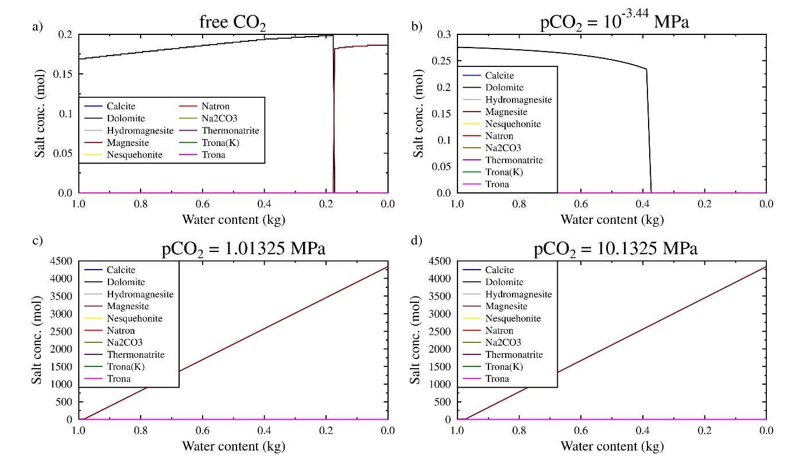
Fig. S7. Secondary carbonates formed by serpentinization as a function of CO₂ partial pressure and fixed temperature (25 °C). a, free CO₂ partial pressure (here 10^{-3.44} MPa at the end of the reaction). b, CO₂ partial pressure of 10^{-3.44} MPa. c, CO₂ partial pressure 1.01325 MPa. d, CO₂ partial pressure of 10.1325 MPa. Only dolomite and magnesite forms.

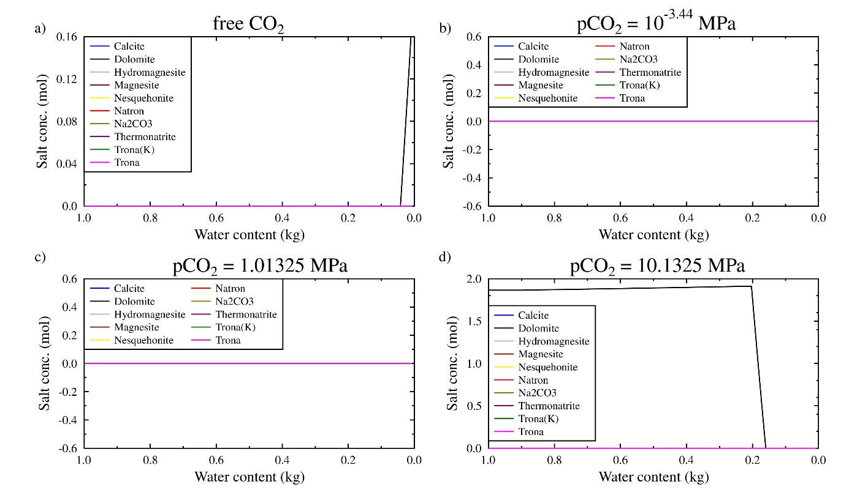
Fig. S8. Secondary carbonates formed by serpentinization as a function of CO₂ partial pressure and fixed temperature (150 °C). a, free CO₂ partial pressure (here 17.7 MPa). b, CO₂ partial pressure of 10^{-3.44} MPa. c, CO₂ partial pressure 1.01325 MPa. d, CO₂ partial pressure of 10.1325 MPa. Only dolomite forms.

Chlorines as a function of the water content:
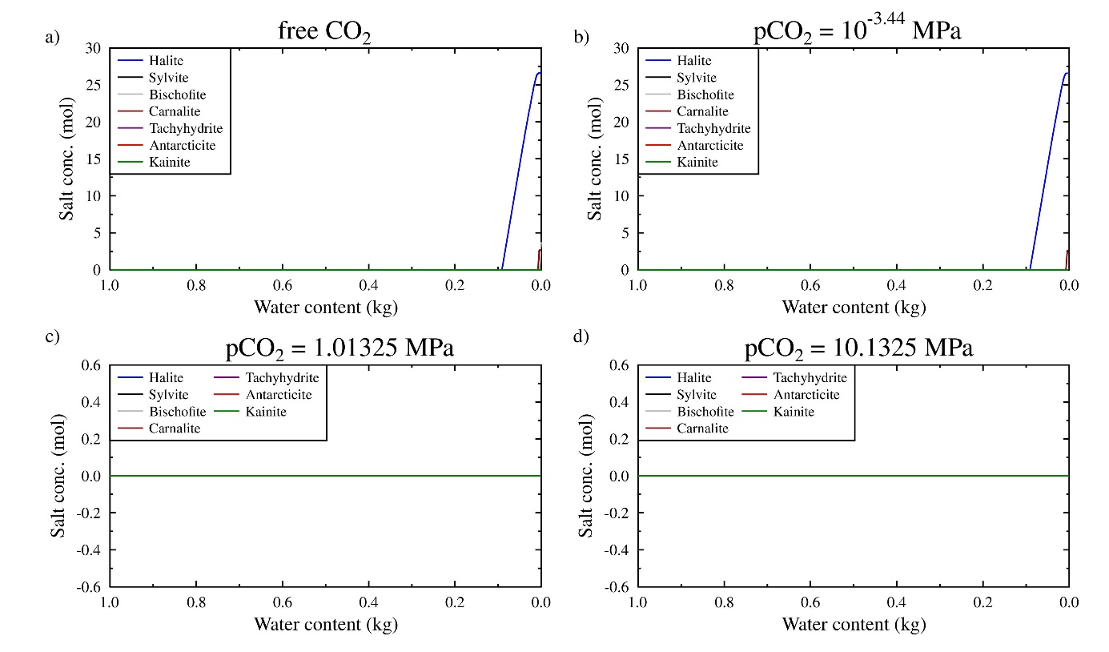
Fig. S9. Secondary chlorines formed by serpentinization as a function of CO₂ partial pressure and fixed temperature (25 °C). a, free CO₂ partial pressure (here 10^{-3.44} MPa at the end of the reaction). b, CO₂ partial pressure of 10^{-3.44} MPa. c, CO₂ partial pressure 1.01325 MPa. d, CO₂ partial pressure of 10.1325 MPa. Only halite and carnallite (free CO₂) forms.

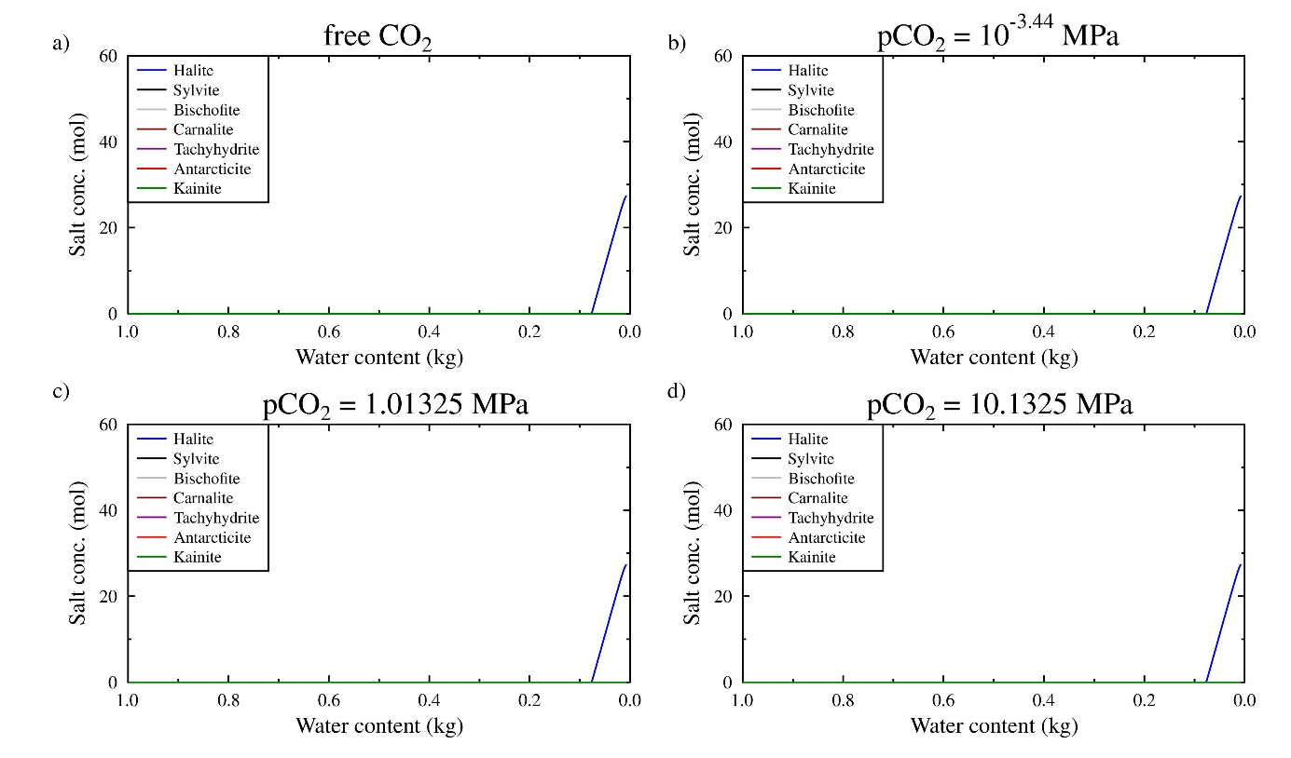
Fig. S10. Secondary chlorines formed by serpentinization as a function of CO₂ partial pressure and fixed temperature (150 °C). a, free CO₂ partial pressure (here 17.7 MPa at the end of the reaction). b, CO₂ partial pressure of 10^{-3.44} MPa. c, CO₂ partial pressure 1.01325 MPa. d, CO₂ partial pressure of 10.1325 MPa. Only halite forms.

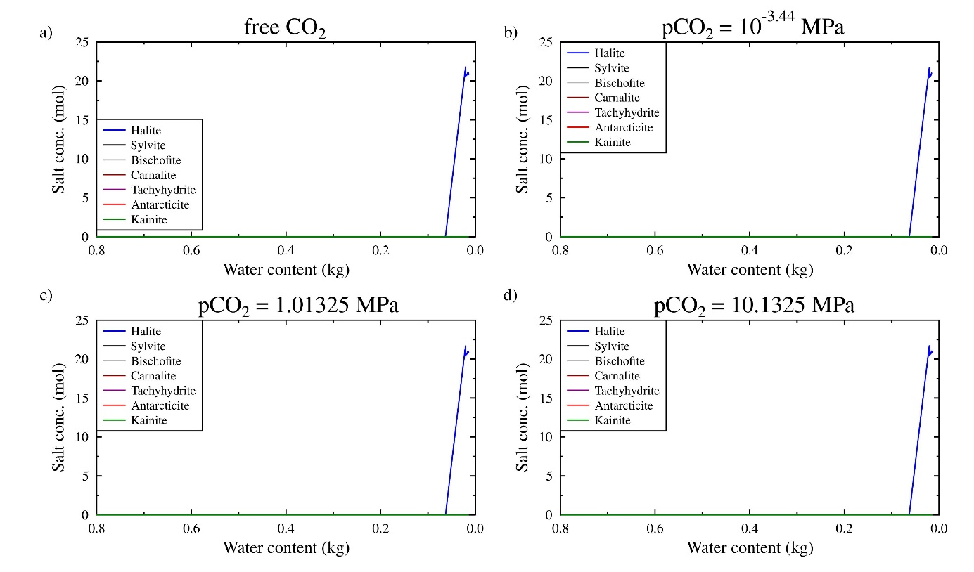
Fig. S11. Secondary chlorines formed by serpentinization as a function of CO₂ partial pressure and fixed temperature (250 °C). a, free CO₂ partial pressure (here 114.5 MPa at the end of the reaction). b, CO₂ partial pressure of 10^{-3.44} MPa. c, CO₂ partial pressure 1.1325 MPa. d, CO₂ partial pressure of 10.1325 MPa. Only halite forms.

Sulfates as a function of the water content:
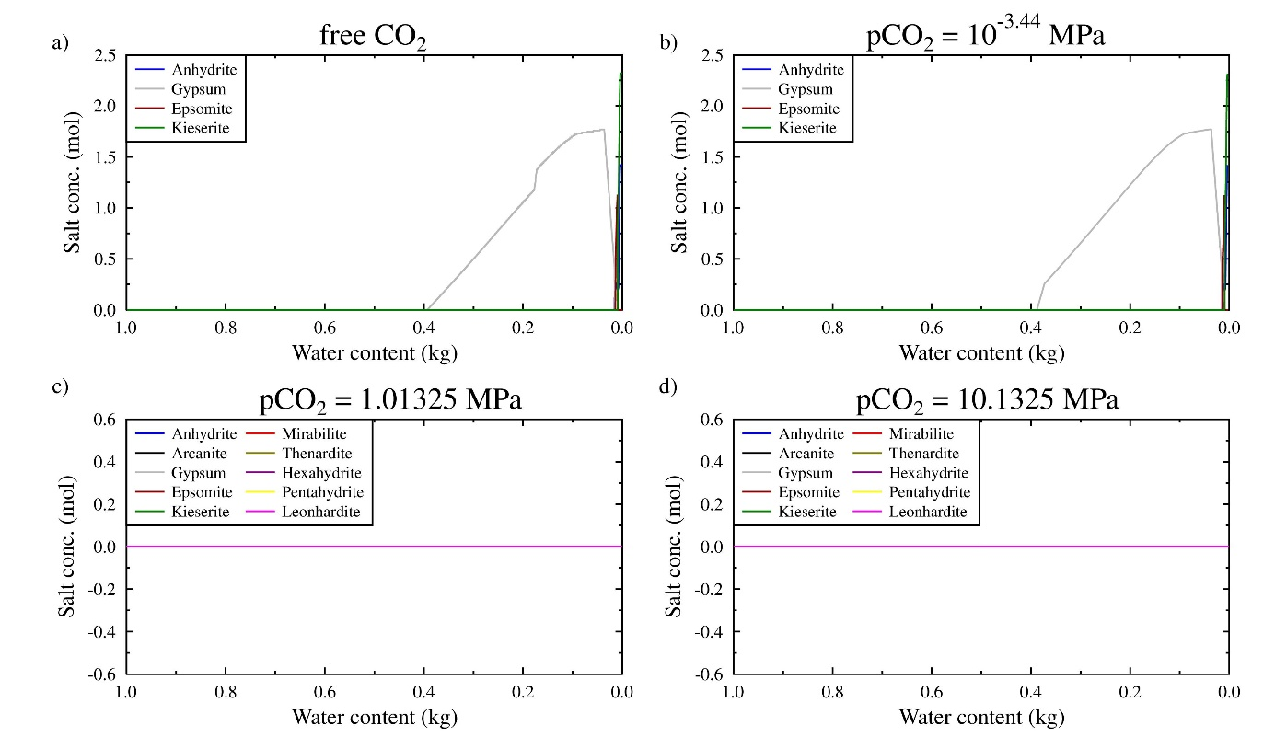
Fig. S12. Secondary sulfates formed by serpentinization as a function of CO₂ partial pressure and fixed temperature (25 °C). a, free CO₂ partial pressure (here 10^{-3.44} MPa at the end of the reaction); gypsum, anhydrite, epsomite and kieserite forms. b, CO₂ partial pressure of 10^{-3.44} MPa; gypsum, anhydrite and epsomite forms. c, CO₂ partial pressure 1.01325 MPa. d, CO₂ partial pressure of 10.1325 MPa.

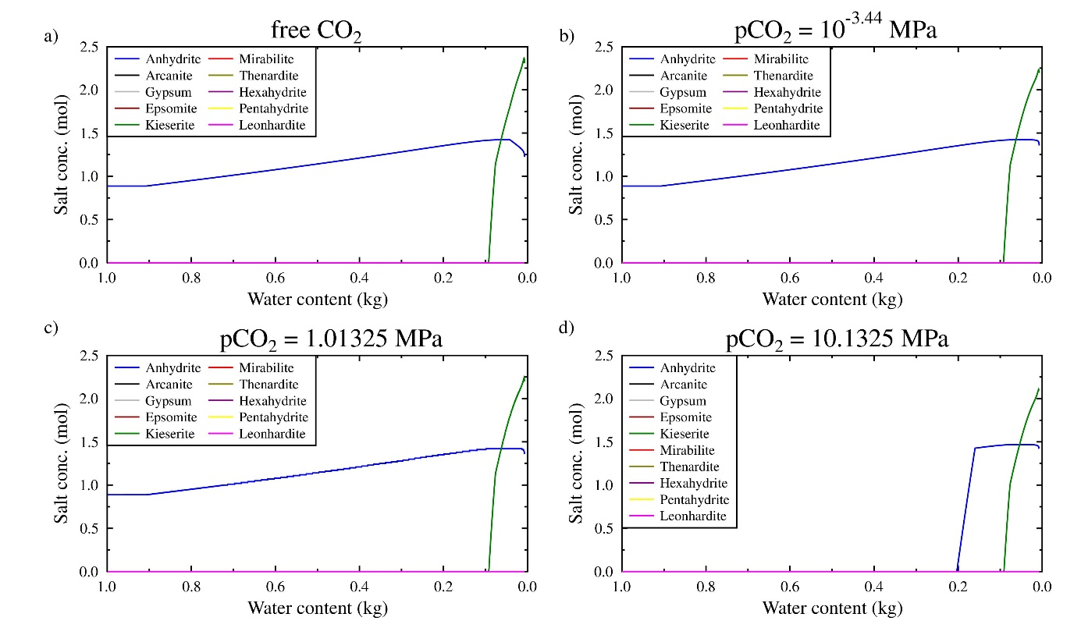
Fig. S13. Secondary sulfates formed by serpentinization as a function of CO₂ partial pressure and fixed temperature (150 °C). a, free CO₂ partial pressure (here 17.7 MPa at the end of the reaction). b, CO₂ partial pressure of 10^{-3.44} MPa. c, CO₂ partial pressure 1.01325 MPa. d, CO₂ partial pressure of 10.1325 MPa. Only halite and kieserite forms.

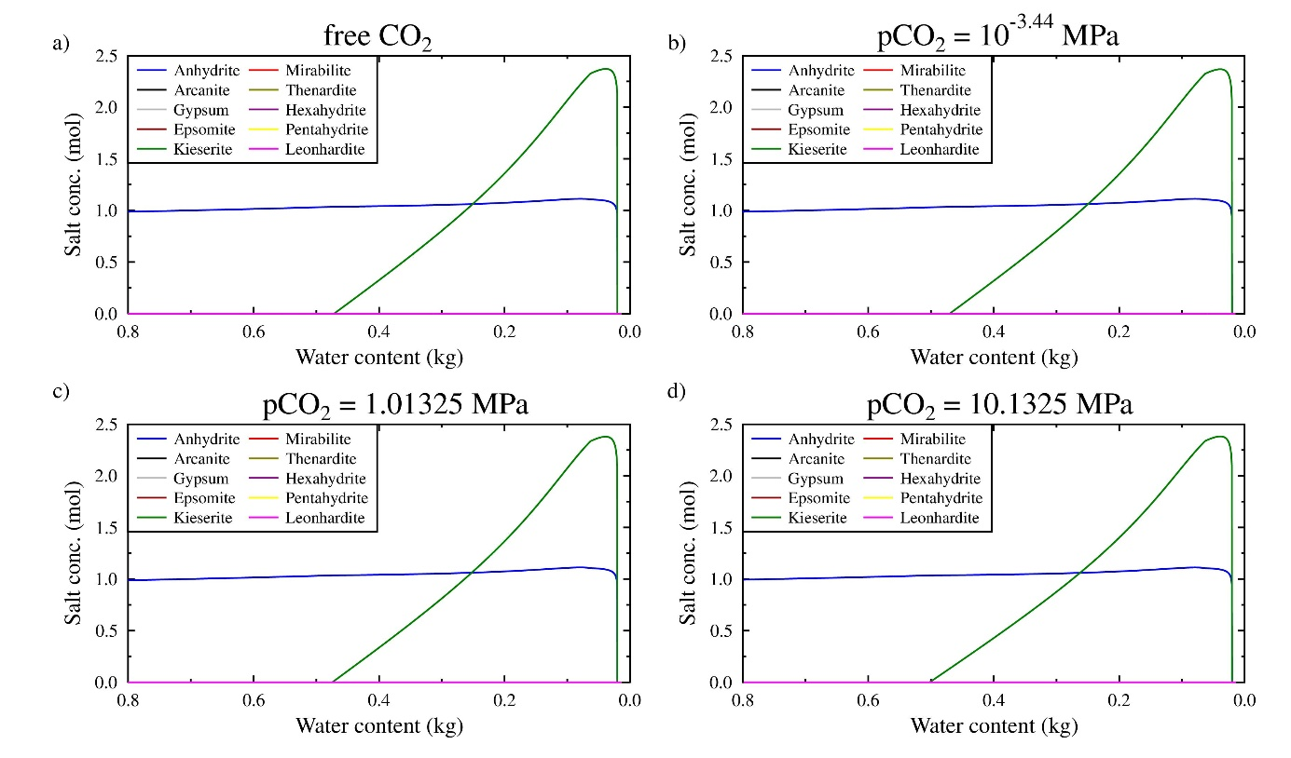
Fig. S14. Secondary sulfates formed by serpentinization as a function of CO₂ partial pressure and fixed temperature (250 °C). a, free CO₂ partial pressure (here 114.5 MPa at the end of the reaction). b, CO₂ partial pressure of 10^{-3.44} MPa. c, CO₂ partial pressure 1.01325 MPa. d, CO₂ partial pressure of 10.1325 MPa. Only halite and kieserite form.

Complex salts as a function of the water content: complex salts are observed at 25°C but not at 150°C and 250°C.

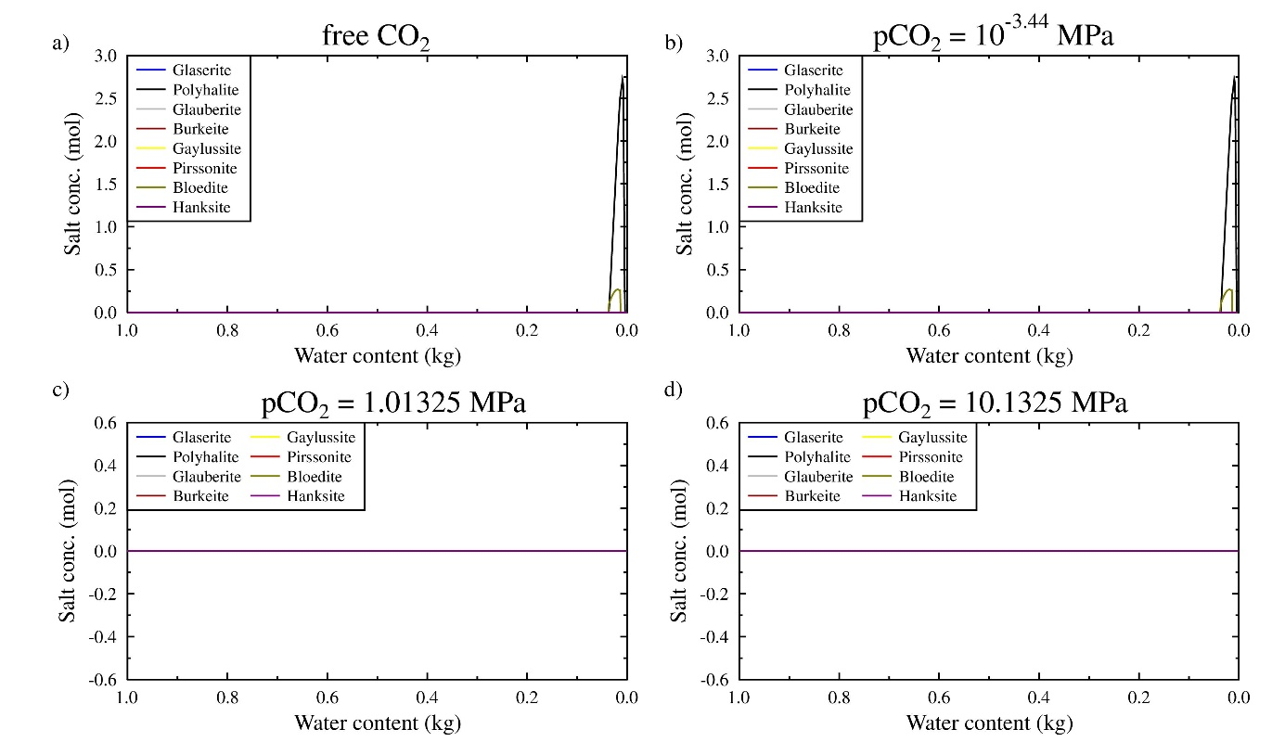
Fig. S15. Secondary complex salt formed by serpentinization as a function of CO₂ partial pressure and fixed temperature (25 °C). a, free CO₂ partial pressure (here 10^{-3.44} MPa at the end of the reaction). b, CO₂ partial pressure of 10^{-3.44} MPa. c, CO₂ partial pressure 1.01325 MPa. d, CO₂ partial pressure of 10.1325 MPa. Only polyhalite and bloedite forms.

Supplementary information 3: Brine composition after the peridotite alteration by seawater.
Table S1: Brine composition (mol L⁻¹) once the maximum amount of seawater is consumed by serpentinization. The free pCO2 is equal to 10^{-3.44} MPa at 25°C, 17.7 MPa at 150°C and 114.5 MPa at 250°C.
pCO₂ | free | atm | 1 atm* | 10 atm | free | atm | 1 atm | 10 atm | free | atm | 1 atm | 10 atm
Temperature | 25 | 25 | 25 | 25 | 150 | 150 | 150 | 150 | 250 | 250 | 250 | 250
pH | 5.93E+00 | 5.93E+00 | 6.05E+00 | 5.50E+00 | 4.42E+00 | 4.42E+00 | 4.42E+00 | 4.44E+00 | 4.25E+00 | 4.26E+00 | 4.25E+00 | 4.25E+00
Alkalinity | 3.00E-04 | 3.00E-04 | 2.57E-02 | 6.97E-02 | 1.66E-02 | 5.45E-04 | 1.41E-03 | 7.09E-03 | 5.03E-02 | 9.12E-04 | 1.46E-03 | 5.05E-03
Ionic strength | 1.76E+01 | 1.76E+01 | 7.58E-01 | 8.24E-01 | 1.82E+01 | 1.80E+01 | 1.80E+01 | 1.72E+01 | 2.10E+01 | 1.96E+01 | 2.07E+01 | 2.08E+01
Remaining H₂O (%) | 2.98E-04 | 3.39E-03 | 9.53E-04 | 6.01E-04 | 7.10E-03 | 7.14E-03 | 7.13E-03 | 7.46E-03 | 1.41E-02 | 1.49E-02 | 1.42E-02 | 1.42E-02
Electrical balance error | 3.03E-07 | 1.60E-08 | 2.41E-09 | 1.23E-09 | 1.89E-09 | 3.18E-09 | 1.67E-09 | 9.16E-10 | 5.30E-11 | 3.86E-10 | 7.93E-11 | 1.78E-10
Si | 1.15E-06 | 1.15E-06 | 1.60E-04 | 1.57E-04 | 1.84E-04 | 1.88E-04 | 1.87E-04 | 2.09E-04 | 4.27E-03 | 4.04E-03 | 4.25E-03 | 4.25E-03
Na | 5.00E-02 | 5.00E-02 | 4.86E-01 | 4.86E-01 | 5.06E-01 | 5.14E-01 | 5.13E-01 | 5.90E-01 | 7.23E+00 | 6.56E+00 | 7.09E+00 | 7.11E+00
Ca | 1.81E-03 | 1.81E-03 | 2.61E-03 | 3.11E-03 | 8.82E-02 | 8.25E-02 | 8.27E-02 | 6.08E-02 | 5.45E-01 | 5.20E-01 | 5.42E-01 | 5.42E-01
K | 1.08E-02 | 1.08E-02 | 1.06E-02 | 1.06E-02 | 1.45E+00 | 1.44E+00 | 1.44E+00 | 1.38E+00 | 6.39E-01 | 6.09E-01 | 6.35E-01 | 6.36E-01
Mg | 5.83E+00 | 5.83E+00 | 7.48E-02 | 9.63E-02 | 5.18E+00 | 5.13E+00 | 5.13E+00 | 4.90E+00 | 3.28E+00 | 3.10E+00 | 3.24E+00 | 3.25E+00
Cl | 1.17E+01 | 1.17E+01 | 5.67E-01 | 5.67E-01 | 1.16E+01 | 1.16E+01 | 1.16E+01 | 1.12E+01 | 1.21E+01 | 1.12E+01 | 1.20E+01 | 1.20E+01
SO₄²⁻ | 1.25E-02 | 1.25E-02 | 2.93E-02 | 2.93E-02 | 4.24E-01 | 3.98E-01 | 3.99E-01 | 3.40E-01 | 1.67E+00 | 1.59E+00 | 1.66E+00 | 1.67E+00
HCO₃⁻ | 5.42E-05 | 5.42E-05 | 5.60E-02 | 3.58E-01 | 3.39E-02 | 6.78E-07 | 1.91E-03 | 1.79E-02 | 1.34E-01 | 4.03E-07 | 1.16E-03 | 1.15E-02
Salinity (psu) | 186 | 186 | 56 | 75 | 283 | 276 | 277 | 265 | 506 | 467 | 492 | 494
* 1 atm = 1.01325 MPa

Table S2: Brine composition (mol L⁻¹) once the 99.0 % of seawater is consumed by serpentinization. The free pCO2 is equal to 10^{-3.23} MPa at 25°C, 18.3 MPa at 150°C and 114.5 MPa at 250°C.
pCO₂ | free | atm | 1 atm* | 10 atm | free | atm | 1 atm | 10 atm | free | atm | 1 atm | 10 atm
Temperature | 25 | 25 | 25 | 25 | 150 | 150 | 150 | 150 | 250 | 250 | 250 | 250
pH | 6.52E+00 | 6.52E+00 | 6.05E+00 | 5.50E+00 | 4.57E+00 | 4.57E+00 | 4.57E+00 | 4.57E+00 | 4.25E+00 | 4.26E+00 | 4.25E+00 | 4.25E+00
Alkalinity | 1.36E-04 | 1.05E-04 | 2.57E-02 | 6.97E-02 | 4.25E-03 | 2.79E-04 | 4.98E-04 | 2.41E-03 | 5.03E-02 | 9.12E-04 | 1.46E-03 | 5.05E-03
Ionic strength | 1.11E+01 | 1.11E+01 | 7.58E-01 | 8.24E-01 | 1.13E+01 | 1.13E+01 | 1.13E+01 | 1.12E+01 | 2.10E+01 | 1.96E+01 | 2.07E+01 | 2.08E+01
Remaining H₂O (%) | 1.40E-02 | 1.40E-02 | 1.44E-02 | 1.39E-02 | 1.41E-02 | 1.41E-02 | 1.41E-02 | 1.44E-02 | 1.41E-02 | 1.49E-02 | 1.42E-02 | 1.42E-02
Electrical balance error | 1.07E-08 | 6.38E-09 | 2.30E-09 | 1.20E-09 | 1.40E-09 | 2.34E-09 | 1.22E-09 | 6.58E-10 | 5.30E-11 | 3.86E-10 | 7.93E-11 | 1.78E-10
Si | 1.69E-05 | 1.70E-05 | 1.60E-04 | 1.57E-04 | 5.20E-04 | 5.22E-04 | 5.22E-04 | 5.30E-04 | 4.27E-03 | 4.04E-03 | 4.25E-03 | 4.25E-03
Na | 1.22E+00 | 1.22E+00 | 4.86E-01 | 4.86E-01 | 2.49E+00 | 2.51E+00 | 2.51E+00 | 2.58E+00 | 7.23E+00 | 6.56E+00 | 7.09E+00 | 7.11E+00
Ca | 2.32E-03 | 2.32E-03 | 2.61E-03 | 3.11E-03 | 1.08E-02 | 1.08E-02 | 1.08E-02 | 1.04E-02 | 5.45E-01 | 5.20E-01 | 5.42E-01 | 5.42E-01
K | 9.69E-02 | 9.71E-02 | 1.06E-02 | 1.06E-02 | 7.33E-01 | 7.31E-01 | 7.31E-01 | 7.16E-01 | 6.39E-01 | 6.09E-01 | 6.35E-01 | 6.36E-01
Mg | 3.11E+00 | 3.10E+00 | 7.48E-02 | 9.63E-02 | 2.63E+00 | 2.62E+00 | 2.62E+00 | 2.57E+00 | 3.28E+00 | 3.10E+00 | 3.24E+00 | 3.25E+00
Cl | 6.52E+00 | 6.52E+00 | 5.67E-01 | 5.67E-01 | 8.11E+00 | 8.11E+00 | 8.11E+00 | 8.07E+00 | 1.21E+01 | 1.12E+01 | 1.20E+01 | 1.20E+01
SO₄²⁻ | 5.04E-01 | 5.04E-01 | 2.93E-02 | 2.93E-02 | 1.92E-01 | 1.95E-01 | 1.95E-01 | 1.91E-01 | 1.67E+00 | 1.59E+00 | 1.66E+00 | 1.67E+00
HCO₃⁻ | 7.10E-05 | 4.40E-05 | 5.60E-02 | 3.58E-01 | 4.18E-02 | 8.11E-07 | 2.28E-03 | 2.27E-02 | 1.34E-01 | 4.03E-07 | 1.16E-03 | 1.15E-02
Salinity (psu) | 195 | 195 | 56 | 75 | 212 | 210 | 210 | 211 | 506 | 467 | 492 | 494
* 1 atm = 1.01325 MPa

Table S3: Brine composition (mol L⁻¹) once the maximum amount of seawater is consumed by serpentinization and talc precipitated. The free pCO2 is equal to 10^{-3.75} MPa at 25°C, 7.2 MPa at 150°C and 94 MPa at 250°C.
pCO₂ | free | atm | 1 atm* | 10 atm | free | atm | 1 atm | 10 atm | free | atm | 1 atm | 10 atm
Temperature | 25 | 25 | 25 | 25 | 150 | 150 | 150 | 150 | 250 | 250 | 250 | 250
pH | 6.08E+00 | 6.61E+00 | 6.05E+00 | 5.50E+00 | 4.62E+00 | 4.62E+00 | 4.62E+00 | 4.61E+00 | 4.45E+00 | 4.41E+00 | 4.43E+00 | 4.45E+00
Alkalinity | 3.88E-04 | 1.40E-04 | 2.57E-02 | 6.97E-02 | 1.18E-02 | 8.69E-04 | 2.34E-03 | 1.45E-02 | 6.34E-02 | 2.38E-03 | 2.80E-03 | 7.69E-03
Ionic strength | 1.76E+01 | 1.12E+01 | 7.58E-01 | 8.24E-01 | 1.84E+01 | 1.82E+01 | 1.83E+01 | 1.80E+01 | 2.09E+01 | 2.21E+01 | 2.14E+01 | 2.07E+01
Remaining H₂O (%) | 7.80E-04 | 3.36E-03 | 9.53E-04 | 6.01E-04 | 6.85E-03 | 6.87E-03 | 6.87E-03 | 6.89E-03 | 1.38E-02 | 1.34E-02 | 1.37E-02 | 1.39E-02
Electrical balance error | 1.10E-07 | 1.44E-09 | 7.08E-09 | 3.12E-10 | 7.68E-08 | 8.72E-08 | 9.23E-08 | -3.49E-10 | 1.11E-10 | 3.87E-10 | 3.73E-10 | 6.60E-10
Si | 3.99E-07 | 8.06E-06 | 1.60E-04 | 1.57E-04 | 4.67E-05 | 4.72E-05 | 4.72E-05 | 4.76E-05 | 1.04E-03 | 1.13E-03 | 1.08E-03 | 1.03E-03
Na | 5.00E-02 | 1.16E+00 | 4.86E-01 | 4.86E-01 | 4.94E-01 | 4.97E-01 | 4.97E-01 | 4.94E-01 | 7.31E+00 | 8.21E+00 | 7.64E+00 | 7.15E+00
Ca | 1.81E-03 | 2.25E-03 | 2.61E-03 | 3.11E-03 | 9.76E-02 | 9.14E-02 | 9.17E-02 | 3.81E-02 | 5.49E-01 | 5.65E-01 | 5.58E-01 | 5.47E-01
K | 1.08E-02 | 9.52E-02 | 1.06E-02 | 1.06E-02 | 1.46E+00 | 1.46E+00 | 1.46E+00 | 1.46E+00 | 6.28E-01 | 6.47E-01 | 6.40E-01 | 6.27E-01
Mg | 5.83E+00 | 3.16E+00 | 7.48E-02 | 9.63E-02 | 5.24E+00 | 5.20E+00 | 5.20E+00 | 5.18E+00 | 3.23E+00 | 3.29E+00 | 3.27E+00 | 3.20E+00
Cl | 1.17E+01 | 6.59E+00 | 5.67E-01 | 5.67E-01 | 1.17E+01 | 1.17E+01 | 1.17E+01 | 1.17E+01 | 1.21E+01 | 1.32E+01 | 1.25E+01 | 1.20E+01
SO₄²⁻ | 1.25E-02 | 4.94E-01 | 2.93E-02 | 2.93E-02 | 4.49E-01 | 4.23E-01 | 4.25E-01 | 3.48E-01 | 1.65E+00 | 1.70E+00 | 1.69E+00 | 1.65E+00
HCO₃⁻ | 4.14E-05 | 5.73E-05 | 5.60E-02 | 3.58E-01 | 1.80E-02 | 8.82E-07 | 2.49E-03 | 2.41E-02 | 1.31E-01 | 5.87E-07 | 1.49E-03 | 1.36E-02
Salinity (psu) | 186 | 194 | 56 | 75 | 286 | 281 | 281 | 273 | 504 | 526 | 509 | 492
* 1 atm = 1.01325 MPa

Table S4: Brine composition (mol L⁻¹) once the 99.0 % of seawater is consumed by serpentinization and talc precipitated. The free pCO2 is equal to 10^{-3.43} MPa at 25°C, 8.2 MPa at 150°C and 94 MPa at 250°C.
pCO₂ | free | atm | 1 atm* | 10 atm | free | atm | 1 atm | 10 atm | free | atm | 1 atm | 10 atm
Temperature | 25 | 25 | 25 | 25 | 150 | 150 | 150 | 150 | 250 | 250 | 250 | 250
pH | 6.63E+00 | 6.63E+00 | 6.05E+00 | 5.50E+00 | 4.74E+00 | 4.74E+00 | 4.74E+00 | 4.74E+00 | 4.45E+00 | 4.41E+00 | 4.43E+00 | 4.45E+00
Alkalinity | 1.37E-04 | 1.36E-04 | 2.57E-02 | 6.97E-02 | 3.19E-03 | 4.78E-04 | 8.12E-04 | 3.77E-03 | 6.34E-02 | 2.38E-03 | 2.80E-03 | 7.69E-03
Ionic strength | 1.09E+01 | 1.08E+01 | 7.58E-01 | 8.24E-01 | 1.16E+01 | 1.16E+01 | 1.16E+01 | 1.15E+01 | 2.09E+01 | 2.21E+01 | 2.14E+01 | 2.07E+01
Remaining H₂O (%) | 1.33E-02 | 1.33E-02 | 1.34E-02 | 1.29E-02 | 1.31E-02 | 1.31E-02 | 1.31E-02 | 1.31E-02 | 1.38E-02 | 1.34E-02 | 1.37E-02 | 1.39E-02
Electrical balance error | 1.14E-08 | 1.34E-09 | 6.98E-09 | 2.92E-10 | 5.88E-08 | 6.64E-08 | 7.03E-08 | -2.81E-10 | 1.11E-10 | 3.87E-10 | 3.73E-10 | 6.60E-10
Si | 9.15E-06 | 9.19E-06 | 1.60E-04 | 1.57E-04 | 1.49E-04 | 1.50E-04 | 1.50E-04 | 1.50E-04 | 1.04E-03 | 1.13E-03 | 1.08E-03 | 1.03E-03
Na | 1.38E+00 | 1.38E+00 | 4.86E-01 | 4.86E-01 | 2.35E+00 | 2.36E+00 | 2.36E+00 | 2.35E+00 | 7.31E+00 | 8.21E+00 | 7.64E+00 | 7.15E+00
Ca | 2.55E-03 | 2.56E-03 | 2.61E-03 | 3.11E-03 | 1.17E-02 | 1.17E-02 | 1.17E-02 | 7.89E-03 | 5.49E-01 | 5.65E-01 | 5.58E-01 | 5.47E-01
K | 1.07E-01 | 1.07E-01 | 1.06E-02 | 1.06E-02 | 7.65E-01 | 7.63E-01 | 7.63E-01 | 7.64E-01 | 6.28E-01 | 6.47E-01 | 6.40E-01 | 6.27E-01
Mg | 2.96E+00 | 2.95E+00 | 7.48E-02 | 9.63E-02 | 2.74E+00 | 2.73E+00 | 2.73E+00 | 2.74E+00 | 3.23E+00 | 3.29E+00 | 3.27E+00 | 3.20E+00
Cl | 6.41E+00 | 6.41E+00 | 5.67E-01 | 5.67E-01 | 8.21E+00 | 8.21E+00 | 8.21E+00 | 8.21E+00 | 1.21E+01 | 1.32E+01 | 1.25E+01 | 1.20E+01
SO₄²⁻ | 4.94E-01 | 4.93E-01 | 2.93E-02 | 2.93E-02 | 1.99E-01 | 2.00E-01 | 1.99E-01 | 1.96E-01 | 1.65E+00 | 1.70E+00 | 1.69E+00 | 1.65E+00
HCO₃⁻ | 5.93E-05 | 5.80E-05 | 5.60E-02 | 3.58E-01 | 1.92E-02 | 8.39E-07 | 2.36E-03 | 2.33E-02 | 1.31E-01 | 5.87E-07 | 1.49E-03 | 1.36E-02
Salinity (psu) | 194 | 194 | 56 | 75 | 212 | 211 | 211 | 212 | 504 | 526 | 509 | 492
* 1 atm = 1.01325 MPa

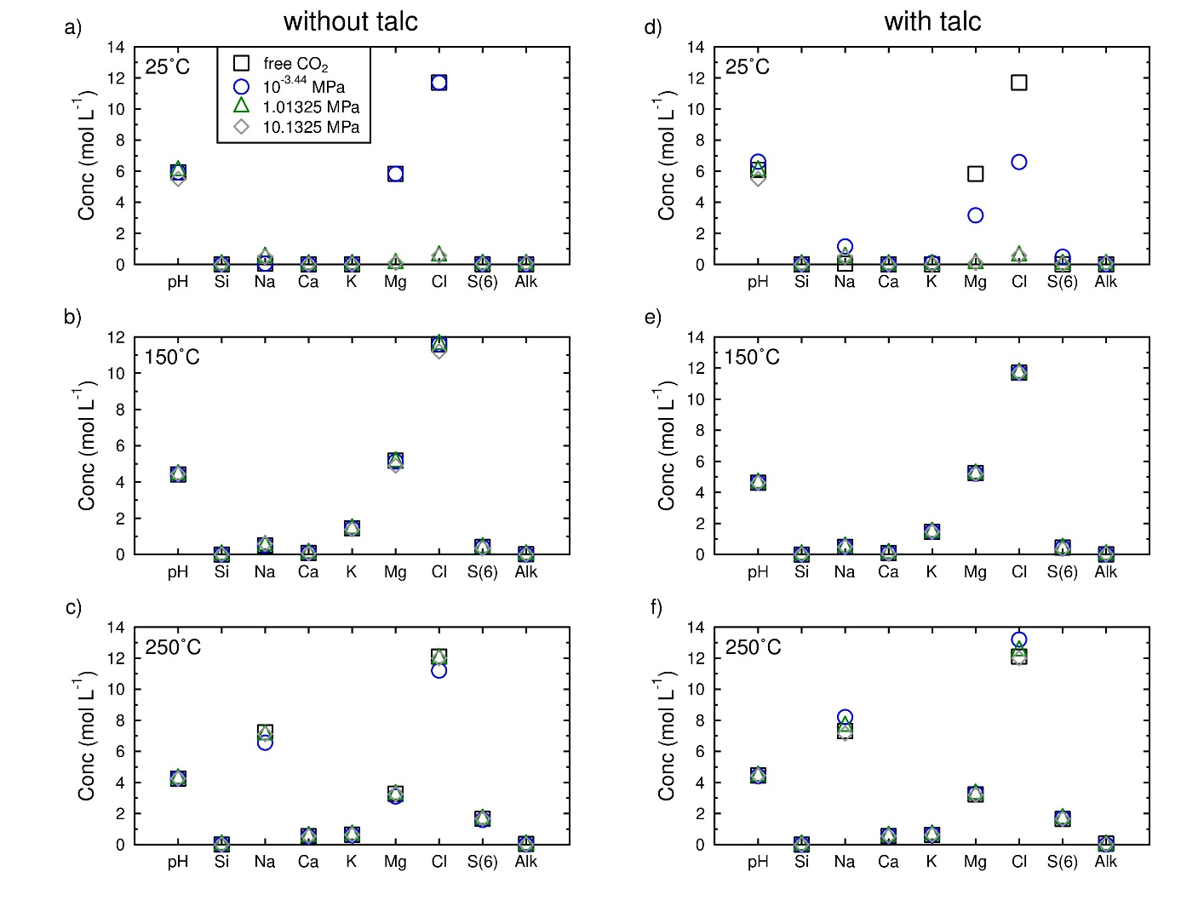
Fig. S16. Brine composition once the seawater is consumed by serpentinization. a, at 25°C without talc with 99.9% of the water consumed and free pCO₂ equal to 10^{-3.44} MPa. b, at 150°C without talc with 99.5% of the water consumed and free pCO₂ equal to 17.7 MPa. c, at 250°C without talc with 99.0% of the water consumed and free pCO₂ equal to 114.5 MPa. d, at 25°C with talc with 99.9% of the water consumed and free pCO₂ equal to 10^{-3.75} MPa. e, at 150°C with talc with 99.5% of the water consumed and free pCO₂ equal to 7.2 MPa. f, at 250°C with talc with 99.0% of the water consumed and free pCO₂ equal to 94 MPa.. The salinity range varies from 55 to 200 psu at 25 °C, 260 to 280 psu at 150°C and 470 to 530 psu at 250°C.

Supplementary information 4: Composition of the salt precipitated when the seawater cools brines at the temperature representative of the bottom of the seas (4°C).
Fig. S17. Additional salt precipitation after cooling the brines initially at 25°C to a temperature of 4°C representative of the bottom of the seas. a, free CO₂ partial pressure (here 10^{-3.44} MPa at the end of the reaction). b, CO₂ partial pressure of 10^{-3.44} MPa. Salt does not precipitate at CO₂ partial pressure of 1.01325 and 10.1325 MPa. The amount of minerals formed is given in wt%.

Fig. S18. Additional salt precipitation after cooling the brines initially at 25°C to a temperature of 4°C representative of the bottom of the seas. a, free CO₂ partial pressure (here 10^{-3.75} MPa at the end of the reaction). b, CO₂ partial pressure of 10^{-3.44} MPa. Salt does not precipitate at CO₂ partial pressure of 1.01325 and 10.1325 MPa. The amount of minerals formed is given in wt%. Talc is considered at thermodynamic equilibrium.
Fig. S19. Additional salt precipitation after cooling the brines initially at 150°C to a temperature of 4°C representative of the bottom of the seas. a, free CO₂ partial pressure (here 17.7 MPa at the end of the reaction). b, CO₂ partial pressure of 10^{-3.44} MPa. c, CO₂ partial pressure 1. 01325 MPa. d, CO₂ partial pressure of 10.1325 MPa. The amount of minerals formed is given in wt%.

Fig. S20. Additional salt precipitation after cooling the brines initially at 150°C to a temperature of 4°C representative of the bottom of the seas. a, free CO₂ partial pressure (here 7.2 MPa at the end of the reaction). b, CO₂ partial pressure of 10^{-3.44} MPa. c, CO₂ partial pressure 1.01325 MPa. d, CO₂ partial pressure of 10.1325 MPa. The amount of minerals formed is given in wt%. Talc is considered at thermodynamic equilibrium.

Fig. S21. Additional salt precipitation after cooling the brines initially at 250°C to a temperature of 4°C representative of the bottom of the seas. a, free CO₂ partial pressure (here 114.5 MPa at the end of the reaction). b, CO₂ partial pressure of 10^{-3.44} MPa. c, CO₂ partial pressure 1.01325 MPa. d, CO₂ partial pressure of 10.1325 MPa. The amount of minerals formed is given in wt%.

Fig. S22. Additional salt precipitation after cooling the brines initially at 250°C to a temperature of 4°C representative of the bottom of the seas. a, free CO₂ partial pressure (here 94 MPa at the end of the reaction). b, CO₂ partial pressure of 10^{-3.44} MPa. c, CO₂ partial pressure 1.01325 MPa. d, CO₂ partial pressure of 10.1325 MPa. The amount of minerals formed is given in wt%. Talc is considered at thermodynamic equilibrium.

Table S5: Mass of halite precipitated at depth after the serpentinization and mass of salt precipitated at the bottom of the seafloor from the hot brines once the seawater cools them. Talc is not considered at thermodynamic equilibrium.
pCO₂ | free | atm | 1 atm* | 10 atm | free | atm | 1 atm | 10 atm | free | atm | 1 atm | 10 atm
Temperature | 25 | 25 | 25 | 25 | 150 | 150 | 150 | 150 | 250 | 250 | 250 | 250
Halite after serpentinization for 1000 kg of initial seawater (g) | 26624 | 26618 | 0 | 0 | 27425 | 27422 | 27422 | 27422 | 20739 | 21016 | 20806 | 20795
Σsalts on the seafloor for 1000 kg of initial seawater (g) | 37 | 419 | 0 | 0 | 3157 | 3117 | 3117 | 2982 | 8763 | 8284 | 8675 | 8722
* 1 atm = 1.01325 MPa

Table S6: Mass of halite precipitated at depth after the serpentinization and mass of salt precipitated at the bottom of the seafloor from the hot brines once the seawater cools them. Talc is considered at thermodynamic equilibrium.
pCO₂ | free | atm | 1 atm* | 10 atm | free | atm | 1 atm | 10 atm | free | atm | 1 atm | 10 atm
Temperature | 25 | 25 | 25 | 25 | 150 | 150 | 150 | 150 | 250 | 250 | 250 | 250
Halite after serpentinization for 1000 kg of initial seawater (g) | 24546 | 23768 | 0 | 0 | 26693 | 26693 | 26692 | 26730 | 20018 | 19459 | 19886 | 20115
Σsalts on the seafloor for 1000 kg of initial seawater (g) | 96 | 286 | 0 | 0 | 3104 | 3078 | 3080 | 3107 | 8557 | 9199 | 8870 | 8501
* 1 atm = 1.01325 MPa

Corresponding author. E-mail address: m.debure@brgm.fr (M. Debure).

