Application of a high-resolution genetic map for chromosome-scale genome assembly and fine QTLs mapping of seed size and weight traits in castor bean
Anmin Yu^{1,3}, Fei Li¹, Wei Xu¹, Zaiqing Wang^{1,3}, Chao Sun¹, Bing Han^{1,3}, Yue Wang¹, Bo Wang⁴, Xiaomao Cheng², Aizhong Liu^{2*}

¹Key Laboratory of Economic Plants and Biotechnology, Yunnan Key Laboratory for Wild Plant Resources, Kunming Institute of Botany, Chinese Academy of Sciences, Kunming 650201, China
²Key Laboratory for Forest Resources Conservation and Utilization in the Southwest Mountains of China, Ministry of Education, Southwest Forestry University, Kunming 650224, China
³University of the Chinese Academy of Sciences, Beijing 100049, China
⁴Wuhan Genoseq Technology Co., Ltd, Wuhan 430070, China

Figure S1 Variations in seed size and weight traits in the two parents. The x-axis shows the castor bean varieties ZB107 and ZB306. The y-axis shows the phenotypic variation of SL (seed length), SW (seed width), ST (seed thickness), SSW (single seed weight). Values are reported as mean ± SD (n =10), ** P< 0.01, *** P< 0.001, **** P< 0.0001 (Student’s test).
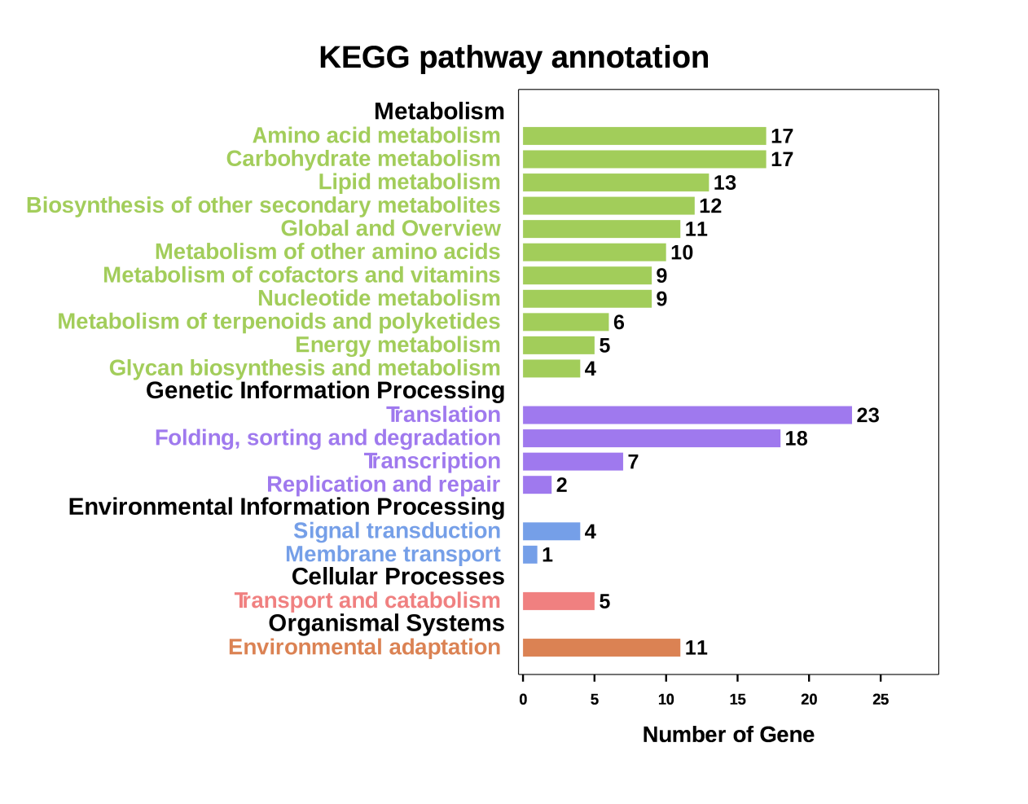
Figure S2 KEGG pathway annotation of the genes related seed size and weight traits.

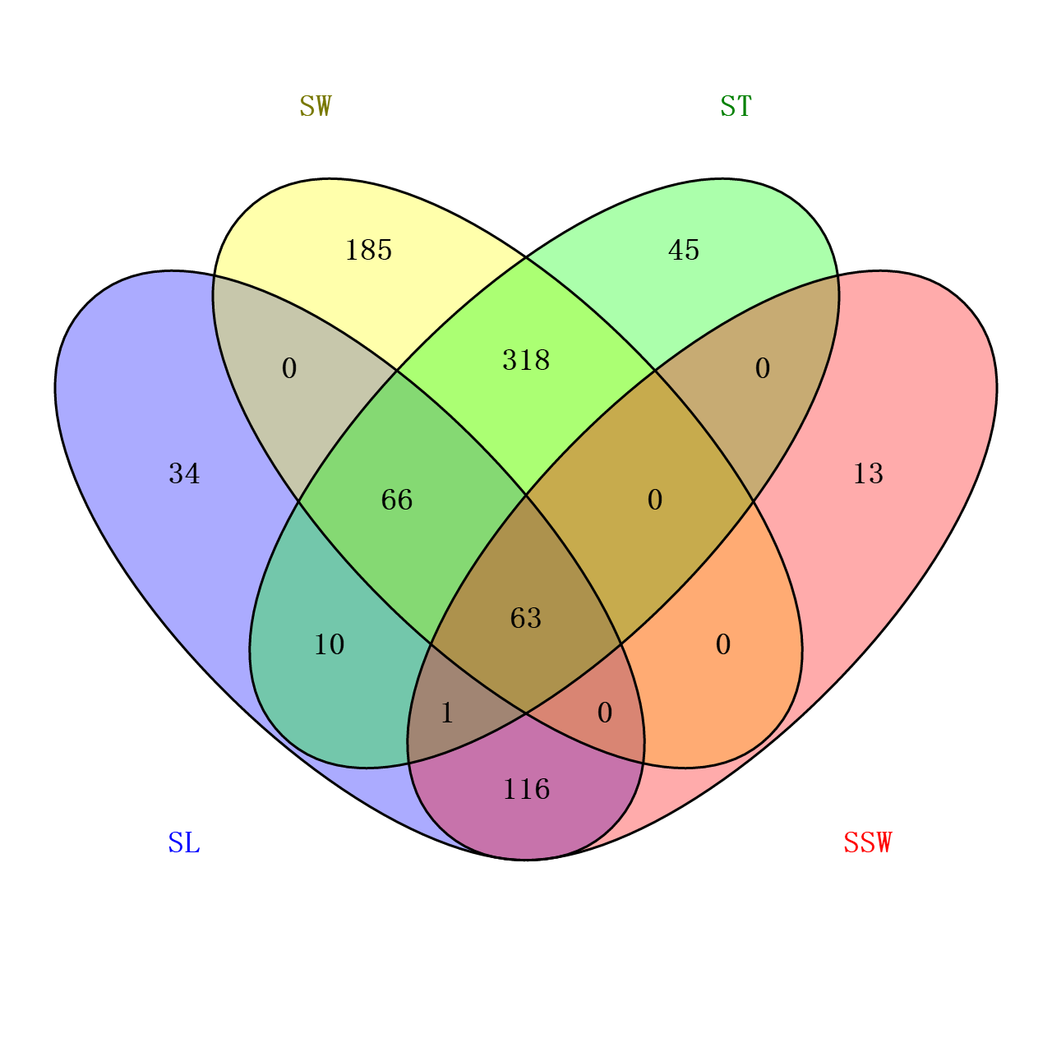
Figure S3 Venn diagrams of candidate genes located in the traits of SL, SW, ST and SSW.

