Supplementary data for:

Drug Screening for Discovery of Broad-spectrum Agents for Soil-transmitted Nematodes
Mostafa A. Elfawal¹, Sergey N. Savinov², and Raffi V. Aroian^{1*}
¹Program in Molecular Medicine, University of Massachusetts Medical School Worcester
²Department of Biochemistry and Molecular Biology, University of Massachusetts Amherst

MOLENAME | HW Adult 30 µM | HW E2L 10 µM | HW E2L 30 µM | C. elegans L4 30 µM | C. elegans E2A 10 µM | C. elegans  E2A 30 µM | HW  iL3  30 µM | HW LB_xiL3  30 µM LB | WW 100 µM
PHENAZOPYRIDINE HYDROCHLORIDE | * | * | * | * |  |  | * | *
FENBENDAZOLE | * | * | * | * |  |  | * | *
FEBUXOSTAT | *
SULCONAZOLE NITRATE | * |  | * | * |  | * |  |  | *
RONIDAZOLE | *
ECONAZOLE NITRATE | * | * | * |  |  |  |  |  | *
PENFLURIDOL | * | * | * | * | * |  | * | * | *
DICHLORVOS | * |  | * |  |  |  | * | * | *
IVERMECTIN | * | * | * | * | * | * | * |  | *
BISACODYL | *
CETYLPYRIDINIUM CHLORIDE | * | * | * | * |  | * |  | * | *
GENTIAN VIOLET | * | * | * | * |  | * |  |  | *
HEXACHLOROPHENE | * |  | * |  |  |  |  |  | *
PHYSOSTIGMINE SALICYLATE | *
PYRANTEL PAMOATE | * |  | * |  |  |  |  |  | *
THIABENDAZOLE | * | * | * |  |  |  | * | *
THIMEROSAL | * | * | * | * | * | * |  | * | *
PHENYLMERCURIC ACETATE | * | * | * | * | * | * | * |  | *
MONENSIN SODIUM | * |  |  |  |  |  |  |  | *
QUINAPRIL HYDROCHLORIDE | *
PARAROSANILINE PAMOATE | * | * | * |  |  |  |  |  | *
PERHEXILINE MALEATE | * |  | * |  |  |  |  |  | *
LEVAMISOLE HYDROCHLORIDE | * | * | * | * | * |  |  |  | *
OXIBENDAZOLE | * | * | * | *
NIMODIPINE | *
BENZALKONIUM CHLORIDE | * | * | * |  |  |  |  |  | *
MOXIFLOXACIN HYDROCHLORIDE | *
OXFENDAZOLE | * |  | * | *
PROTRYPTYLINE HYDROCHLORIDE | * |  |  |  |  |  |  |  | *
NICOTINE DITARTRATE | * |  |  |  |  |  |  |  | *
CHINIOFON | *
HEXETIDINE | * |  | * |  |  |  |  |  | *
SALINOMYCIN, SODIUM | * |  | *
ALEXIDINE HYDROCHLORIDE | * | * | * |  |  | *
CETRIMONIUM BROMIDE | * | * | * |  | * | *
MORANTEL CITRATE | *
SELAMECTIN | * | * | * | * | * | *
BENZETHONIUM CHLORIDE | * |  | *
PYRVINIUM PAMOATE | * | * | * | * |  | *
Table-S1 List of the 39 compounds active against A. ceylanicum adult hookworms (HW) and their cross-activity against all other nematode and nematode stages screened. Among those, 32 were tested against T. muris whipworm (WW) adults. * indicates compound was active against nematode. Shaded cells indicate compound was not tested against nematode.

Table-S2. Mined cytotoxicity data for the adult hookworm actives.

Compound Name | PubChem CIDª | Selectivity Class^{b} | DT40 IC50, uM (PubChem AID743012)^{c} | DT40 Cytotox. Ranking^{d} | HEK293 IC50, uM (PubChem AID1224886)^{e,f} | HEK293 Cytotox. Ranking^{d}
PYRVINIUM PAMOATE | 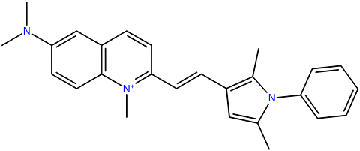  54680693 | NG | 0.25 | High | NT
PHENYLMERCURIC ACETATE | 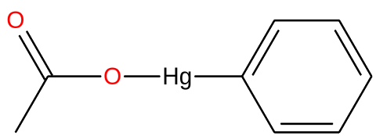  16682730 | NG | 0.11 | High | 0.24 | High
GENTIAN VIOLET | 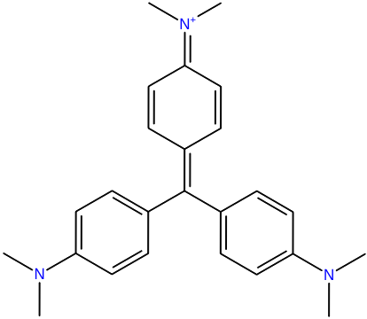  11057 | NG | 0.19 | High | 5.47 | Moderate
THIMEROSAL | 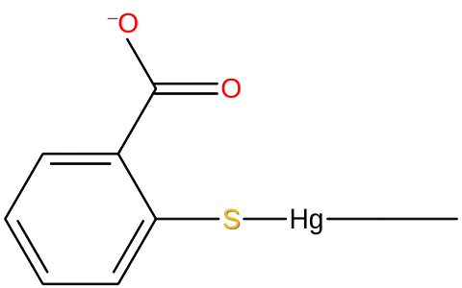  16684434 | NG | 0.17 | High | 1.10 | Moderate
PENFLURIDOL | 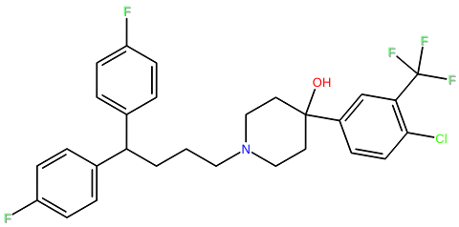  33630 | NG | 4.22 | Moderate | 9.52 | Moderate
CETYLPYRIDINIUM CHLORIDE | 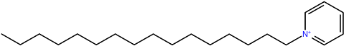  2683, 31239 | NG | 0.43 | High | 17.37 | Low
SULCONAZOLE NITRATE | 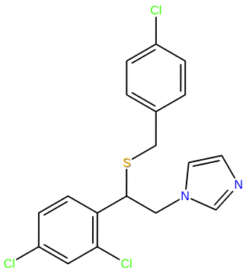  5318, 65495 | NG | 10.12 | Low | 16.93 | Low
PHENAZOPYRIDINE HYDROCHLORIDE | 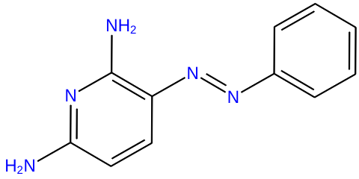  4756, 8691 | NG | 4.22 | Moderate | 24.54 | Low
IVERMECTIN | 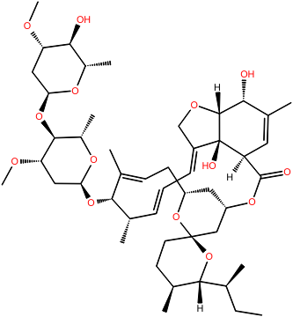  3085416, 11957587 | NG | NT |  | NT
SELAMECTIN | 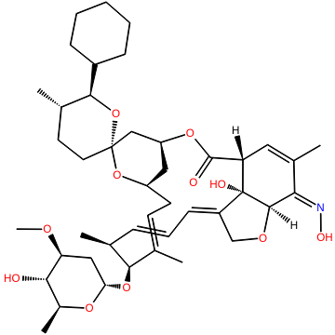  9578507 | NG | Inactive | Low | NT
OXFENDAZOLE | 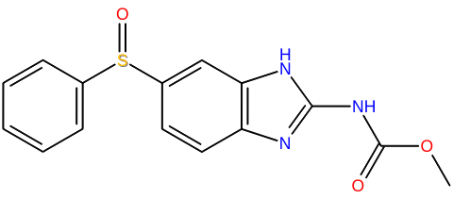  40854 | NG | 9.44 | Moderate | 0.95 | High
OXIBENDAZOLE | 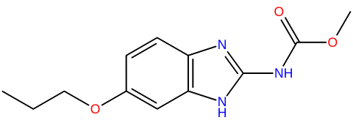  4622 | NG | 0.23 | High | 0.17 | High
FENBENDAZOLE | 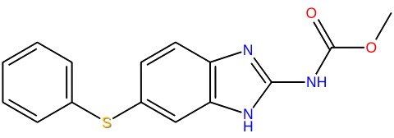  3334 | NG | 0.40 | High | 0.87 | High
LEVAMISOLE HYDROCHLORIDE | 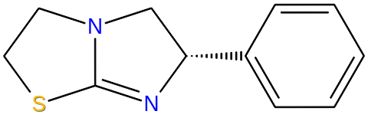  26879, 27944 | NG | Inactive | Low | Inactive | Low
BENZALKONIUM CHLORIDE | 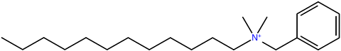  23705 | PS(AD) | 0.42 | High | 3.01 | Moderate
MONENSIN SODIUM | 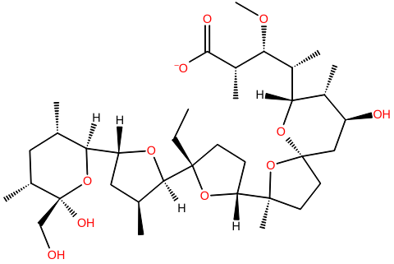  441145. 23667299 | PS(AS) | 0.47 | High | NT
FEBUXOSTAT | 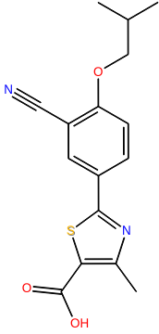  134018 | PS(AS) | Inactive | Low | Inactive | Low
HEXACHLOROPHENE | 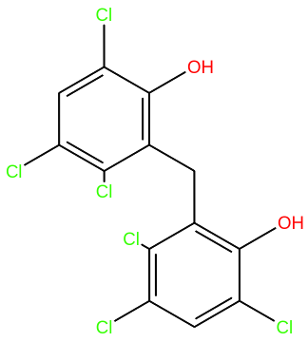  3598 | PS(AS) | 3.05 | Moderate | 3.88 | Moderate
ALEXIDINE HYDROCHLORIDE | 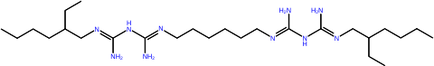  2090, 102678 | PS(AD) | 8.41 | Moderate | 5.35 | Moderate
CETRIMONIUM BROMIDE | 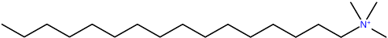  5974, 8154 | PS(AD) | 0.47 | High | 9.42 | Moderate
PARAROSANILINE PAMOATE | 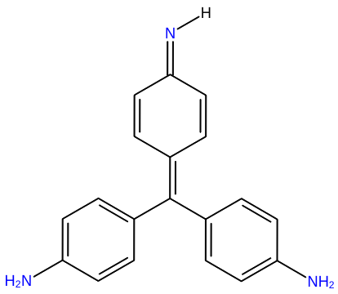  11292, 11293 | PS(AD) | 9.69 | Moderate | 3.47 | Moderate
ECONAZOLE NITRATE | 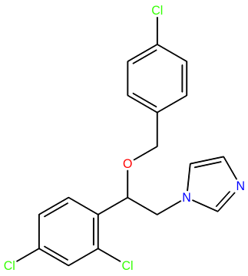  3198, 68589 | PS(AD) | 7.50 | Moderate | 21.79 | Low
CHINIOFON | 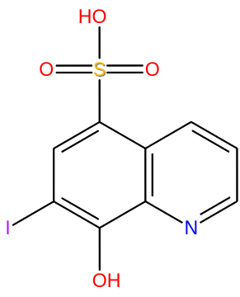  11043 | PS(AS) | Inactive | Low | Inactive | Low
BENZETHONIUM CHLORIDE | 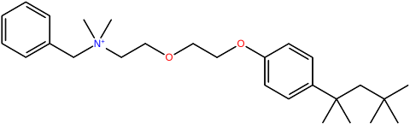  2335, 8478 | PS(AD) | 1.53 | Moderate | 9.52 | Moderate
SALINOMYCIN, SODIUM | 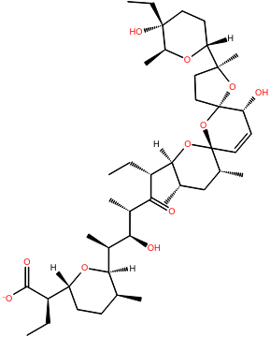  3085092, 45479870 | PS(AD) | NT |  | NT
PROTRYPTYLINE HYDROCHLORIDE | 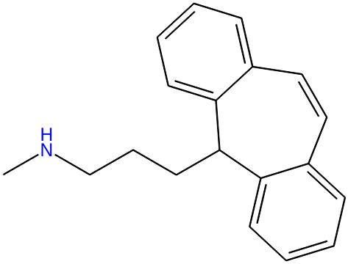  4976 | PS(AS) | NT |  | NT
PERHEXILINE MALEATE | 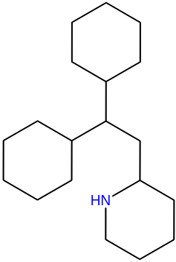  4746, 5284439 | PS(AD) | 2.66 | Moderate | 16.93 | Low
PYRANTEL PAMOATE | 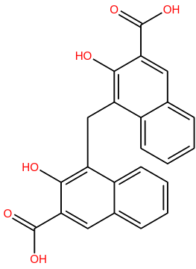  708857, 5281033 | PS(AD) | NT |  | NT
NICOTINE DITARTRATE | 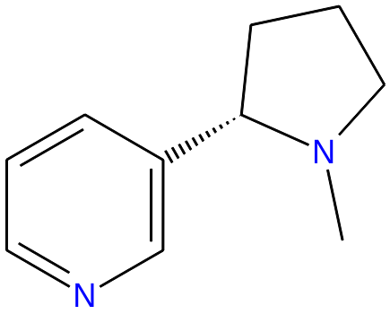  89594, 5702296 | PS(AS) | Inactive | Low | Inactive | Low
MOXIFLOXACIN HYDROCHLORIDE | 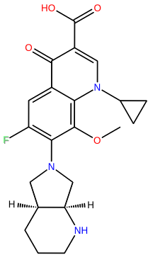  101526, 152946 | PS(AS) | Inactive | Low | Inactive | Low
DICHLORVOS | 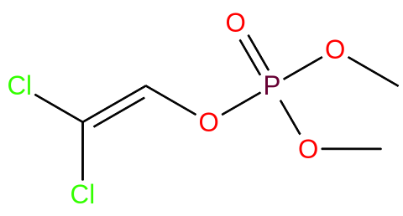  3039 | PS(AD) | 9.44 | Moderate | Inactive | Low
NIMODIPINE | 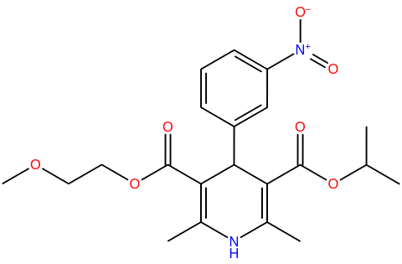  4497 | PS(AS) | Inactive | Low | 10.68 | Low
BISACODYL | 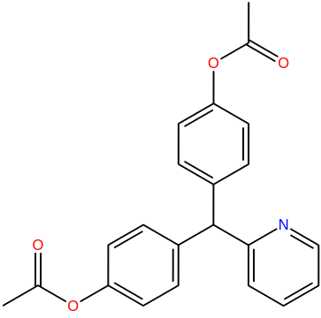  2391 | PS(AS) | Inactive | Low | Inactive | Low
THIABENDAZOLE | 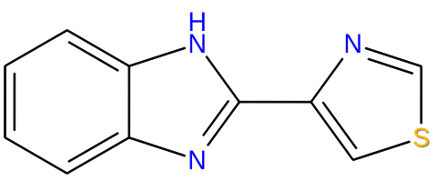  5430 | PS(AD) | Inactive | Low | 27.53 | Low
MORANTEL CITRATE | 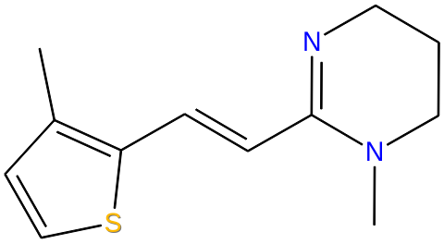  5353792, 5702276 | PS(AS) | NT |  | NT
HEXETIDINE | 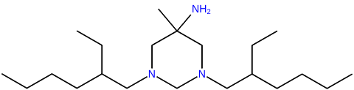  3607 | PS(AD) | 10.12 | Low | 8.49 | Moderate
QUINAPRIL HYDROCHLORIDE | 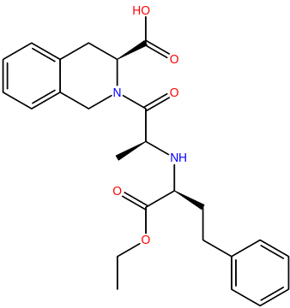  54891, 54892 | PS(AS) | Inactive | Low | Inactive | Low
RONIDAZOLE | 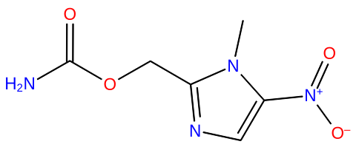  5094 | PS(AS) | Inactive | Low | Inactive | Low
PHYSOSTIGMINE SALICYLATE | 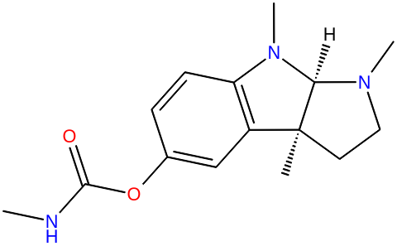  657348, 16212981 | PS(AS) | NT |  | NT
ª Parent CIDs for salt-free forms are provided where appropriate
^{b} NG: Nematode-general, PS(AD): Parasite-selective (adult and E2L), PS(AS): Parasite-selective (adult-selective)
^{c} Data are from https://pubchem.ncbi.nlm.nih.gov/bioassay/743012
^{d} High: IC₅₀ ≤ 1 uM, Moderate: 1 uM < IC₅₀ < 10 uM, Low: IC₅₀ ≥ 10 uM
^{e} Data are from https://pubchem.ncbi.nlm.nih.gov/bioassay/1224886
^{f} NT: not tested

Table-S3(Aroian). Acute toxicity and cytotoxicity data for broad-spectrum (adult hookworm and whipworm) actives.

 | A. ceylanicum Adult 30uM | A. ceylanicum E2L 30 µM | C. elegans L4 30 µM | T. muris, 100 µM | Oral LD50ª (mouse), mg/kg | PubChem CID | Selectivity Class | DT40 IC50, uM (PubChem AID743012) | DT40 Cytotox. Ranking | HEK293 IC50, uM (PuChem AID1224886) | HEK293 Cytotox. Ranking
PHENYLMERCURIC ACETATE | * | * | * | * | 13 | 16682730 | NG | 0.11 | High | 0.24 | High
IVERMECTIN | * | * | * | * | 25 | 3085416, 11957587 | NG | NT |  | NT
MONENSIN SODIUM | * |  |  | * | 44 | 441145. 23667299 | PS(AS) | 0.47 | High | NT
DICHLORVOS | * | * |  | * | 61 | 3039 | PS(AD) | 9.44 | Moderate | Inactive | Low
NICOTINE DITARTRATE | * |  |  | * | 65 | 89594, 5702296 | PS(AS) | Inactive | Low | Inactive | Low
HEXACHLOROPHENE | * | * |  | * | 67 | 3598 | PS(AS) | 3.05 | Moderate | 3.88 | Moderate
PENFLURIDOL | * | * | * | * | 87 | 33630 | NG | 4.22 | Moderate | 9.52 | Moderate
THIMEROSAL | * | * | * | * | 91 | 16684434 | NG | 0.17 | High | 1.10 | Moderate
GENTIAN VIOLET | * | * | * | * | 96 | 11057 | NG | 0.19 | High | 5.47 | Moderate
CETYLPYRIDINIUM CHLORIDE | * | * | * | * | 108 | 2683, 31239 | NG | 0.43 | High | 17.37 | Low
LEVAMISOLE HYDROCHLORIDE | * | * | * | * | 223 | 26879, 27944 | NG | Inactive | Low | Inactive | Low
PROTRYPTYLINE HYDROCHLORIDE | * |  |  | * | 269 | 4976 | PS(AS) | NT |  | NT
ECONAZOLE NITRATE | * | * |  | * | 462 | 3198, 68589 | PS(AD) | 7.50 | Moderate | 21.79 | Low
BENZALKONIUM CHLORIDE | * | * |  | * | 919 | 23705 | PS(AD) | 0.42 | High | 3.01 | Moderate
HEXETIDINE | * | * |  | * | 1520 | 3607 | PS(AD) | 10.12 | Low | 8.49 | Moderate
SULCONAZOLE NITRATE | * | * | * | * | 2475 | 5318, 65495 | NG | 10.12 | Low | 16.93 | Low
PERHEXILINE MALEATE | * | * |  | * | 2641 | 4746, 5284439 | PS(AD) | 2.66 | Moderate | 16.93 | Low
PYRANTEL PAMOATE | * | * | * | * | 4090 | 708857, 5281033 | PS(AD) | NT |  | NT
PARAROSANILINE PAMOATE | * | * |  | * | 5000 | 11292, 11293 | PS(AD) | 9.69 | Moderate | 3.47 | Moderate
ª ChemIDplus database of TOXNET (https://chem.nlm.nih.gov/chemidplus/)

Figure-S1(Aroian) in vivo activity against A. ceylanicum infections in hamsters.

