EXTL3-interacting endometriosis-specific serum factors induce colony formation of endometrial stromal cells
Alar Aints ^{a,b*}, Signe Mölder ^{c} and Andres Salumets ^{a,c,d,e}

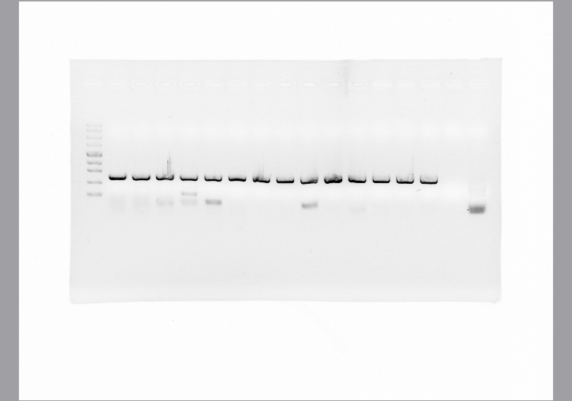
Supplementary Figure 1 – Uncropped.

