Supplementary data

Title:
Determination of the pathogenicity of known COL4A5 intronic variants by in vitro splicing assay

Tomoko Horinouchi, Kandai Nozu, Tomohiko Yamamura, Shogo Minamikawa, China Nagano, Nana Sakakibara, Koichi Nakanishi, Yuko Shima, Naoya Morisada, Shinya Ishiko, Yuya Aoto, Hiroaki Nagase, Hiroki Takeda, Rini Rossanti, Hiroshi Kaito, Masafumi Matsuo, Kazumoto Iijima

Supplementary Figure 1.
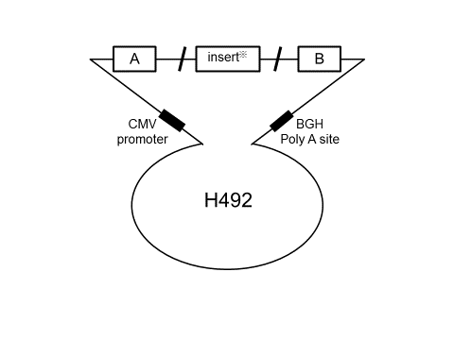
Supplementary Figure 2.
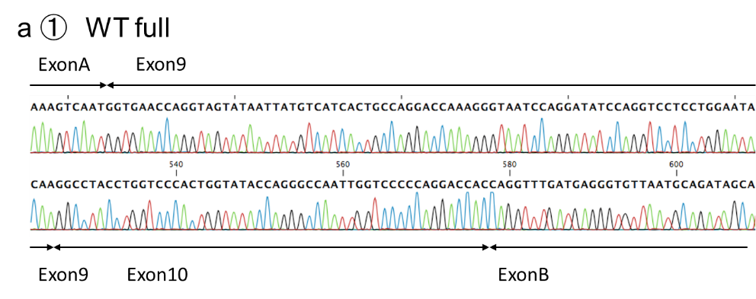
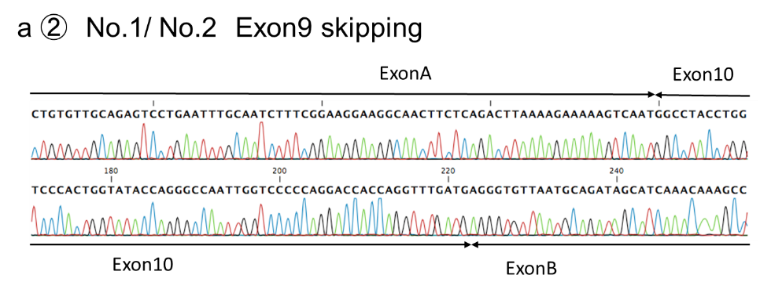
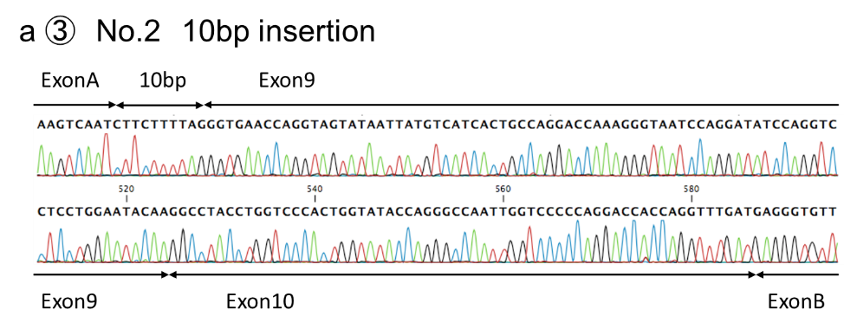
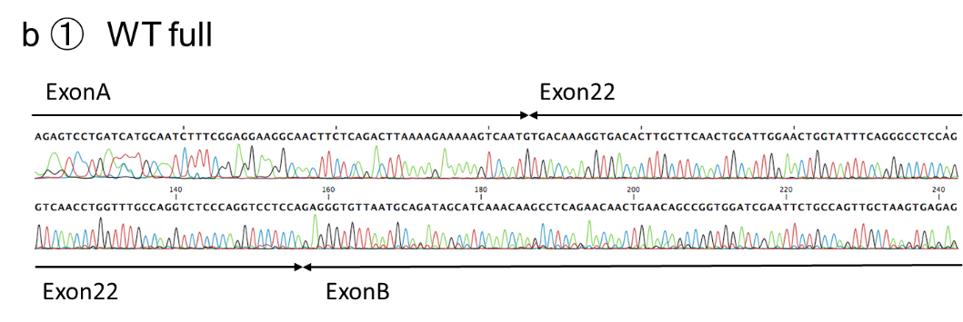
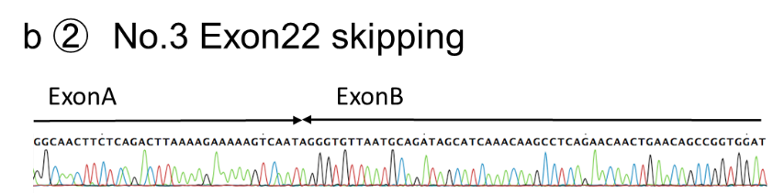

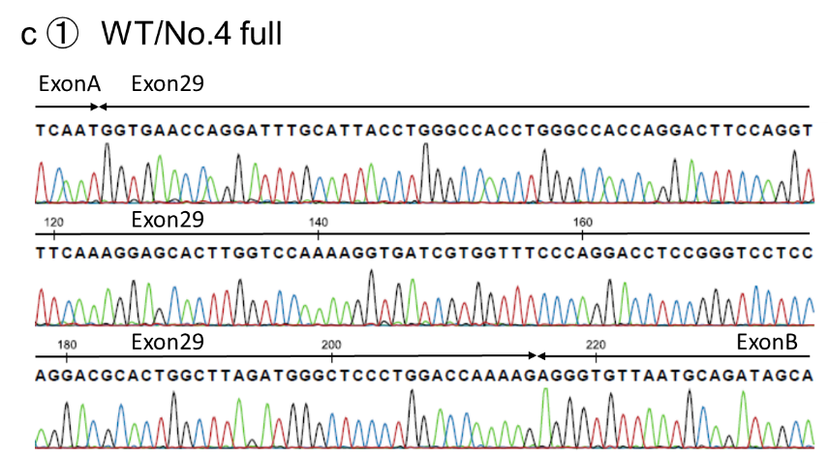
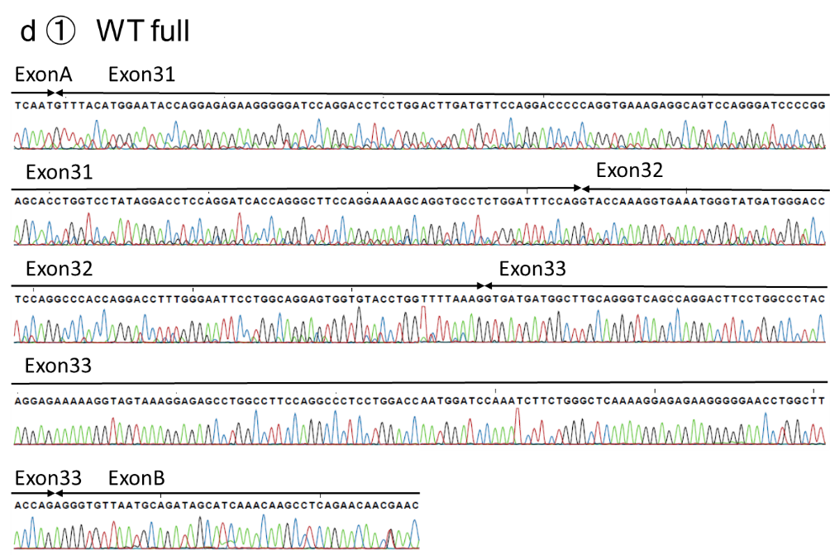
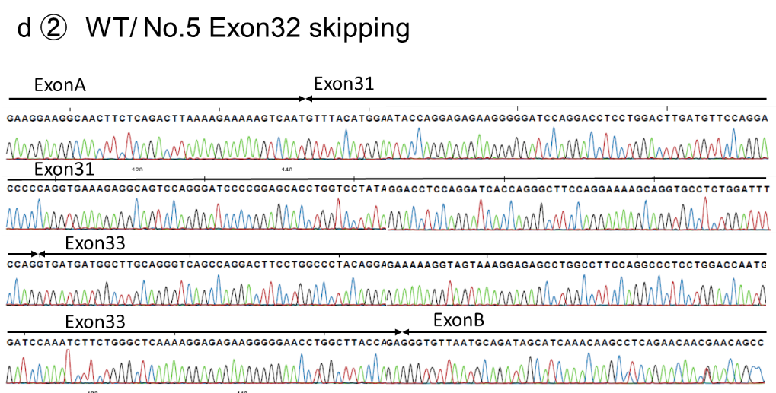
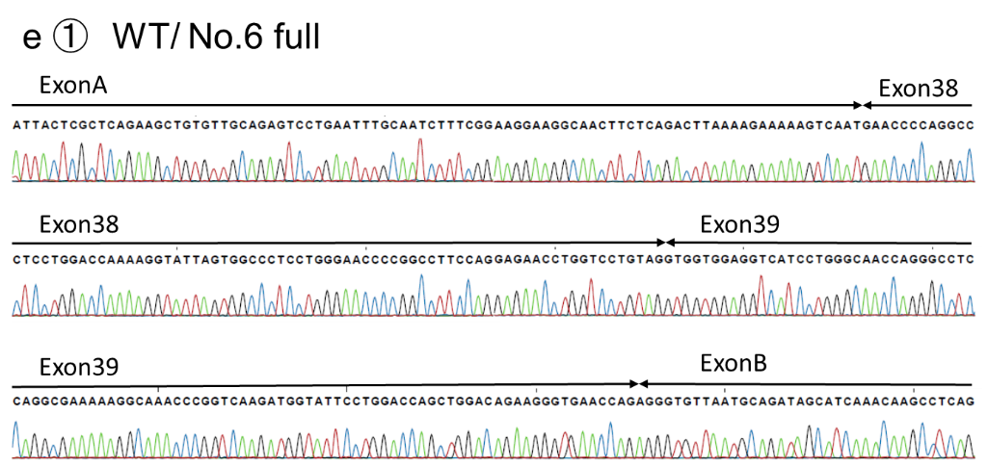

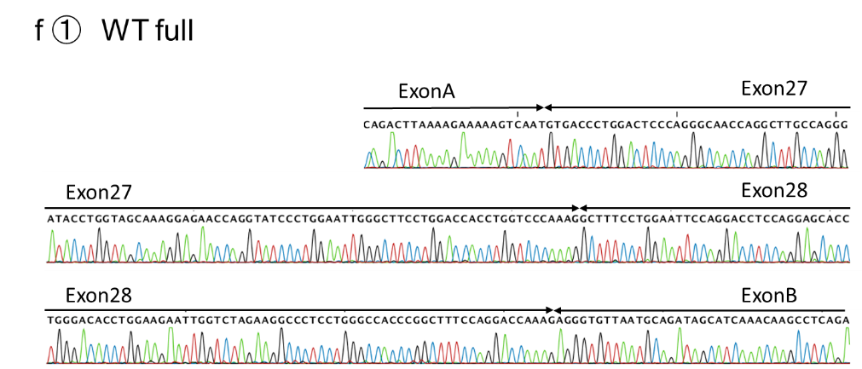
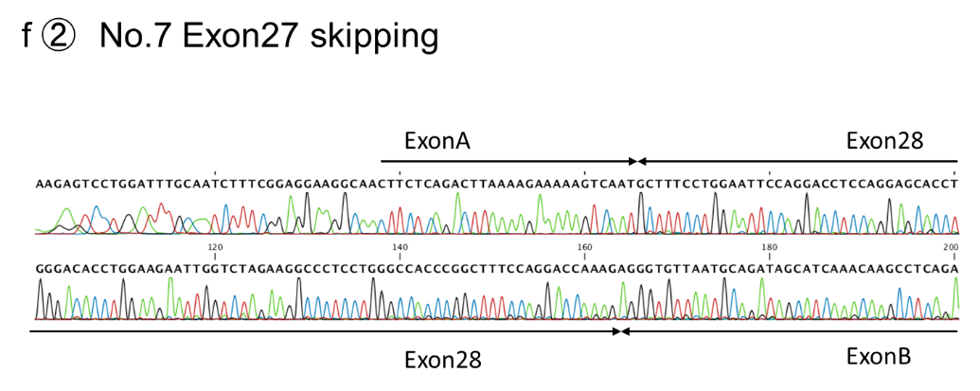

Supplementary Figure 3.
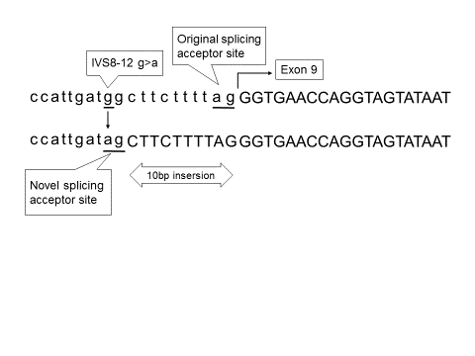

Figure legends
Supplementary Figure 1. Schema for the hybrid minigene
H492 vector has two cassette exons, A and B, between which is a multicloning site. H492 vector also has cytomegalovirus (CMV) enhancer–promoter and a bovine growth hormone gene (BGH) polyadenylation site.

Supplementary Figure 2. Direct sequencing for transcript analysis from the minigene constructs
The numbers correspond to those in Figure 1.
a.① The single band shown in the wild type (WT) corresponded to exon 9 and exon 10 between exon A and exon B; the splicing pattern was normal.
a.② The single band shown in No. 1 and the lower band shown in No. 2 corresponded to only exon 10 between exon A and exon B; exon 9 skipping occurred.
a.③ The upper band shown in No. 2 corresponded to a 10-bp insertion and exon 9 and exon 10 between exon A and exon B; a 10-bp insertion occurred.
b.① The single band shown in WT corresponded to exon 22 between exon A and exon B; the splicing pattern was normal.
b.② The single band shown in No. 3 directly connected exon A and exon B; exon 22 skipping occurred.
d.① The upper band shown in WT corresponded to exon 31, exon 32 and exon 33 between exon A and exon B; the splicing pattern was normal.
d.② The lower band shown in WT and the single band shown in No. 5 corresponded to exon 31 and exon 33 between exon A and exon B; exon 32 skipping occurred.
e.① The single band shown in WT and No. 6 corresponded to exon 38 and exon 39 between exon A and exon B; the splicing pattern was normal.
f.① The single band shown in WT corresponded to exon 27 and exon 28 between exon A and exon B; the splicing pattern was normal.
f.② The single band shown in No. 7 corresponded to exon 28 between exon A and exon B; exon 27 skipping occurred.

Supplementary Figure 3. Alignment of COL4A5 exon 9 and its boundaries (No. 2)
The single-nucleotide substitution activates a novel splicing acceptor site and induces a 10-bp insertion.

Supplementary Table 1
In silico analysis of COL4A5 cases for which in vitro (minigene) results have been reported
gDNA mutation | mRNA | In vitro (minigene) | In silico |  |  |  | Reference
gDNA mutation | mRNA | In vitro (minigene) | HSF  (original ASS) | HSF  (novel ASS) | SVM-BPF (PPT score) | HSF  (Branch point) | Reference
IVS28-40 A>G | N/A | Ex29 skipping/ 43bp del | N/A | N/A | ↓ | 59.3→29.6 | Chiereghin et al. 2017
IVS24-6 T>G | N/A | Frequent skipping of Ex25 | 12.9→11.2 | / | → | No change | Malone et al.  2017
c.548dupG (Ex10) | Exon10 skipping | Ex10 skipping | 6.8→6.3 | / | → | No change | Horinouchi et al. 2018

IVS: intron, N/A: not available, Ex: exon
HSF: Human Splicing Finder, ASS: acceptor site score, SVM-BPF: SVM-BPfinder, PPT: polypyrimidine tract

Supplementary Table 2
The primers for cloning
No. 1 F: GCAGCTAGCGGCCACTTCCTCATTTTCC
No. 1 R: CGTGGATCCTCTGAAATGGCCAGAATTGA
No. 2 F: GCAGCTAGCGGCCACTTCCTCATTTTCC
No. 2 R: CGTGGATCCTCTGAAATGGCCAGAATTGA
No. 3 F: GCAGCTAGCCTGGAACAGTTCTTGGCACA
No. 3 R: CGTGGATCCGCTTCAGGTATTAGAAACAAGAGCA
No. 4 Fragment F: CCGTGCTTTGTTAGCTTTCCCTACAAGGGTAGTC
No. 4 Fragment R: TCGATGTTAACGCTAACCTTCACCTCCCAAGTTC
No. 4 Vector F: TAGCGTTAACATCGATATCCGG
No. 4 Vector R: GCTAACAAAGCACGGAGTTTAC
No. 5 Fragment F: AGCGTTAACATCGATTGCATCTTTGGCTTTTTATTC
No. 5 Fragment R: AACCAGGATCCGGATAGTGGTTAGGTAAAGCTCG
No. 5 Vector F: ATCCGGATCCTGGTTTGA
No. 5 Vector R: ATCGATGTTAACGCTAGC
No. 6 Fragment F: AGCGTTAACATCGATAGTCCAGCAAGAGGAATGG
No. 6 Fragment R: AACCAGGATCCGGATAAACATATATTCTATTTCCGATG
No. 6 Vector F: ATCCGGATCCTGGTTTGA
No. 6 Vector R: ATCGATGTTAACGCTAGC
No. 7 F: GCAGCTAGCGTACAGTGGCGTGATGTTGG
No. 7 R: CGTGGATCCTTGCTCCAAATGTGACCTTG

The primers for mutagenesis
No. 1 F: ACTTCCAGTGATGGCTTCTTTTAGGG
No. 1 R: GCCATCACTGGAAGTTCTAAGACACA
No. 2 F: CATTGATAGCTTCTTTTAGGGTGAAC
No. 2 R: AAGAAGCTATCAATGGAAGTTCTAAG
No. 3 F: ATTTGTTAGTTATTATGATTTCACTA
No. 3 R: TAATAACTAACAAATTTTACTGAAAG
No. 4 F: TTTGTCAAGTGTATGCTCAAGGGTGA
No. 4 R: CATACACTTGACAAAACACAACAAAA
No. 5 F: ATTGATAGTCTTCAAAGGTACCAAAG
No. 5 R: TTGAAGACTATCAATAAGTAATGTTTG
No. 6 F: TTGAGCTATTTACTCTAGGAACCCC
No. 6 R: GAGTAAATAGCTCAATTTAAAAATG

