Transcriptome and gene expression analysis of three developmental stages of the coffee berry borer, Hypothenemus hampei

Daniel D. Noriega^{1, 2, §, *}, Paula L. Arias^{3, §}, Helena R. Barbosa^{2, 4, §}, Fabricio B.M. Arraes^{2, 4}, Gustavo A. Ossa³, , Bernardo Villegas⁵, Roberta R. Coelho², Erika S. Albuquerque², Roberto C. Togawa², Priscila Grynberg², Haichuan Wang⁶, Ana M. Vélez⁶, Jorge W. Arboleda⁷, Maria F. Grossi-de-Sa^{2, 8, *}, Maria C.M Silva^{2, δ}, Arnubio Valencia-Jiménez^{5, δ, *}

¹Department of Cellular Biology, University of Brasília, Brasília-DF, Brazil.
²Embrapa Genetic Resources and Biotechnology, Brasília-DF, Brazil.
³Departamento de Ciencias Biológicas, Universidad de Caldas, Manizales, Colombia.
⁴Biotechnology Center, UFRGS, Porto Alegre-RS, Brazil.
⁵Departamento de Producción Agropecuaria, Universidad de Caldas, Manizales, Colombia.
⁶University of Nebraska-Lincoln, Nebraska, United States of America.
⁷Centro de Investigaciones en Medio Ambiente y Desarrollo – CIMAD, Universidad de Manizales, Manizales, Caldas, Colombia.
⁸Catholic University of Brasília - Postgraduate Program in Genomic Sciences and Biotechnology, Brasília-DF, Brazil

§Authors contributed equally to the work.
^{δ} Co-last authors

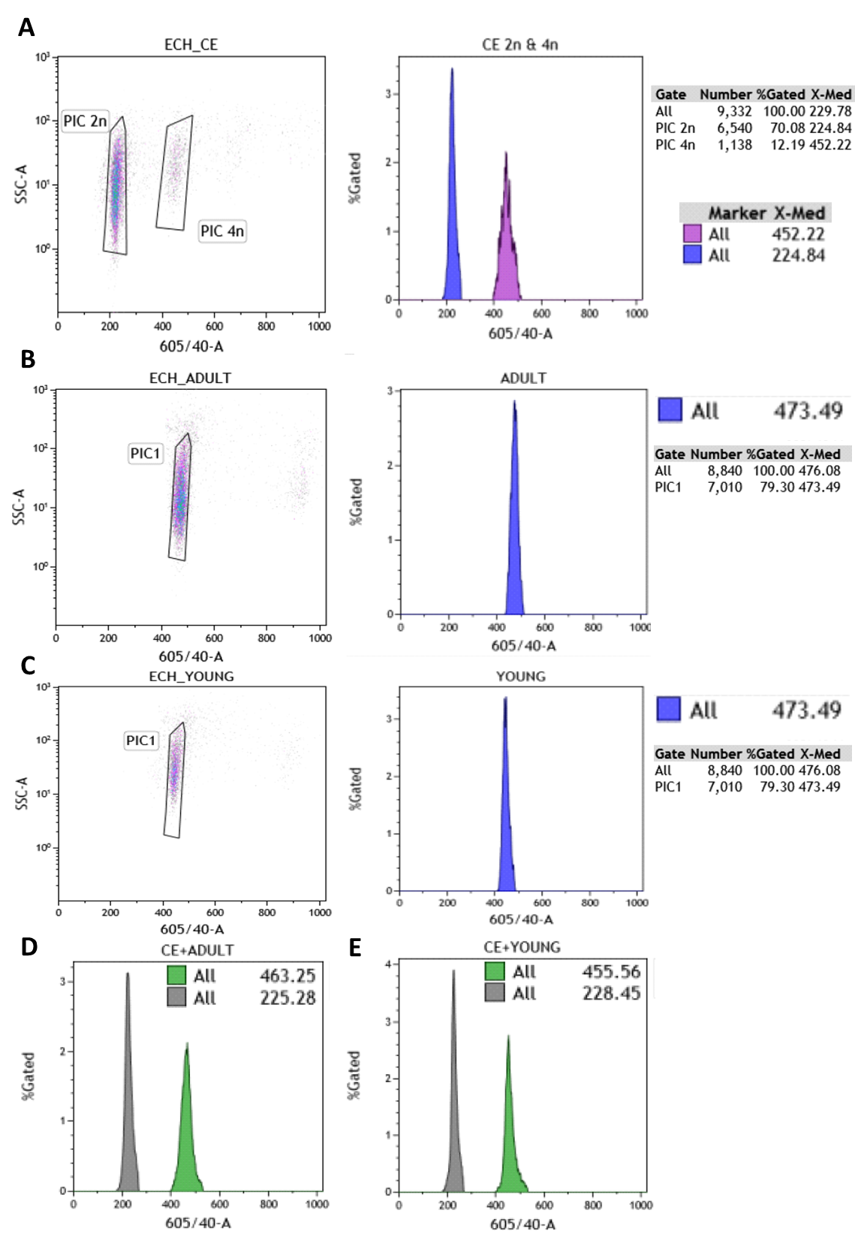
Supplementary Figure S1. Flow cytometry estimation of the genome size for Hypothenemus hampei. Caenorhabditis elegans was used as a reference standard (known genome size 1C=100 Mb). The X-axis represents the relative fluorescence intensity of nuclei stained with propidium iodide in a nuclear suspension from an adult insect. The Y-axis represents the number of nuclei. (a) C. elegans 2C and 4C. (b) H. hampei adult female. (c) H. hampei young female L. oryzophilus females. (d) and (e) are mixed samples of C. elegans and H. hampei adult or young females, respectively. Green square: (CE 4n + CBB 2n) 605\ 40-A. Grey square: (CE 2n) 605\ 40-A. Violet square: (PIC 4n) 605\ 40-A. Purple square: (PIC 2n) 605\ 40-A.
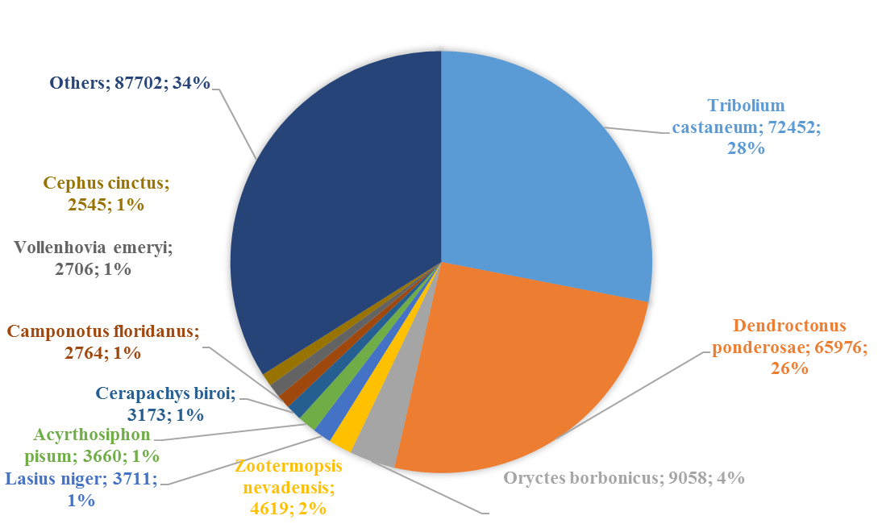
Supplementary Figure S2. Top-hit species distribution for BLAST analysis to the NR database from NCBI. Right to species name is showed the number of contigs with at least one match and the respective percent.
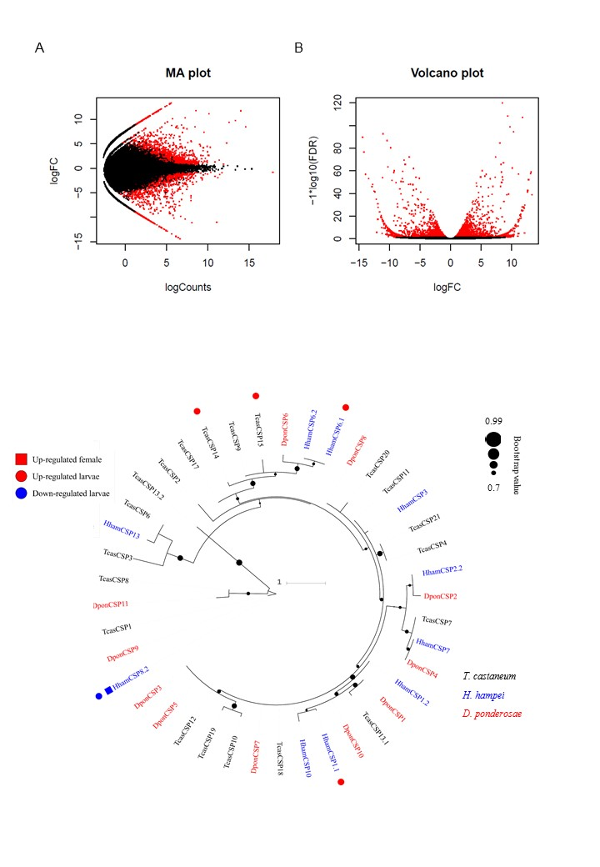
Supplementary Figure S3. Foldchange (FC) values distribution of differential expression analysis. (a) MA plot showing counts distribution among FC value. (b) Volcano plot showing statiscal significance (FDR) across FC range in the analysis.
Functional group | DEG set | Contig | Log2FC | Predicted protein annotation
Chemosensory receptors | L2 Larvae Down | Hypothenemus_hampei_contig_12430|c2_g1_i2 | -7.364387221 | chemosensory 8
Chemosensory receptors | L2 Larvae Down | Hypothenemus_hampei_contig_154|c0_g2_i1 | -8.498910824 | odorant binding 1
Chemosensory receptors | L2 Larvae Down | Hypothenemus_hampei_contig_18674|c0_g1_i1 | -7.259677487 | odorant binding 5
Chemosensory receptors | L2 Larvae Down | Hypothenemus_hampei_contig_24447|c0_g2_i1 | -7.584157057 | odorant-binding 6
Chemosensory receptors | L2 Larvae Down | Hypothenemus_hampei_contig_28774|c0_g1_i1 | -8.870528234 | chemosensory 10
Chemosensory receptors | L2 Larvae Down | Hypothenemus_hampei_contig_41080|c0_g1_i1 | -2.081118277 | odorant binding 2
Chemosensory receptors | L2 Larvae Up | Hypothenemus_hampei_contig_14038|c0_g3_i1 | 2.475518468 | odorant binding 13
Chemosensory receptors | L2 Larvae Up | Hypothenemus_hampei_contig_1665|c0_g3_i1 | 8.325106899 | odorant binding partial
Chemosensory receptors | L2 Larvae Up | Hypothenemus_hampei_contig_23152|c0_g11_i1 | 8.699211567 | chemosensory 2
Chemosensory receptors | L2 Larvae Up | Hypothenemus_hampei_contig_24369|c0_g1_i5 | 3.098464896 | odorant-binding 30
Chemosensory receptors | L2 Larvae Up | Hypothenemus_hampei_contig_36517|c2_g1_i2 | 2.479809422 | chemosensory 1
Chemosensory receptors | L2 Larvae Up | Hypothenemus_hampei_contig_41326|c0_g1_i4 | 2.648608777 | odorant binding
Chemosensory receptors | L2 Larvae Up | Hypothenemus_hampei_contig_43372|c0_g1_i1 | 5.230483388 | odorant-binding partial
Chemosensory receptors | L2 Larvae Up | Hypothenemus_hampei_contig_46690|c4_g83_i2 | 3.577373325 | chemosensory 6
Chemosensory receptors | L2 Larvae Up | Hypothenemus_hampei_contig_5388|c0_g2_i1 | 9.046621442 | odorant receptor 15
Chemosensory receptors | Male Down | Hypothenemus_hampei_contig_18674|c0_g1_i1 | -6.007212075 | odorant binding 5
Chemosensory receptors | Male Down | Hypothenemus_hampei_contig_24447|c0_g1_i1 | -5.142375943 | odorant-binding 6
Chemosensory receptors | Male Up | Hypothenemus_hampei_contig_11391|c1_g1_i1 | 10.65449291 | odorant receptor 297
Chemosensory receptors | Male Up | Hypothenemus_hampei_contig_13390|c0_g1_i1 | 3.689765561 | odorant binding 18
Chemosensory receptors | Male Up | Hypothenemus_hampei_contig_14038|c0_g3_i1 | 2.31085715 | odorant binding 13
Chemosensory receptors | Male Up | Hypothenemus_hampei_contig_15489|c2_g3_i1 | 5.93059934 | chemosensory 8
Chemosensory receptors | Male Up | Hypothenemus_hampei_contig_15508|c0_g1_i15 | 8.751246469 | odorant receptor 5
Chemosensory receptors | Male Up | Hypothenemus_hampei_contig_1665|c0_g3_i1 | 5.314689903 | odorant binding partial
Chemosensory receptors | Male Up | Hypothenemus_hampei_contig_1701|c0_g1_i1 | 6.738745942 | odorant receptor 8
Chemosensory receptors | Male Up | Hypothenemus_hampei_contig_21708|c0_g1_i1 | 4.633997268 | odorant binding 13
Chemosensory receptors | Male Up | Hypothenemus_hampei_contig_41326|c0_g1_i2 | 2.151226339 | odorant-binding 11
Chemosensory receptors | Male Up | Hypothenemus_hampei_contig_43372|c0_g1_i1 | 5.172777189 | odorant-binding partial
Chemosensory receptors | Male Up | Hypothenemus_hampei_contig_44237|c0_g2_i1 | 8.474440924 | odorant receptor 23
Chemosensory receptors | Male Up | Hypothenemus_hampei_contig_7961|c0_g1_i1 | 9.355341059 | chemosensory ionotropic receptor partial
Juvenile Hormone-related proteins | L2 Larvae Down | Hypothenemus_hampei_contig_16847|c0_g1_i1 | -6.858838883 | juvenile hormone esterase
Juvenile Hormone-related proteins | L2 Larvae Down | Hypothenemus_hampei_contig_22441|c1_g2_i1 | -8.836359879 | juvenile hormone esterase
Juvenile Hormone-related proteins | L2 Larvae Down | Hypothenemus_hampei_contig_32744|c0_g1_i1 | -4.330971965 | juvenile hormone inducible partial
Juvenile Hormone-related proteins | L2 Larvae Down | Hypothenemus_hampei_contig_33576|c0_g1_i5 | -6.921776554 | hemolymph juvenile hormone-binding partial
Juvenile Hormone-related proteins | L2 Larvae Down | Hypothenemus_hampei_contig_36519|c1_g2_i1 | -3.156955487 | juvenile hormone epoxide hydrolase 2
Juvenile Hormone-related proteins | L2 Larvae Up | Hypothenemus_hampei_contig_28980|c0_g2_i1 | 3.281054999 | Juvenile hormone epoxide hydrolase 1
Juvenile Hormone-related proteins | L2 Larvae Up | Hypothenemus_hampei_contig_43090|c0_g1_i1 | 2.605937818 | juvenile hormone binding partial
Juvenile Hormone-related proteins | Male Down | Hypothenemus_hampei_contig_32744|c0_g1_i1 | -3.385304319 | juvenile hormone inducible partial
Juvenile Hormone-related proteins | Male Down | Hypothenemus_hampei_contig_36519|c1_g2_i7 | -5.190221679 | Juvenile hormone epoxide hydrolase 1
Juvenile Hormone-related proteins | Male Down | Hypothenemus_hampei_contig_46456|c0_g1_i1 | -2.349915233 | juvenile hormone inducible partial
Juvenile Hormone-related proteins | Male Up | Hypothenemus_hampei_contig_12157|c2_g2_i1 | 7.881819692 | juvenile hormone binding partial
Juvenile Hormone-related proteins | Male Up | Hypothenemus_hampei_contig_36519|c1_g2_i6 | 4.906379336 | Juvenile hormone epoxide hydrolase 1
Juvenile Hormone-related proteins | Male Up | Hypothenemus_hampei_contig_43090|c0_g1_i1 | 3.517623035 | juvenile hormone binding partial
Cytochrome P450 | L2 Larvae Down | Hypothenemus_hampei_contig_19523|c0_g1_i12 | -3.607762784 | cytochrome P450 CYP9Z18
Cytochrome P450 | L2 Larvae Down | Hypothenemus_hampei_contig_20776|c0_g4_i1 | -12.39663459 | cytochrome P450 4C1-like isoform X1
Cytochrome P450 | L2 Larvae Down | Hypothenemus_hampei_contig_29164|c0_g2_i1 | -3.738540115 | cytochrome P450 CYP6DJ1
Cytochrome P450 | L2 Larvae Down | Hypothenemus_hampei_contig_41707|c0_g2_i1 | -9.958282254 | cytochrome P450 CYP6DK1
Cytochrome P450 | L2 Larvae Down | Hypothenemus_hampei_contig_42922|c0_g1_i3 | -2.666546622 | cytochrome P450
Cytochrome P450 | L2 Larvae Down | Hypothenemus_hampei_contig_47722|c0_g2_i1 | -4.281093434 | cytochrome P450 4d2
Cytochrome P450 | L2 Larvae Down | Hypothenemus_hampei_contig_9539|c0_g1_i12 | -11.08721952 | cytochrome P450
Cytochrome P450 | L2 Larvae Up | Hypothenemus_hampei_contig_16892|c0_g3_i3 | 3.949868276 | cytochrome P450 CYP410a1
Cytochrome P450 | L2 Larvae Up | Hypothenemus_hampei_contig_26843|c0_g1_i2 | 4.456558812 | cytochrome P450 CYP6DG1v3
Cytochrome P450 | L2 Larvae Up | Hypothenemus_hampei_contig_2800|c0_g1_i2 | 2.129248554 | cytochrome P450
Cytochrome P450 | L2 Larvae Up | Hypothenemus_hampei_contig_30541|c0_g1_i1 | 3.990036997 | cytochrome P450
Cytochrome P450 | L2 Larvae Up | Hypothenemus_hampei_contig_46655|c3_g3_i4 | 9.038733964 | cytochrome P450 CYP9Z18
Cytochrome P450 | Male Down | Hypothenemus_hampei_contig_20776|c0_g4_i1 | -4.994447758 | cytochrome P450 4C1-like isoform X1
Cytochrome P450 | Male Down | Hypothenemus_hampei_contig_9539|c0_g1_i29 | -11.49454208 | cytochrome P450
Cytochrome P450 | Male Up | Hypothenemus_hampei_contig_15417|c0_g1_i6 | 11.84472649 | cytochrome P450
Cytochrome P450 | Male Up | Hypothenemus_hampei_contig_15515|c3_g3_i1 | 10.08424781 | cytochrome P450 301B1
Cytochrome P450 | Male Up | Hypothenemus_hampei_contig_27911|c0_g2_i1 | 8.254635333 | cytochrome P450 4- partial
Cytochrome P450 | Male Up | Hypothenemus_hampei_contig_38896|c0_g1_i1 | 8.317881171 | cytochrome P450
Cytochrome P450 | Male Up | Hypothenemus_hampei_contig_41710|c0_g1_i2 | 8.883828658 | cytochrome P450 CYP334e1
Cytochrome P450 | Male Up | Hypothenemus_hampei_contig_46708|c10_g15_i1 | 2.707082132 | cytochrome P450 CYP4g56
Chitin and cuticle metabolism | L2 Larvae Up | Hypothenemus_hampei_contig_22262|c1_g3_i1 | 3.705852995 | chitin deacetylase 2 isoform A precursor
Chitin and cuticle metabolism | L2 Larvae Up | Hypothenemus_hampei_contig_25945|c0_g1_i4 | 9.03947933 | chitinase 10 isoform X1
Chitin and cuticle metabolism | L2 Larvae Up | Hypothenemus_hampei_contig_2772|c0_g1_i18 | 11.82909541 | probable chitinase 3 isoform X2
Chitin and cuticle metabolism | L2 Larvae Up | Hypothenemus_hampei_contig_34530|c0_g1_i2 | 3.320319165 | acidic mammalian chitinase-like
Chitin and cuticle metabolism | L2 Larvae Up | Hypothenemus_hampei_contig_34894|c0_g1_i1 | 2.613834113 | chitinase 3
Chitin and cuticle metabolism | L2 Larvae Up | Hypothenemus_hampei_contig_38387|c0_g2_i1 | 2.302089878 | chitin deacetylase 1 precursor
Chitin and cuticle metabolism | L2 Larvae Up | Hypothenemus_hampei_contig_38648|c0_g1_i1 | 9.226841757 | chitinase 3
Chitin and cuticle metabolism | L2 Larvae Up | Hypothenemus_hampei_contig_41684|c0_g1_i1 | 6.898576189 | chitinase 10 precursor
Chitin and cuticle metabolism | L2 Larvae Up | Hypothenemus_hampei_contig_41905|c0_g2_i1 | 3.883482818 | chitin deacetylase 4 precursor
Chitin and cuticle metabolism | L2 Larvae Up | Hypothenemus_hampei_contig_42180|c8_g21_i9 | 3.647977925 | probable chitinase 2
Chitin and cuticle metabolism | L2 Larvae Up | Hypothenemus_hampei_contig_42493|c2_g2_i1 | 2.629436698 | chitinase 2
Chitin and cuticle metabolism | L2 Larvae Up | Hypothenemus_hampei_contig_10377|c0_g1_i1 | 8.732506739 | cuticular analogous to peritrophins 3-A1 precursor
Chitin and cuticle metabolism | L2 Larvae Up | Hypothenemus_hampei_contig_10456|c0_g2_i1 | 3.845468686 | Larval cuticle 5
Chitin and cuticle metabolism | L2 Larvae Up | Hypothenemus_hampei_contig_1161|c0_g1_i1 | 6.633876703 | Endocuticle structural glyco bd-1
Chitin and cuticle metabolism | L2 Larvae Up | Hypothenemus_hampei_contig_17490|c0_g1_i1 | 5.167043527 | flexible cuticle 12-like
Chitin and cuticle metabolism | L2 Larvae Up | Hypothenemus_hampei_contig_24570|c0_g1_i1 | 6.862918603 | larval pupal cuticle H1C
Chitin and cuticle metabolism | L2 Larvae Up | Hypothenemus_hampei_contig_25260|c0_g1_i1 | 4.317273345 | cuticular analogous to peritrophins 1-I precursor
Chitin and cuticle metabolism | L2 Larvae Up | Hypothenemus_hampei_contig_28252|c0_g1_i1 | 6.36297928 | larval pupal cuticle H1C
Chitin and cuticle metabolism | L2 Larvae Up | Hypothenemus_hampei_contig_28334|c0_g1_i1 | 4.654366648 | cuticular analogous to peritrophins 3-B precursor
Chitin and cuticle metabolism | L2 Larvae Up | Hypothenemus_hampei_contig_32180|c0_g1_i1 | 6.623967078 | larvae cuticle
Chitin and cuticle metabolism | L2 Larvae Up | Hypothenemus_hampei_contig_36516|c0_g3_i1 | 9.703418726 | endocuticle structural glyco bd-3-like
Chitin and cuticle metabolism | L2 Larvae Up | Hypothenemus_hampei_contig_41008|c0_g4_i1 | 4.914158627 | larval cuticle A2B
Chitin and cuticle metabolism | L2 Larvae Up | Hypothenemus_hampei_contig_43159|c0_g1_i1 | 2.558831583 | cuticular analogous to peritrophins 1-H isoform X1
Chitin and cuticle metabolism | L2 Larvae Up | Hypothenemus_hampei_contig_47696|c0_g2_i1 | 7.159814466 | flexible cuticle 12-like
Chitin and cuticle metabolism | L2 Larvae Up | Hypothenemus_hampei_contig_6260|c0_g2_i2 | 4.575007002 | cuticular analogous to peritrophins 3-C5 isoform 1 precursor
Chitin and cuticle metabolism | Male Up | Hypothenemus_hampei_contig_22262|c1_g2_i2 | 5.147090168 | chitin deacetylase 2 isoform B precursor
Chitin and cuticle metabolism | Male Up | Hypothenemus_hampei_contig_22482|c0_g1_i2 | 3.716844783 | chitin synthase I
Chitin and cuticle metabolism | Male Up | Hypothenemus_hampei_contig_2959|c0_g1_i1 | 5.637187262 | Chitinase Idgf4
Chitin and cuticle metabolism | Male Up | Hypothenemus_hampei_contig_34894|c0_g1_i1 | 3.295033366 | chitinase 3
Chitin and cuticle metabolism | Male Up | Hypothenemus_hampei_contig_37458|c0_g1_i2 | 5.400556347 | chitin deacetylase 5 isoform X5
Chitin and cuticle metabolism | Male Up | Hypothenemus_hampei_contig_39314|c0_g1_i2 | 2.899599712 | chitinase 3
Chitin and cuticle metabolism | Male Up | Hypothenemus_hampei_contig_42493|c2_g2_i1 | 2.569405783 | chitinase 2
Chitin and cuticle metabolism | Male Up | Hypothenemus_hampei_contig_10377|c0_g2_i1 | 2.331728354 | cuticular analogous to peritrophins 3-A1 precursor
Chitin and cuticle metabolism | Male Up | Hypothenemus_hampei_contig_10456|c0_g2_i1 | 2.586900208 | Larval cuticle 5
Chitin and cuticle metabolism | Male Up | Hypothenemus_hampei_contig_10475|c0_g3_i1 | 8.156682199 | cuticle 7
Chitin and cuticle metabolism | Male Up | Hypothenemus_hampei_contig_12353|c0_g1_i1 | 8.141146694 | adult-specific cuticular ACP-20
Chitin and cuticle metabolism | Male Up | Hypothenemus_hampei_contig_1308|c1_g2_i1 | 11.82367254 | Adult-specific rigid cuticular
Chitin and cuticle metabolism | Male Up | Hypothenemus_hampei_contig_21349|c0_g1_i1 | 9.961775767 | cuticle 19
Chitin and cuticle metabolism | Male Up | Hypothenemus_hampei_contig_23394|c0_g1_i2 | 6.2511725 | Insect cuticle partial
Chitin and cuticle metabolism | Male Up | Hypothenemus_hampei_contig_25099|c0_g1_i1 | 5.684376167 | cuticle precursor
Chitin and cuticle metabolism | Male Up | Hypothenemus_hampei_contig_25260|c0_g1_i1 | 3.488849275 | cuticular analogous to peritrophins 1-I precursor
Chitin and cuticle metabolism | Male Up | Hypothenemus_hampei_contig_28334|c0_g1_i1 | 3.23955422 | cuticular analogous to peritrophins 3-B precursor
Chitin and cuticle metabolism | Male Up | Hypothenemus_hampei_contig_28839|c0_g5_i1 | 8.99950278 | Insect cuticle partial
Chitin and cuticle metabolism | Male Up | Hypothenemus_hampei_contig_40497|c2_g2_i1 | 2.748881597 | cuticular analogous to peritrophins 1-J precursor
Chitin and cuticle metabolism | Male Up | Hypothenemus_hampei_contig_41008|c0_g2_i1 | 9.002801673 | larval cuticle A2B
Chitin and cuticle metabolism | Male Up | Hypothenemus_hampei_contig_41551|c0_g3_i1 | 3.673346651 | cuticular precursor
Chitin and cuticle metabolism | Male Up | Hypothenemus_hampei_contig_43159|c0_g1_i1 | 2.474745336 | cuticular analogous to peritrophins 1-H isoform X1
Chitin and cuticle metabolism | Male Up | Hypothenemus_hampei_contig_46076|c0_g1_i1 | 4.062737975 | Insect cuticle partial
Chitin and cuticle metabolism | Male Up | Hypothenemus_hampei_contig_5351|c0_g1_i4 | 9.128104103 | cuticle CP7
Chitin and cuticle metabolism | Male Up | Hypothenemus_hampei_contig_6260|c0_g2_i2 | 2.602113098 | cuticular analogous to peritrophins 3-C5 isoform 1 precursor

Supplementary Table S1. Physiological and metabolic processes enriched in differential expression analysis. Contigs with their respective foldchanges are given for each differentially expressed genes set.

Gene | Primer Sequence Forward (5'-3') | Primer Sequence Reverse (5'-3') | Amplicon (bp) | Efficiency (%) | Correlation efficiency
Act2 | F: GGGAAATTGTTCGTGACATCA | R: GGGCAACGGAATCTTTCG | 157 | 90.79 | 0.9964
ChiX | F: TTGGATAGAACAAGGAGCTGAC | R: CTCTTGCACGGGTATCTTCTC | 149 | 105.98 | 0.9907
CPAP3A1 | F: AATATGCCCATCCCACAGAC | R: GTCTTCACATCCAGCAACATTC | 146 | 107.52 | 0.9949
CPAP3C5 | F: GGAGGTCAGTAACACAGGTTC | R: ACCAGTACCATCTGCATCAC | 153 | 101.15 | 0.9713
HexI | F: AAGTCAAGCGGTGGAGAAAG | R: TGTTCATCCTGGCCTGTTG | 145 | 109.53 | 0.9988
JHEHII | F: AAATTCCTGCGACCGTACC | R: AGATCAGGTACTTCCAAAGCAG | 154 | 105.64 | 0.9856
JHE | F: ACCCGAGGAAACTAGAAAGC | R: GGTCCTCCAGGTTAATTTGTTC | 158 | 99.27 | 0.9881

Supplementary Table S2. Primers used for RT-qPCR validation with their respective PCR amplification efficiencies (E) and correlation coefficients (R2).

