Supplemental Information

Novel Method for Rapid Assessment of Cognitive Impairment Using High-Performance Eye-Tracking Technology

Akane Oyama¹⁾, Shuko Takeda²⁾*, Yuki Ito²⁾, Tsuneo Nakajima¹⁾, Yoichi Takami¹⁾, Yasushi Takeya¹⁾, Koichi Yamamoto¹⁾, Ken Sugimoto¹⁾, Hideo Shimizu^{2),3)}, Munehisa Shimamura⁴⁾, Taiichi Katayama⁵⁾, Hiromi Rakugi¹⁾, Ryuichi Morishita²⁾*

1) Department of Geriatric and General Medicine, Graduate School of Medicine, Osaka University, Suita, Osaka, 565-0871, Japan.
2) Department of Clinical Gene Therapy, Graduate School of Medicine, Osaka University, Suita, Osaka, 565-0871, Japan.
3) Department of Internal Medicine, Osaka Dental University, Hirakata, Osaka 573-1121, Japan
4) Department of Neurology, Department of Health Development and Medicine, Osaka University, Suita, Osaka 565-0871, Japan
5) Department of Child Development, United Graduate School of Child Development, Osaka University, Kanazawa University, Hamamatsu University School of Medicine, Chiba University, and University of Fukui, Suita, Osaka 565-0871, Japan

Task movies and pictures for the assessment of cognitive function
Representative images of each task movie and picture are shown below. See also Methods section in the main text. Images are obtained from JVC KENWOOD Corporation (Japan) with permission.

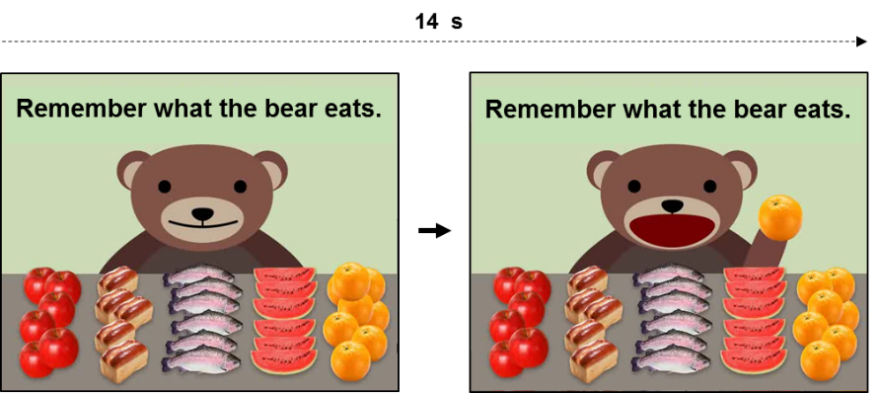
Task 1-a: Memory task (encoding) (14 s)

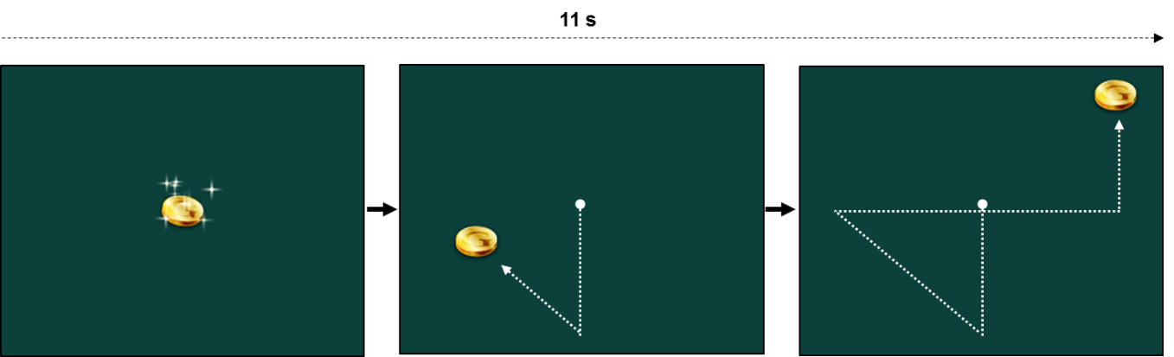
Task 2: Assessment of smooth pursuit eye tracking (11 s)

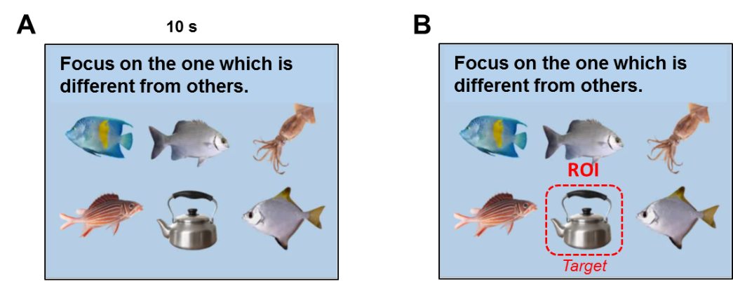

Task 3: Deductive reasoning (odd one task) (10 s)
(A) The picture displayed on the monitor. (B) ROI on the correct answer (target) is overlaid on the image.

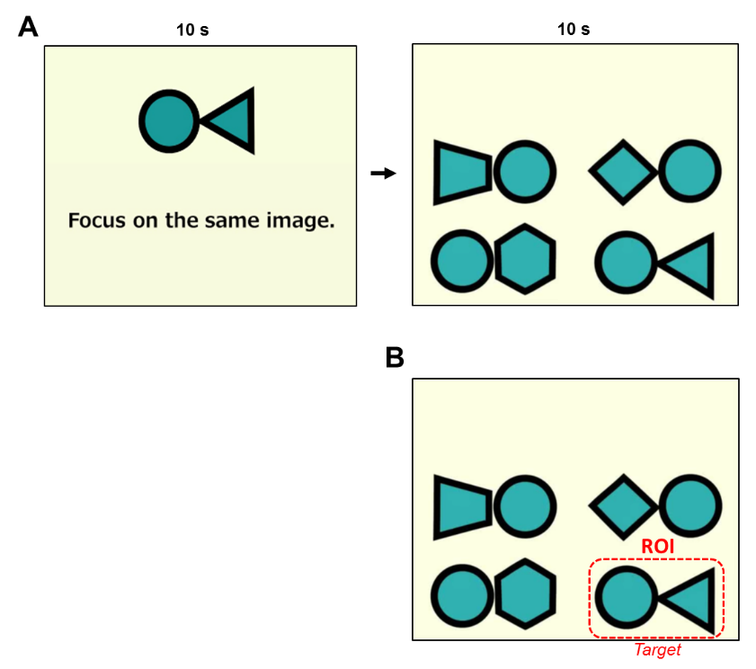
Task 4: Visual working memory task 1 (pattern matching) (20 s)
(A) The pictures displayed on the monitor. (B) ROI on the correct answer (target) is overlaid on the image.

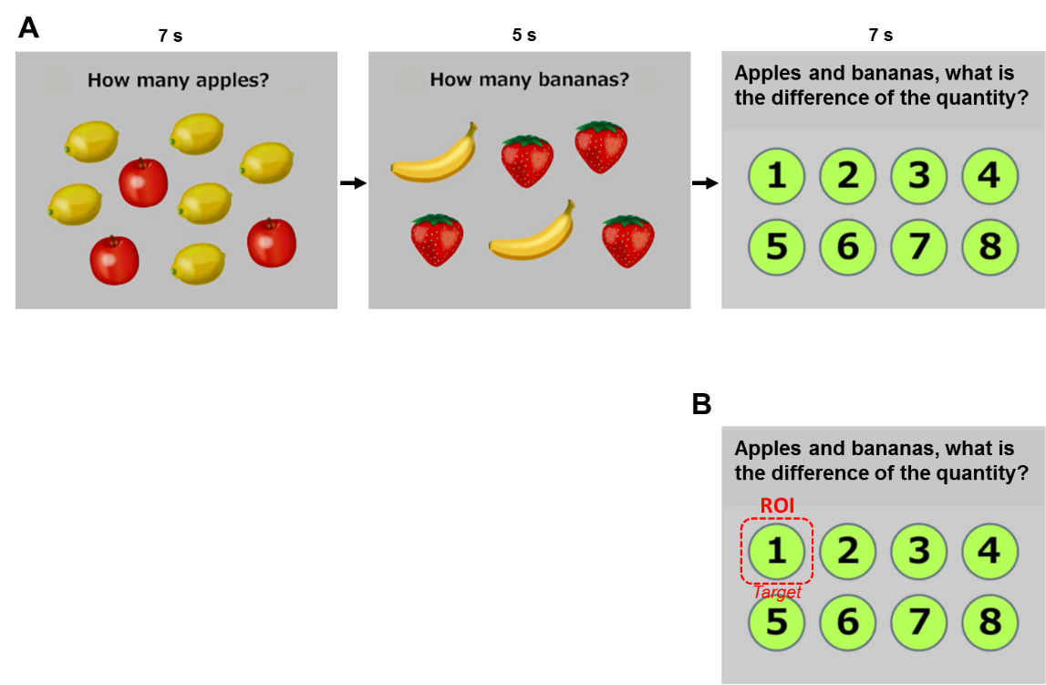

Tasks 5–7: Attention and calculation task (56 s in total)
(A) The pictures displayed on the monitor. (B) ROI on the correct answer (target) is overlaid on the image.

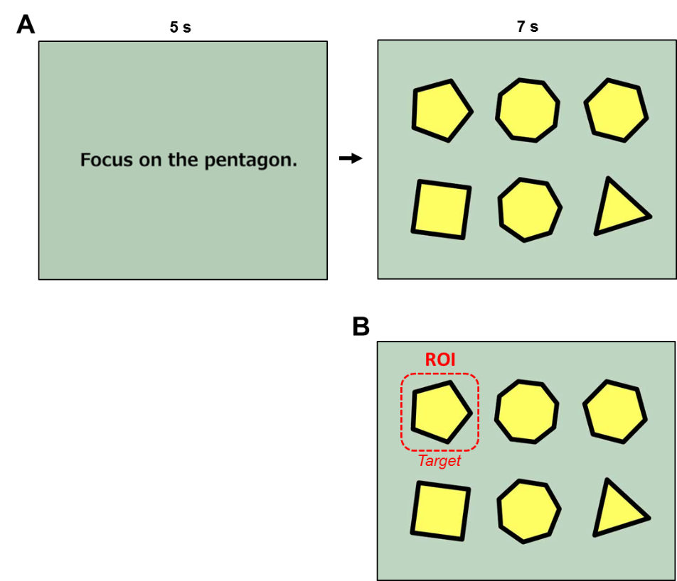

Tasks 8–9: Visuospatial function task (24 s in total)
(A) The pictures displayed on the monitor. (B) ROI on the correct answer (target) is overlaid on the image.

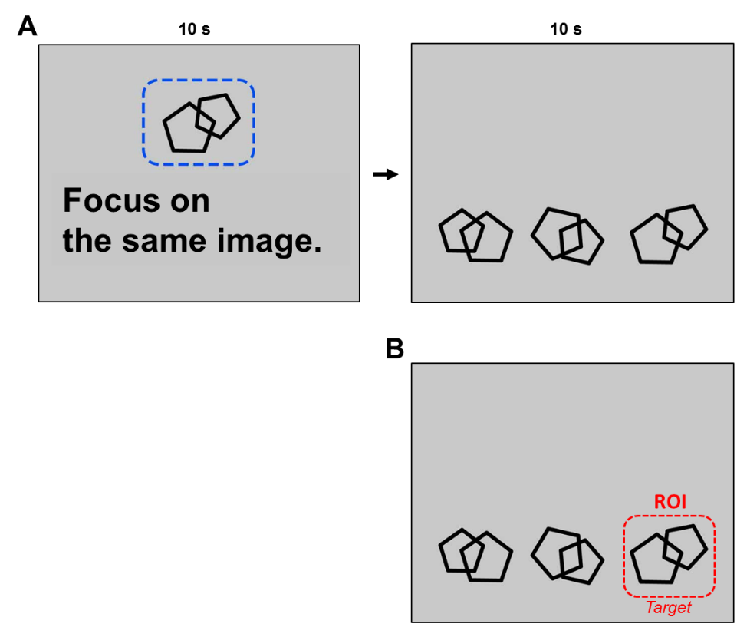
Task 10: Visual working memory task 2 (intersecting double pentagon) (20 s in total)
(A) The pictures displayed on the monitor. (B) ROI on the correct answer (target) is overlaid on the image.

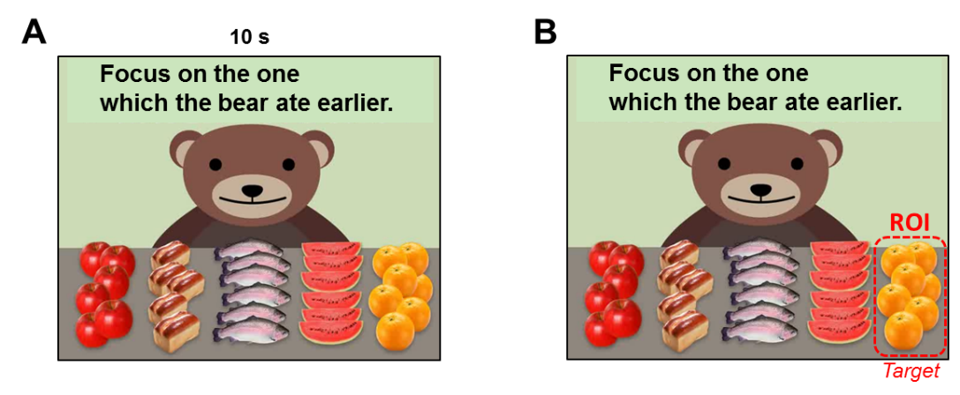
Task 1-b: Memory task (recall) (10 s)
(A) The movie displayed on the monitor. (B) ROI on the correct answer (target) is overlaid on the image.

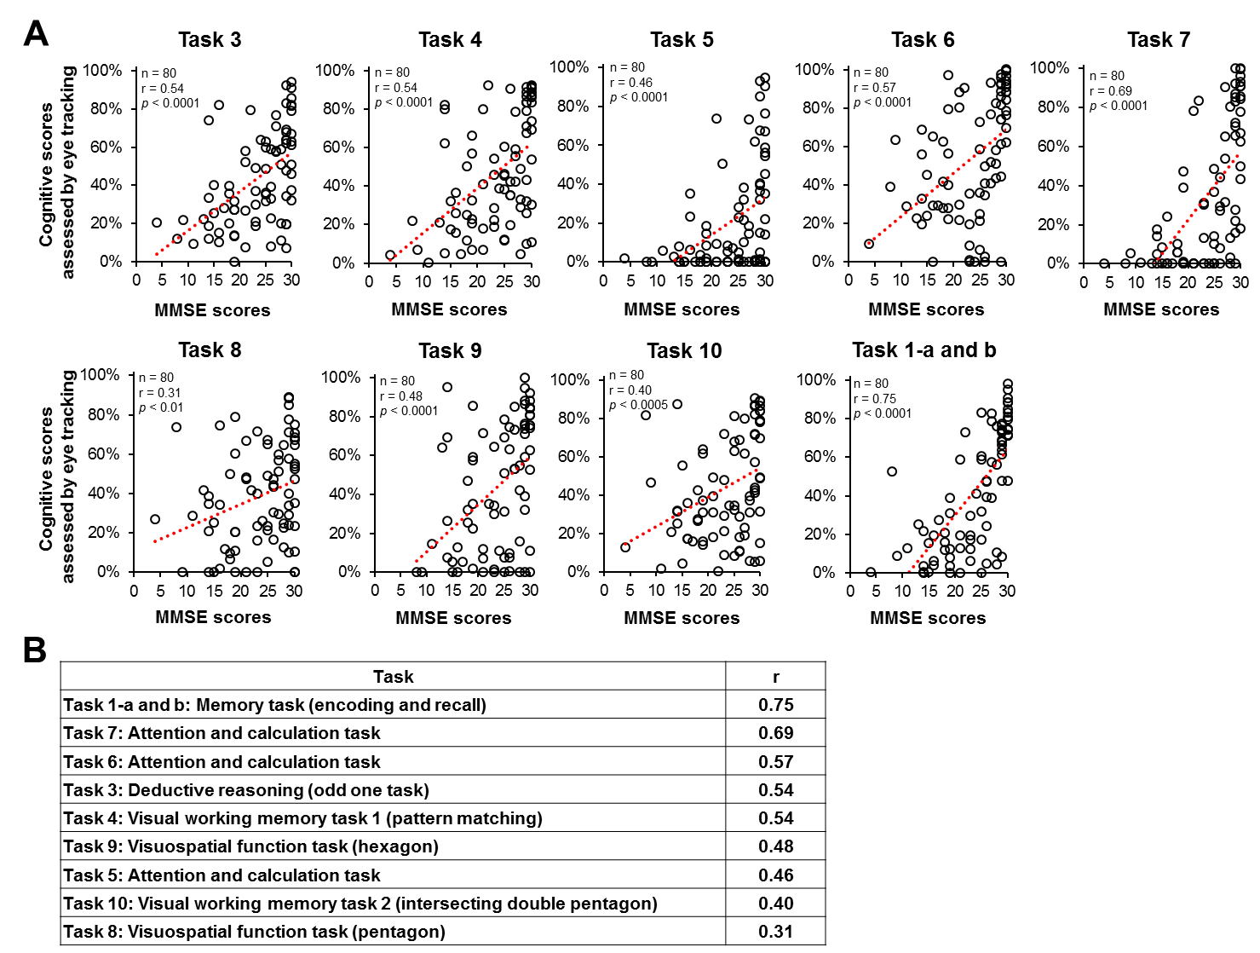
Supplemental figure 1
Correlation between MMSE scores and eye tracking-based cognitive scores in each task movie or picture. (A) Scattered plots of MMSE scores vs. eye tracking-based cognitive scores in each task. (B) Tasks are ordered in decreasing level of correlation according to Spearman’s coefficient r value.

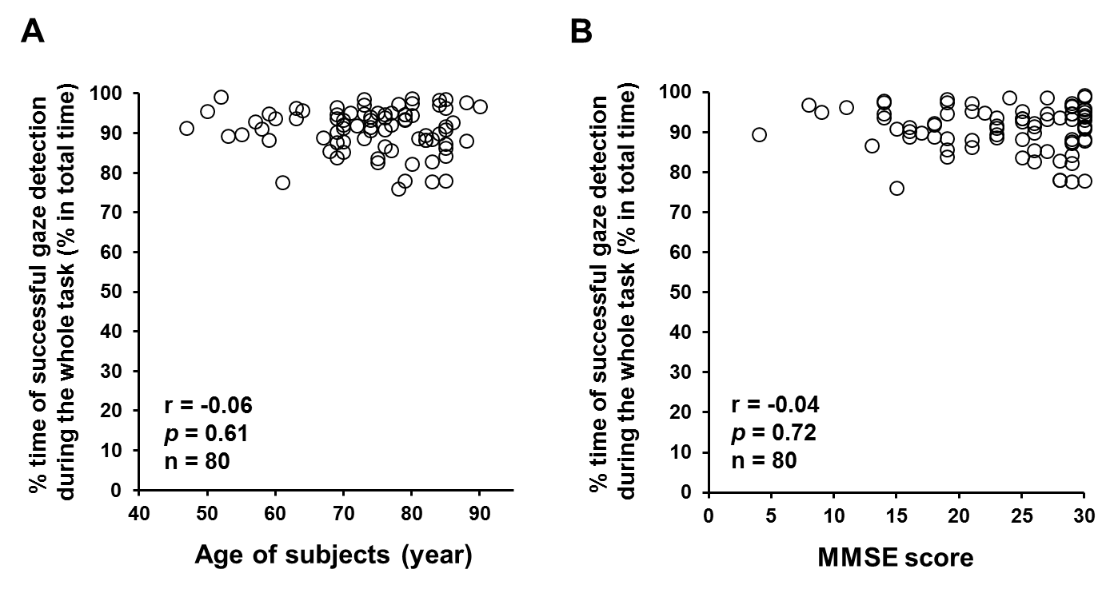
Supplemental figure 2
Successful gaze detection in the elderly and subjects with severe cognitive impairment. (A) The correlation between the age of subjects and the % time of successful gaze detection during the whole task (= 178 s). Age does not affect the efficiency of gaze detection. p = 0.61, Spearman’s rank test, n = 80. (B) The correlation between the MMSE scores of subjects and the % time of successful gaze detection during the whole task. Cognitive impairment does not affect the efficiency of gaze detection. p = 0.71, Spearman’s rank test, n = 80. MMSE, Mini–Mental State Examination.

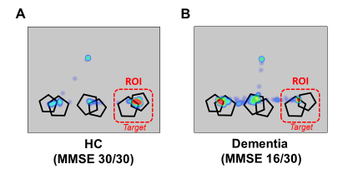
Supplemental figure 3
Duration-based heatmap images of eye movements during cognitive tasks. Representative heatmap images obtained from HC (A) and dementia (B) during the visual working memory task (Task 10). (A) HC subject (MMSE 30/30) successfully remembered the target image during the encoding session and was able to focus on the same image (right) during the recall session. (B) Subject with dementia (MMSE 16/30) showed a low frequency of fixation to the target image and a higher frequency to the non-target images (left and middle). HC, healthy control; MMSE, Mini–Mental State Examination; ROI, region of interest.

