SUPPLEMENTARY INFORMATION
The involvement of McpB chemoreceptor from Pseudomonas aeruginosa PAO1 in virulence
Cristina García-Fontana¹, Juan I. Vílchez¹, Marta Gonzalez-Requena¹, Jesús González-López¹, Tino Krell², Miguel A. Matilla² and Maximino Manzanera^{1*}
- Institute for Water Research and Department of Microbiology, University of Granada, Granada, Spain.
- Department of Environmental Protection, Estación Experimental del Zaidín, Consejo Superior de Investigaciones Científicas, Prof. Albareda 1, 18008 Granada, Spain.
* Corresponding author: Maximino Manzanera
Address: Institute for water Research. CL. Ramón y Cajal No. 4. Granada. 18071. Phone: +34 958 248324. Fax: +34 958 243094. E-mail address: manzanera@ugr.es
Running Title: McpB chemoreceptor and virulence

Table S1. Oligonucleotides used in this study.
Name | Sequence (5´-3´) | Description | Reference
mcpB-up-EcoRI-F | TAATGAATTCCACTGAGGCAAGCCAGGCG | Forward primer to clone upstream flanking region of mcpB for in-frame deletion | This study
mcpB-up-BamHI-R | TAATGGATCCACCTGCTGGAGTTCGGC | Reverse primer to clone upstream flanking region of mcpB for in-frame deletion | This study
mcpB-dw-BamHI-F | TAATGGATCCGAATGCCCGCCAGGCCAACTC | Forward primer to clone downstream flanking region of mcpB for in-frame deletion | This study
mcpB-dw-HindIII-R | TAATAAGCTTTCAGAACTCTTCCCAGCCGTCT | Reverse primer to clone downstream flanking region of mcpB for in-frame deletion | This study
mcpB-compl-NdeI-F | TAATCATATGGGTCTGTTCAATGCACATGCGG | Forward primer to generate the plasmid for complementation assays | This study
mcpB-compl-EcoRI-R | TAATGAATTCGGAGGTGGGCATTGGCGTCG | Reverse primer to generate the plasmid for complementation assays | This study

Table S2. Plasmids used in this study.
Plasmids | Relevant characteristics and usesª | Reference
pUC18NotI | Ap^{R}; identical to pUC18 but with two NotI sites flanking pUC18 polylinker. | Herrero et al., 1990
pKNG101 | Sm^{R}; oriR6K mob sacBR. | Kaniga et al., 1991
pBBR1MCS-2_START | Km^{R}; oriRK2 mobRK2 | Obranić et al., 2013
pUC18:ΔmcpB | Ap^{R}; 1.4-Kb PCR product containing a 1116 bp in-frame deletion of mcpB inserted into the EcoRI/HindIII sites of pUC18Not. | This study
pKNG:ΔmcpB | Sm^{R}; 1.5-kb NotI fragment of pMAMV249 was cloned at the same site in pKNG101. | This study
pBBR1:mcpB | Km^{R}; mcpB gene was cloned into NdeI and EcoRI sites of pBBR1MCS-2_START | This study
ªAp, ampicillin; Km, kanamycin; Sm, streptomycin; Em, erythromycin

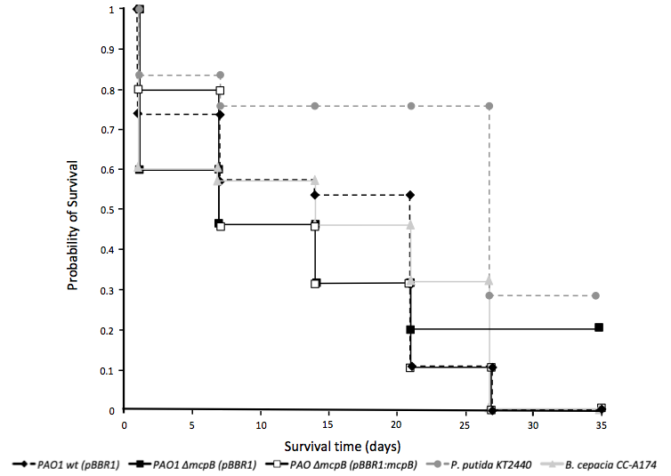Figure S1. Survival of A. bipunctata fed with different bacterial strains. The probability of survival of two controls, B. cepacia CC-A174 (pathogenic control) and P. putida KT2440 (non- pathogenic controls), and the survival of the wild-type P. aeruginosa PAO1 and its mutant in the mcpB gene, both carrying the pBBR1MCS-2 plasmid, as well as the restored mcpB strain carrying the pBBR1:mcpB plasmid. A representative experiment with three biological replicates is shown.

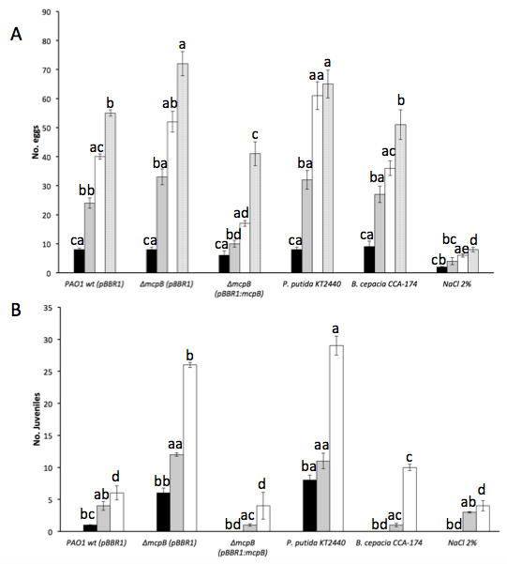Figure S2. Reproductive efficiency of E. foetida fed with different bacterial strains or in the presence of NaCl. Eggs laid (panel A) and juveniles (panel B) were monitored in 5 individuals at 7 (black bars), 14 (grey bars), 21 (white bars), and 28 days (dotted bars). Means and standard deviations of 5 individuals in three biological replicates are shown. B. cepacia and NaCl 2% (w/v) were used as pathogenic and toxic controls, respectively. P. putida KT2440 was used as a non-pathogenic control. For panel A, different single letters indicate statistically significant differences among treatments at day 28, double letters starting with a indicate differences at 21 days and double letters starting with b indicate differences at 14 days and double letters starting with c indicate differences at 7 days based on the ANOVA test (P ≤ 0.05) and posthoc Tukey. For panel B, different single letters indicate statistically significant differences among treatments at day 21, double letters starting with a indicate differences at 14 days and double letters starting with b indicate differences at 7 days based on the ANOVA test (P ≤ 0.05) and posthoc Tukey.

