Supplementary information

A role of eosinophils in mediating the anti-tumour effect of cryo-thermal treatment

Shengguo Jia¹, Wentao Li^{2,3}, Ping Liu^{1,} *, Lisa X. Xu¹

¹School of Biomedical Engineering and Med-X Research Institute,
Shanghai Jiao Tong University, Shanghai, P.R. China;
²Fudan University Shanghai Cancer Center, Shanghai, China;
³Department of Oncology, Shanghai Medical College, Fudan University,
Shanghai, China
Corresponding Author (*):
Ping Liu: pingliu@sjtu.edu.cn

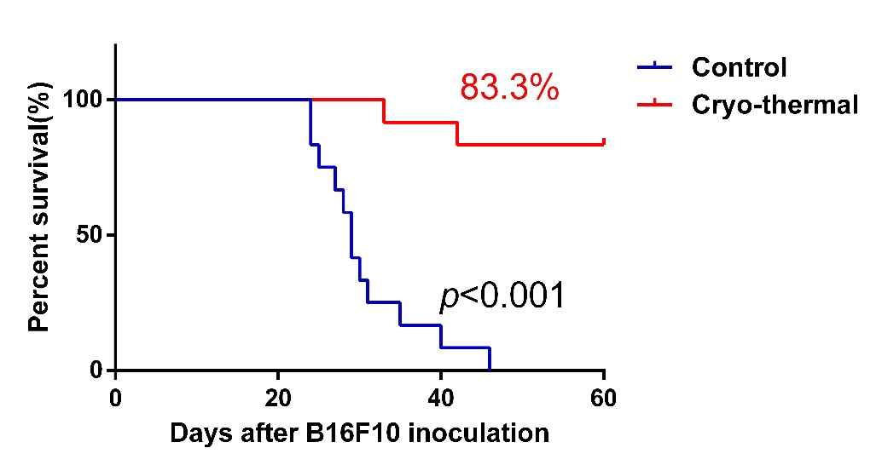

Supplementary Figure 1 Kaplan–Meier survival curve was compared using log-rank tests. Survival rate of the cryo-thermal group was indicated; n=12 for control and the cryo-thermal group, respectively.

Supplementary Figure 2 The phenotype changes of splenic DCs and macrophages on day 3 after cryo-thermal therapy. (A) Percentage of CD86⁺MHC II⁺ cells in splenic CD11c⁺DCs were analyzed by flow cytometry in cryo-thermal treated mice and untreated mice on day 3 after cryo-thermal therapy. (B) Percentage of CD86⁺MHC II⁺ cells in splenic CD11b⁺ F4/80⁺macrophages were analyzed by flow cytometry in cryo-thermal-treated mice and untreated mice on day 3 after cryo-thermal therapy. n=4 mice per group. Data was shown as mean ± SD.
Supplementary Figure 3 The expression of IL-4 and IFN-γ in splenic eosinophils after cryo-thermal therapy. (A) The proportion of IL-4⁺ cells in splenic eosinophils in the cryo-thermal-treated mice or untreated mice was analyzed by flow cryometry. (B) The proportion of IFN-γ⁺ cells in splenic eosinophils in the cryo-thermal-treated mice or untreated mice was analyzed by flow cryometry. n=4 mice per group. Data was shown as mean ± SD. Data for bar graphs was calculated using student’s t-test. * p < 0.05; ** p <0.01; *** p < 0.001.
Supplementary Figure 4 The changes of CD11c⁺DCs and F4/80⁺ macrophages after co-cultured with eosinophils. (A) Flow cryometry analysis of the CD11c⁺DCs after co-cultured with eosinophils. (B) Flow cryometry analysis of the F4/80⁺ macrophages after co-cultured with eosinophils. Data was shown as mean ± SD. Data for bar graphs was calculated using student’s t-test. ** p < 0.01.
Supplementary Figure 5 Effect of cytotoxic against tumor cells mediated by CD4⁺ and CD8⁺ T cells after cryo-thermal therapy with eosinophils depletion. Splenic CD4⁺ and CD8⁺ T cells from tumor-bearing mice, cryo-thermal with isotype treated mice and cryo-thermal with Siglec-F mAb treated mice were purified and co-cultured with B16F10 cells at indicated ratios for 24h, and the cell viability (%) was determined by a CCK-8 assay. (A)The B16F10 cell viability (%) in co-cultured with tumor-bearing CD8⁺ T cells, cryo-thermal + isotype treated CD8⁺ T cells and cryo-thermal +Siglec-F mAb treated CD8⁺ T cells. (B) The B16F10 cell viability (%) in co-cultured with tumor-bearing CD4⁺ T cells, cryo-thermal + isotype treated CD4⁺ T cells and cryo-thermal +Siglec-F mAb treated CD4⁺ T cells. Data was shown as mean ± SD. Data for bar Data for bar graphs was calculated using student’s t-test. * p < 0.05; ** p < 0.01; *** p < 0.001 was considered to be statistically significant between cryo-thermal + Siglec-F mAb and cryo-thermal + isotype group.

Supplementary Table S1. Primers used for RT-PCR analysis

Gene | Primer | Sequence (5´-3´)
IFN-γ | forward  reverse | ATGAACGCTACACACTGCATC  CCATCCTTTTGCCAGTTCCTC
IL-6 | forward  reverse | GACAAAGCCAGAGTCCTTCAGAGAGATACAG  TTGGATGGTCTTGGTCCTTAGCCAC
IL-12 | forward  reverse | TGGTTTGCCATCGTTTTGCTG  ACAGGTGAGGTTCACTGTTTCT
IL-15 | forward  reverse | AGAGGCCAACTGGATAGATGT  AGAGCACGTTTCTTACTGTTTCA
TNF-α | forward  reverse | TTCTGTCTACTGAACTTCGGGGTGATCGGTCC  GTATGAGATAGCAAATCGGCTGACGGTGTGGG
CCL5 | forward  reverse | GCTGCTTTGCCTACCTCTCC  TCGAGTGACAAACACGACTGC
CXCL10 | forward  reverse | CCAAGTGCTGCCGTCATTTTC  GGCTCGCAGGGATGATTTCAA
MHC II | forward  reverse | AGCCCCATCACTGTGGAGT  GATGCCGCTCAACATCTTGC
CD86 | forward  reverse | GAGCTGGTAGTATTTTGGCAGG  GGCCCAGGTACTTGGCATT
Perforin | forward  reverse | CTGCCACTCGGTCAGAATG  CGGAGGGTAGTCACATCCAT
Granzyme-B | forward  reverse | CCACTCTCGACCCTACATGG  GGCCCCCAAAGTGACATTTATT
IL-4 | forward  reverse | CCCCAGCTAGTTGTCATCCTG  CAAGTGATTTTTGTCGCATCCG
IL-1β | forward  reverse | ACAGCAGCACATCAACAAGAG  ATGGGAACGTCACACACCAG
IL-7 | forward  reverse | TTCCTCCACTGATCCTTGTTCT  AGCAGCTTCCTTTGTATCATCAC
IL-10 | forward  reverse | GCTCTTACTGACTGGCATGAG  CGCAGCTCTAGGAGCATGTG
HO-1 | forward  reverse | AAGCCGAGAATGCTGAGTTCA  GCCGTGTAGATATGGTACAAGGA
STAT3 | forward  reverse | AATATAGCCGATTCCTGCAAGAG  TGGCTTCTCAAGATACCTGCTC
Foxo3 | forward  reverse | CTGGGGGAACCTGTCCTATG  TCATTCTGAACGCGCATGAAG
IDO2 | forward  reverse | CCAGAAGGACCGTTGGAAATC  ACTGTCACTAGGATGAAGCCC
IDO1 | forward  reverse | CAAAGCAATCCCCACTGTATCC  ACAAAGTCACGCATCCTCTTAAA
VEGFR2 | forward  reverse | TTTGGCAAATACAACCCTTCAGA  GCAGAAGATACTGTCACCACC
PD-L1 | forward  reverse | GCTTCTCAATGTGACCAGCA  GAGGAGGACCGTGGACACTA
iNOS | forward  reverse | ACATCGACCCGTCCACAGTAT  CAGAGGGGTAGGCTTGTCTC
Arg-1 | forward  reverse | TTGGGTGGATGCTCACACTG  GTACACGATGTCTTTGGCAGA
CD206 | forward  reverse | GCAGGTGGTTTATGGGATGT  GGGTTCAGGAGTTGTTGTGG
Eomes | forward  reverse | GGCCCCTATGGCTCAAATTCC  CCTGCCCTGTTTGGTGATG
IL-2 | forward  reverse | TGAGCAGGATGGAGAATTACAGG  GTCCAAGTTCATCTTCTAGGCAC
T-bet | forward  reverse | GTTCAACCAGCACCAGACAGAG  TGGTCCACCAAGACCACATC
CCL20 | forward  reverse | TACAGACGCCTCTTCCTTCCA  CAGCCCTTTTCACCCAGTTC
IL-17A | forward  reverse | GAAGGCCCTCAGACTACCTCAA  TCATGTGGTGGTCCAGCTTTC
RORγt | forward  reverse | CGCGGAGCAGACACACTTA  CCCTGGACCTCTGTTTTGGC
TGF-β | forward  reverse | CTCCCGTGGCTTCTAGTGC  GCCTTAGTTTGGACAGGATCTG
Foxp3 | forward  reverse | AGCAGTGTGGACCGTAGATGA  GGCAGGGATTGGAGCACTT
IL-13 | forward  reverse | CGGCAGCATGGTATGGAGTG  ATTGCAATTGGAGATGTTGGTCAG
IL-5 | forward  reverse | TCAGGGGCTAGACATACTGAAG  CCAAGGAACTCTTGCAGGTAAT
GATA3 | forward  reverse | GGATGTAAGTCGAGGCCCAAG  ATTGCAAAGGTAGTGCCCGGTA
GAPDH | forward  reverse | AGGTCGGTGTGAACGGATTTG  GGGGTCGTTGATGGCAACA

