Supplementary Materials for
Ratiometric Impedance Sensing of Fingers for Robust Identity Authentication

Hyung Wook Noh^{1,2}, Chang-Geun Ahn¹, Hyoun-Joong Kong² and Joo Yong Sim^{1,*}
¹ Medical Information Research Section, Welfare & Medical ICT Research Department,
Electronics and Telecommunications Research Institute, Daejeon, 34129, Republic of Korea
² Department of Biomedical Engineering, Chungnam National University College of Medicine,
266 Munwha-ro, Jung-gu, Daejeon 35015, Republic of Korea
*corresponding author: jsim@etri.re.kr
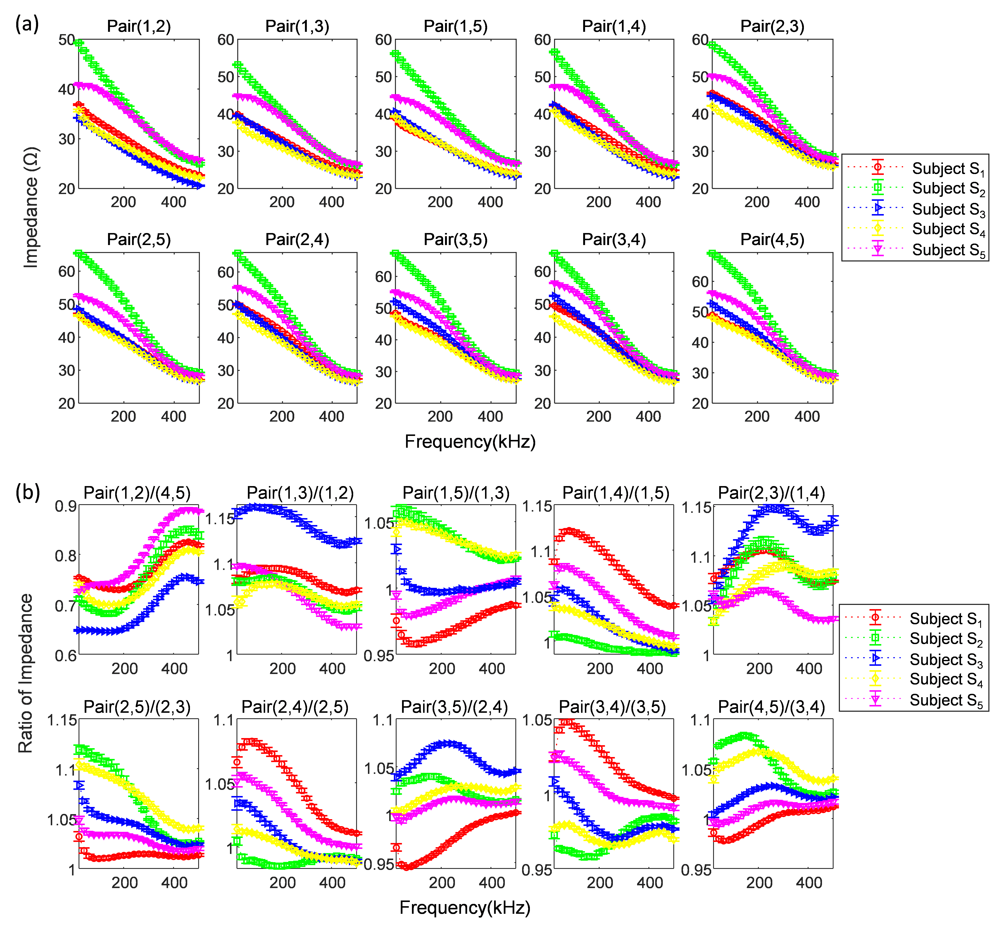
Supplementary Figure S1. Comparison of (a) raw data and (b) ratiometric features. The measured impedance of 10 finger pairs for five subjects over five days. Values are the mean ± S.D. (at least n = 50).

