Tumor Infiltrating Lymphocytes and Macrophages Improve Survival in Microsatellite Unstable Colorectal Cancer

Sumana Narayanan**¹, MD., Tsutomu Kawaguchi**¹, MD, Ph.D., Xuan Peng², MS., Qianya Qi², MS., Song Liu², PhD., Li Yan², PhD., and Kazuaki Takabe*^{1,3}, MD, Ph.D, FACS

** These authors contributed equally to this work.

¹ Department of Surgical Oncology, Roswell Park Cancer Institute, Buffalo, NY, USA
² Department of Biostatistics & Bioinformatics, Roswell Park Cancer Institute, Buffalo, NY, USA
³ Department of Surgery, Jacobs School of Medicine and Biomedical Sciences, University at Buffalo, The State University of New York, Buffalo, NY, USA

Supplementary Figure S1- Kaplan-Meier (KM) Curves of Overall Survival (OS) comparing high vs. low expression of DNA repair genes: a) ATM, b) PMS2, c) MLH3, d) MLH1, e) ATR and f) PMS1.

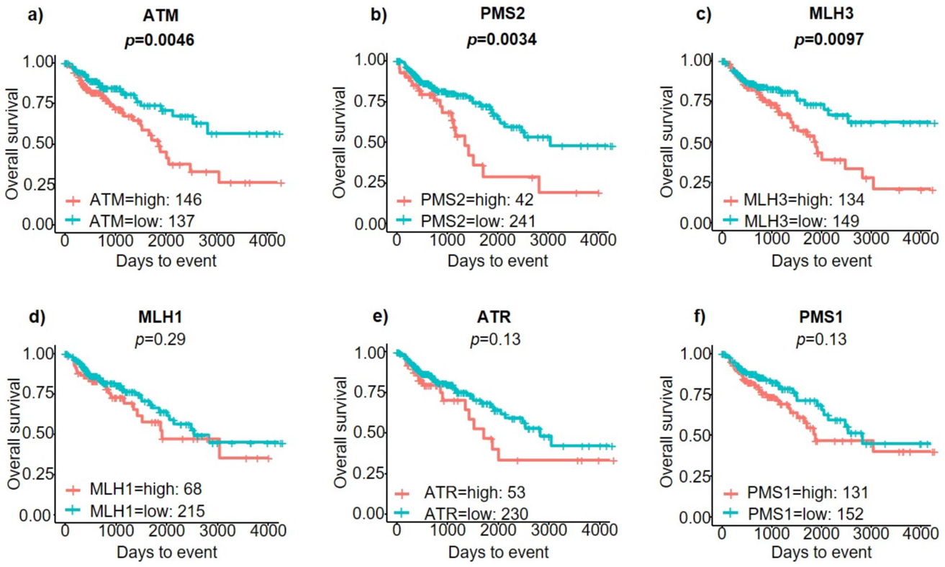

Supplementary Table 1- Gene Sets Enrichment Analysis (GSEA) including 15 available immune-response related gene sets, which were significantly upregulated in the MSI-H CRC tumors. ES- enrichment score; NES- normalized enrichment score; NOM p-value- normalized p-value; FDR- false discovery rate.

