Supplementary Information
Pb nanospheres in ancient zircon yield model ages for zircon formation and Pb mobilization.
Ian C. Lyon^{*1,2}, Monika A. Kusiak^{3,4}, Richard Wirth⁵, Martin J. Whitehouse⁶, Daniel J. Dunkley⁷, Simon A. Wilde⁸, Dirk Schaumlöffel⁹, Julien Malherbe⁹ and Katie L. Moore^{2,10}
*corresponding author
¹Department of Earth and Environmental Sciences, University of Manchester, UK (Ian.Lyon@manchester.ac.uk)
²Photon Science Institute, University of Manchester, UK
³Institute of Geological Sciences, Polish Academy of Sciences, PL-00818 Warsaw, Poland (mkusiak@twarda.pan.pl)
⁴GeoForschungsZentrum, Section 3.6 Chemistry and Physics of Earth Materials, D-14473 Potsdam, Germany (mkusiak@gfz-potsdam.de)
⁵GeoForschungsZentrum, Section 3.5 Interface Geochemistry D-14473 Potsdam, Germany (wirth@gfz-potsdam.de)
⁶Swedish Museum of Natural History, SE-104 05 Stockholm, Sweden (Martin.Whitehouse@nrm.se)
⁷Faculty of Earth Sciences, University of Silesia in Katowice, PL-41205 Sosnowiec, Poland (daniel.dunkley@us.edu.pl)
⁸School of Earth and Planetary Sciences, Curtin University, PO BOX U1987, WA 6845, Perth, Australia (s.wilde@curtin.edu.au)
⁹CNRS/Université de Pau et des Pays de l’Adour, E2S UPPA, IPREM, UMR 5254, 64000 Pau, France (dirk.schaumloeffel@univ-pau.fr)
¹⁰Department of Materials, University of Manchester, UK (Katie.Moore@manchester.ac.uk)

Table 1. ²⁰⁷Pb/²⁰⁶Pb ratios acquired from individual discrete nanospheres and from zircon host around the nanospheres. A ratio of ‘zero’ results from zero counts for that species in the region of interest defined in the analysis area. ‘n.a.’ indicates ‘not available’, detectors were set to acquire ions for ²⁰⁷Pb and ²⁰⁶Pb only and not ²⁰⁴Pb or ²⁰⁸Pb.

Sample 975 grain 66
Nanospheres
²⁰⁷Pb^{/206}Pb | ²⁰⁸Pb^{/206}Pb | ²⁰⁴Pb^{/206}Pb
0.542 ± 0.042 | 0.030 ± 0.015 | 0.008 ± 0.008
0.533 ± 0.072 | 0.052 ± 0.037 | 0
0.397 ± 0.059 | 0.171 ± 0.066 | 0
0.403 ± 0.054 | 0.060 ± 0.035 | 0
0.448 ± 0.048 | 0.054 ± 0.027 | 0.014 ± 0.014
0.547 ± 0.045 | 0.060 ± 0.024 | 0.010 ± 0.010
0.467 ± 0.040 | 0.086 ± 0.029 | 0
0.581 ± 0.061 | n.a. | n.a.
0.475 ± 0.068 | n.a. | n.a.
0.533 ± 0.063 | n.a. | n.a.
0.552 ± 0.065 | n.a. | n.a.
0.564 ± 0.070 | n.a. | n.a.
0.700 ± 0.100 | n.a. | n.a.
0.590 ± 0.055 | n.a. | n.a.
0.493 ± 0.042 | n.a. | n.a.
0.453 ± 0.046 | n.a. | n.a.
0.533 ± 0.047 | n.a. | n.a.
0.422 ± 0.044 | n.a. | n.a.
0.533 ± 0.073 | n.a. | n.a.
0.603 ± 0.105 | n.a. | n.a.
0.401 ± 0.056 | n.a. | n.a.
0.460 ± 0.070 | n.a. | n.a.
0.643 ± 0.196 | n.a. | n.a.
0.446 ± 0.025 | n.a. | n.a.
0.597 ± 0.041 | n.a. | n.a.
0.573 ± 0.062 | n.a. | n.a.
0.493 ± 0.040 | n.a. | n.a.
0.521 ± 0.040 | n.a. | n.a.
0.600 ± 0.069 | n.a. | n.a.
0.538 ± 0.046 | n.a. | n.a.
0.531 ± 0.049 | n.a. | n.a.
0.550 ± 0.044 | n.a. | n.a.
0.539 ± 0.047 | n.a. | n.a.
0.540 ± 0.038 | n.a. | n.a.
0.526 ± 0.051 | n.a. | n.a.
0.468 ± 0.040 | 0.046 ± 0.032 | 0
0.685 ± 0.072 | 0.045 ± 0.045 | 0
0.685 ± 0.072 | 0.045 ± 0.045 | 0
0.627 ± 0.053 | 0.042 ± 0.017 | 0
0.575 ± 0.052 | 0.061 ± 0.022 | 0
0.398 ± 0.043 | 0.0410 ± 0.018 | 0.025 ± 0.014
0.462 ± 0.070 | 0.018 ± 0.018 | 0
0.501 ± 0.075 | 0.038 ± 0.027 | 0
0.643 ± 0.082 | 0.016 ± 0.016 | 0
0.423 ± 0.063 | 0.049 ± 0.029 | 0
0.283 ± 0.018 | 0.044 ± 0.010 | 0.007 ± 0.004
0.246 ± 0.022 | 0.020 ± 0.009 | 0.004 ± 0.004
0.269 ± 0.032 | 0.044 ± 0.018 | 0.022 ± 0.013
0.611 ± 0.027 | 0.015 ± 0.007 | 0
0.657 ± 0.028 | 0.033 ± 0.011 | 0
Weighted mean = 0.528
σ = 0.079
St. err = 0.012

Sample 975 grain 66
Zircon host areas around nanospheres

²⁰⁷Pb^{/206}Pb | ²⁰⁸Pb^{/206}Pb | ²⁰⁴Pb^{/206}Pb
0.151 ± 0.051 | 0 | 0
0.219 ± 0.030 | 0.216 ± 0.055 | 0
0.148 ± 0.048 | 0.053 ± 0.053 | 0.053 ± 0.053
0.156 ± 0.012 | n.a. | n.a.
0.170 ± 0.034 | n.a. | n.a.
0.151 ± 0.033 | n.a. | n.a.
0.130 ± 0.015 | n.a. | n.a.
0.171 ± 0.020 | n.a. | n.a.
0.177 ± 0.009 | n.a. | n.a.
0.208 ± 0.013 | n.a. | n.a.
Weighted mean = 0.170
σ = 0.026
St. err = 0.008

Sample 975 Grain 07
Nanospheres

²⁰⁷Pb^{/206}Pb | ²⁰⁸Pb^{/206}Pb | ²⁰⁴Pb^{/206}Pb
0.567 ± 0.049 | 0.049 ±0.034 | 0
0.630 ± 0.206 | 0 | 0.251 ±0.251
0.544 ± 0.116 | 0.158 ± 0.158 | 0
0.527 ± 0.121 | 0 | 0
0.548 ± 0.112 | 0.527 ± 0.313 | 0
0.353 ± 0.106 | 0 | 0
0.387 ± 0.097 | 0.374 ± 0.270 | 0
0.298 ± 0.102 | 0 | 0
0.474 ± 0.109 | 0.320 ± 0.230 | 0
0.500 ± 0.076 | 0 | 0
0.488 ± 0.069 | 0.054 ± 0.054 | 0
0.311 ± 0.061 | 0.150 ± 0.106 | 0
0.694 ± 0.054 | 0 | 0
0.555 ± 0.041 | 0 | 0
0.593 ± 0.056 | 0 | 0
0.537 ± 0.054 | 0 | 0
0.556 ± 0.065 | 0 | 0.043 ± 0.043
0.408 ± 0.053 | 0 | 0
0.582 ± 0.057 | 0 | 0
0.321 ± 0.132 | 0 | 0
0.515 ± 0.208 | 0 | 0
0.576 ± 0.107 | 0 | 0
0.511 ± 0.098 | 0 | 0
0.532 ± 0.115 | 0 | 0
0.611 ± 0.028 | 0.018 ± 0.006 | 0.002 ±0.002
0.593 ± 0.023 | 0.019 ± 0.005 | 0.001 ± 0.001
0.504 ± 0.036 | 0.009 ± 0.006 | 0.004 ± 0.004
0.522 ± 0.031 | 0.028 ± 0.009 | 0
0.525 ± 0.034 | 0.030 ± 0.010 | 0.007 ± 0.005
0.592 ± 0.036 | 0.010 ± 0.006 | 0
0.540 ± 0.037 | 0.016 ± 0008 | 0.004 ± 0.004
0.456 ± 0.038 | 0.011 ± 0.008 | 0.006 ± 0.006
0.510 ± 0.039 | 0.005 ± 0.005 | 0
0.527 ± 0.037 | 0.022 ± 0.010 | 0
0.440 ± 0.040 | 0.020 ± 0.010 | 0
0.567 ± 0.049 | 0.027 ± 0.014 | 0.013 ±0.009
0.552 ± 0.042 | 0.015 ± 0.009 | 0.005 ± 0.005
0.646 ± 0.052 | 0.030 ± 0.015 | 0.013 ± 0.009
Weighted mean = 0.495
σ = 0.112
St. err = 0.016

Sample 975 grain 07
Zircon host around nanospheres

²⁰⁷Pb^{/206}Pb | ²⁰⁸Pb^{/206}Pb | ²⁰⁴Pb^{/206}Pb
0.204 ± 0.033 | 0 | 0
0.200 ± 0.054 | 0 | 0
0.193 ± 0.009 | 0.027 ± 0.005 | 0.031 ± 0.006
0.211 ± 0.013 | 0.027 ± 0.007 | 0.007 ± 0.004
0.185 ± 0.008 | 0.027 ± 0.004 | 0.023 ± 0.004
Weighted mean = 0.195
σ = 0.010
St. err = 0.004

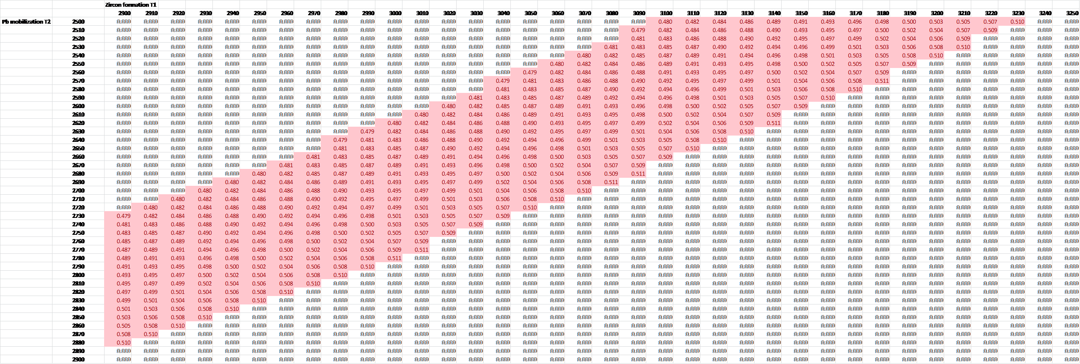

Figure 1a. Model ages within the pink highlighted band can give the ²⁰⁷Pb/²⁰⁶Pb ratios measured in nanospheres and zircon host in grains 66 and 07.

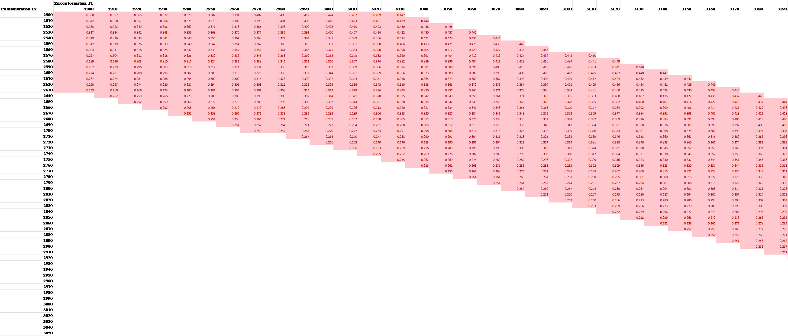
Figure 1b. Model T₁ and T₂ ages which satisfy the measured abundance ratio of Pb in nanospheres to Pb in the host zircon.

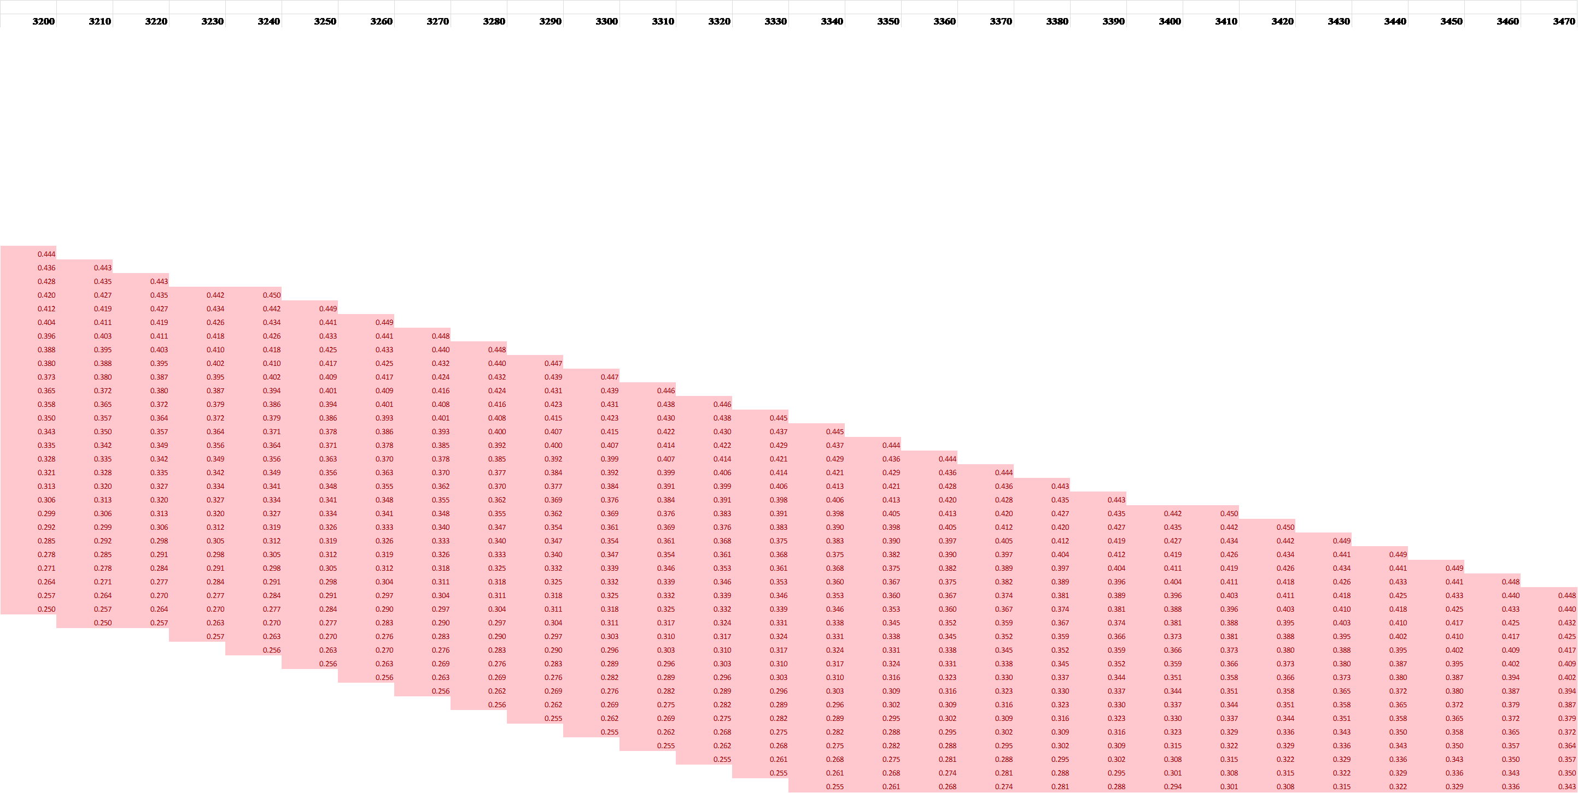

Fig. 1b-continued. Range of model T1 and T2 which give the experimentally measured ratio of Pb in nanospheres to Pb in the zircon host.

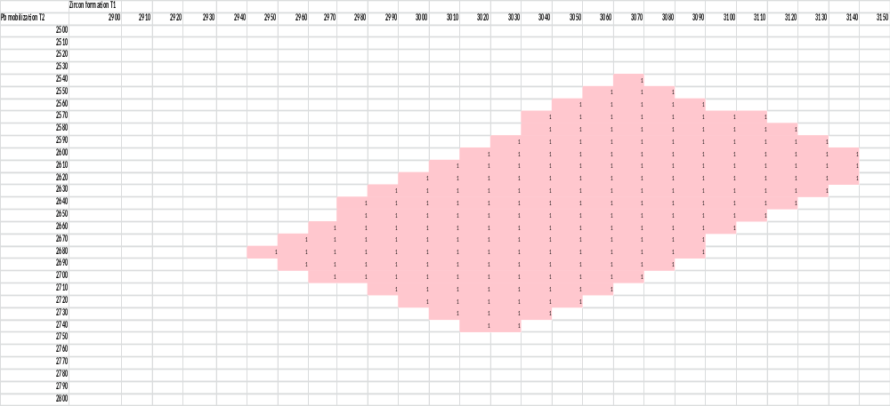
Figure 1c. Range of model T₁ and T₂ (pink area) which satisfy the measured ²⁰⁷Pb/²⁰⁶Pb ratios in nanospheres and host zircon and also satisfy the measured Pb abundance ratio between nanospheres and the host zircon.

Figure 2. ⁴⁰Ca⁺ map acquired at the same time and covering the same area as the images in figure 2 of the main paper.

