Supporting Information
Random transposon insertion in the Mycoplasma hominis minimal genome
Authors
Fabien Rideau¹⁻², Chloé Le Roy¹⁻², Eveline Sagné³, Hélène Renaudin¹⁻², Sabine Pereyre¹⁻², Birgit Henrich⁴, Emilie Dordet-Frisoni³, Christine Citti³, Carole Lartigue⁵⁻⁶†*, Cécile Bébéar¹⁻²†*
¹Univ. Bordeaux, USC-EA3671 Mycoplasmal and Chlamydial Infections in Humans, Bordeaux, France.
²INRA, USC-EA3671 Mycoplasmal and Chlamydial Infections in Humans, Bordeaux, France.
³IHAP, Université de Toulouse, INRA, ENVT, Toulouse, France.
⁴Institute of Medical Microbiology and Hospital Hygiene, Heinrich Heine University, Düsseldorf, Germany.
⁵INRA, UMR 1332 de Biologie du Fruit et Pathologie, F-33140 Villenave d'Ornon, France
⁶Univ. Bordeaux, UMR 1332 de Biologie du Fruit et Pathologie, F-33140 Villenave d'Ornon, France
†Co-last authors
*Corresponding authors: cecile.bebear@u-bordeaux.fr; carole.lartigue-prat@inra.fr

System | Type I |  |  | Type II |  |  |  |  |  |  | Type III | Type IV
System | EcoR124II | EcoKI | BcgIA | Sau96I | HaeIII | FokI | DpnII | Eco57I | BspRI | VspI | Type III | McrB-like
Specificity | 5'-GAAN₇RTCG-3' | 5'-AACN₆GTGC-3' | 5'-CGAN₆TGC-3' | G/GNCCª | GG/CC | GGATG(N)9/ | /GATC | CTGAAG (16/14) | GG/CC | AT/TAAT | ? | N4- and C5-methylcytosine
Adenine or Cytosine methylation | Adenine | Adenine | Adenine | Cytosine | Cytosine | Adenine | Adenine | Adenine 5 | Cytosine | Adenine 5 | Adenine? | -
Number of restriction sites in pMT85-Tet | 0 | 0 | 0 | 9 | 12 | 3 | 9 | 1 | 12 | 4 | ? | -
Table S1. Name and specificity of the R-M systems predicted in the M. hominis strains.

ª Red letter indicates the methylation position.

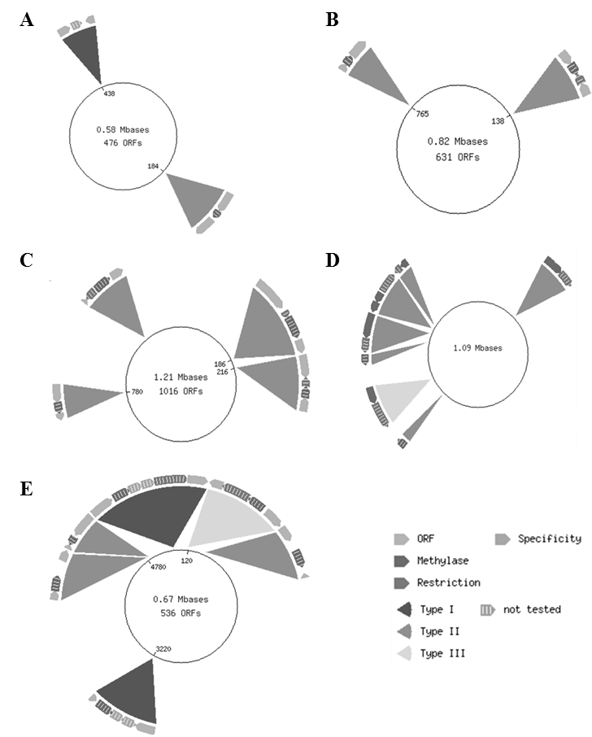

Figure S1. Prediction of restriction-modification systems in different mycoplasma species by the Rebase database. Representation of restriction-modification (R-M) systems of (A) M. genitalium G37, (B) M. arthritidis 158 L3-1, (C) M. mycoides subsp. mycoides PG1, (D) M. mycoides subsp. capricolum GM12 and (E) M. hominis PG21, based on the Rebase database. The smallest genome of M. genitalium G37 (A) only harbors one type I R-M system and one type II system. Cattle pathogens, such as M. mycoides subsp. mycoides strain PG1 (C) and M. mycoides subsp. capri strain GM12 (D), contain four type II R-M systems and seven R-M systems (six type II and one type III), respectively. M. arthritidis 158L3-1 (B) has only two type II R-M systems. Two type I, three type II and one type III systems are predicted to be present in the M. hominis PG21 genome by Rebase.
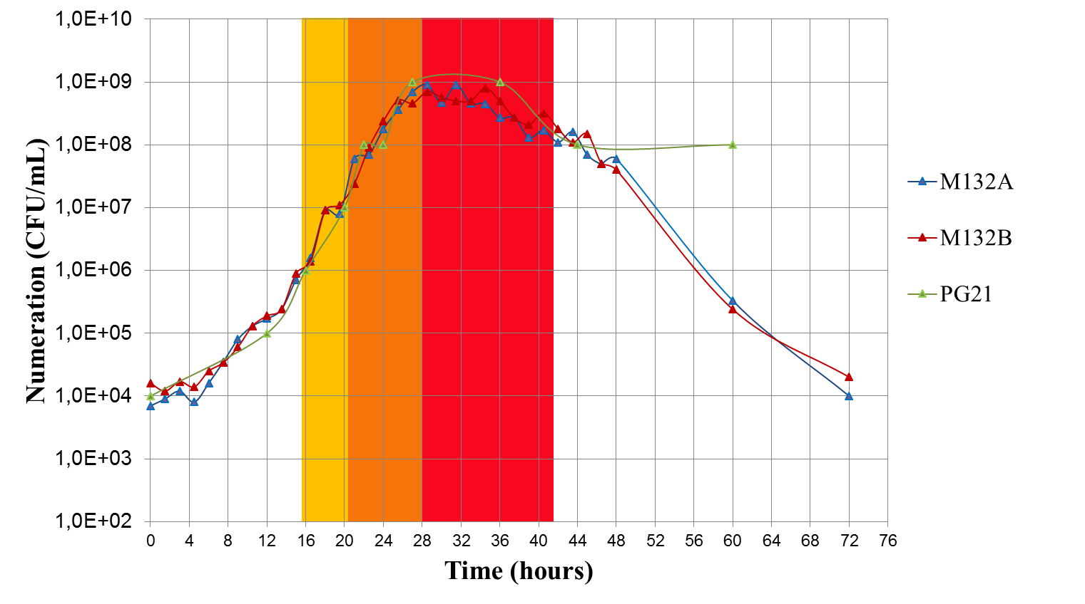

Figure S2. M. hominis M132 growth curve. Experiments were performed in duplicate (red and blue curves), and the M. hominis PG21 growth curve was added (Bébéar, personal data). Yellow, orange and red zones correspond to early, mid-log and late phases, respectively, that we defined. The doubling time for M. hominis strain M132 is approximately 65 minutes.

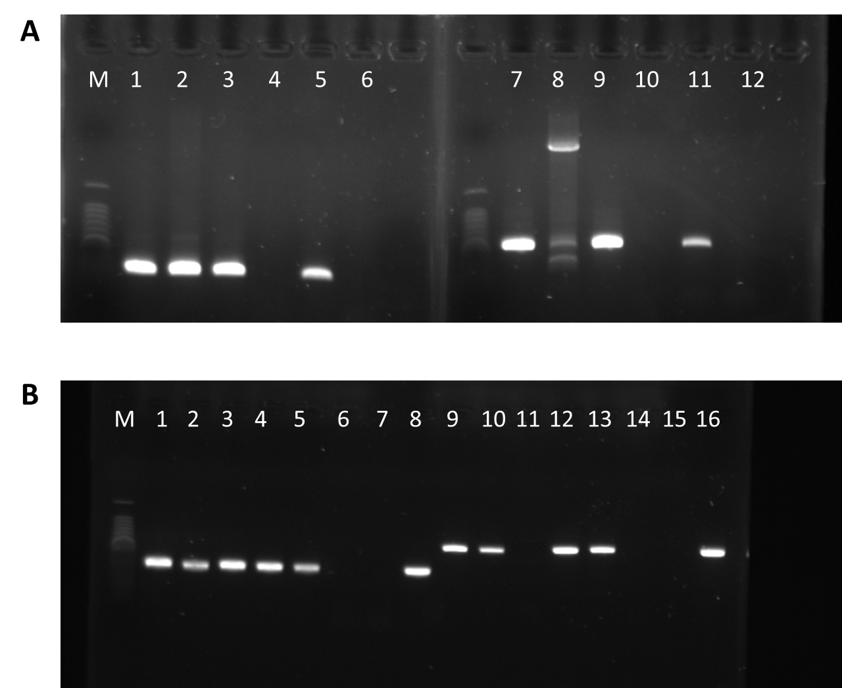

Figure S3. Quantification of the P75 gene expression by semi-quantitative RT-PCR. These gels were cropped to improve the presentation (Full-length gels are presented in supplemental figure S4).
(A) PCR amplification of the P75 gene. M: ladder 100 bp (Promega), 1: M. hominis M132, 2: mutant 28-2, 3: M. hominis PG21, 4: M. arthritidis 158L3-1, 5: mutant 39-5, 6: H₂O, 7: M. hominis M132, 8: mutant 28-2, 9: M. hominis PG21, 10: M. arthritidis 158L3-1, 11: mutant 39-5, and 12: H₂O. 1-6: primers P75-F1 and P75-R1, 7-12: primers P75-F2 and P75-R2.
(B) PCR amplification of cDNA after reverse transcription. 1: M. hominis M132 cDNA, 2: mutant 28-1, 3: mutant 28-2, 4: mutant 29-1, 5: mutant 39-5, 6: No RT control, 7: H₂O, 8: M. hominis M132 DNA, 9: M. hominis M132 cDNA, 10: mutant 28-1, 11: mutant 28-2, 12: mutant 29-1, 13: mutant 39-5, 14: No RT control, 15: H₂O, and 16: M. hominis M132 DNA. 1-8: primers P75-F1 and P75-R1, 9-16: primers P75-F2 and P75-R2.

Figure S4. Additional informations for figure S3. (A) Full-length gel for figure S3 panel A. (B) Full-length gel for figure S3 panel B.
B
A

