Supplementary Information

Thorn-like TiO₂ nanoarrays with broad spectrum antimicrobial activity through physical puncture and photocatalytic action

Eun-Ju Kim^{1,†}, Mingi Choi^{2,†}, Hyeon Yeong Park^{1,3}, Ji Young Hwang⁴, Hyung-Eun Kim¹, Seok Won Hong¹, Jaesang Lee³, Kijung Yong^{2,}* & Wooyul Kim^{4, 5,}*

(†These authors contributed equally to this work.)

¹Center for Water Resources Cycle Research, Korea Institute of Science and Technology (KIST), Seoul 02792, Korea
²Department of Chemical Engineering, Pohang University of Science and Technology (POSTECH), Pohang 37673, Korea
³Civil, Environmental, and Architectural Engineering, Korea University, Seoul 02841, Korea
⁴Department of Chemical and Biological Engineering, ⁵Institute of Advanced Materials and Systems, Sookmyung Women’s University, Seoul 04310, Korea

*Corresponding author: kyong@postech.ac.kr, wykim@sookmyung.ac.kr

Materials and chemicals
The following reagents were obtained from Sigma-Aldrich and used as received: 4-chlorophenol (4-CP), dichloroacetate (DCA, CHCl₂CO₂Na), formate, benzoic acid, acetonitrile, hexavalent chromium, (Cr(VI), Na₂Cr₂O₇∙2H₂O), superoxide dismutase (SOD, manganese-containing enzyme, lyophilized), oxalate, Fe(II)-EDTA, isopropanol, titanium foil (0.127 mm thick, 99.7% trace metals basis), sodium hydroxide (NaOH, pellets, semiconductor grade, 99.99% trace metals basis), hydrochloric acid (HCl, ACS reagent, 37%), ethanol, and HClO₄ (ACS Reagent, 70%). HClO₄ and NaOH were used to adjust the pH of the aqueous suspensions. Escherichia coli (E. coli, KCTC 2571) and Staphylococcus aureus (S. aureus, KCTC 3881) were obtained from the Korean Collection for Type Culture (KCTC). MS2 bacteriophage (ATCC 15597-B1) was purchased from the American Tissue Type Culture Collection (ATCC). All working solutions were prepared with deionized ultrapure water (18 MΩ∙cm), which was obtained by a Barnstead purification system.
Preparation of anatase TiO₂ nanowire films (TNWs)
A clean Ti foil (3 × 5 cm²) was immersed with the conducting side face down in 0.5 M NaOH and reacted in a Teflon-lined stainless-steel autoclave. The reactor was placed in an oven at 220 ºC for different times (5−24 h) to control the NW length. After the reactor was cooled to room temperature for 2 h, the sample was immersed in 1 M HCl for 10 min. Thereafter, the samples were rinsed with water and ethanol, and then annealed at 500 ºC for 3 h in air.

Characterization
The morphology of the TNWs was observed by field-emission scanning electron microscopy (FE-SEM; XL30S, Philips) operating with a 5.0-kV beam energy and high-resolution scanning transmission electron microscopy (HR-STEM; JEM-2200FS with Image Cs-corrector; JEOL) operating with a 200-kV beam energy. The fast-Fourier transformation (FFT) patterns from TEM, X-ray diffraction (XRD; D/MAX-2500, Rigaku) with Cu Kα radiation (40 kV, 100 mA), and Raman spectroscopy (Alpha300R, WITec) with an excitation wavelength of 514 nm were used to verify the crystal structures. X-ray photoelectron spectroscopy (XPS, ESCA LAB 250, VG scientific) using 15 kV monochromatic Al-Kα radiation over an analysis area of 1.1 mm × 1.1 mm was used to determine the surface composition, and the results were calibrated at C 1s peak (285 eV). The surface areas of TiO₂ nanostructures can be extrapolated by the amount of an adsorbed and desorbed dye. In this case, the TNP and TNW samples were immersed in a 0.3 mM N719 (C₅₈H₈₆O₈N₈S₂Ru) solution for 24 h. After complete adsorption, the samples were rinsed by ethanol and then immersed in a 0.1 M NaOH solution for desorption. The concentration of the desorbed dye solution was determined spectrophotometrically by monitoring its absorbance.

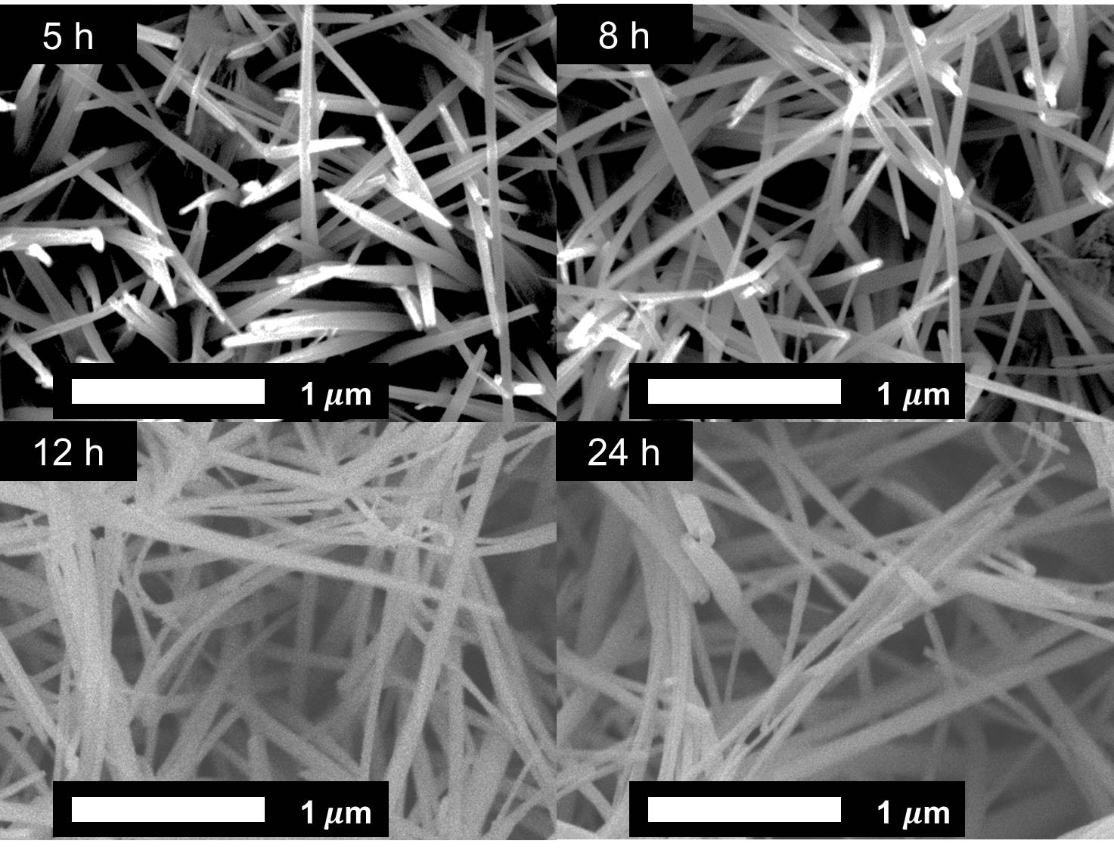

Figure S1. Top-view SEM images of TNW samples used to determine the diameter and density using ImageJ software.

Table S1. Average length, diameter, density, and aspect ratio (length/diameter) of TNW samples at different growth times
Growth time | Length  (μm) | Diameter  (nm) | Density  (N/μm²) | Aspect ratio
5 h | 3.5 ± 0.1 | 65 ± 1 | 22.7 ± 2.1 | 53.8
8 h | 5.0 ± 0.2 | 66 ± 3 | 26.3 ± 1.5 | 75.8
12 h | 7.5 ± 0.3 | 78 ± 5 | 21.3 ± 3.0 | 96.2
24 h | 12.0 ± 0.5 | 83 ± 6 | 15.7 ± 2.1 | 144.6

Figure S2. (a) Ti 2p and (b) O 1s XPS analysis of TNW/5 μm using 15 kV monochromatic Al X-rays.

Figure S3. Raman spectrum of TNW/5 μm using a 514-nm laser.

Figure S4. UV-Vis absorption spectra of the desorbed N-719 dye solution from TNP and TNW/5 μm.

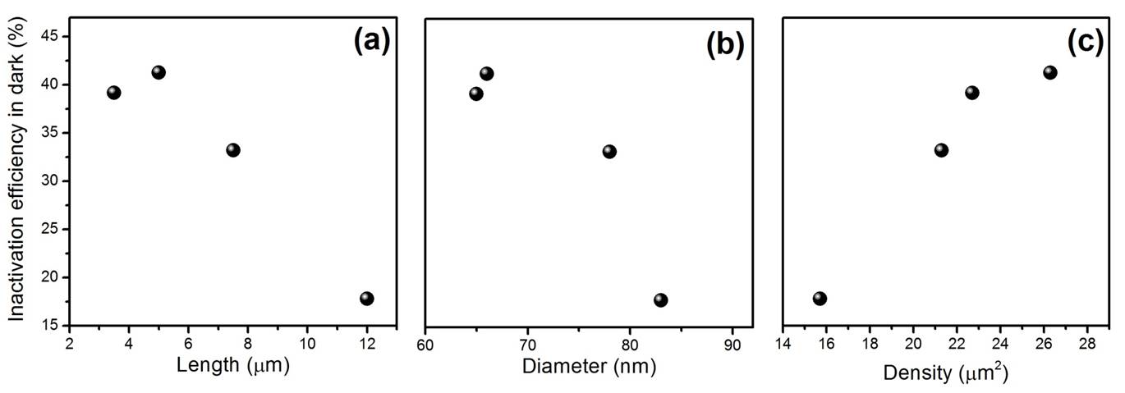

Figure S5. E. coli inactivation efficiency of TNWs in dark as a function of (a) length, (b) diameter, and (c) number density of NWs.

Figure S6. TEM images of E. coli (a) untreated and treated with TNW/5 μm (b) in the dark and (c) under UV irradiation.

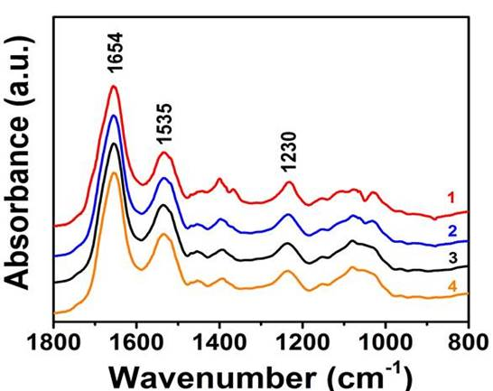

Figure S7. Enlarged FT-IR spectra of E. coli exposed to TNW/5 μm and TNP under different conditions (trace 1, TNW/5 μm under UV irradiation; trace 2, TNW/5 μm in the dark; trace 3, TNP in the dark; trace 4, E. coli only).

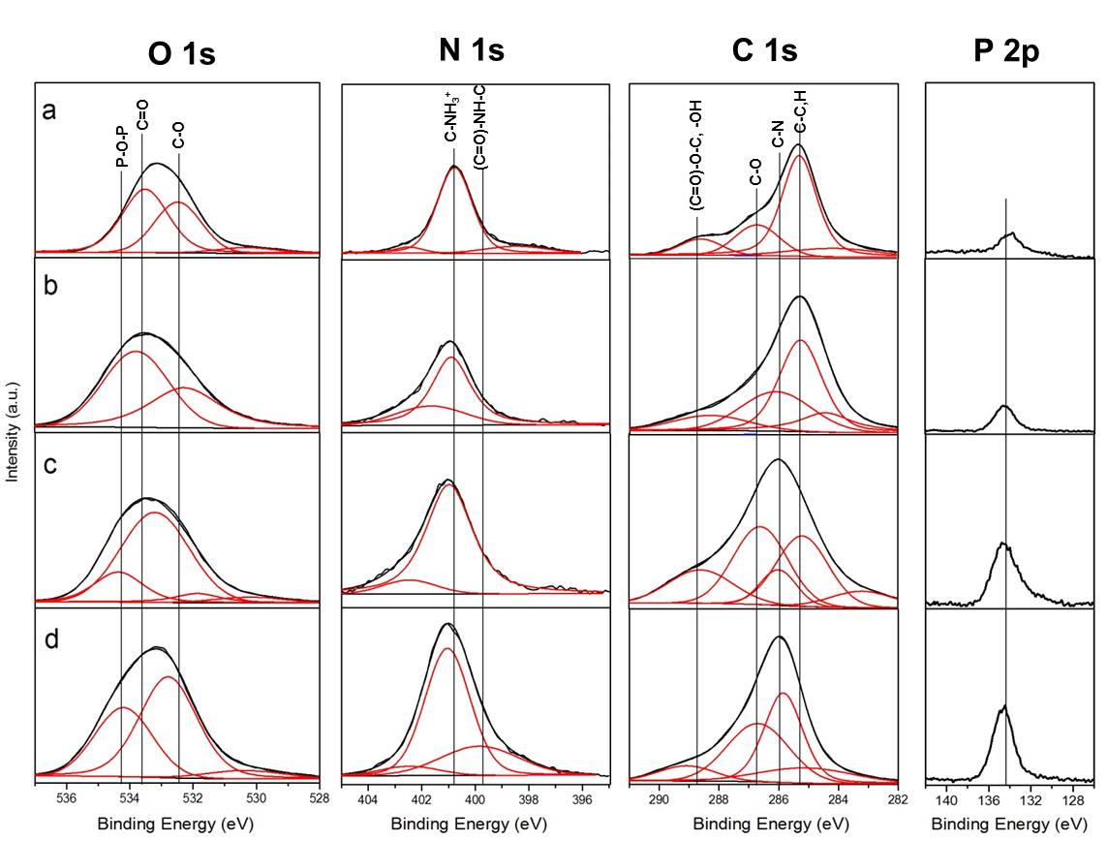
Figure S8. High resolution O 1s, N 1s, C 1s and P 2p XPS spectra of E. coli exposed to TNW/5 μm and TNP under different conditions (a, E. coli only; b, TNP in the dark; c, TNW/5 μm in the dark; d, TNW/5 μm under UV irradiation). Peak assignments are indicated in the figure.

Table S2. Surface composition determined by XPSª
Sample | O/C | N/C
E. coli control | 27.8 ± 0.4 | 7.7 ± 0.1
E. coli under TNP/dark | 29.5 ± 0.2 | 7.2 ± 0.1
E. coli under TNW/dark | 31.2 ± 0.7 | 10.8 ± 0.2
E. coli under TNW/UV light | 30.5 ± 0.1 | 12.5 ± 0.0
ª Data are expressed as atomic concentration ratios with respect to total carbon, multiplied by 100. Values represent means±s.d.s for two sets of determination.

Figure S9. Potassium ion (K⁺) leakage from E. coli after incubation of TNP or TNW/5 μm under dark and light conditions

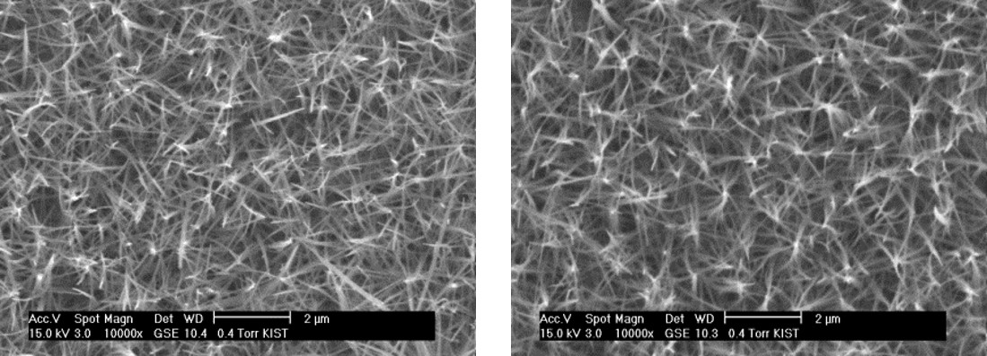

Figure S10. SEM images of TNW/5 μm recycled after the 5th reaction in the dark (left) and UV light (right).

Table S3. Inactivation efficiencies (%)ª of TNW 5/μm and TNP against single cultures and mixed cultures of E. coli, S. aureus, and MS2 phage^{b} upon a 30 min exposure.

 |  |  | TNW/5 µm | TNP
Single culture | Dark | E. coli | 41.6±7.1 | 3.45±1.3
Single culture | Dark | S. aureus | 46.4±6.3 | 8.29±2.3
Single culture | Dark | MS2 phage | 74.8±2.9 | 3.13±4.2
Single culture | UV light | E. coli | 94.9±0.5 | 59.4±4.8
Single culture | UV light | S. aureus | 99.8±0.1 | 65.9±4.6
Single culture | UV light | MS2 phage | 100±1.5 | 100±3.1
Mixed culture | Dark | E. coli | 38.0±4.8 | 0.55±4.1
Mixed culture | Dark | S. aureus | 42.9±5.1 | 4.3±1.9
Mixed culture | Dark | MS2 phage | 67.9±3.5 | 1.13±1.0
Mixed culture | UV light | E. coli | 79.6±8.8 | 32.5±0.2
Mixed culture | UV light | S. aureus | 82.2±2.1 | 40.2±1.3
Mixed culture | UV light | MS2 phage | 99.1±2.3 | 92.3±2.2

ª Values represent means±s.d.s of three independent experiments.
^{b} Initial concentrations of E. coli, S. aureus, and MS2 phage are ~10⁷ CFU/ml and ~10⁷ PFU/ml, respectively.

