Supporting information

Low CYP24A1 mRNA expression and its role in prognosis of breast cancer
Authors：Hongqiao Cai¹, Yan Jiao¹, Yanqing Li², Zhaoying Yang^{3*}, Miao He⁴, Yahui Liu¹*
Affilations：1 Department of Hepatobiliary and Pancreatic Surgery, The First Hospital of Jilin University, Changchun, Jilin 130021, P.R. China.
2 Department of Pathophysiology, College of Basic Medical Sciences, Jilin University, Changchun, Jilin 130021, P.R. China.
3 Department of Breast Surgery, China-Japan Union Hospital of Jilin University, 126 Xiantai Street, Changchun 130033, P. R. China.
4 Department of Anesthesia, The Second Hospital of Jilin University, Changchun 130022, P. R. China.
Co-corresponding author: Zhaoying Yang and Yahui Liu (*)
Email address: Zhaoying Yang: zhaoyingyang@163.com;
Yahui Liu: liuyahui2008@yeah.net

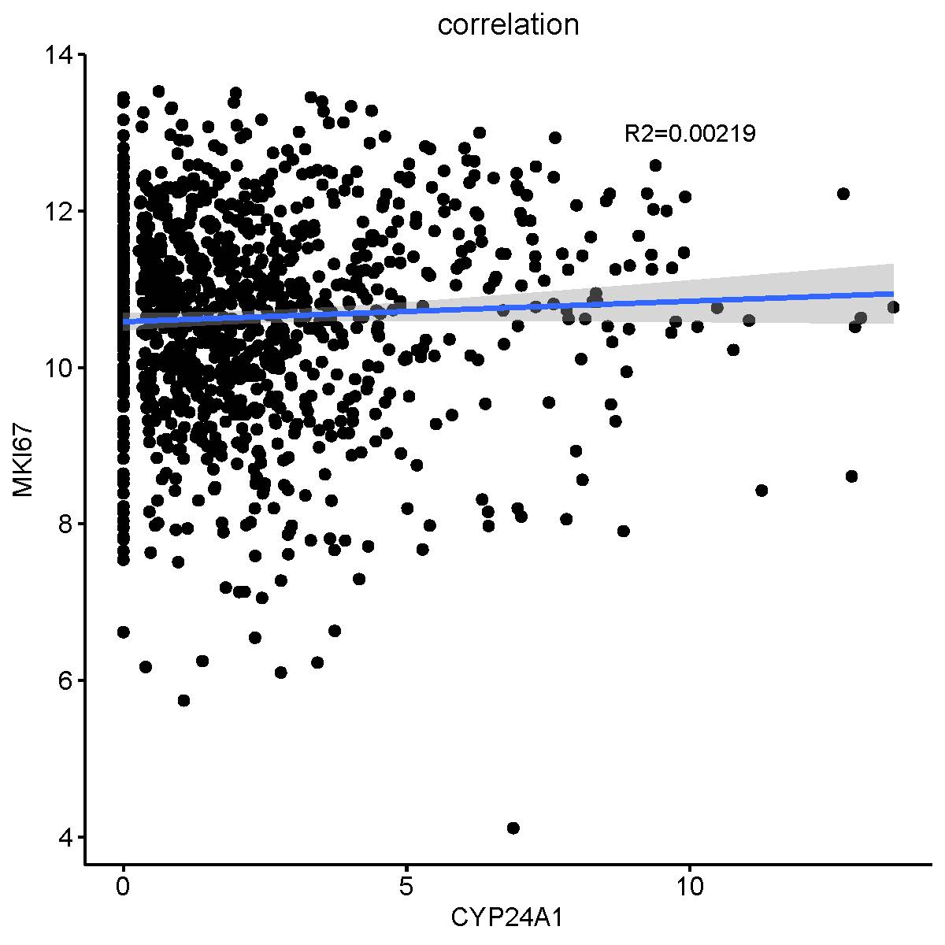
Figure S1. The correlation between CYP24A1 expression and KI67 (gene MKI67).

