Evaluation of a Recombinant Newcastle Disease Virus Expressing Human IL12 against Human Breast Cancer
Zahiah Mohamed Amin¹, Muhammad Alhapis Che Ani², Sheau Wei Tan¹, Swee Keong Yeap³, Noorjahan Banu Alitheen^{1,2}, Syed Umar Faruq Syed Najmuddin¹, Jeevanathan Kalyanasundram², Soon Choy Chan⁴, Abhi Veerakumarasivam^{5,6}, Suet Lin Chia^{1,2} & Khatijah Yusoff^{2,6*}

¹ Institute of Bioscience, Universiti Putra Malaysia, 43400 Serdang, Selangor, Malaysia
² Faculty of Biotechnology and Biomolecular Sciences, Universiti Putra Malaysia, 43400 Serdang, Selangor, Malaysia
³ Xiamen University Malaysia, Jalan Sunsuria, Bandar Sunsuria, 43900 Sepang, Selangor Darul Ehsan, Malaysia
⁴ Perdana University, Block B and D1, MAEPS Building, MARDI Complex Jalan MAEPS Perdana, 43400 Seri Kembangan, Selangor Darul Ehsan, Malaysia Ehsan, Malaysia
⁵ Department of Biological Sciences, School of Science and Technology, Sunway University, 5, Jalan Universiti, Bandar Sunway, 47500 Subang Jaya, Selangor Darul
⁶ Malaysian Genome Institute, Jalan Bangi, 43000 Kajang, Selangor, Malaysia

Correspondence should be addressed to Khatijah Yusoff; kyusoff@upm.edu.my

Supplementary information

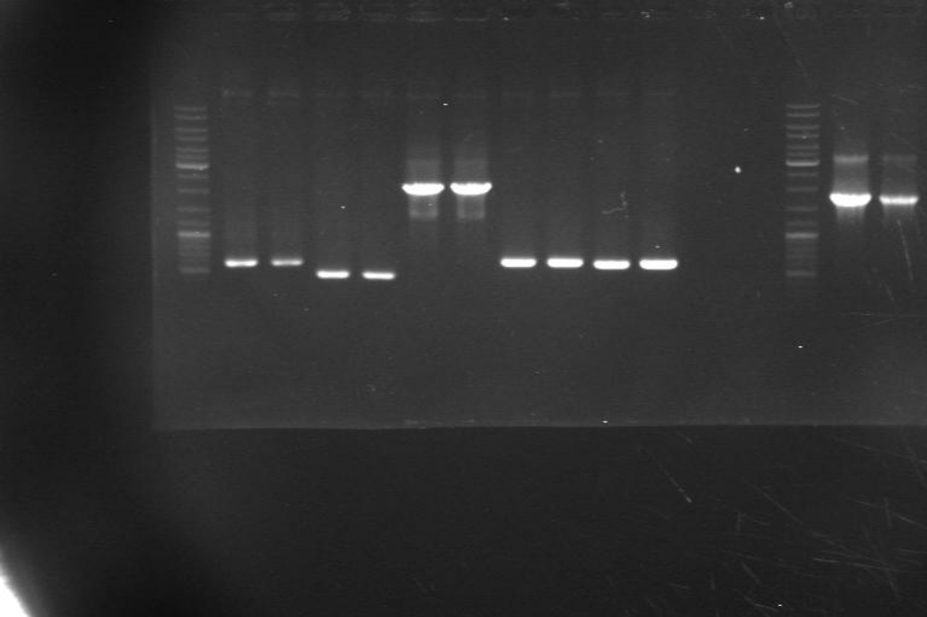
0.5 kb
1 kb
2 kb
3 kb
Fig. S1 PCR was carried out amplify intergenic region of each gene in plasmid rAF-IL12 using specific primers. NP/P region indicates region between NP and P gene, P/M indicates region between P and M gene, M/F indicates region between M and F gene, F/HN indicates region between F and HN gene and HN/L indicates region between HN and L gene. The dashed lines separate samples unrelated to this study.

Ladder NP/P P/M M/F F/HN HN/L
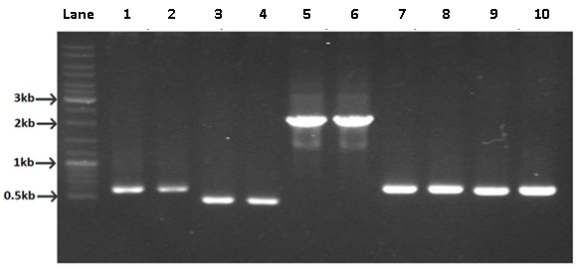
Fig. S2 PCR was carried out to amplify the intergenic region of each gene in the rAF-IL12 plasmid. Lane 1&2: NP/P region; Lane 3/4: P/M region; Lane 5/6: M/F region; Lane 7/8: F/HN region and; Lane 9/10: HN/L region.

Fig. S3 Design construction of rAF-IL12. The insertion of transgene, Kozak sequence was included preceding the start codon of IL-12 gene in the 3’ UTR region. Upstream of IL12 gene, IG, GS and 3’ UTR was inserted allowing the replication and transcription of the transgene.
UTR: Untranslated region; IG: Intergenic sequence; GS: Gene start; GE: Gene end.

