Supplementary Materials for

Green Synthesis of Substituted Anilines and Quinazolines from Isatoic Anhydride-8-amide

Sudershan Gondi, Asim Bera, Kenneth D. Westover.

Correspondence to: kenneth.westover@utsouthwestern.edu

Fig. S1. Examples of FDA approved and tool compounds incorporating the quinazoline pharmacophore.

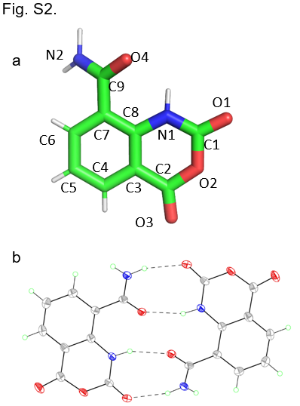

Fig. S2. IAA crystal structure. (A) Numbering scheme for coordinates. (B) H-bonding in IAA crystals. Displacement ellipsoids are scaled to the 50% probability level.
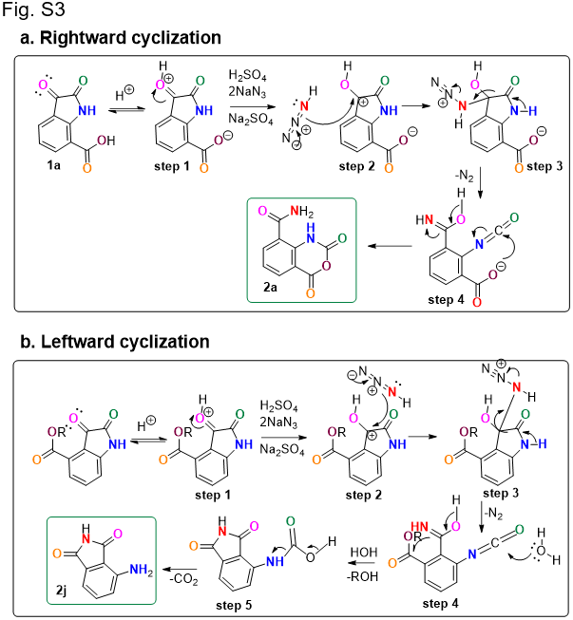

Fig. S3. Mechanisms of (A) rightward (clockwise) and (B) leftward (counterclockwise) cyclization reactions related to formation of IAA.

Fig. S4. Proposed mechanism of cyano derivative substituted anilines.

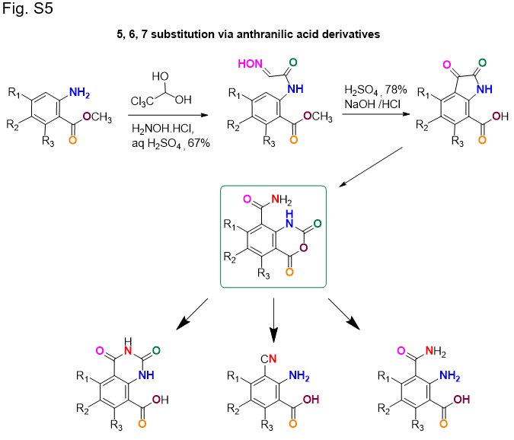

Fig. S5. Strategy for obtaining substituted quinazolines and substituted anilines from anthranilic acid derivatives.

Table S1. Crystal data and structure refinement for IAA
Table S1. Crystal data and structure refinement for IAA
Empirical formula | C₉ H₆ N₂ O₄
Formula weight | 206.16
Temperature | 100 K
Wavelength | 1.54184 Å
Crystal system | monoclinic
Space group | P 21/c
Unit cell dimensions | a = 7.6432 Å | α = 90 °
 | b = 4.8714 Å | β = 95.006 °
 | c = 22.3617 Å | γ = 90 °
Volume | 829.42(6) Å³
Z | 4
Density (calculated) | 1.651 Mg/m³
Absorption coefficient | 1.145 mm⁻¹
F(000) | 424
Crystal size | 0.380 x 0.060 x 0.040 mm³
Theta range for data collection | 3.969 to 68.769°.
Index ranges | -9<=h<=8, -5<=k<=5, -26<=l<=26
Reflections collected | 6181
Independent reflections | 1521 [R(int) = 0.0439]
Completeness to theta = 67.684° | 100.00%
Absorption correction | Semi-empirical from equivalents
Max. and min. transmission | 1.00 and 0.743
Refinement method | Full-matrix least-squares on F²
Data / restraints / parameters | 1521 / 0 / 148
Goodness-of-fit on F² | 1.056
Final R indices [I>2sigma(I)] | R1 = 0.0444, wR2 = 0.1206
R indices (all data) | R1 = 0.0513, wR2 = 0.1267
Extinction coefficient | n/a
Largest diff. peak and hole | 0.311 and -0.293 e.Å⁻³
Rw(F²) = {Sw(|Fo|² -|Fc|²)²/Sw(|Fo|)⁴}^{1/2} where w is the weight given each reflection.
R(F) = S(|Fo| - |Fc|)/S|Fo|} for reflections with Fo > 4(s(Fo)). S = [Sw(|Fo|² - |Fc|²)²/(n - p)]^{1/2}, where n is the number of reflections and p is the number of refined parameters

Data S1. CCDC 1896630 file. Coordinates file for IAA x-ray structure.

Table S2. Atomic coordinates (x 10⁴) and equivalent isotropic displacement parameters (Å² x 10³) for IAA. Ueq is defined as one third of the trace of the orthogonalized Uij tensor.
________________________________________________________________________________
 | x | y | z | Ueq
________________________________________________________________________________
C1 | 8930(2) | 4323(3) | 4332(1) | 18(1)
C2 | 9828(2) | 7162(4) | 3511(1) | 21(1)
C3 | 8120(2) | 8537(3) | 3491(1) | 20(1)
C4 | 7705(2) | 10581(4) | 3064(1) | 22(1)
C5 | 6104(2) | 11891(4) | 3048(1) | 24(1)
C6 | 4916(2) | 11170(3) | 3460(1) | 20(1)
C7 | 5295(2) | 9143(3) | 3892(1) | 16(1)
C8 | 6929(2) | 7783(3) | 3902(1) | 17(1)
C9 | 3977(2) | 8333(3) | 4317(1) | 17(1)
N1 | 7408(2) | 5741(3) | 4318(1) | 17(1)
N2 | 2890(2) | 10246(3) | 4480(1) | 20(1)
O1 | 9325(2) | 2429(2) | 4664(1) | 21(1)
O2 | 10107(2) | 5093(3) | 3934(1) | 21(1)
O3 | 10988(2) | 7621(3) | 3197(1) | 28(1)
O4 | 3941(2) | 5927(2) | 4504(1) | 19(1)
________________________________________________________________________________

