Effect of feed supplementation with biosynthesized silver nanoparticles using leaf extract of Morus indica L. V1 on Bombyx mori L. (Lepidoptera: Bombycidae)

Mr. Sudip Some¹, Mr. Onur Bulut^{2,3,4}, Dr. Kinkar Biswas⁵, Dr. Anoop Kumar⁶, Dr. Anupam Roy⁷, Dr. Ipsita Kumar Sen⁸, Dr. Amitava Mandal⁹, Prof. Dr. Octavio L. Franco^{10,11}, Prof. Dr. İkbal Agah İnce¹², Dr. Kartik Neog¹³, Mr. Sandip Das¹, Mr. Sayantan Pradhan¹, Mr. Subhadeep Dutta¹, Mr. Debjoy Bhattacharjya¹⁴, Dr. Soumen Saha¹⁴, Dr. Pradeep K. Das Mohapatra¹⁵, Prof. Anil Bhuimali¹⁶, Prof. B.G. Unni¹⁷, Dr. Ahmet Kati^{12,18}, Dr. Amit Kumar Mandal^{1,*} Prof. Dr. M. Deniz Yilmaz^{4,19*}, Dr. Ismail Ocsoy^{20,*}

¹Chemical Biology Laboratory, Department of Sericulture, Raiganj University, Uttar Dinajpur-733134, West Bengal, India
²Department of Molecular Biology and Genetics, Faculty of Agriculture and Natural Sciences, Konya Food and Agriculture University, 42080 Konya, Turkey
³Department of Biological Sciences, Middle East Technical University, 06800 Ankara, Turkey
⁴Research and Development Center for Diagnostic Kits (KIT-ARGEM), Konya Food and Agriculture University, 42080 Konya, Turkey
⁵Laboratory of Organic Synthesis, Department of Chemistry, Raiganj University, Raiganj–733134, Uttar Dinajpur, West Bengal, India
⁶ANMOL Laboratory, Department of Biotechnology, North Bengal University, Raja Ram Mohanpur, Siliguri, Darjeeling-734013, India
⁷Laboratory of Food Chemistry and Technology, Department of Chemical Engineering, Birla Institute of Technology, Mesra, Ranchi-835215, India
⁸Department of Science and Humanities, Sidhu Kanhu Birsa Polytechnic, Keshiary-721133, West Bengal, India
⁹Molecular Complexity Laboratory, Department of Chemistry, Raiganj University, Raiganj–733 134, Uttar Dinajpur, West Bengal, India
¹⁰S-INOVA Biotech, Post-Graduate Program in Biotechnology, Catholic University Dom Bosco, Campo Grande, Mato Grosso Do Sul, Brazil
¹¹Center of Proteomic and Biochemical Analysis, Post Graduate Program in Genomic Sciences and Biotechnology, Catholic University of Brasilia, Brasilia, Brazil
¹²Department of Medical Microbiology, School of Medicine, Acibadem Mehmet Ali Aydinlar University, 34752 Ataşehir, Istanbul, Turkey
¹³Biotechnology Division, Central Muga Eri Research & Training Institute (CMER&TI), Central Silk Board, Ministry of Textiles: Govt. of India, Lahdoigarh-785700, Jorhat, Assam, India
¹⁴Cytogenetics & Plant Biotechnology Research Unit, Department of Sericulture, Raiganj University, Uttar Dinajpur-733134, India
¹⁵Department of Microbiology, Raiganj University, Uttar Dinajpur-733134, West Bengal, India
¹⁶Hon’ble Vice-Chancellor, Raiganj University, Uttar Dinajpur-733134, West Bengal, India
¹⁷Director Research, Assam Down town University, Sankar Madhav Path, Gandhi Nagar, Panikhaiti, Guwahati 781026, Assam, India
¹⁸Department of Detergent and Chemical Technologies, Hayat Kimya Research and Development Center, Kocaeli, 41250, Turkey
¹⁹Department of Bioengineering, Faculty of Engineering and Architecture, Konya Food and Agriculture University, 42080 Konya, Turkey
²⁰Department of Analytical Chemistry, Faculty of Pharmacy, Erciyes University, Kayseri, 38039, Turkey

Supplementary Table 1: Spectrometric data of compounds found in Morus indica L. V1.
Sl No. | M (m/z) Cal. | M (m/z) found | Formula | Compound structure | Compound name | Ref
1 | 464.0955 | 464.2910 | C₂₁H₂₀O₁₂ | 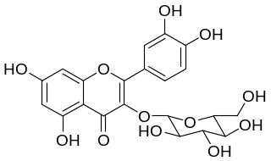 | Isoquercetin | 36
2 | 170.0215 | 170.8545 | C₇H₆O₅ | 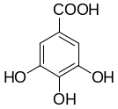 | Gallic acid | 37
3 | 392.1988 | 392.1861 | C₂₅H₂₈O₄ | 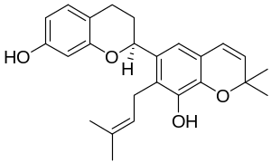 | Kazinol B | 38
4 | 370.1416 | 370.1861 | C₂₁H₂₂O₆ | 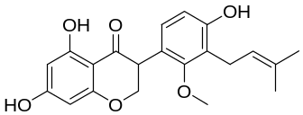 | Sophoraisoflavanone A | 38
5 | 418.1416 | 418.1799 | C₂₅H₂₂O₆ | 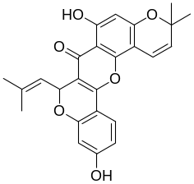 | Cyclomorusin | 38
6 | 422.0849 | 422.2616 | C₁₉H₁₈O₁₁ | 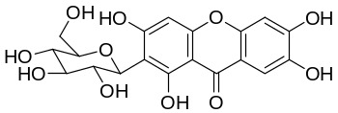 | Mangiferin xanthonoid | 39
7 | 412.3705 | 412.1508 | C₂₉H₄₈O | 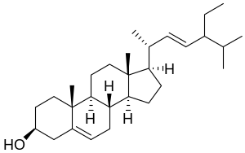 | Stigmasterol | 40
Supplementary Figure 1: Various components in the aqueous mulberry leaf extract identified by LC-QTOF/MS.
Supplementary Figure 2: Various peaks of the aqueous mulberry leaf extract assigned from HRMS spectra and corresponding compounds.

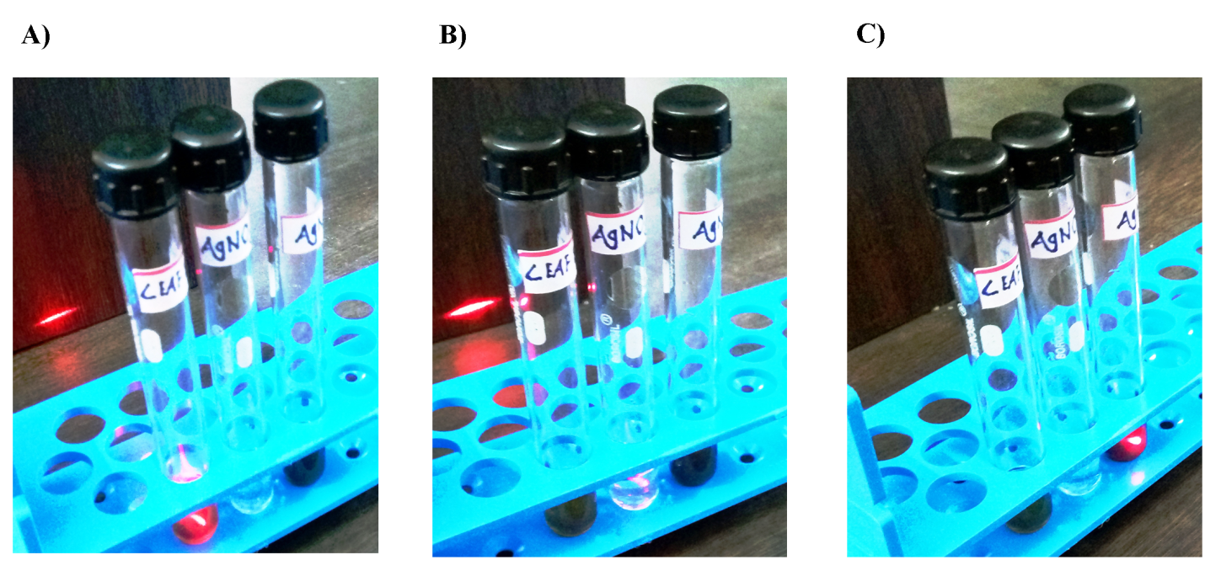
Supplementary Figure 3: Confirmation of the AgNP formation via laser light scattering: Laser light is passing through Morus indica V1 leaf extract (A), and 0.01 M AgNO₃ solution (B). Laser light is scattered by AgNPs due to Tyndall scattering which confirms the formation of AgNPs (C).

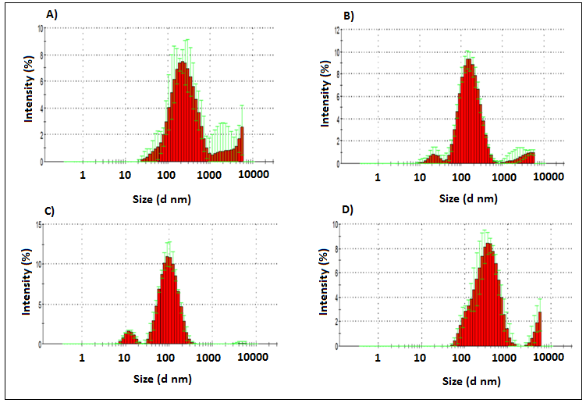
Supplementary Figure 4: Dynamic light scattering of the synthesized AgNPs in various media at pH 7.2: (A) Deionized water; (B) PBS; (C) LB broth, and D) DMEM F-12.

Supplementary Figure 5: Zeta potential distribution of the synthesized AgNPs.
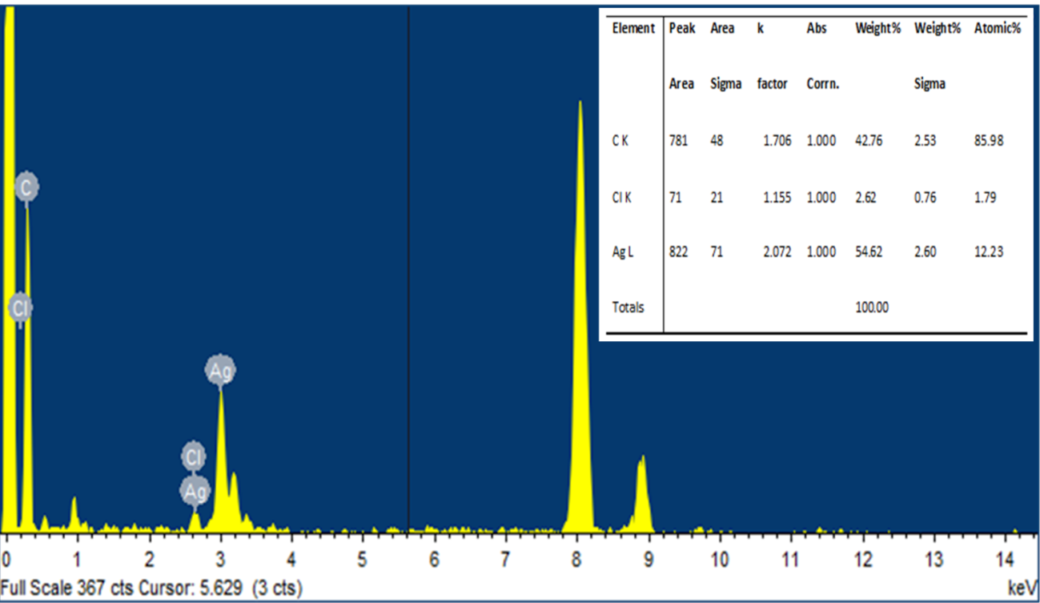
Supplementary Figure 6: EDX spectrum of the synthesized AgNPs.

Supplementary Figure 7: The microscope images of HepG2 cells exposed to the synthesized AgNPs for 24 h.
Supplementary Figure 8: The microscope images of WRL-68 cells exposed to the synthesized AgNPs for 24 h.

