A novel therapeutic approach for anaplastic thyroid cancer through inhibition of LAT1

Keisuke Enomoto ¹, Fuyuki Sato ², Shunji Tamagawa ¹, Mehmet Gunduz ¹, Naoyoshi Onoda ³, Shinya Uchino ⁴, Yasuteru Muragaki ², Muneki Hotomi ¹

- Departments of Otolaryngology-Head and Neck Surgery, Wakayama Medical University, Wakayama, Japan
- Departments of Pathology, Wakayama Medical University, Wakayama, Japan
- Department of Breast & Endocrine Surgery, Graduate School of Medicine, Osaka City University, Osaka, Japan
- Noguchi Thyroid Clinic and Hospital Foundation, Oita, Japan

*Correspondence to; Muneki Hotomi, Professor and Head
Department of Otolaryngology-Head and Neck Surgery, School of Medicine, Wakayama Medical University 811-1 Kimiidera, Wakayama, 641-8509, Japan
Tel: +81-73-441-0651. Fax: +81-73-446-3846;
E-mail: mhotomi@wakayama-med.ac.jp

Abbreviated title: LAT1 inhibition in anaplastic thyroid cancer

Key terms: JPH203, anaplastic thyroid cancer, amino acid transporter, therapy, LAT1

Supplemental Figure S1
Western blot analyses of LAT1 knockdown by siRNA. Representative images of LAT1 siRNA significantly decreased endogenous LAT1 protein expression in ATC cells. Expressions of 4F2hc and phosphorylated p70S6K were decreased by LAT1 knockdown using both siRNA_#1 and _#2. The cyclin D1 expression significantly decreased by LAT1 siRNA treatment in ATC cells.

Supplemental Figure S2
Comparison of body weight ratio of the animals according to the treatment. There is no difference between JPH203 treatment and control DMSO (p=0.1449).

Supplemental Figure 1

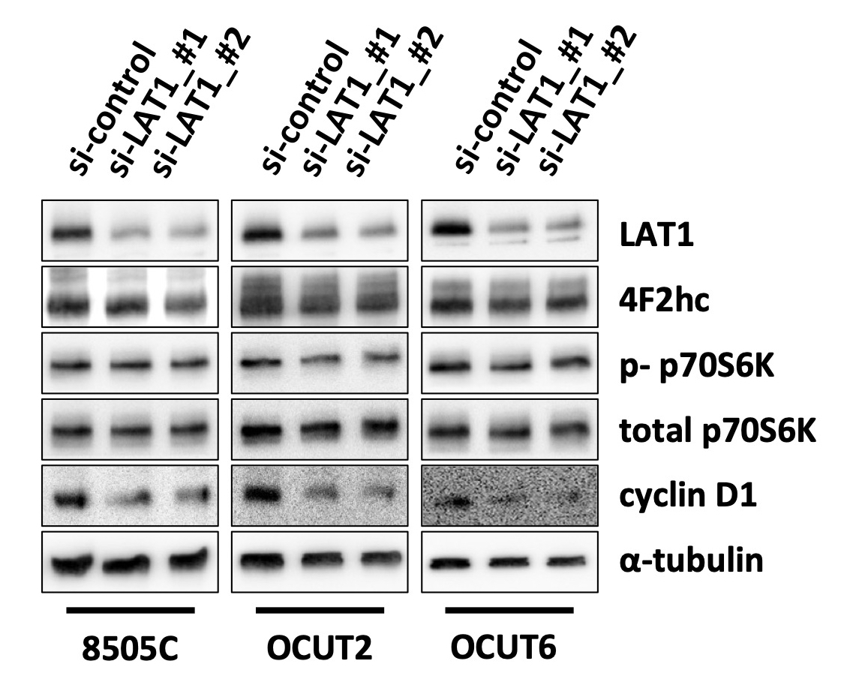

Supplemental Figure 2
