Multi-tissue network analysis for drug prioritization in knee osteoarthritis

Michael Neidlin¹, Smaragda Dimitrakopoulou¹, Leonidas G Alexopoulos¹

Departmental and institutional affiliations
1: Department of Mechanical Engineering, National Technical University of Athens, Greece

Corresponding Author
Leonidas G Alexopoulos, Department of Mechanical Engineering,
National Technical University of Athens,
Heroon Polytechniou 9, 15780 Zografou, Greece
Email: leo@mail.ntua.gr Phone: +30 210 7721666

Supplementary Appendix

At total there are two different parts in the supplementary appendix.

Supplementary Methods
Supplementary Results 1, 2, 3,4

Table of contents

Supplementary Methods:
MA Plots – Fig S1
Outlier removal Fig.S2-S5
Choice of WGCNA parameter β Fig S6

Supplementary Results 1:
Stability of WGCNA module detection, Fig S7-S9

Supplementary Results 2:
Gene significance vs. gene connectivity plots for all tissues, Fig S10

Supplementary Results 3:
Sensitivity of agglomeration measures. Fig. S11

Supplementary Results 4:
Differential expression analysis of four joint tissues, Tab. S1

Supplementary Methods
Herein the results of data pre-processing and outlier removal are shown.

Background correction and normalisation
MA plots after RMA background correction and quantile normalisation. Most of the values are scattered around the zero line and thus show appropriate correction and normalisation.
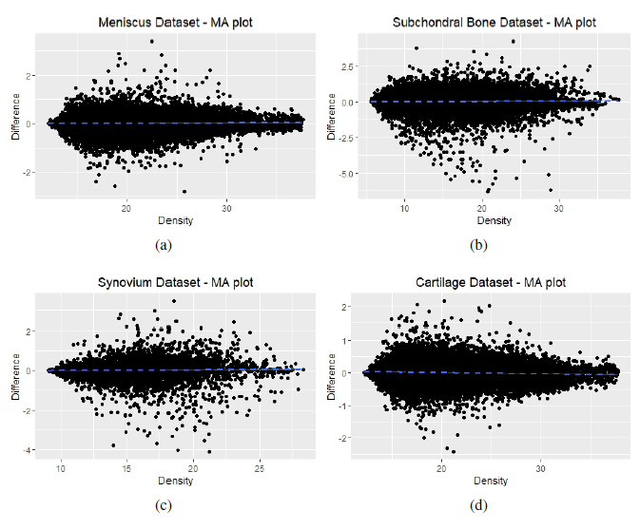
Figure S1: MA plots of the four datasets after background correction and normalisation

Clustering and outlier removal
Gene expression values are hierarchically clustered for the normal and the OA datasets of each of the four tissues. Outliers are marked with a red frame and removed from further analysis.
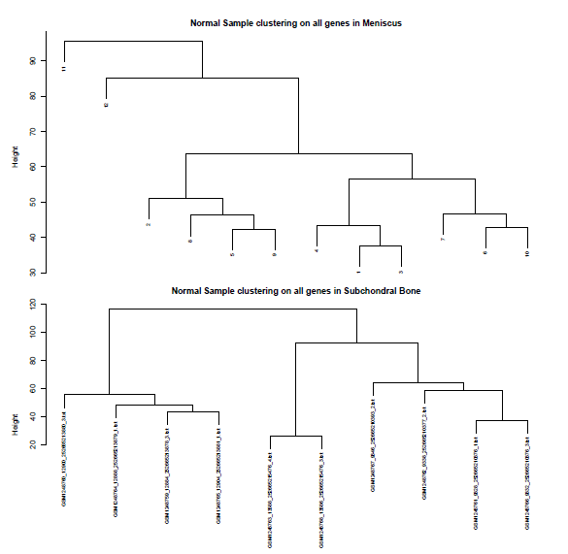
Figure S2: Hierarchical clustering of normal samples for meniscus and subchondral bone

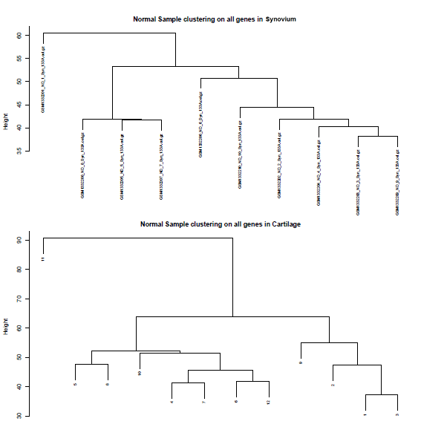
Figure S3: Hierarchical clustering of normal samples for synovium and cartilage

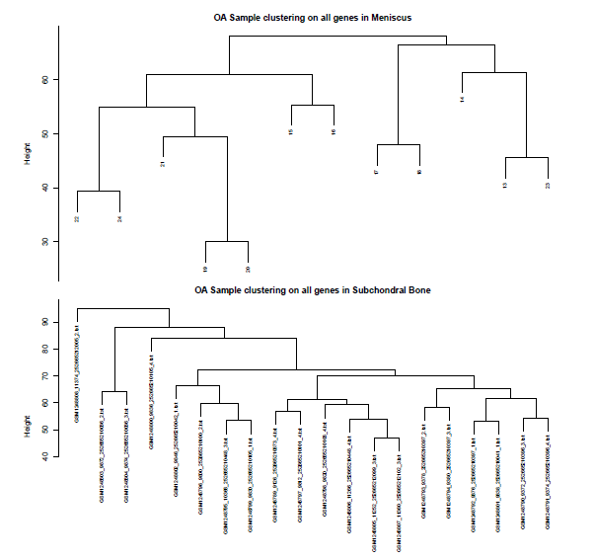
Figure S4: Hierarchical clustering of OA samples for meniscus and subchondral bone

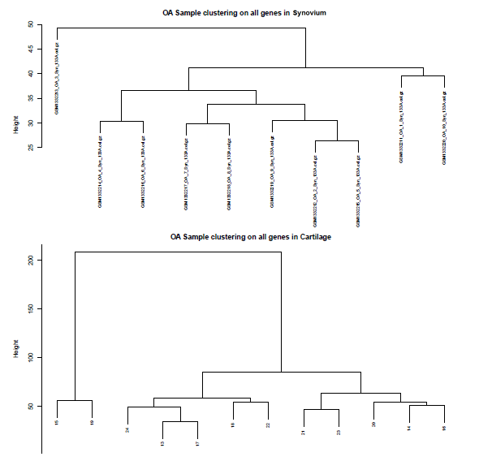
Figure S5: Hierarchical clustering of OA samples for synovium and cartilage

Choice of parameter β and scale-free topology model fit

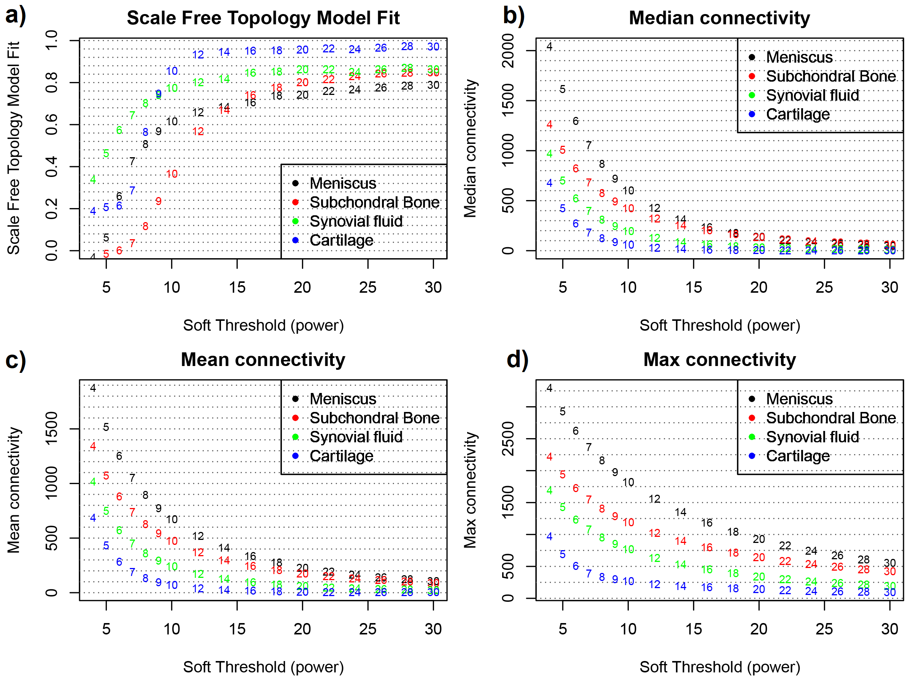
Figure S6 (a) Plot of Scale free topology Model Fit index ~ Soft threshold power β. (b) Plot of
Median Connectivity ~ Soft threshold power β. (c) Plot of Mean Connectivity ~ Soft threshold
power β. (d) Plot of Max Connectivity ~ Soft threshold power β.

Supplementary Results 1

Module stability
Figure S7 shows the percentage of preserved genes related to the preserved genes in the original dataset.
Figure S7: Percentage of preserved genes after resampling and 10% removal. Result of 50 runs.

The dendrogram plots in Figures S8 and S9 show the hierarchical clustering and the module identification for the “resampling” and “removal” approaches.

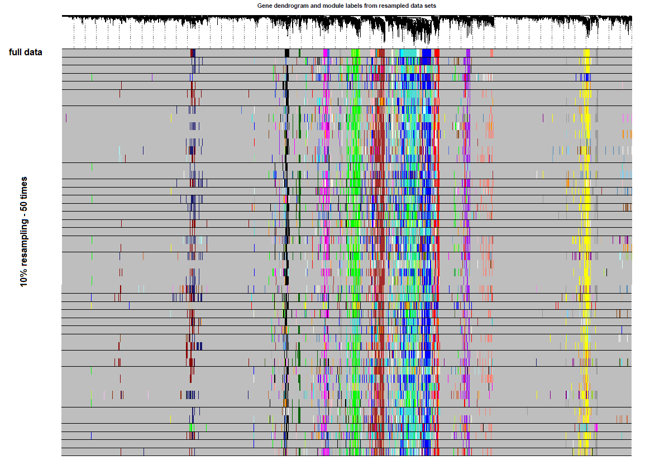
Figure S8: Hierarchical clustering dendrogram and module identification for the resampling case
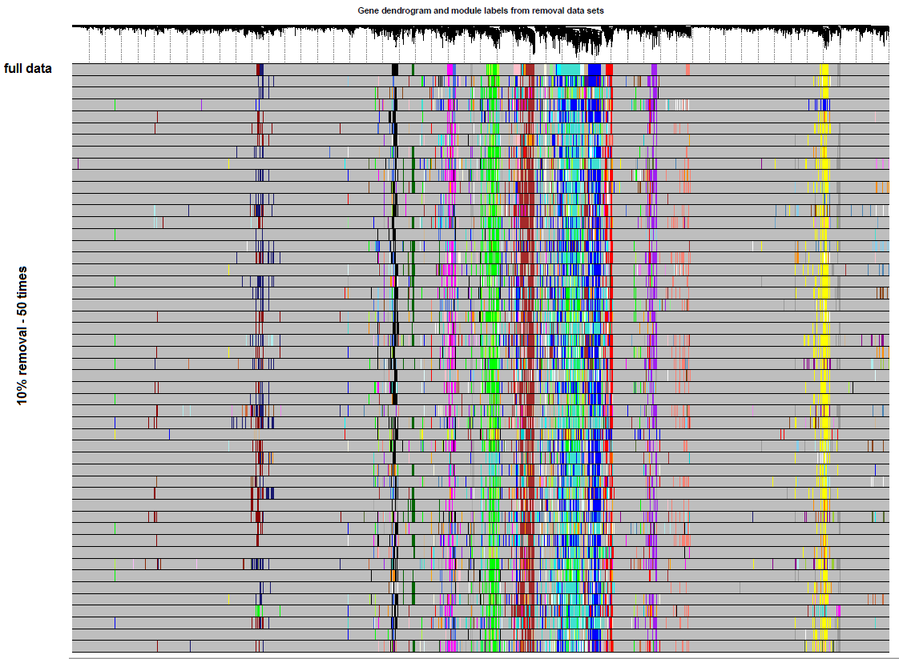
Figure S9: Hierarchical clustering dendrogram and module identification for the removal case

Supplementary Results 2

Gene significance vs. gene connectivity plots for all tissues:

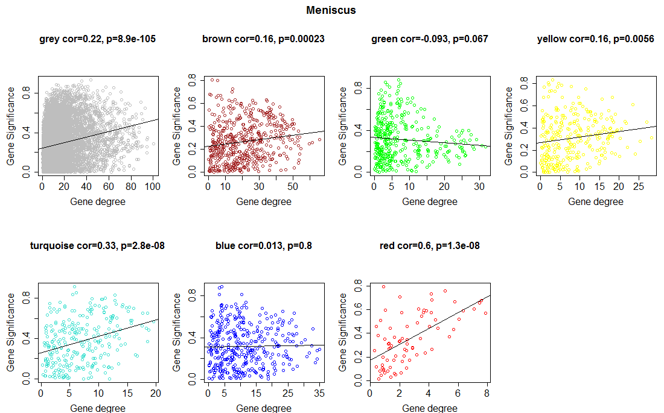

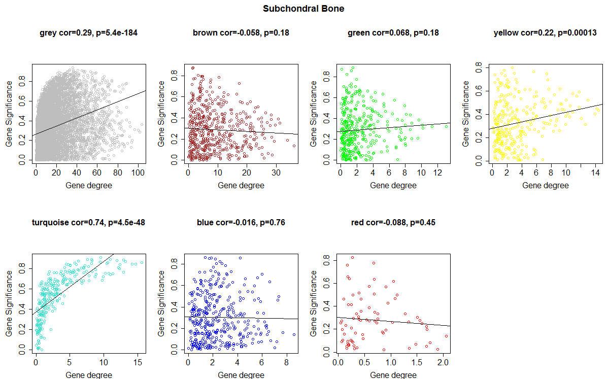

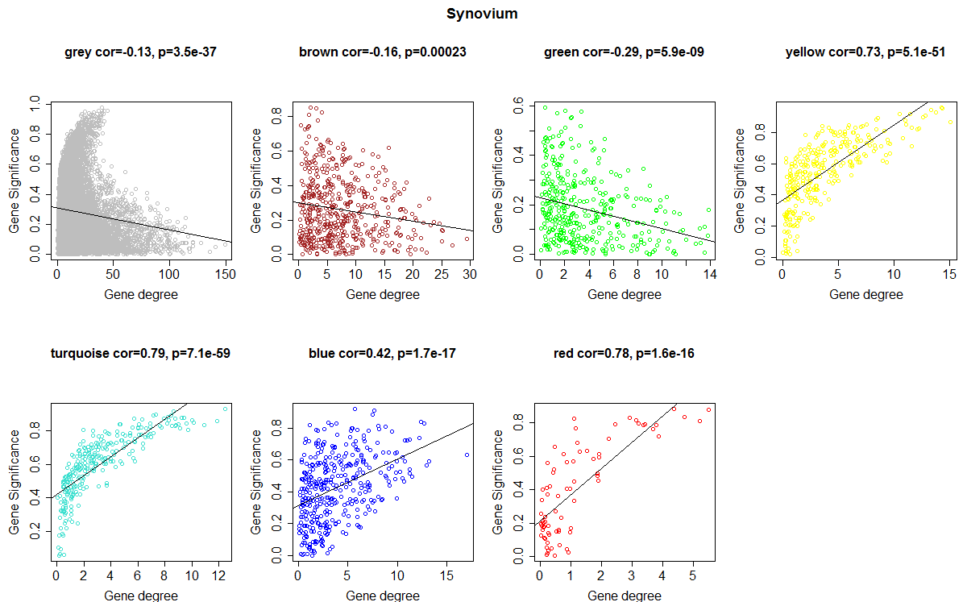

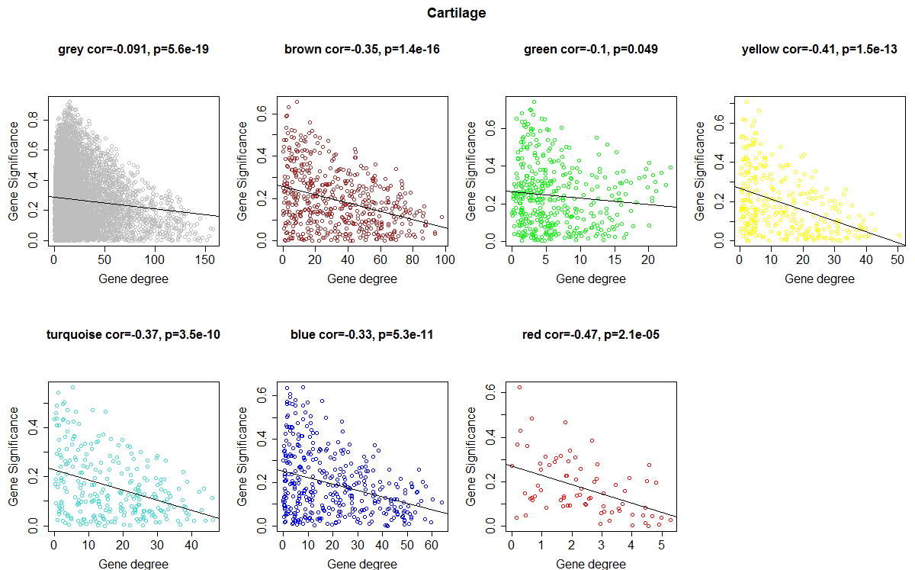

Figure S10: Plot of gene significance (correlation with disease) vs. gene degree for each meta-module and each joint tissue. A: Meniscus, B: Subchondral bone, C: Synovium, D: Cartilage.

Supplementary Results 3

Sensitivity of agglomeration

Figure S11 shows z-scores for the largest connected component (LCC) and the mean shortest distance (MSD) for different cut-off thresholds. It can be observed that the threshold of 80% delivers the best results for both measures (12.04 and -1.75).

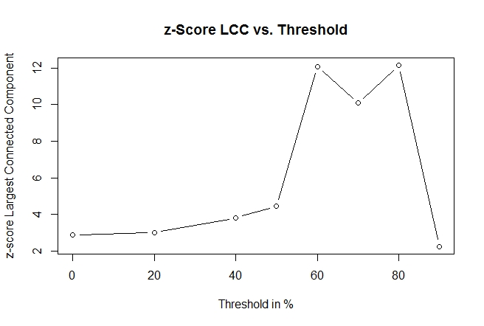 | 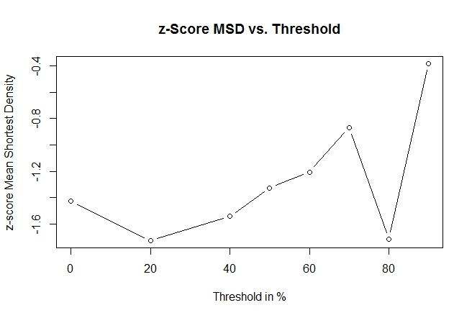
Figure S11: Agglomeration measures vs. cutoff threshold for the definition of the disease signature. LCC: Largest connected component, MSD: mean shortest distance. See equation (12) in the main text
Supplementary Results 4
Differential expression analysis
The analysis revealed that the cartilage dataset had 32 DEGs (21 up/11 down), synovial tissue had 126 DEGs (85 up/41 down), meniscus had 69 DEGs (33 up/36 down) and subchondral bone had 712 DEGs (292 up/420 down). The genes with the logFC changes and the adjusted p-values are shown in Supplementary Table 2. Further on, volcano plots were used to show the DEGs with |logFC| > 1.5 (yellow dots) and |logFC| >2.5 (red dots) in the individual sheets of Supplementary Table 2.
A Venn diagram showing the DEGs for all four tissues and their overlaps is found in Figure 5 of the main text.
There are no genes differentially expressed in all four datasets, however there exist 8 genes that are differentially expressed in 3 out of 4 tissues. Their names and respective function (if relevant for OA) as described in the Uniprot database is shown in Table S1:
Gene name | Function
CSN1S1 | Encodes Alpha-S1-casein
APOD | Encodes component of high density lipoprotein, involved in transport and lipoprotein metabolism
FAP | Encodes prolyl endopeptidase protein, participates in extracellular matrix degradation and tissue remodelling
COL5A2 | Encodes the collagen alpha-2(V) chain, constituent of extracellular matrix
MXRA5 | Encodes matrix-remodeling-associated protein 5
DEFA3 | Encodes defensin 3 protein, involved in various defense/innate immune responses
DEFA4 | Encodes defensin 4 protein, involved in various defense/innate immune responses
S100A8 | Encodes calcium –and zinc binding protein S100-A8, regulates inflammatory processes
Table S1: DEGs (overlap in 3 out of 4 datasets) and their function

