Design of highly stabilized nanocomposite inks based on biodegradable polymer-matrix and gold nanoparticles for Inkjet Printing
Belen Begines^{1,+}, Ana Alcudia¹, Raul Aguilera-Velazquez¹, Guillermo Martinez¹, Yinfeng He², Gustavo F. Trindade^{2,3}, Ricky Wildman², Maria-Jesus Sayagues⁴, Aila Jimenez-Ruiz^{5,+,*}, Rafael Prado-Gotor^{5,*}

¹Department of Organic and Medicinal Chemistry, School of Pharmacy, University of Seville. Seville, 41012. Spain
²Centre for Additive Manufacturing, Faculty of Engineering. University of Nottingham. Nottingham, NG7 2RD. United Kingdom
³ Advanced Materials and Healthcare Technologies, School of Pharmacy, The University of Nottingham, University Park, Nottingham, NG7 2RD, UK
⁴Material Science Institute of Seville, CSIC/US. Seville, 41092. Spain
⁵Department of Physical Chemistry, School of Pharmacy, University of Seville. Seville, 41012. Spain
* To whom correspondence should be addressed. Email: ajimenez28@us.es, pradogotor@us.es
+ These authors contributed equally to this work

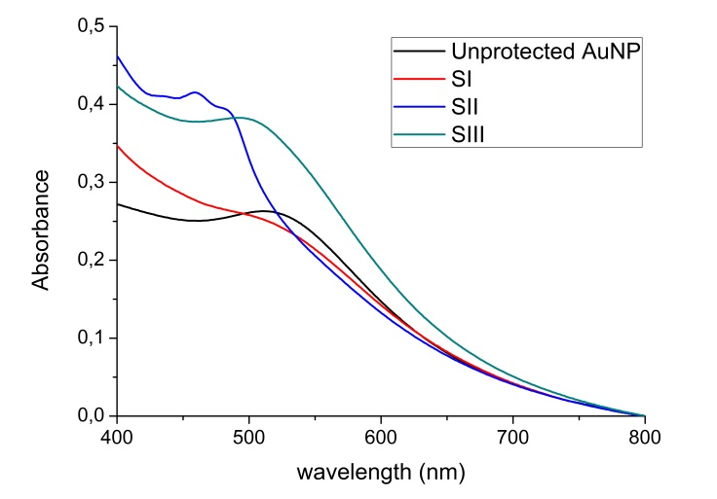
Figure S1. Absorbance measurements of the gold nanoparticles obtained by gold salt reduction in the presence and absence of polymers.

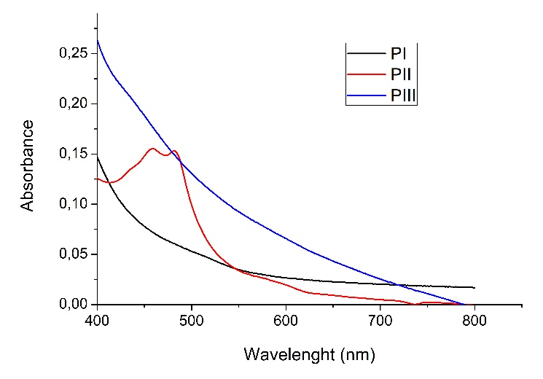
Figure S2. Absorbance spectra of gold-free PI-PIII solutions at the synthesis concentrations
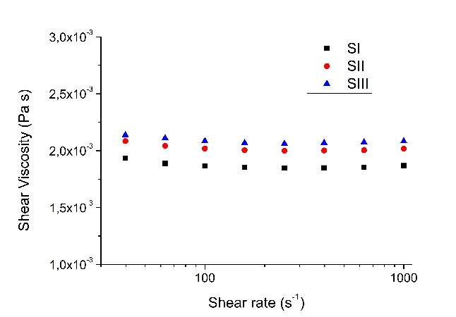
Figure S3. Viscosity data as a function of shear rate for each ink.

Polymer | M_{n} (Da) | M_{w} (Da) | M_{n}/M_{w}
PI | 24300 | 55100 | 2.3
PII | 27700 | 60500 | 2.2
PIII | 23100 | 48200 | 2.1
Table S1: Molecular weights and polydispersities of polymers, both determined by GPC.

Polymers | T_{g} (°C)ª | T_{m} (°C)ª | ΔH_{m} (J/g)ª | °T_{d} (°C)^{b} | ^{max}T_{d} (°C)^{b} | ΔW (%)^{b}
PI | 10 | 21 | 33 | 309 | 264/394 | 8/82
PII | -1 | 18/118 | 8/11 | 300 | 271/335/393 | 7/20/64
PIII | 6/68 | 21/129 | 31/14 | 303 | 297/347/394/449 | 9/28/58/2
Table S2: Thermal properties of polymers. ª Glass transition temperature (T_{g}), melting temperature (T_{m}) and enthalpy (ΔH_{m}) measured by DSC; ^{b} Onset decomposition temperature corresponding to 10% of weight loss (°T_{d}), maximum rate decomposition temperatures (^{max}T_{d}) and weight loss at the respective decomposition step [ΔW(%)] determined by TGA.

System | Initial λ_{max} (nm) | Initial absorbance | Final λ_{max} (nm) | Final absorbance | % λ_{max} drift (40 days) | % Abs loss (40 days)
AuNP  (no polymer) | 511 | 0.263 | 519 | 0.209 | 1.6% | 20.5%
SI | 505 | 0.256 | 516 | 0.234 | 2.1% | 9.4%
SII | - | 0.415 | - | 0.333 | - | 19.8%
SIII | 493 | 0.383 | 499 | 0.283 | 1.2% | 35.3%
Table S3. Normalized absorbance band intensities and positions over the measured time spans

System | Particle size (nm) | Polydispersity
AuNP (no polymer) | 3.2 ± 1.0 | 33%
SI | 2.7 ± 0.7 | 25%
SII | 2.3 ± 0.7 | 30%
SIII | 4.2 ± 0.6 | 16%
Table S4. Particle size and polydispersity values obtained through TEM image analysis

