Detecting long-lasting transients of earthquake activity on a fault system by monitoring apparent stress, ground motion and clustering

Supplementary information

Picozzi M.¹*, Bindi D.², A. Zollo¹, G. Festa¹, and D. Spallarossa³
¹University of Naples Federico II, Italy
²Helmholtz Centre Potsdam, GFZ German Research Centre for Geosciences, Germany
³University of Genova, Italy

*Corresponding author: matteo.picozzi@unina.it

Introduction
The Supplementary Information contains information about:
- The estimation of radiated energy (E_{S}) and seismic moment (M₀) for microearthquakes
- Scaled energy versus seismic moment – self-similarity
- Scaling between seismic energy (E_{S}) and seismic moment (M₀)
- Supplementary figures, 1 to 11.
- Regression parameters of Eq. (2) and Eq. (3)
- Regression parameters of Eq. (7)
- References

- The estimation of radiated energy (E_{S}) and seismic moment (M₀) for microearthquakes

We summarize here our procedure for the estimation of E_{S} and M₀ for microearthquakes. We refer to Picozzi et al. (2019)³⁵ for further details.
The procedure is based on calibrating empirical models which connect the source parameters to features extracted from the seismograms. The calibration data set is composed by 216 earthquakes in the magnitude range Mw 1.2 and Mw 3.2 occurred over the Irpinia fault. The source parameters for the calibration events were computed by Zollo et al. (2014)⁹ considering the following parametric model (reference):
$$M\left(f\right)=\frac{M_{0}}{1+{\left(\frac{f}{f_{c}}\right)}^{γ}}$$
where M₀ is the seismic moment, fc is the corner frequency and γ is the high-frequency fall-off. Following Izutani and Kanamori (2001), we computed the radiated energy E_{S} for the calibration events by numerical integration of the theoretical source spectrum M(f), that is:
$$E_{S}=\frac{4π}{5ρv_{S}^{5}}\int_{0}^{∞}{{\left|fM\left(f\right)\right|}^{2}}df$$
The reliability of the source parameters has been discussed by Zollo et al. (2014)⁹. Regarding the seismic energy, considering a theoretical source model allows us to integrate over a wide range of frequency, avoiding the missing energy outside the frequency band as highlighted by Ide and Beroza (2001)³⁶. Furthermore, the theoretical study on the reliability of estimates of source parameters of small earthquakes presented by Kwiatek and Ben-Zion (2016)⁸ indicates that, considering the sensor characteristics, the hypocentral distances, the magnitude range and the level of seismic noise at the ISNet network, reliable earthquake source parameters can be estimated for the range of magnitude analyzed by Zollo et al., (2014)⁹. Therefore, we consider reliable E_{S} and M₀ estimated for the calibration earthquakes.
Following Picozzi et al. (2019)³⁵, we consider two parameters measured on the S-wave signals in the time domain to calibrate empirical attenuation models to estimate the source parameters for the application data set. The two parameters are the integral velocity square (IV2_{S}), used to estimate E_{S}, and the peak in displacement (PD_{S}), used to estimate M₀. The empirical model for computing E_{S} from IV2_{S} is defined in equation (S1)
$log\left[{IV2}_{S}\left(R_{H}\right)\right]=A+Blog\left(E_{S}\right)+w_{j}C_{j}+\left(1-w_{j}\right)C_{j+1}$ (S1)
where the hypocentral distance R_{H} range is discretized into Nbin; the index j =1,..,Nbin indicates the j-th node selected such that R_{H} is between the distances rj≤ R_{H}< rj+1; the attenuation function is linearized between nodes rj and rj+1 using the weights w, computed as wj = (rj+1 – R_{H})/(rj+1 – rj).
The R_{H} range 5-60 km is discretized into 12 bins with equal width (i.e., 5 km). The minimum distance is fixed to 5 km given the lack of recordings at shorter distances. The coefficients A, B, Cj are determined by solving the over-determined linear system (S1) in a least-square sense. To fix the trade-off between A and Cj, the attenuation is constrained to zero at r2=10 km.
Similarly, the relationship between the peak displacement PD and M₀ has been expressed in the form:
$log\left[{PD}_{S}\left(R_{H}\right)\right]=D+Flog\left(M_{0}\right)+w_{j}G_{j}+\left(1-w_{j}\right)G_{j+1}$ (S2).
Figure S5 shows the attenuation models of Eqs. S1 and S2 (orange stars) in comparison with those obtained by Picozzi et al. (2019)³⁵ in Central Italy (green stars).

The number of events in the calibration data set is only about 10% of the number of events in the application data set. However, we highlight that one should not look at the percentage, which obviously depends on the number of events in the application data set, but to the suitability of the calibration data set for constraining the empirical model in the magnitude range of interest (and for the region of interest). Figure S9 compares the distribution of the energy versus moment scaling of the calibration earthquakes (white squares with red contour) with the scaling relevant to the application data set (white stars with orange contour). In order to avoid extrapolation towards lower magnitudes, in the present study we only interpret results for seismic moment above 10¹¹ Nm (blue stars). We consider the population in the calibration data set suitable to calibrate robust attenuation models over the energy and seismic moment application ranges of interest.
To show few examples of performance of the attenuation model for E_{S}, in Figure S10 we present the single stations E_{S} estimates before and after the correction for the path. The plots a) and b) refer to events (stars with the same colour are different stations for the same event) with M₀ between 11 Nm and 11.5 Nm, the lowest M₀ available from Zollo et al. (2014)⁹. Plots c) and d) refer to events with M₀ between 13 Nm and 13.5 Nm. We highlight that any kind of trend with distance is observed after the correction for the path.

- Scaled energy versus seismic moment – self-similarity

Here we verify if the studied seismicity is self-similar.
As shown in Figure S2, the variation of the scaled energy (i.e., E_{S}/M₀) for two or three order of magnitude when represented as function of moment magnitude (i.e., non-self-similarity) is not uncommon. Most of the represented datasets shows a non-constant scaled energy with magnitude. We followed Kanamory and Rivera (2004, BSSA)^{R1} to investigate the source scaling by checking if the parameter ε in the scaling relation Mo ∝ fc-(3+ε) is different from zero.
We considered the E_{S} and M₀ derived using IV2_{S} and PD_{S}, the E_{S} and M₀ estimates of the calibration dataset by Zollo et al. (2014)⁹, and those for Central Italy derived by Picozzi et al. (2019)³⁵.
Figure S11 shows the normalized scaled energy with respect to the normalized seismic moment (blue stars, this study; red stars, Zollo et al., 2014⁹; orange stars Picozzi et al., 2019³⁵) and the best-fit lines obtained parameterizing Eq. 15 of Kanamory and Rivera (2004, BSSA)^{R1}. In all three cases, ε is different from zero (i.e., 0.3 this study; 0.31 Zollo et al., 2014⁹; 0.17 Picozzi et al., 2019³⁵). The implications of our results is that large and small earthquakes occurring in the investigated areas have different rupture dynamics, as discussed by Kanamory and Rivera (2004, BSSA)^{R1}.

- Scaling between seismic energy (E_{S}) and seismic moment (M₀)

Figure S2b shows the existing scaling between seismic energy (E_{S}) and seismic moment (M₀), together with the E_{S}-M₀ best fit model (black line). Data have been coloured differently to emphasize that for a given M₀ (i.e., for an average slip over the fault area), earthquakes can release different amount of seismic energy depending on the dynamic characteristics of the rupture process (e.g., stress drop, Δσ, and rupture velocity play a significant role). Similarly, earthquakes radiating the same amount of seismic energy can be associated to different deformation features (average slip and rupture dimension). The apparent stress τ_{a} (i.e., the ratio between E_{S} and M₀ multiplied by the rigidity μ of the medium at the source location) contains the complementary nature of the information provided by E_{S} and M₀ and is related to the stress-drop Δσ. Studying only M₀ provides a partial view of the earthquake dynamic, being it a static measure of the rupture process. Differences in τ_{a} among earthquakes with equal M₀ are very important to single out those associated to high rupture velocity and/or high Δσ (i.e., in the case of large earthquakes, τ_{a} can be exploited to characterize those with larger energy radiation and higher devastating power).

- Supplementary figures, 1 to 8.

Supplementary figure 1
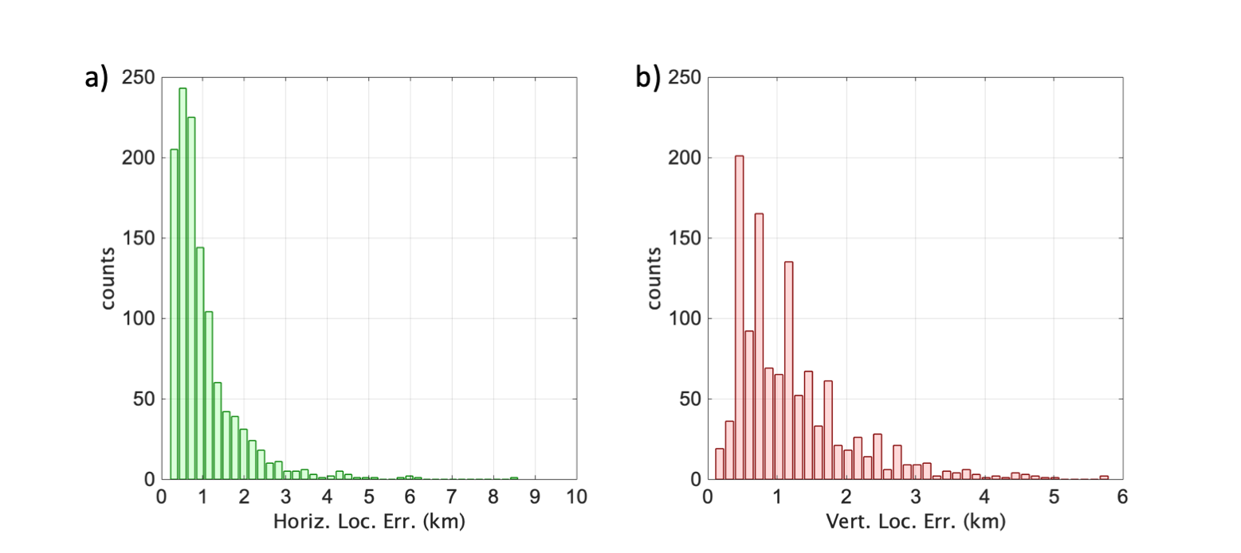
Supplementary Figure S1: (a) horizontal location errors. (b) vertical location errors.

Supplementary figure 2
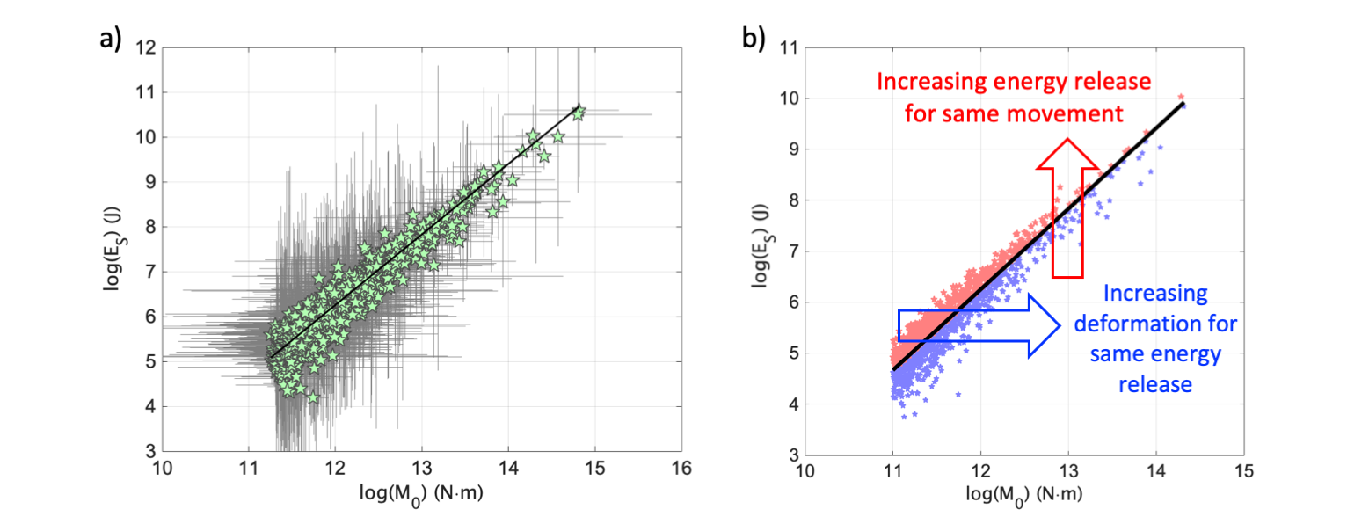
Supplementary Figure S2: (a) E_{S} versus M₀ computed for the microearthquakes recorded at the ISNet seismic network (green stars, with ±1 standard deviations shown as vertical and horizontal bars); best-fit model (black line). (b) The same data of (a), but coloured according to their position with respect to the best-fit model: data above the model (red), below the model (blue).

Supplementary figure 3
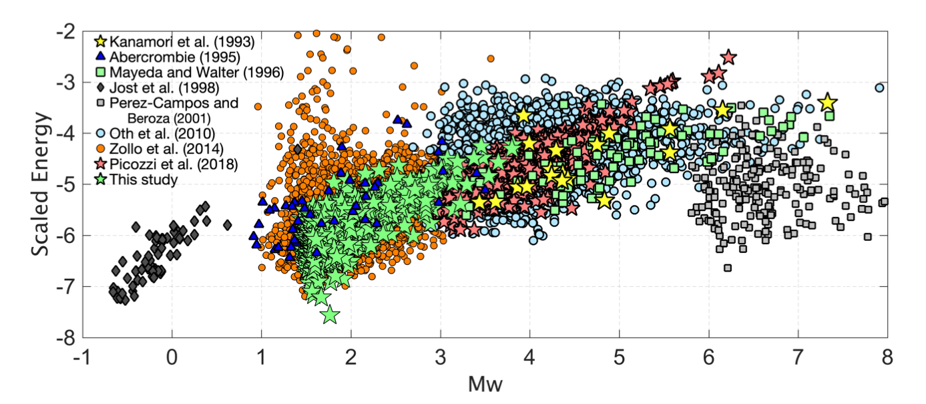
Supplementary Figure S3: Scaled energy versus moment magnitude for the dataset analysed in the present study (green stars) and eight additional other seismological data sets from tectonic areas worldwide involving a wide range of distances (i.e., from local to teleseismic) and seismic phases (e.g., direct P- and S-waves and coda)^{R2-R5}.

Supplementary figure 4

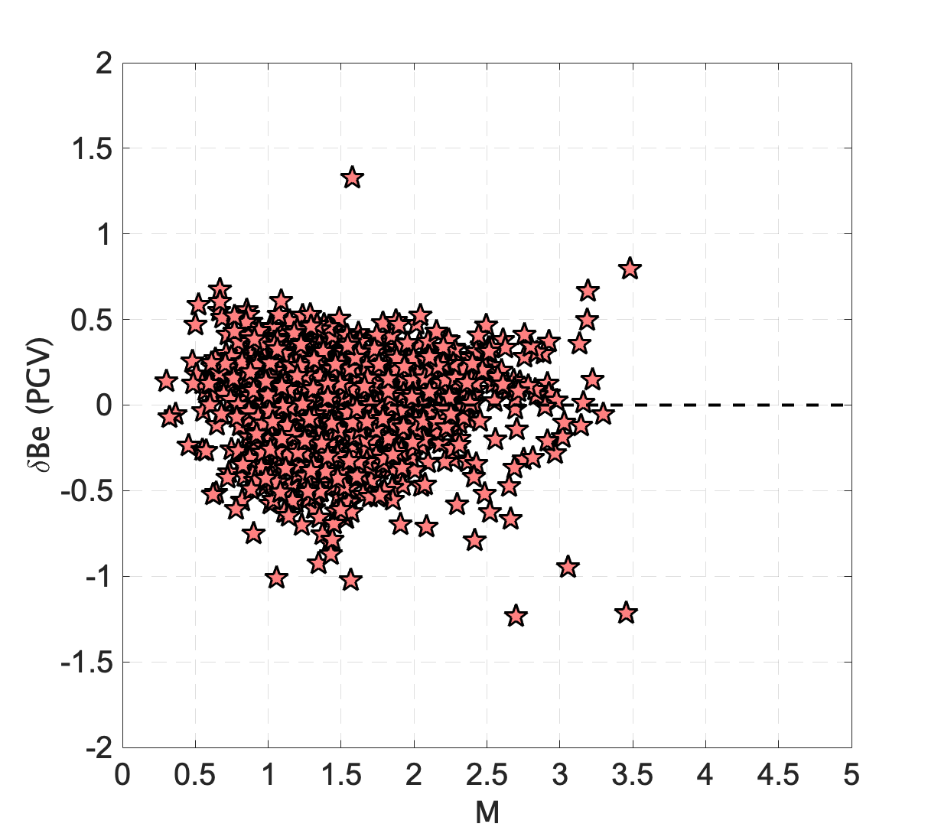
Supplementary Figure S4: δBe residuals for PGV versus magnitude; the zero-bias value (dashed line) is shown for reference.

Supplementary figure 5
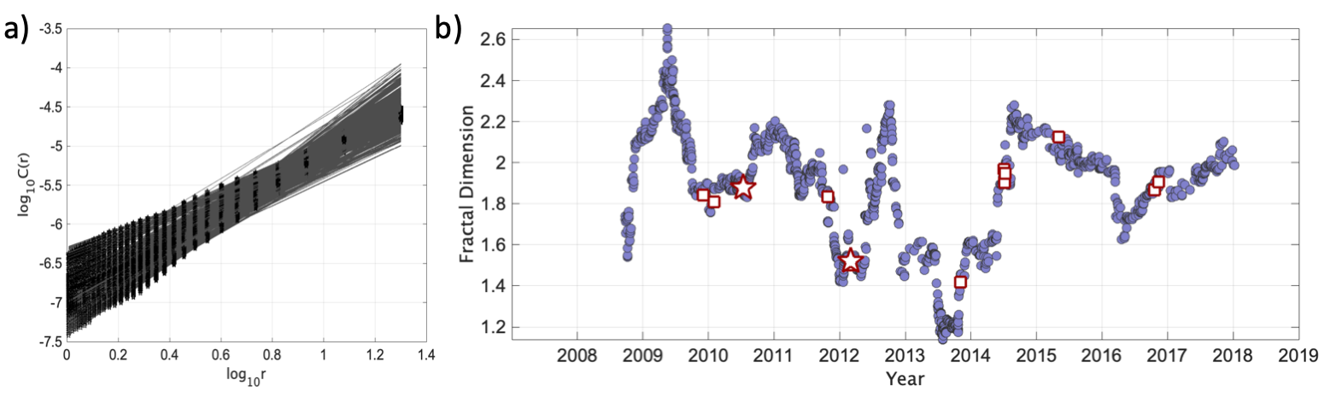
Supplementary Figure S5: (a) Plot of the correlations integral [log10(C(r)] against the radius of a sphere of investigation log₁₀(r) for the 200-event windows (black points) together with best-fit models (grey lines). (b) Fractal dimension, d, versus time. Events with magnitude below Mw 3.0 (blue dots), with Mw >= 3.0 and Mw < 3.5 (white square with red contour), and those with Mw = 3.5 (white stars with red contour).
Supplementary figure 6
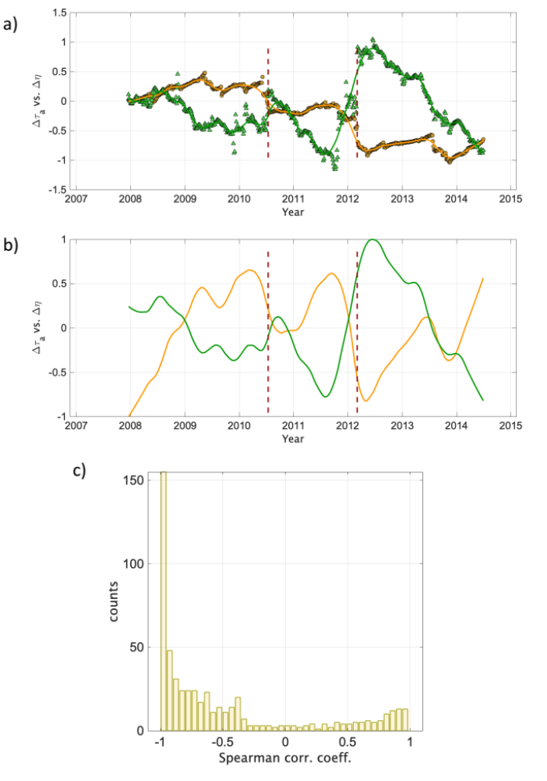
Supplementary Figure S6: (a) Plot of normalized Δτ_{a} (green triangles) and Δη (yellow dots) with and splines (lines). The vertical red dashed lines indicate the occurrence of the two Mw 3.5 earthquakes. (b) Splines as in (a), but after the trend removal. (c) histogram of the Spearman’s correlation.

Supplementary figure 7
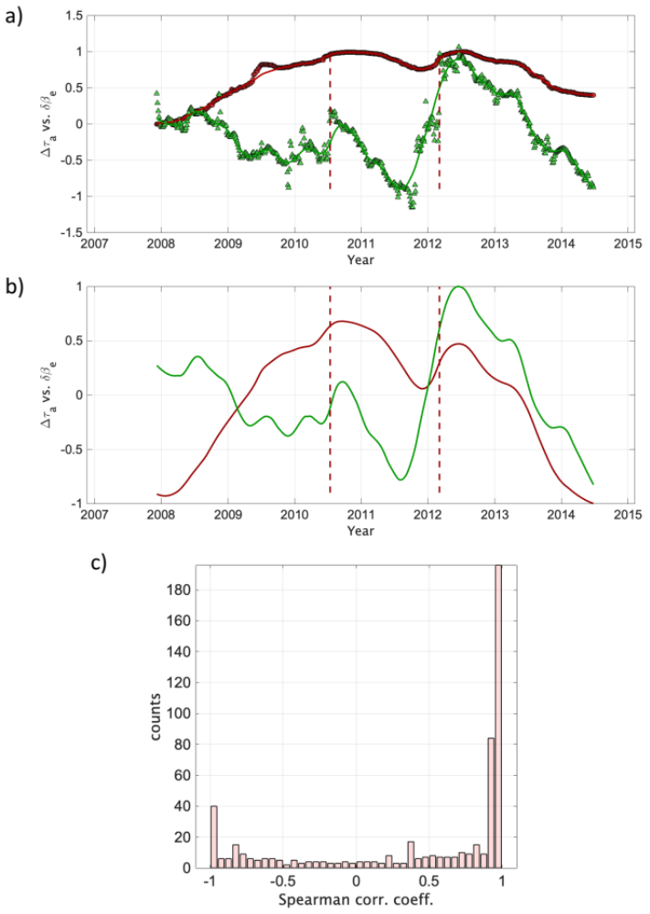
Supplementary Figure S7: (a)The same as Figure_4_R2 but for normalized Δτ_{a} (green) and δΒe (red) and splines.
Supplementary figure 8
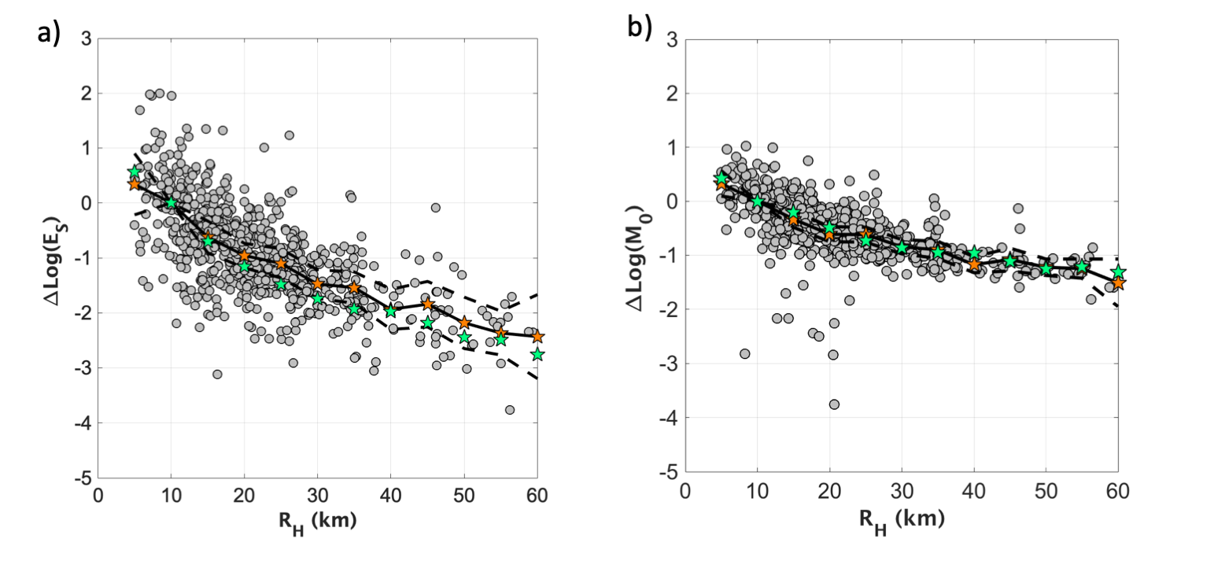
Supplementary Figure S8: (a) Results of the calibrations between IV2_{S} and E_{S} (Eq.2) and between PD_{S} and M₀ (Eq.3). a) the coefficients C_{j} of Eq.2 (orange) are compared with the residuals $∆log\left(E_{S}\right)=log\left[{IV2}_{S}\left(R_{H}\right)\right]-A-Blog\left(E_{S}\right)$ (grey circles); the coefficients C_{j} obtained for the Central Italy seismic sequence³⁵ are also shown (green). (b) the coefficients G_{j} in Eq.3 (orange circles) are compared with the residuals $∆log\left(M_{0}\right)=log\left[{PD}_{S}\left(R_{H}\right)\right]-D+Flog\left(M_{0}\right)$ (grey circles); the coefficients G_{j} obtained for the Central Italy seismic sequence³⁵ are also shown (green). ±1 standard deviation associated to the C_{i} and G_{j} parameters (dashed black lines).

Supplementary figure 9

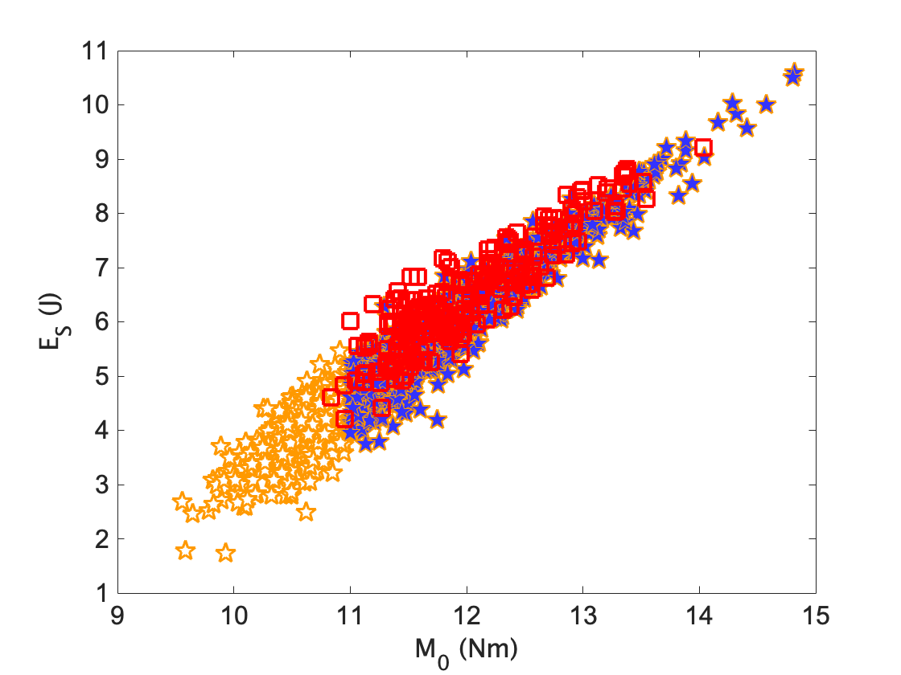
Supplementary Figure S9: E_{S} vs M₀ for all the available events (orange stars), Zollo et al. (2014)⁹ (white squares with red contour), and those used to derive the apparent stress (blue stars).

Supplementary figure 10
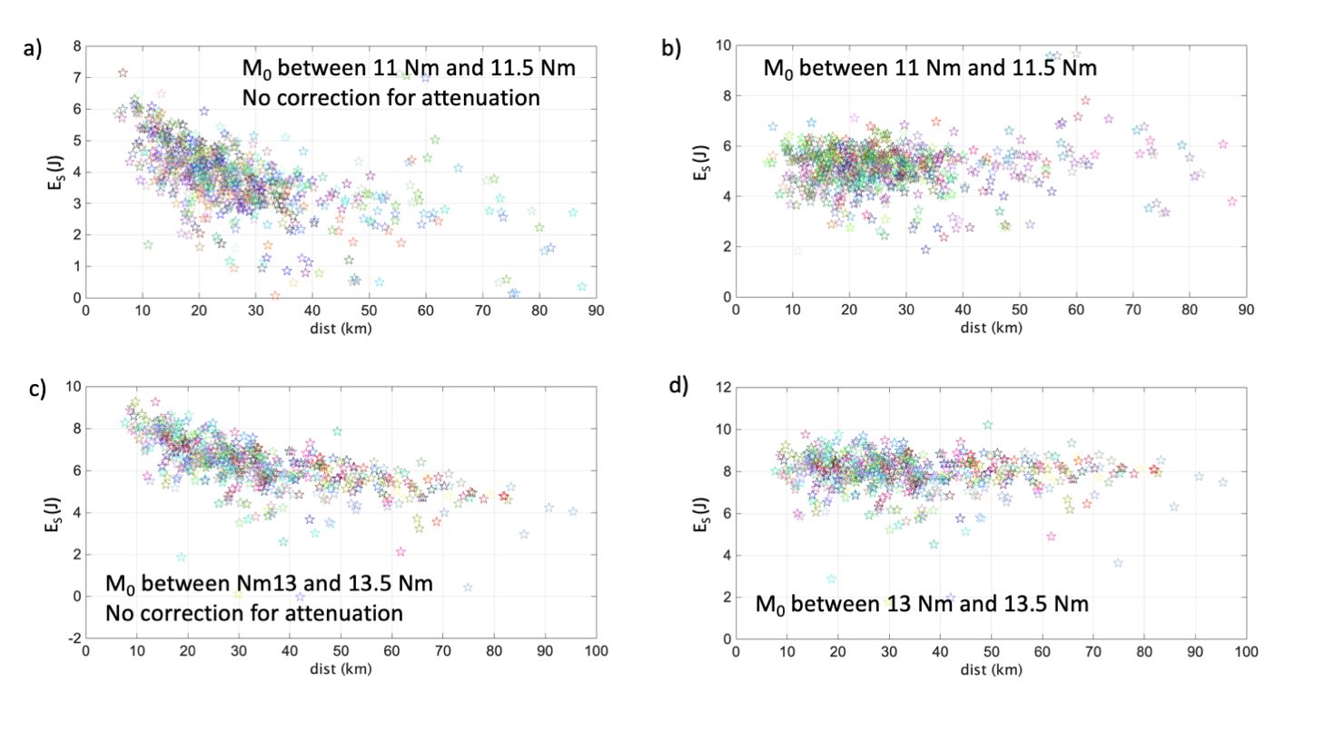

Supplementary Figure S10: Single stations E_{S} estimates before (a, c) and after (b, d) the path corrections. Stations with the same colour belong to the same event.

Supplementary figure 11

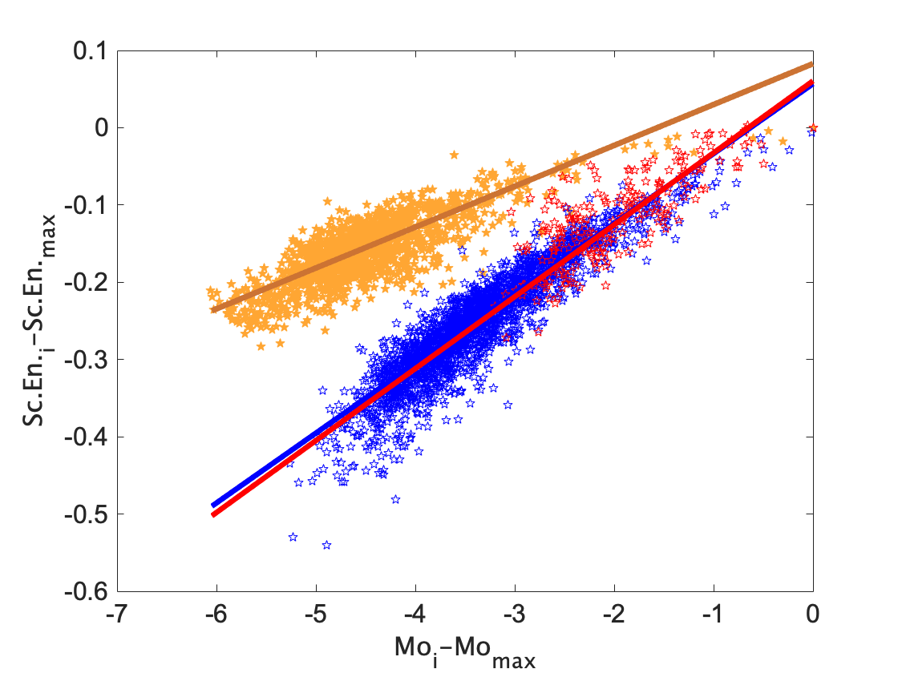
Supplementary Figure S11: Normalized scaling energy versus normalized seismic moment with best-fit lines for the dataset of this study (blue), Zollo et al.,2014⁹ (red), and Picozzi et al., 2019³⁵ (orange).

- Regression parameters of Eq. (2) and Eq. (3)

Parameters | Mean ± Stand. dev. |  | Parameters | Mean ± Stand. dev.
A | -12.43 ± 0.18 |  | D | -14.69 ± 0.42
B | 0.63 ± 0.03 |  | F | 0.712 ± 0.035
Parameters | Values | Stand. dev. | Parameters | Values | Stand. dev.
C₁ | 0.343 | 0.285 | G₁ | 0.33 | 0.121
C₂ | 0.0 | 0.0 | G₂ | 0.0 | 0.0
C₃ | -0.618 | 0.148 | G₃ | -0.332 | 0.077
C₄ | -0.957 | 0.114 | G₄ | -0.609 | 0.071
C₅ | -1.101 | 0.135 | G₅ | -0.618 | 0.070
C₆ | -1.476 | 0.132 | G₆ | -0.842 | 0.068
C₇ | -1.541 | 0.145 | G₇ | -0.899 | 0.080
C₈ | -1.936 | 0.186 | G₈ | -1.175 | 0.076
C₉ | -1.841 | 0.211 | G₉ | -1.078 | 0.107
C₁₀ | -2.180 | 0.238 | G₁₀ | -1.221 | 0.077
C₁₁ | -2.367 | 0.203 | G₁₁ | -1.250 | 0.090
C₁₂ | -2.431 | 0.390 | G₁₂ | -1.510 | 0.224

Supplementary Table S1: Regression parameters of Eq. (2) and Eq. (3) with their standard deviations for the calibration dataset.

- Regression parameters of Eq. (4)
A | B1 | B2 | C | Stand. dev.
-4.36 | 1.11 | -0.11 | -1.31 | 0.23

Supplementary Table S2: Regression parameters of Eq. (4) and the standard deviation.

Supplementary References:
R1. Kanamori, H., and L. Rivera (2004), Static and dynamic scaling relations for earthquakes and their implications for rupture speed and stress drop, Bull. Seismol. Soc. Am., 94, 314–319.
R2. Oth, A., et al. Earthquake scaling characteristics and the scale-(in)dependence of seismic energy-to-moment ratio: Insights from KiK-net data in Japan. Geophys. Res. Lett. 37, L19304, doi:10.1029/2010GL044572. (2010).
R3. Ide, S., & Beroza G. C. (2001), Does apparent stress vary with earthquake size? Geophys. Res. Lett. 28, 3349-3352. (2001).
R4. Zollo, A., et al. Source parameter scaling and radiation efficiency of microearthquakes along the Irpinia fault zone in southern Apennines, Italy. J. Geophys. Res. Solid Earth 119, 3256–3275, doi:10.1002/2013JB010116. (2014).
R5. Picozzi, M., Bindi, D., Spallarossa, D., Di Giacomo, D., Zollo A. (2019). A rapid response magnitude scale for timely assessment of the high frequency seismic radiation. Scientific Reports – Nature (2018) 8:8562 | DOI:10.1038/s41598-018-26938-9.

