Binding and structural analyses of potent inhibitors of the human Ca²⁺/calmodulin dependent protein kinase kinase 2 (CAMKK2) identified from a collection of commercially-available kinase inhibitors

Gerson S. Profeta ^{1,2}, Caio V. dos Reis ^{1,2}, André da S. Santiago ^{1,2}, Paulo H. C. Godoi ^{1,2}, Angela M. Fala ^{1,2}, Carrow I. Wells ⁴, Roger Sartori ², Anita P. T. Salmazo ², Priscila Z. Ramos ^{1,2}, Katlin B. Massirer ^{1,2}, Jonathan M. Elkins ^{2,3}, David H. Drewry ⁴, Opher Gileadi ³ & Rafael M. Couñago ^{1,2 *}
1. Centro de Química Medicinal (CQMED), Centro de Biologia Molecular e Engenharia Genética (CBMEG), Universidade Estadual de Campinas (UNICAMP), Campinas, SP, 13083-875, Brazil
2. Structural Genomics Consortium, Departamento de Genética e Evolução, Instituto de Biologia, UNICAMP, Campinas, SP, 13083-886, Brazil
3. Structural Genomics Consortium, University of Oxford, Old Road Campus Research Building, Roosevelt Drive, Oxford, OX3 7DQ, UK
4. Structural Genomics Consortium, UNC Eshelman School of Pharmacy, University of North Carolina at Chapel Hill, Chapel Hill, NC 27599, USA
* Electronic address: rafael.counago@unicamp.br

Supplementary Information

Supplementary Figure Legends
Supplementary Figure S1 - IC₅₀ curves for indicated compounds against CAMKK2-FL. Solid circles indicate enzyme activity relative to control (DMSO vehicle only) at indicated compound concentrations. Data was analyzed in GraphPad PRISM version 7. Calculated IC₅₀ are shown in Table 1.
Supplementary Figure S2 - IC₅₀ curves for indicated compounds against CAMKK1-FL. Solid circles indicate enzyme activity relative to control (DMSO vehicle only) at indicated compound concentrations. Data was analyzed in GraphPad PRISM version 7. Calculated IC₅₀ are shown in Table 1. All data shown are for single measurements.
Supplementary Figure S3 - 2-D diagram showing potential polar interactions between different ligands and CAMKK2-KD. Diagrams were generated using PoseView within the Proteins Plus web portal. Polar interactions between protein and ligand are drawn as dashed lines. Hydrophobic contacts are represented by green splines. Contacting amino acids are indicated.

Supplementary Table S1 - DSF screening results for compounds that increased the Tm of CAMKK2-KD > 4.0 °C.
Compound | ΔTm (°C)^{c} |  | Source
Staurosporine ª | 17.1 | SelleckChem
GSK650394 ª | 16.2 | SelleckChem
ALK-IN-1 ª | 11.2 | SelleckChem
Crenolanib (CP-868596) ª | 10.6 | SelleckChem
CP-673451 ª | 10.0 | SelleckChem
Ponatinib ª | 9.8 | SelleckChem
AZD3463 ª | 9.3 | SelleckChem
LDK378 ª | 8.0 | SelleckChem
Pacritinib (SB1518) ª | 7.8 | SelleckChem
TAE226 ª | 7.5 | SelleckChem
Hesperadin ª | 7.3 | SelleckChem
PIK-75 ª | 7.2 | SelleckChem
Milciclib (PHA-848125) ª | 7.0 | SelleckChem
GNE-9605 ª | 6.4 | SelleckChem
Foretinib ª | 6.3 | SelleckChem
LY2835219 ª | 6.2 | SelleckChem
BI 2536 ª | 6.1 | SelleckChem
Volasertib (BI 6727) ª | 6.0 | SelleckChem
BX-795 ª | 5.1 | SelleckChem
Danusertib ª | 5.1 | SelleckChem
PHA-665752 ª | 4.9 | SelleckChem
Pelitinib ª | 4.8 | SelleckChem
WZ8040 ª | 4.8 | SelleckChem
A-674563 ª | 4.7 | SelleckChem
CCT137690 ª | 4.7 | SelleckChem
BMS-777607 ª | 4.7 | SelleckChem
TAK-901 ª | 4.7 | SelleckChem
PF-573228 ª | 4.5 | SelleckChem
Sunitinib Malate ª | 4.5 | SelleckChem
Ro3280 ª | 4.5 | SelleckChem
Flavopiridol HCl ª | 4.5 | SelleckChem
CO-1686 ª | 4.4 | SelleckChem
PF-3758309 ª | 4.4 | SelleckChem
CYC116 ª | 4.4 | SelleckChem
GSK1059615 ª | 4.4 | SelleckChem
AZ 960 ª | 4.3 | SelleckChem
LY2784544 ª | 4.3 | SelleckChem
CYT387 ª | 4.3 | SelleckChem
HS-173 ª | 4.2 | SelleckChem
PF-562271 ª | 4.2 | SelleckChem
AZD9291 ª | 4.1 | SelleckChem
K252a ^{b} | 18.3 | LC Laboratories
TAE684 ^{b} | 16.3 | SelleckChem
Aminopurvalanol ^{b} | 9.7 | Calbiochem (EMD)
Syk Inhibitor ^{b} | 9.4 | Calbiochem (EMD)
AZD 7762 ^{b} | 8.4 | Axon Ligands
Wee1/Chk1 inhibitor ^{b} | 8.3 | Calbiochem (EMD)
BIM IX ^{b} | 8.1 | AXXORA
Flt3 Inhibitor III ^{b} | 7.5 | Calbiochem (EMD)
BioFocus 229-4051-4145 ^{b} | 7.2 | BioFocus
BIM I ^{b} | 7.2 | AXXORA
Dovitinib ^{b} | 6.9 | LC Laboratories
IKK 16 ^{b} | 6.8 | Tocris
NG 52 (Compound 52) ^{b} | 6.8 | Calbiochem (EMD)
JNK Inhibitor II ^{b} | 6.8 | Calbiochem (EMD)
GW806742X ^{b} | 5.8 | GSK
Indirubin-3monoxime ^{b} | 5.4 | Calbiochem (EMD)
Chk2 inhibitor II ^{b} | 5.4 | Calbiochem (EMD)
BioFocus 184-7897-0069 ^{b} | 5.1 | BioFocus
SU9516 ^{b} | 5.0 | Calbiochem (EMD)
GSK978744A ^{b} | 4.9 | GSK
T5694244 ^{b} | 4.8 | Enamine
JAK Inhibitor I ^{b} | 4.7 | Calbiochem (EMD)
Reversine ^{b} | 4.6 | Calbiochem (EMD)
BioFocus 184-7897-4140 ^{b} | 4.6 | BioFocus
ChemDiv C285-0110 ^{b} | 4.4 | ChemDiv
CID 755673 ^{b} | 4.4 | Tocris
Cdk2 Inhibitor III ^{b} | 4.4 | Calbiochem (EMD)
Aurora/Cdk Inhibitor ^{b} | 4.3 | Calbiochem (EMD)
BioFocus 184-0049-7467 ^{b} | 4.3 | BioFocus
Bosutinib isomer ^{b} | 4.1 | LC Laboratories
BioFocus 190-0053-4147 ^{b} | 4.1 | BioFocus
ChemDiv C285-0104 ^{b} | 4.1 | ChemDiv
BioFocus 184-4051-0074 ^{b} | 4.0 | BioFocus
a - 384-well format; b - 96-well format; c - values reported from single measurements

Supplementary Table S2 - Literature Data for Binding and Enzymatic Assays Using Compounds Shown in Table1 Against CAMKK1 and CAMKK2
Compound | % Activity Remaining  at 0.5 µM ª |  | Binding results  (Kd's in nM) ^{b}
Compound | CAMKK2 | CAMKK1 | CAMKK2 | CAMKK1
Staurosporine | 0.24 | -3.13 | 0.16 | 0.039
GSK650394 | N/T | N/T | N/T | N/T
ALK-IN-1 | N/T | N/T | N/T | N/T
Crenolanib (CP-868596) | N/T | N/T | N/T | N/T
CP-673451 | N/T | N/T | N/T | N/T
TAE226 | N/T | N/T | N/T | N/T
Foretinib | N/T | N/T | N/T | N/T
BI 2536 | N/T | N/T | 23 | 22
BI 6727 | N/T | N/T | N/T | N/T
Crizotinib | N/T | N/T | 1,500 | >10,000
K252a | N/T | N/T | N/T | N/T
TAE684 | N/T | N/T | 11 | 50
Aminopurvalanol | 33.3 | 86.8 | N/T | N/T
BIM I | N/T | N/T | N/T | N/T
a - Anastassiadis et al. (2011); b - Davis et al. (2011); N/T - not tested

Supplementary Figure S1
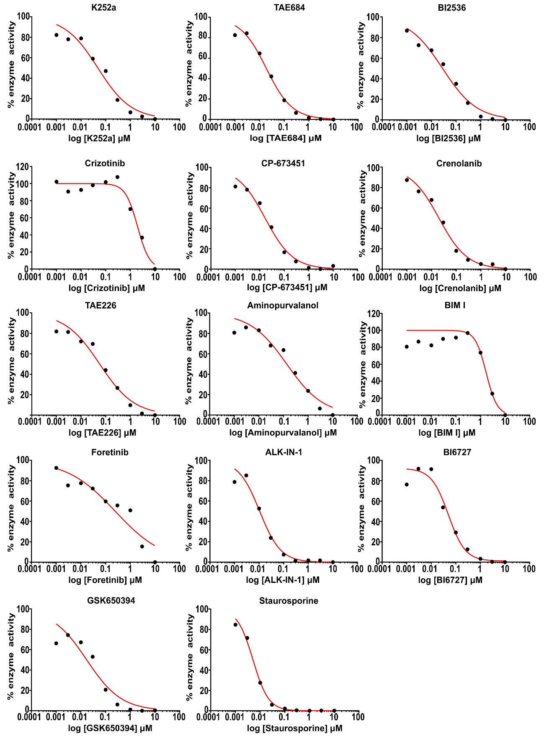

Supplementary Figure S2
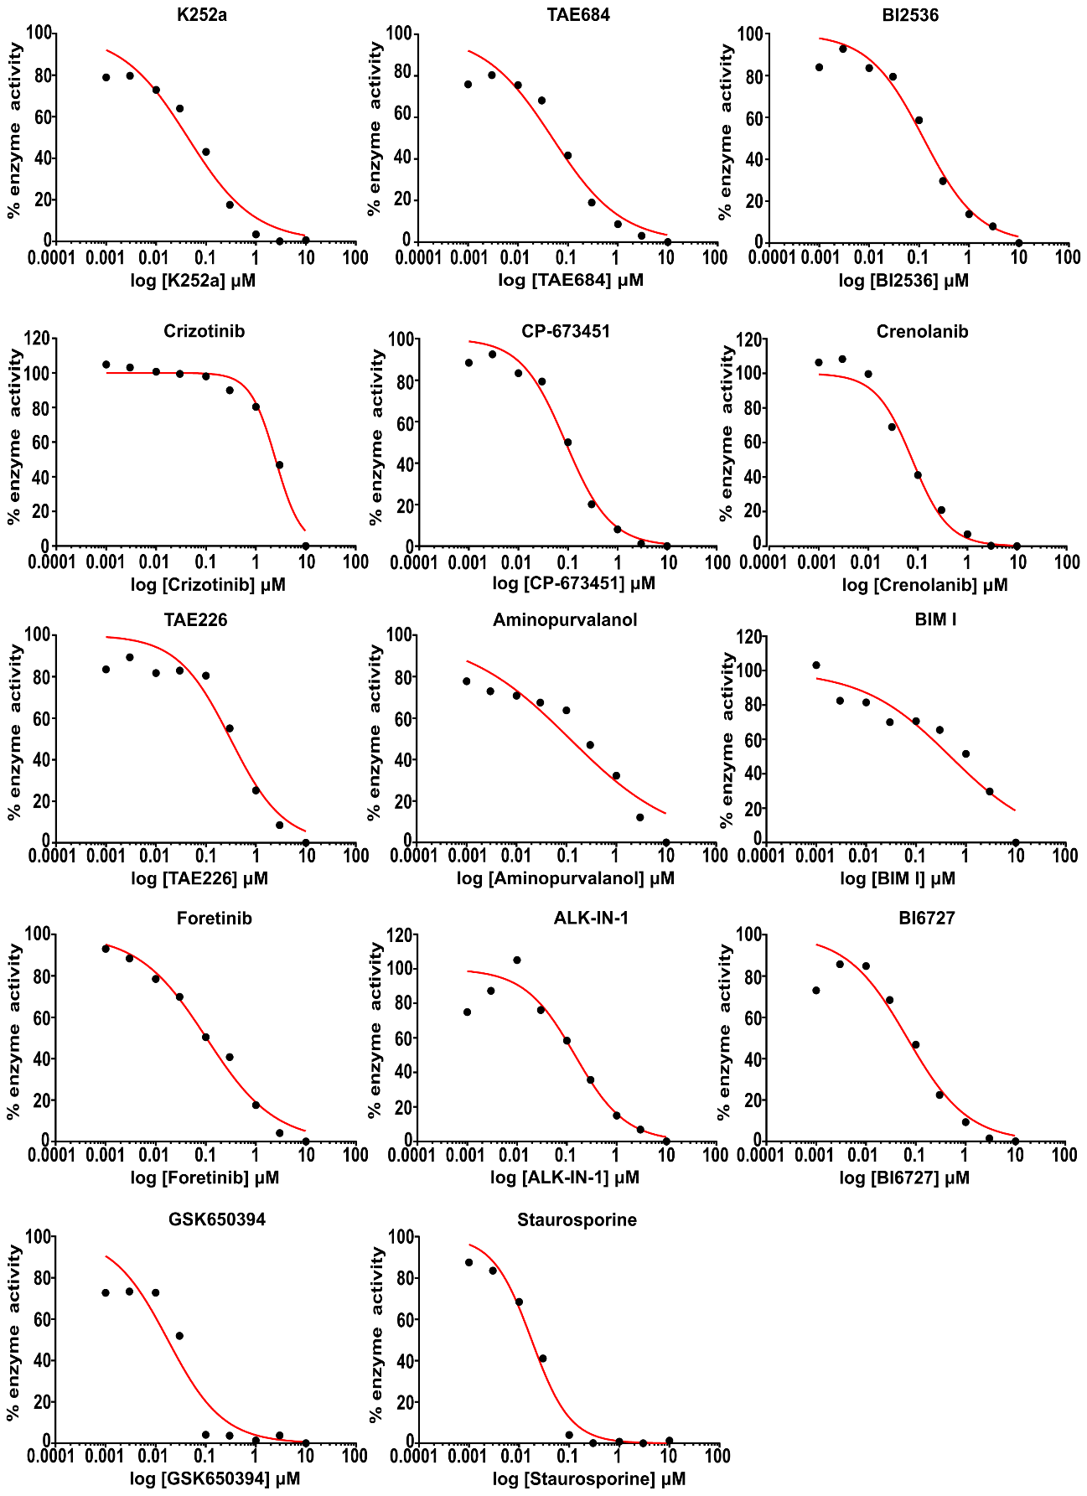

Supplementary Figure S3
