SUPPLEMENTARY MATERIALS

DNA sequence differences are determinants of meiotic recombination outcome

Simon D. Brown^{1,3,†}, Samantha J. Mpaulo^{1,†}, Mimi N. Asogwa¹, Marie Jézéquel¹, Matthew C. Whitby², Alexander Lorenz^{1,}*

¹The Institute of Medical Sciences (IMS), University of Aberdeen, Foresterhill, Aberdeen AB25 2ZD, UK
²Department of Biochemistry, University of Oxford, South Parks Road, Oxford OX1 3QU, UK
³Present address: MRC Institute of Genetics & Molecular Medicine, University of Edinburgh, Edinburgh EH4 2XU, UK

†These authors contributed equally to this study.

*Correspondence should be addressed to
Alexander Lorenz
Institute of Medical Sciences (IMS)
University of Aberdeen
Foresterhill
Aberdeen AB25 2ZD
United Kingdom
Phone: +44 1224 437323
E-mail: a.lorenz@abdn.ac.uk
Specifics of yeast strain and plasmid construction
The open reading frame of msh2 (SPBC19G7.01c) overlaps with the open reading frame of cwf14, to avoid potentially affecting Cwf14 expression and function only a small portion of the 5’ end of msh2 was deleted. A targeting cassette for msh2 was constructed by cloning an upstream flanking sequence of msh2 (PCR using oligonucleotides oUA47 5’-AATTAAcagctgCTTTAGAAAGTTCCCACC-3’ and oUA48 5’-AATTAAggatccGCATTCGAACTATTAAACACC-3’ on genomic DNA of ALP1594) digested with PvuII and BamHI into pAG32¹ linearized with PvuII and BamHI. The resulting plasmid (pALo129) was linearized by digesting with SacI and SpeI and a part of the coding sequence of msh2 (PCR using oligonucleotides oUA49 5’-AATTAAgagctcGTTTTCTAGGAATTTTACGTTGC-3’ and oUA50 5’-AATTAAactagtCAAGTTCAACATCTCGAGC-3’ on genomic DNA of ALP1594) digested with SacI and SpeI was inserted by standard cloning to give pALo130. The transformation cassette was released by a PvuII-SpeI digest and transformed into the standard lab strain FO652. This construct removes the 242 bps at the very 5’ end of the msh2 coding sequence plus an additional 299 bps upstream of the Start codon. Correct integration was monitored by selection for hygromycin B resistance and verified by PCR; all strains carrying the msh2-30::hphMX4 insertion mutation are derived by crossing from the original transformant (UoA459).
A deletion cassette for msh3 (SPAC8F11.03) was constructed by cloning an upstream flanking sequence of msh3 (PCR using oligonucleotides oUA51 5’-AATTAAcagctgCACGATGTAAAGAGTAGC-3’ and oUA52 5’-AATTAAggatccGCTCAACATAGATTTGTAACG-3’ on genomic DNA of ALP1594) digested with PvuII and BamHI into pAG25¹ linearized with PvuII and BamHI. The resulting plasmid (pALo131) was linearized by digesting with SacI and SpeI and a downstream flanking sequence of msh3 (PCR using oligonucleotides oUA53 5’-AATTAAgagctcGAAGAAATCTGAGAGAGAGC-3’ and oUA54 5’-AATTAAactagtCTAAAAGAGCAGAGCAAACC-3’ on genomic DNA of ALP1594) digested with SacI and SpeI was inserted by standard cloning to give pALo132. The transformation cassette was released by a PvuII-SpeI digest and transformed into the standard lab strain ALP729. This construct almost completely removes the msh3 coding sequence: at the 5’ end an additional 37 bps upstream of the Start codon are deleted, and at the 3’ end the last 12 bps of the coding sequence are retained. Correct integration was monitored by selection for CLONNAT-resistance and verified by PCR; all strains carrying the msh3Δ-32::natMX4 deletion are derived by crossing from the original transformant (UoA460).
A deletion cassette for msh6 (SPCC285.16c) was constructed by cloning an upstream flanking sequence of msh6 (PCR using oligonucleotides oUA55 5’-AATTAAcagctgTTCTCTTTGCTGGTTTC-3’ and oUA56 5’-AATTAAggatccGAACAAGTGTTGGTTTTGG-3’ on genomic DNA of ALP1594) digested with PvuII and BamHI into pFA6a-kanMX6² linearized with PvuII and BamHI. The resulting plasmid (pALo133) was linearized by digesting with SacI and SpeI and a downstream flanking sequence of msh6 (PCR using oligonucleotides oUA57 5’-AATTAAgagctcACCTCTCATACTTGATTCG-3’ and
oUA58 5’-AATTAAactagtCGTTACGAATAATGGAACG-3’ on genomic DNA of ALP1594) digested with SacI and SpeI was inserted by standard cloning to give pALo134. The transformation cassette was released by a PvuII-SpeI digest and transformed into the standard lab strain FO652. This construct almost completely removes the msh6 coding sequence: at the 5’ end an additional 4 bps upstream of the Start codon are deleted, and at the 3’ end the last 9 bps of the coding sequence are retained. Correct integration was monitored by selection for G418-resistance and verified by PCR; all strains carrying the msh6Δ-34::kanMX6 deletion are derived by crossing from the original transformant (UoA461).
All plasmid constructs were verified by DNA sequencing (Source BioScience plc, Nottingham, UK). DNA modifying enzymes (high-fidelity DNA polymerase Q5, restriction endonucleases, T4 DNA ligase) were supplied by New England BioLabs. Oligonucleotides were obtained from Sigma-Aldrich Co. (St. Louis, MO, USA).
Plasmid sequences are available online as supporting material (https://dx.doi.org/10.6084/m9.figshare.6949274).

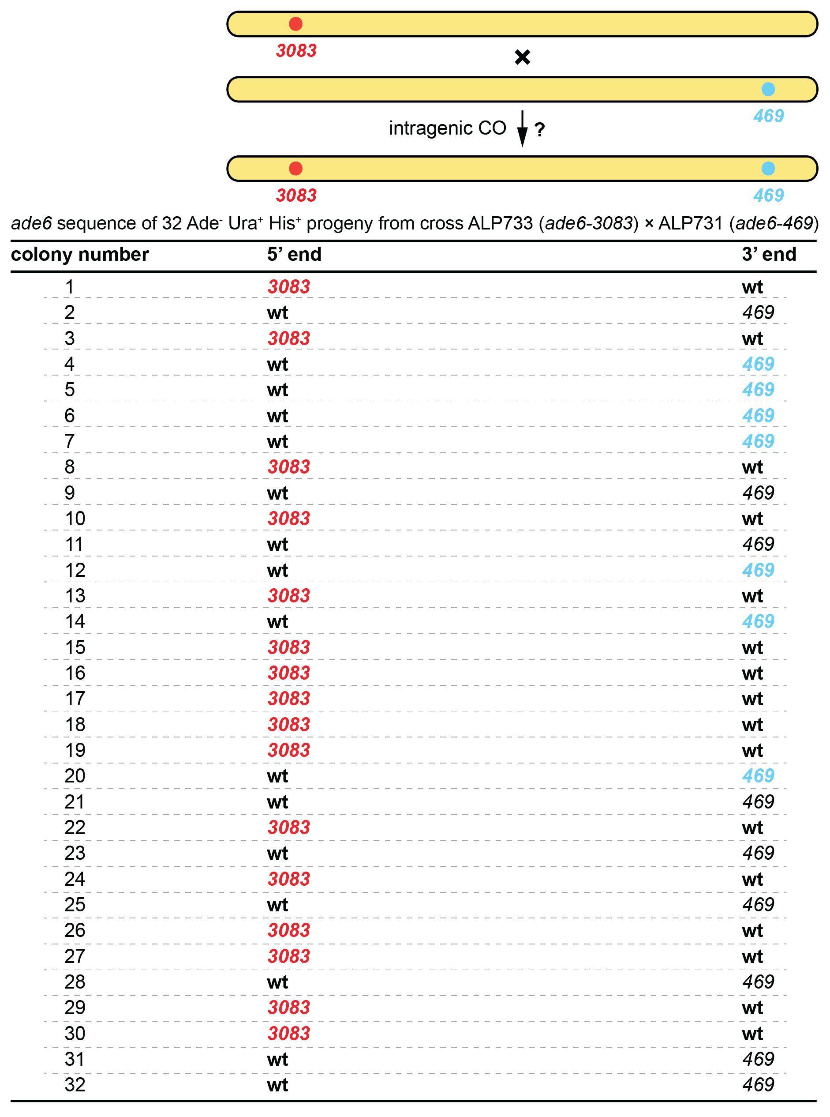
Supplementary Figure S1. Intragenic COs between the 3083 and the 469 point mutations in ade6 could not be confirmed. The ade6 locus was sequenced in 32 Ade- Ura+ His+ colonies from an ade6-3083×ade6-469 (ALP733×ALP731) cross, no instances carrying both mutations were recorded. wt (wild type), 3083, and 469 in bold indicate the status of the sequence confirmed by Sanger sequencing at the 5’ and 3’ ends, respectively. At the 3’ end, the presence of 469 was assumed in some cases (not bold, black) based on the colony being Ade⁻ and having a wt sequence at the 5’ end.

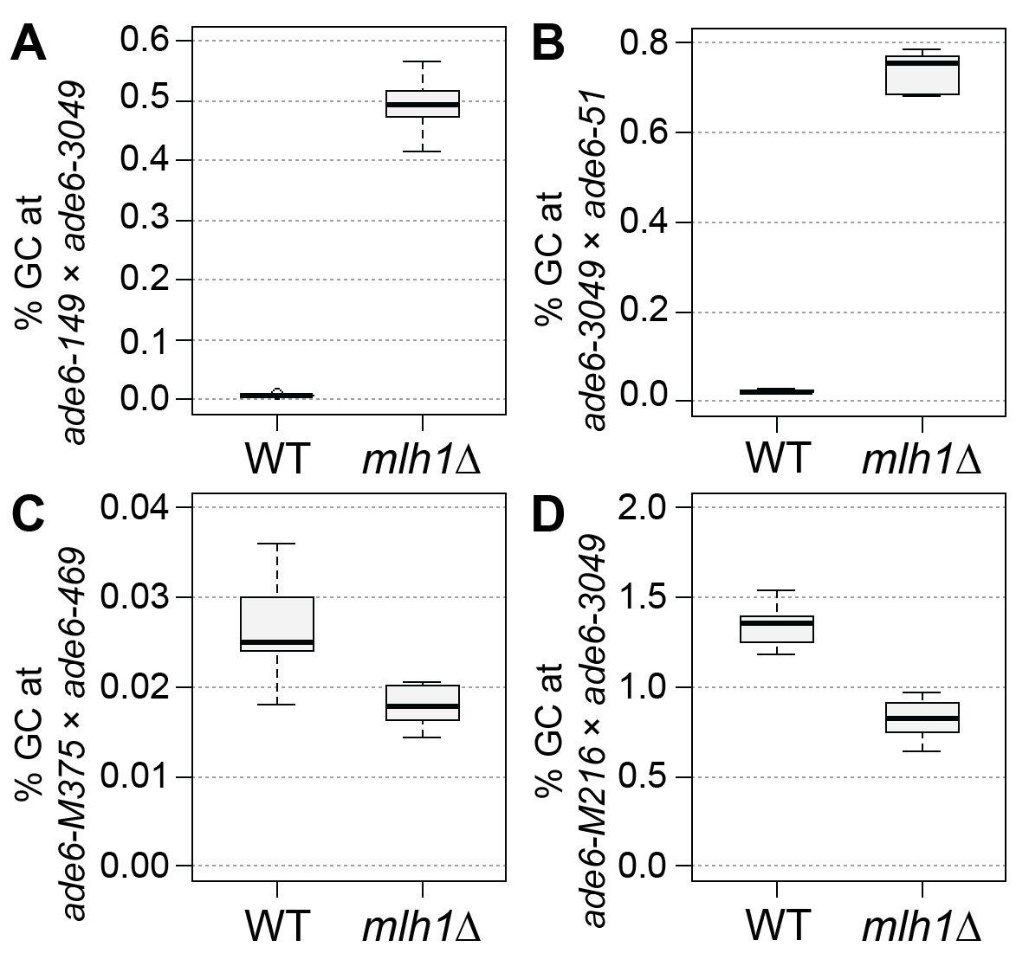
Supplementary Figure S2. MutLα is a major modulator of gene conversion (GC) rate. Frequency of GC in wild type (WT), and mlh1Δ. (A) at the intragenic 33 bp interval ade6-149×ade6-3049: UoA122×UoA497 (WT, n = 6), UoA368×UoA512 (mlh1Δ, n = 6); (B) at the intragenic 53 bp interval ade6-3049×ade6-51: UoA120×UoA463 (WT, n = 6), UoA366×UoA511 (mlh1Δ, n = 6); (C) at the intragenic 1,335 bp interval ade6-M375×ade6-469: ALP1541×ALP731 (WT, n = 16), UoA510×UoA371 (mlh1Δ, n = 6); (D) at the intragenic 1,168 bp interval ade6-M216×ade6-3049: UoA99×UoA123 (WT, n = 12), UoA368×UoA361 (mlh1Δ, n = 12); n indicates the number of independent crosses. For details of data see Supplementary Table S3.

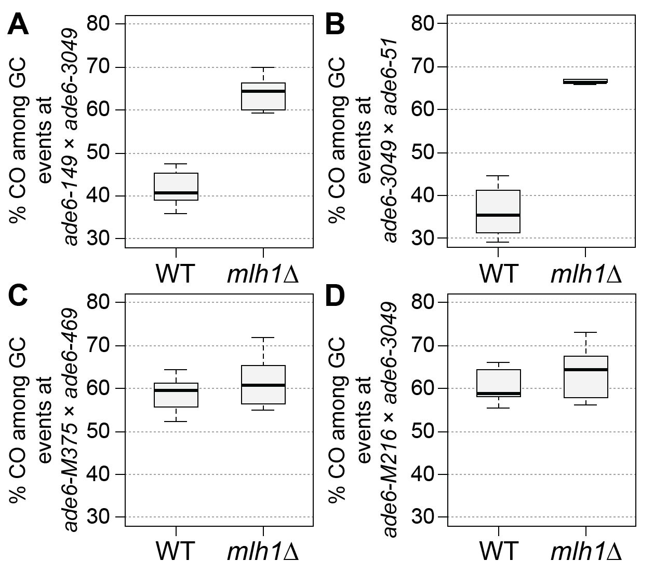
Supplementary Figure S3. MutLα is a major modulator of crossover (CO) frequency among gene coversion (GC) events. Frequency of CO between his3⁺-aim and ura4⁺-aim2 associated with GC events at ade6 in wild type (WT), and mlh1Δ. (A) at the intragenic 33 bp interval ade6-149×ade6-3049: UoA122×UoA497 (WT, n = 6), UoA368×UoA512 (mlh1Δ, n = 6); (B) at the intragenic 53 bp interval ade6-3049×ade6-51: UoA120×UoA463 (WT, n = 6), UoA366×UoA511 (mlh1Δ, n = 6); (C) at the intragenic 1,335 bp interval ade6-M375×ade6-469: ALP1541×ALP731 (WT, n = 16), UoA510×UoA371 (mlh1Δ, n = 6); (D) at the intragenic 1,168 bp interval ade6-M216×ade6-3049: UoA99×UoA123 (WT, n = 12), UoA368×UoA361 (mlh1Δ, n = 12); n indicates the number of independent crosses. For details of data see Supplementary Table S3.

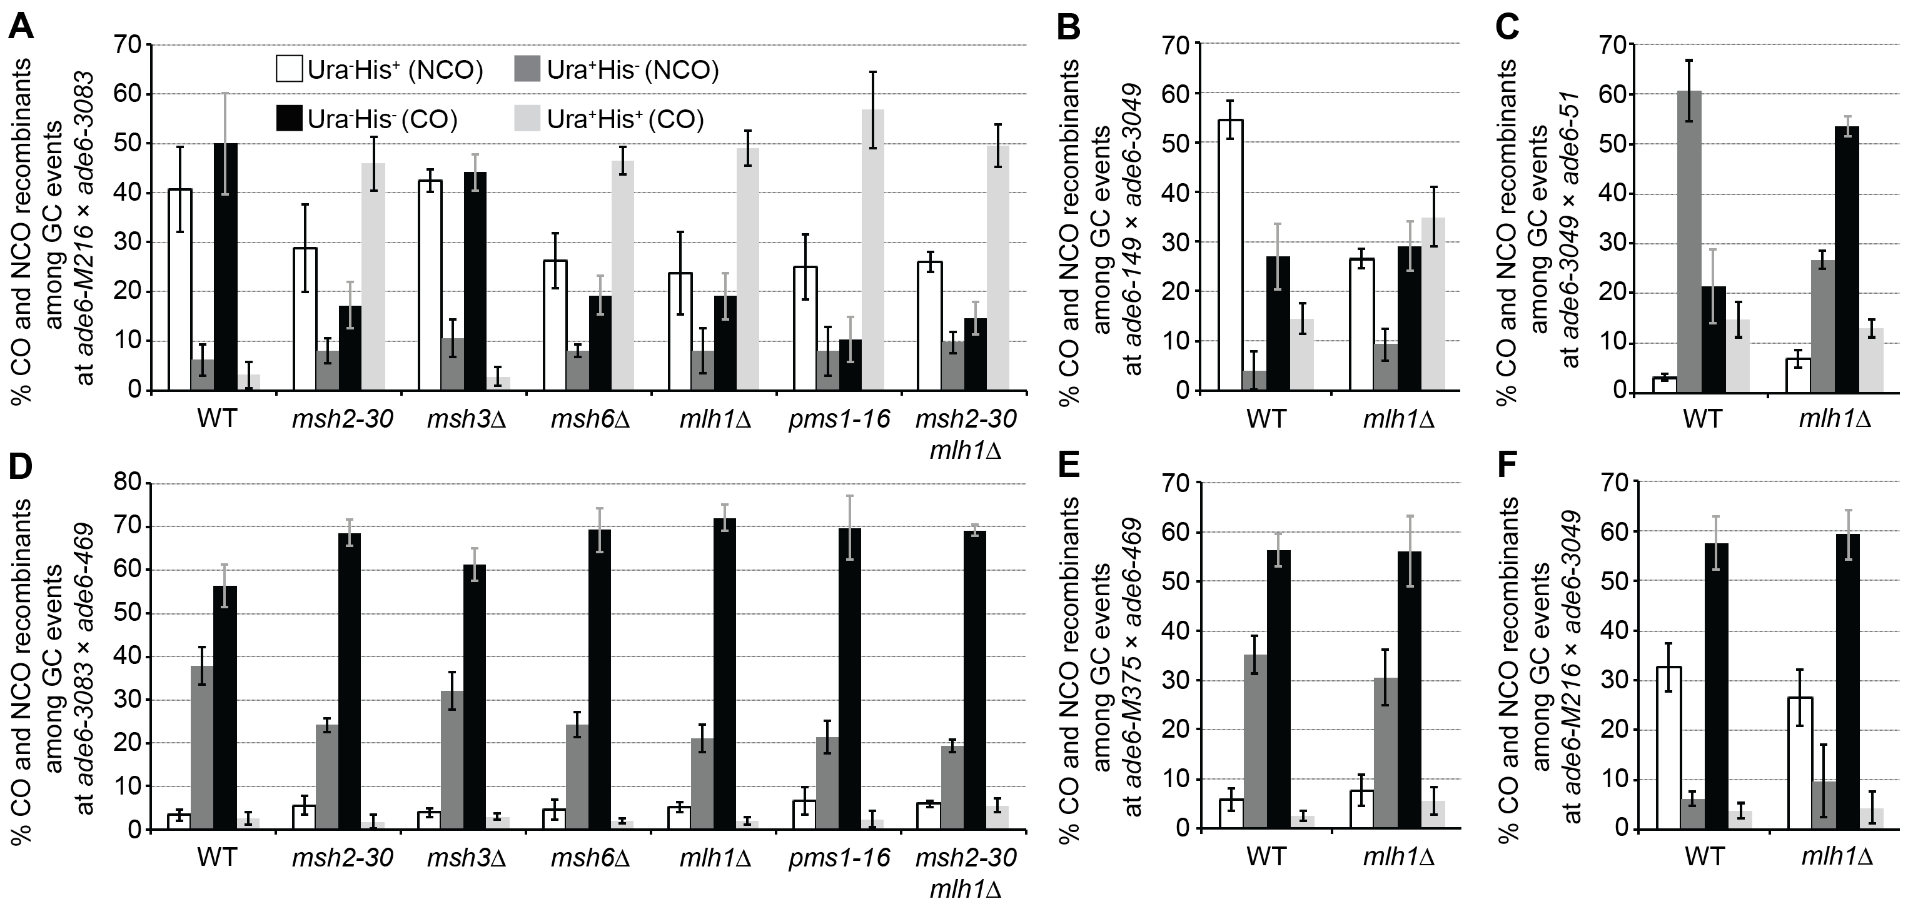
Supplementary Figure S4. Distribution of non-crossover (NCO; Ura⁺ His⁻ & Ura⁻ His⁺) and crossover (CO; Ura⁺ His⁺ & Ura⁻ His⁻) classes among Ade⁺ gene conversion (GC) events in wild type (WT), msh2, msh3, msh6, mlh1, and pms1 mutants (percentages in each class are shown as means ± Std. Dev.. (A) at the intragenic 84 bp interval ade6-M216×ade6-3083: UoA110×UoA100 (WT, n = 12), UoA478×UoA476 (msh2-30, n = 6), UoA494×UoA492 (msh3Δ, n = 6), UoA482×UoA480 (msh6Δ, n = 6), UoA364×UoA361 (mlh1Δ, n = 8), UoA407×UoA405 (pms1-16, n = 5), UoA828×UoA830 (msh2-30 mlh1Δ, n = 6); (B) at the intragenic 33 bp interval ade6-149×ade6-3049: UoA122×UoA497 (WT, n = 6), UoA368×UoA512 (mlh1Δ, n = 6); (C) at the intragenic 53 bp interval ade6-3049×ade6-51: UoA120×UoA463 (WT, n = 6), UoA366×UoA511 (mlh1Δ, n = 6); (D) at the intragenic 1,320 bp interval ade6-3083×ade6-469: ALP733×ALP731 (WT, n = 20), UoA477×UoA479 (msh2-30, n = 6), UoA493×UoA495 (msh3Δ, n = 6), UoA481×UoA483 (msh6Δ, n = 6), UoA362×UoA371 (mlh1Δ, n = 11), UoA406×UoA410 (pms1-16, n = 6), UoA827×UoA829 (msh2-30 mlh1Δ, n = 6); (E) at the intragenic 1,335 bp interval ade6-M375×ade6-469: ALP1541×ALP731 (WT, n = 16), UoA510×UoA371 (mlh1Δ, n = 6); (F) at the intragenic 1,168 bp interval ade6-M216×ade6-3049: UoA99×UoA123 (WT, n = 12), UoA368×UoA361 (mlh1Δ, n = 12); n indicates the number of independent crosses. For details of data see Supplementary Table S3.

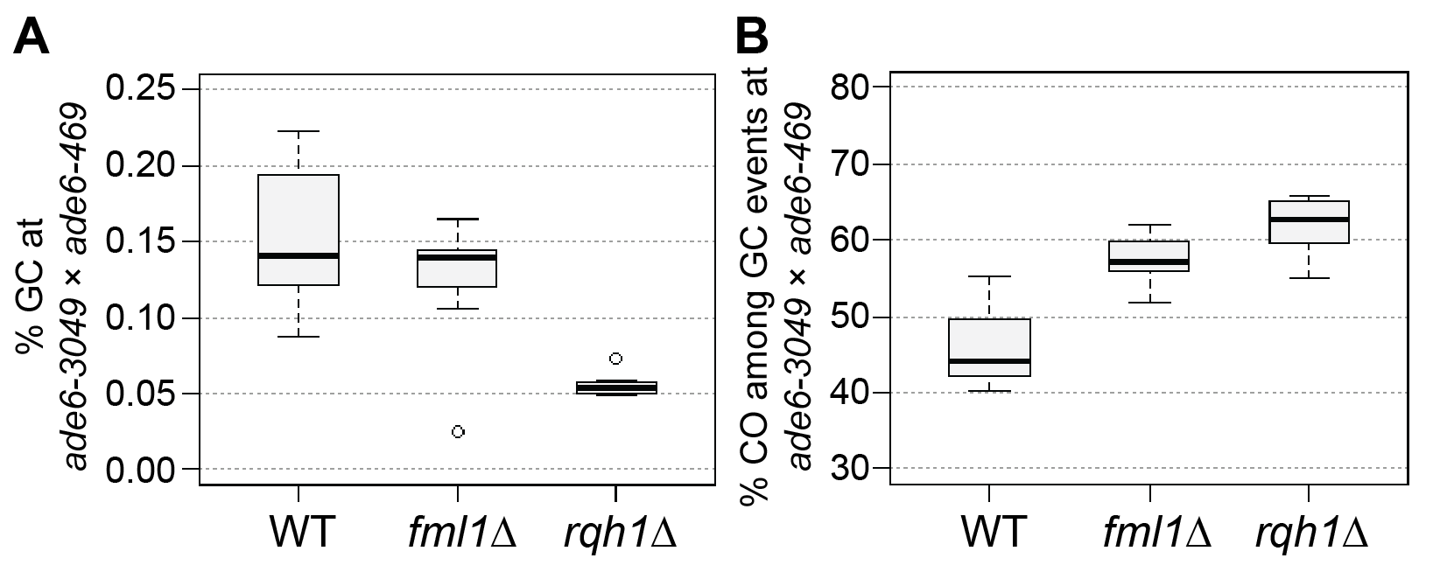
Supplementary Figure S5. Rqh1 and Fml1 modulating meiotic recombination outcome at the intragenic 254 bp interval ade6-3049×ade6-469: (A) Frequency of gene conversion (GC) in wild type (WT), fml1, and rqh1 mutants, UoA120×ALP731 (WT, n = 31), ALP1716×MCW4718 (fml1Δ, n = 11), MCW6587×ALP780 (rqh1Δ, n = 10); (B) Frequency of crossovers (CO) among GC events at ade6 in wild type (WT), fml1, and rqh1 mutants, crosses as in (A). n indicates the number of independent crosses. For details of data see Supplementary Table S3.

Supplementary Table S1. Sequence and position (counted from the A of the start codon ATG as first position) of ade6 point mutations (indicated in bold)
allele | position | DNA sequence | reference
ade6-M216 | G47A | ggtcaattggAccgaatgatg | Szankasi et al., 1988³
ade6-M375 | G133T | acaaattgatTgaggacgtga | Szankasi et al., 1988³
ade6-M26 | G136T | aattgatggaTgacgtgagca | Szankasi et al., 1988³
ade6-3074 | G136T/G142C | aattgatggaTgacgtCagcacattga | Steiner & Smith, 2005⁴
ade6-3083 | A131G/G134T/G136T/G142C/G144T/A146G/A148C | aaattgGtgTaTgacgtCaTcGcCttgatgc | Steiner & Smith, 2005⁴
ade6-704ª | T645A | ataatgtttgAcatttagtat | Park et al., 2007⁵
ade6-52^{b} | G796A | tttactcaacAaaattgctcc | Steiner et al., 2009⁶
ade6-149 | C1181T | atcatgggttTggattctgat | Schär & Kohli, 1993⁷
ade6-3049 | C1214A | aaagatgctgAcgtcatttta | Steiner & Smith, 2005⁴
ade6-51 | C1267T | tgtttcagctTaccgcacacc | Schär et al., 1993⁸
ade6-469 | C1468T | tcagatgcctTgaggtgtccc | Szankasi et al., 1988³
ªpreviously estimated by positional mapping to be C846A⁷; theoretically both, T645A and C846A, create a UGA stop codon suppressible by sup3-5⁵.
^{b}previously reported as T956C⁸

Supplementary Table S4. Yeast strain list
Strain | Relevant genotype | Origin
ALP729 | h^{+S} arg3-D4 his3-D1 leu1-32 ura4-D18 | lab strain⁹
ALP731 | h^{-smt0} ade6-469 his3⁺-aim arg3-D4 his3-D1 ura4-D18 | Lorenz et al., 2010¹⁰
ALP733 | h^{+S} ade6-3083 ura4⁺-aim2 his3-D1 leu1-32 ura4-D18 | Lorenz et al., 2010¹⁰
ALP780 | h^{-smt0} rqh1Δ::kanMX6 ade6-469 his3⁺-aim arg3-D4 his3-D1 ura4-D18 | Lorenz et al., 2014¹¹
ALP781 | h^{+S} rqh1Δ::kanMX6 ade6-3083 ura4⁺-aim2 his3-D1 leu1-32 ura4-D18 | Lorenz et al., 2014¹¹
ALP1133 | h^{+S} fml1Δ::hphMX4 ade6-3083 ura4⁺-aim2 his3-D1 leu1-32 ura4-D18 | Lorenz et al., 2012⁹
ALP1541 | h^{+N} ade6-M375 ura4⁺-aim2 his3-D1 leu1-32 ura4-D18 | Lorenz et al., 2012⁹
ALP1594 | h^{-smt0} ade7-50 arg3-D4 his3-D1 ura4-D18 | lab strain¹²
ALP1716 | h^{+S} fml1Δ::hphMX4 ura4⁺-aim2 ade6-3049 his3-D1 leu1-32 ura4-D18 | this study
FO652 | h^{-smt0} arg3-D4 his3-D1 leu1-32 ura4-D18 | lab strain¹¹
FO1285 | h^{+N} ade6-M26 ura4⁺-aim2 arg3-D4 his3-D1 leu1-32 ura4-D18 | lab strain
MCW4718 | h^{-smt0} fml1Δ::hphMX4 ade6-469 his3⁺-aim arg3-D4 his3-D1 ura4-D18 | Lorenz et al., 2012⁹
MCW6587 | h^{+S} rqh1Δ::kanMX6 ura4⁺-aim2 ade6-3049 his3-D1 leu1-32 ura4-D18 | this study
UoA95 | h^{+S} ura4⁺-aim2 his3-D1 leu1-32 ura4-D18 | this study
UoA96 | h^{-smt0} ura4⁺-aim2 his3-D1 leu1-32 ura4-D18 | this study
UoA97 | h^{+S} his3+-aim arg3-D4 his3-D1 ura4-D18 | this study
UoA98 | h^{-smt0} his3+-aim arg3-D4 his3-D1 ura4-D18 | this study
UoA99 | h^{+S} ade6-M216 ura4⁺-aim2 his3-D1 leu1-32 ura4-D18 | this study
UoA100 | h^{-smt0} ade6-M216 ura4⁺-aim2 his3-D1 leu1-32 ura4-D18 | this study
UoA104 | h^{+S} ade6-3074 ura4⁺-aim2 arg3-D4 his3-D1 ura4-D18 | this study
UoA106 | h^{+S} ade6-3074 his3⁺-aim arg3-D4 his3-D1 ura4-D18 | this study
UoA110 | h^{+S} ade6-3083 his3⁺-aim arg3-D4 his3-D1 ura4-D18 | this study
UoA112 | h^{+S} ade6-704 ura4⁺-aim2 his3-D1 leu1-32 ura4-D18 | this study
UoA115 | h^{-smt0} ade6-704 his3⁺-aim arg3-D4 his3-D1 ura4-D18 | this study
UoA116 | h^{+S} ade6-52 ura4⁺-aim2 his3-D1 leu1-32 ura4-D18 | this study
UoA119 | h^{-smt0} ade6-52 his3⁺-aim arg3-D4 his3-D1 ura4-D18 | this study
UoA120 | h^{+S} ade6-3049 ura4⁺-aim2 his3-D1 leu1-32 ura4-D18 | this study
UoA122 | h^{+S} ade6-3049 his3⁺-aim arg3-D4 his3-D1ura4-D18 | this study
UoA123 | h^{-smt0} ade6-3049 his3⁺-aim arg3-D4 his3-D1 ura4-D18 | this study
UoA361ª | h^{-smt0} mlh1Δ::kanMX6 ade6-M216 ura4⁺-aim2 his3-D1 leu1-32 ura4-D18 | this study
UoA362ª | h^{+S} mlh1Δ::kanMX6 ade6-3083 ura4⁺-aim2 his3-D1 leu1-32 ura4-D18 | this study
UoA364ª | h^{+S} mlh1Δ::kanMX6 ade6-3083 his3⁺-aim arg3-D4 his3-D1 ura4-D18 | this study
UoA366ª | h^{+S} mlh1Δ::kanMX6 ade6-3049 ura4⁺-aim2 his3-D1 leu1-32 ura4-D18 | this study
UoA368ª | h^{+S} mlh1Δ::kanMX6 ade6-3049 his3⁺-aim arg3-D4 his3-D1 ura4-D18 | this study
UoA371ª | h⁻ mlh1Δ::kanMX6 his3⁺-aim ade6-469 arg3-D4 his3-D1 ura4-D18 | this study
UoA405^{b} | h^{-smt0} pms1-16::natMX4 ade6-M216 ura4⁺-aim2 his3-D1 leu1-32 ura4-D18 | this study
UoA406^{b} | h^{+S} pms1-16::natMX4 ura4⁺-aim2 ade6-3083 his3-D1 leu1-32 ura4-D18 | this study
UoA407^{b} | h^{+S} pms1-16::natMX4 ade6-3083 his3⁺-aim arg3-D4 his3-D1 ura4-D18 | this study
UoA410^{b} | h^{-smt0} pms1-16::natMX4 his3⁺-aim ade6-469 arg3-D4 his3-D1 ura4-D18 | this study
UoA447 | h^{-smt0} fml1Δ::natMX6 ade6-M216 ura4⁺-aim2 his3-D1 leu1-32 ura4-D18 | this study
UoA450 | h^{+S} fml1Δ::natMX6 ade6-3083 his3⁺-aim arg3-D4 his3-D1 ura4-D18 | this study
UoA459 | h^{-smt0} msh2-30::hphMX4 arg3-D4 his3-D1 leu1-32 ura4-D18 | this study
UoA460 | h^{+S} msh3Δ-32::kanMX6 arg3-D4 his3-D1 leu1-32 ura4-D18 | this study
UoA461 | h^{-smt0} msh6Δ-34::natMX4 arg3-D4 his3-D1 leu1-32 ura4-D18 | this study
UoA463 | h^{-smt0} ade6-51 his3⁺-aim arg3-D4 his3-D1 ura4-D18 | this study
UoA476 | h^{-smt0} msh2-30::hphMX4 ade6-M216 ura4⁺-aim2 his3-D1 leu1-32 ura4-D18 | this study
UoA477 | h^{+S} msh2-30::hphMX4 ade6-3083 ura4⁺-aim2 his3-D1 leu1-32 ura4-D18 | this study
UoA478 | h^{+S} msh2-30::hphMX4 ade6-3083 his3⁺-aim arg3-D4 his3-D1 ura4-D18 | this study
UoA479 | h^{-smt0} msh2-30::hphMX4 ade6-469 his3⁺-aim arg3-D4 his3-D1 ura4-D18 | this study
UoA480 | h^{-smt0} msh6Δ-34::natMX4 ade6-M216 ura4⁺-aim2 his3-D1 leu1-32 ura4-D18 | this study
UoA481 | h^{+S} msh6Δ-34::natMX4 ade6-3083 ura4⁺-aim2 his3-D1 leu1-32 ura4-D18 | this study
UoA482 | h^{+S} msh6Δ-34::natMX4 ade6-3083 his3⁺-aim arg3-D4 his3-D1 ura4-D18 | this study
UoA483 | h^{-smt0} msh6Δ-34::natMX4 ade6-469 his3⁺-aim arg3-D4 his3-D1 ura4-D18 | this study
UoA492 | h^{-smt0} msh3Δ-32::kanMX6 ade6-M216 ura4⁺-aim2 his3-D1 leu1-32 ura4-D18 | this study
UoA493 | h^{+S} msh3Δ-32::kanMX6 ade6-3083 ura4⁺-aim2 his3-D1 leu1-32 ura4-D18 | this study
UoA494 | h^{+S} msh3Δ-32::kanMX6 ade6-3083 his3⁺-aim arg3-D4 his3-D1 ura4-D18 | this study
UoA495 | h^{-smt0} msh3Δ-32::kanMX6 ade6-469 his3⁺-aim arg3-D4 his3-D1 ura4-D18 | this study
UoA497 | h^{-smt0} ade6-149 ura4⁺-aim2 his3-D1 leu1-32 ura4-D18 | this study
UoA499 | h^{-smt0} rqh1Δ-G1::natMX6 ade6-M216 ura4⁺-aim2 his3-D1 leu1-32 ura4-D18 | this study
UoA502 | h^{+S} rqh1Δ-G1::natMX6 ade6-3083 his3⁺-aim arg3-D4 his3-D1 ura4-D18 | this study
UoA510 | h^{+N} mlh1Δ::kanMX6 ura4⁺-aim2 ade6-M375 his3-D1 leu1-32 ura4-D18 | this study
UoA511ª | h^{-smt0} mlh1Δ::kanMX6 ade6-51 his3⁺-aim arg3-D4 his3-D1 ura4-D18 | this study
UoA512ª | h^{-smt0} mlh1Δ::kanMX6 ade6-149 ura4⁺-aim2 his3-D1 leu1-32 ura4-D18 | this study
UoA827ª | h^{+S} mlh1Δ::kanMX6 msh2-30::hphMX4 ura4⁺-aim2 ade6-3083 his3-D1 leu1-32 ura4-D18 | this study
UoA828ª | h^{+S} mlh1Δ::kanMX6 msh2-30::hphMX4 ade6-3083 his3⁺-aim arg3-D4 his3-D1 ura4-D18 | this study
UoA829ª | h^{+S} mlh1Δ::kanMX6 msh2-30::hphMX4 his3⁺-aim ade6-3083 arg3-D4 his3-D1 ura4-D18 | this study
UoA830ª | h^{-smt0} mlh1Δ::kanMX6 msh2-30::hphMX4 ade6-M216 ura4⁺-aim2 his3-D1 leu1-32 ura4-D18 | this study
UoA861 | h^{+S} ade6-M375 his3⁺-aim arg3-D4 his3-D1 ura4-D18 | this study
ªmlh1Δ strains are derivatives of OL937¹³, provided as FY18813 by the National BioResource Project (NBRP) of the MEXT, Japan.
^{b}pms1 insertion mutant strains are derivatives of PRS301¹⁴, provided as FY18790 by the National BioResource Project (NBRP) of the MEXT, Japan.

Supplementary References
1. Goldstein, A. L. & McCusker, J. H. Three new dominant drug resistance cassettes for gene disruption in Saccharomyces cerevisiae. Yeast 15, 1541–53 (1999).
2. Bähler, J. et al. Heterologous modules for efficient and versatile PCR-based gene targeting in Schizosaccharomyces pombe. Yeast 14, 943–51 (1998).
3. Szankasi, P., Heyer, W. D., Schuchert, P. & Kohli, J. DNA sequence analysis of the ade6 gene of Schizosaccharomyces pombe - wild-type and mutant alleles including the recombination hot spot allele ade6-M26. J. Mol. Biol. 204, 917–25 (1988).
4. Steiner, W. W. & Smith, G. R. Optimizing the nucleotide sequence of a meiotic recombination hotspot in Schizosaccharomyces pombe. Genetics 169, 1973–83 (2005).
5. Park, J.-M., Intine, R. V & Maraia, R. J. Mouse and human La proteins differ in kinase substrate activity and activation mechanism for tRNA processing. Gene Expr. 14, 71–81 (2007).
6. Steiner, W. W., Steiner, E. M., Girvin, A. R. & Plewik, L. E. Novel nucleotide sequence motifs that produce hotspots of meiotic recombination in Schizosaccharomyces pombe. Genetics 182, 459–69 (2009).
7. Schär, P. & Kohli, J. Marker effects of G to C transversions on intragenic recombination and mismatch repair in Schizosaccharomyces pombe. Genetics 133, 825–35 (1993).
8. Schär, P., Munz, P. & Kohli, J. Meiotic mismatch repair quantified on the basis of segregation patterns in Schizosaccharomyces pombe. Genetics 133, 815–824 (1993).
9. Lorenz, A. et al. The fission yeast FANCM ortholog directs non-crossover recombination during meiosis. Science 336, 1585–8 (2012).
10. Lorenz, A., West, S. C. & Whitby, M. C. The human Holliday junction resolvase GEN1 rescues the meiotic phenotype of a Schizosaccharomyces pombe mus81 mutant. Nucleic Acids Res. 38, 1866–73 (2010).
11. Lorenz, A., Mehats, A., Osman, F. & Whitby, M. C. Rad51/Dmc1 paralogs and mediators oppose DNA helicases to limit hybrid DNA formation and promote crossovers during meiotic recombination. Nucleic Acids Res. 42, 13723–13735 (2014).
12. Brown, S. D., Jarosinska, O. D. & Lorenz, A. Genetic interactions between the chromosome axis-associated protein Hop1 and homologous recombination determinants in Schizosaccharomyces pombe. Curr. Genet. 64, 1089–1104 (2018).
13. Marti, T. M., Mansour, A. A., Lehmann, E. & Fleck, O. Different frameshift mutation spectra in non-repetitive DNA of MutSα- and MutLα-deficient fission yeast cells. DNA Repair (Amst). 2, 571–580 (2003).
14. Schär, P., Baur, M., Schneider, C. & Kohli, J. Mismatch repair in Schizosaccharomyces pombe requires the mutL homologous gene pms1: molecular cloning and functional analysis. Genetics 146, 1275–1286 (1997).

