Supplementary data

Pseudomonas aeruginosa quorum sensing inhibition by clinical isolate Delftia tsuruhatensis 11304: involvement of N-octadecanoylhomoserine lactones
Milka Malešević¹, Flaviana Di Lorenzo², Brankica Filipić^{1, 3}, Nemanja Stanisavljević¹, Katarina Novović¹, Lidija Senerovic¹, Natalija Polović⁴, Antonio Molinaro², Milan Kojić¹, Branko Jovčić^{1, 5}
¹Institute of Molecular Genetics and Genetic Engineering, University of Belgrade, Belgrade, 11010, Serbia ²University of Napoli Federico II, Department of Chemical Sciences, Napoli, 80126, Italy ³Faculty of Pharmacy, University of Belgrade, Belgrade, 11221, Serbia ⁴Faculty of Chemistry, University of Belgrade, Belgrade, 11000, Serbia ⁵Faculty of Biology, University of Belgrade, Belgrade, 11000, Serbia
*Correspondence: Branko Jovčić bjovcic@bio.bg.ac.rs
Supplementary table S1. The 633 clinical isolates belonging to 11 different bacterial taxa from Laboratory for Molecular Microbiology, Institute of Molecular Genetics and Genetic Engineering, University of Belgrade collection, analyzed in this study.
Bacterial taxon | Number of tested isolates
Acinetobacter spp. | 39
Achromobacter spp. | 128
Burkholderia cepacia complex | 218
Delftia spp. | 2
Klebsiella spp. | 27
Escherichia coli | 1
Chryseobacterium spp. | 38
Ochrobactrum spp. | 5
Ralstonia spp. | 26
Pseudomonas spp. | 2
Stenotrophomonas spp. | 147

Supplementary table S2. The 19 (belonging to five genera) of 633 analyzed strains that showed quorum sensing inhibitory activity according to colorimetric agar well diffusion assay. Diameter of inhibition zones of violacein production by C. violaceum CV026 was detrmined for each strain.
Bacterial genera | Designation of the strain | Zone diameter (mm)
Achromobacter spp. | 13011 | 14
Burkholderia cepacia complex | BCC7  BCC8  BCC9  BCC19  BCC20  BCC24  BCC66  BCC301  BCC302  BCC532  BCC4135 | 17  16  17  12  13  15  17  17  19  19  20
Delftia spp. | 11304  6960/2 | 23  17
Stenotrophomonas spp. | 1556  6646  6960  7451 | 11  12  15  14
Ralstonia spp. | 630 | 13

Supplementary table S3. MIC value of bis (2-ethylhexyl) phthalate and diisooctyl phthalate against test strains C. violaceum CV026 and P. aeruginosa MMA83.
Name of the bacterial strain | MIC (µg/ml)
Name of the bacterial strain | bis (2-ethylhexyl) phthalate | diisooctyl phthalate
C. violaceum CV026 | >1024 | >1024
P. aeruginosa MMA83 | >1024 | >1024
Supplementary table S4. List of virulence factors genes found in D. tsuruhatensis 11304 genome using virulence factor database (VFDB) and Linux command line.
Supplementary table S5. List of antibiotic resistance determinants detected in D. tsuruhatensis 11304 genome. CARD database was used for the prediction of the D. tsuruhatensis 11304 resistome.

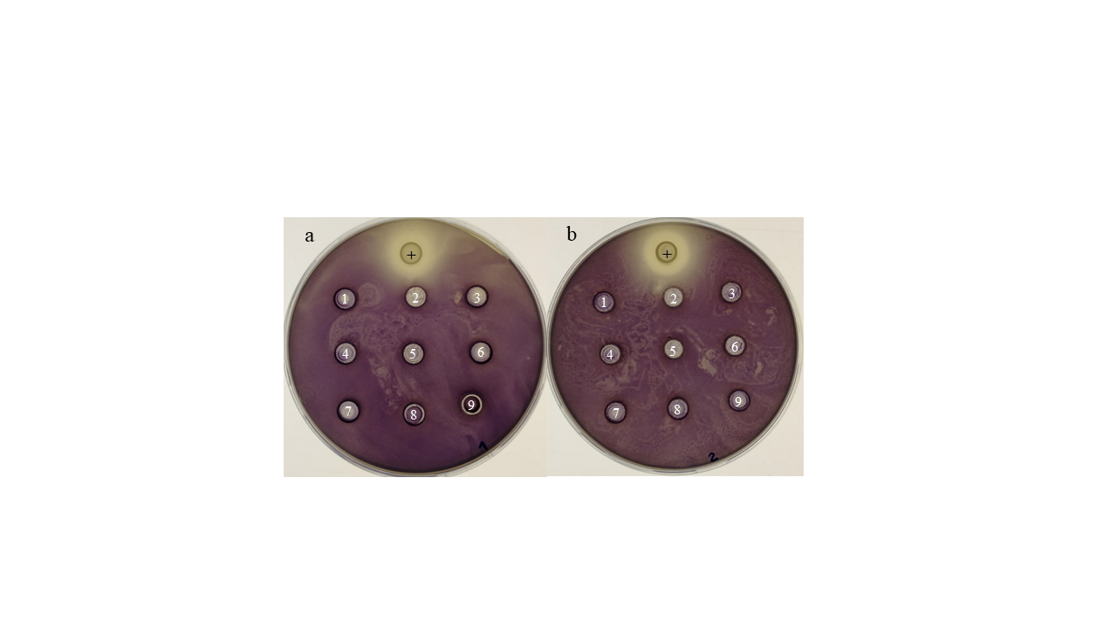
Supplementary figure S1. The effect of different concentrations (4 µg/ml to 1024 µg/ml) of (a) bis (2-ethylhexyl) phthalate and (b) diisooctyl phthalate on violacein pigment production. Neither of these compounds showed QSI activity at the used concentrations when tested with a colorimetric agar well diffusionassay using Chromobacterium violaceum CV026 as an indicator strain. Different concentrations are labeled from 1-9 following the order: 1-1024 µg/ml; 2-512µg/ml; 3-256µg/ml; 4-128µg/ml; 5-64µg/ml; 6-32µg/ml; 7-16µg/ml; 8-8µg/ml; 9-4µg/ml. Positive control (D. tsuruhatensis 11304 culture) is designated with ’+’.
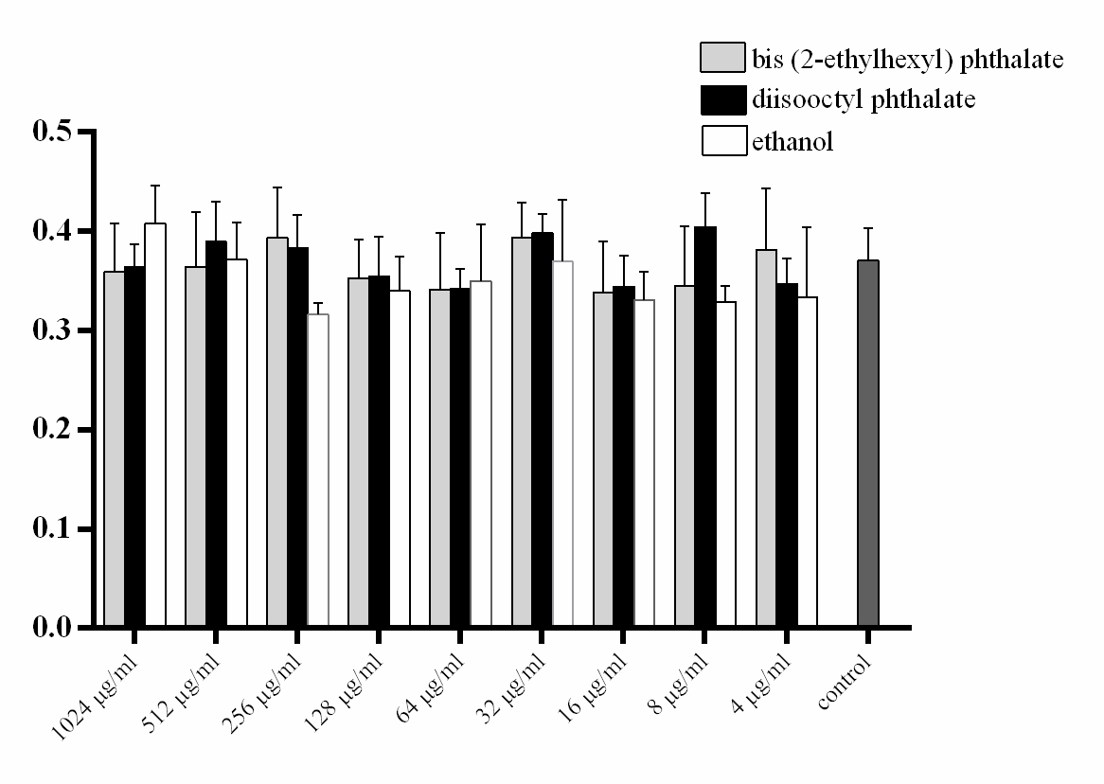
Supplementary figure S2. The effect of different concentrations of bis (2-ethylhexyl) phtalata and diisooctyl phtalate on biofilm formation of Pseudomonas aeruginosa MMA83. Axis – optical density of at 600 nm.

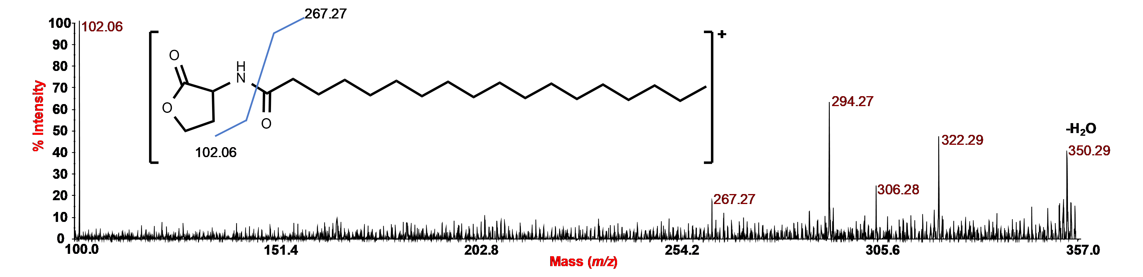
Supplementary figure S3. MALDI MS²studyof N-octadecanoylhomoserine lactone (C₁₈-HSL). Positive ion MS² spectrum of precursor ion (C₁₈-HSL) is at m/z 368.3. The relative C₁₈-HSL structure is reported in the inset.

